Collective Bargaining Agreement between the

Sheriff of Howard County, Maryland and the

Fraternal Order of Police, Howard County Sheriffs, Lodge #131



July 1, 2020-June 30, 2021

 

 Agreement 5

 Recognition 5

 Unit Description 5

 Re-Titled Classifications 5

 New Classifications 5

 Probationary Deputy Sheriff 6



 Scope 6

 Selection of Representatives 7

 Non-Discrimination 7

 Individual Representation 7

 Lodge Visitation 8

 Lodge Representation 8

 Consultation Rights 8

 Use of Bulletin Boards, Interoffice Mail, and Email 8

 Lodge Orientation/Briefings 9

 Lodge Office 9

 Rights and Authority 9

 Work Periods 10

 ESTABLISHMENT 11

 PROCESS / PROCEDURE 11

 ORDER OF LAYOFFS AND REHIRES 13



 Wage Adjustments 14

 Salaries for Probationary Deputy Sheriffs 14

 Step Increments 14

Longevity Steps 15

 Promotion to Deputy First Class 15

 Overtime Pay / Compensatory Time 15

 Shift Differential 16

 Stand-by Pay 16

 Call-in Pay 16

 Court Time 16

 Field Training Sheriff Compensation 17

 Acting Duty Pay 17

 Canine Pay 18

 Holiday Pay 18

 Clothing and Uniform Allowance 19

 No Duplication or Pyramiding of Premium Pay 20

 Specialty Pay 20

 Detail Pay 21

 Meal Allowance 21

 Howard County Closing 21

 Scope 21

 Holidays 22

 Annual Leave 22

 Personal Leave 23

 Disability Leave 23

 Disability Leave Donation 25

 Worker’s Compensation Leave 25

 Jury Leave 25

 Military Leave 26

 Bereavement Leave 26

 Leave of Absence without Pay 27

 Lodge Leave 27

 Leave for Negotiations 28

Family and Medical Leave 28

 Health Insurance 28

 Life Insurance 28

 Disbursement 29



 Scope 30



 Time Limitations 31

 Procedural Steps 31

 Other Conditions 33

 Administrative Procedure 33

 Composition of Hearing Boards 33

 Criminal Charges 33



 Bargaining Unit Member Access 34

 Removal of Information 34

 Bargaining Unit Member Additions 34

 Referral Services 34

 Policy 35

 Purpose and Composition 35



 Agreement 36

 Promotional Process 36

 Involuntary Transfers 36

 Posting and Filling of Vacancies 36



 Scope 37

Scope 38

 Standard Issue 38

 No Strike 39

 No Lockouts 39

 Agreement of Saving Clause 40

 ONE YEAR AGREEMENT 40

 For the Sheriff of Howard County 41

 For the Lodge, Fraternal Order of Police, Howard County Sheriffs Lodge #131 41

# PREAMBLE

## Agreement

This AGREEMENT, made on this 1st day of July 2020, between the Sheriff of Howard County, Maryland (hereinafter referred to as the “Sheriff”), and HCSO FOP Lodge 131 (hereinafter referred to as the “Lodge”) shall be in effect as of July 1, 2020. WHEREAS, the Sheriff and the Lodge, in consideration of the mutual covenants and promises herein contained, do hereby agree that the terms of the Agreement are as follows:

# RECOGNITION AND UNIT DESCRIPTION

## Recognition

The Sheriff recognizes the Lodge as the exclusive representative of certain bargaining unit members, as defined in Section 2.02(a) of this Article, for the purpose of negotiating collectively with the Sheriff pursuant to Article – Courts and Judicial Proceedings, Section 2-327(f), Annotated Code of Maryland with respect to wages, hours, and other terms and conditions of employment.

## Unit Description

The unit shall consist of State Authorized Exempt positions held by Probationary Deputy Sheriffs and Sworn Deputy Sheriffs, Deputy Sheriffs First Class, and Corporals; confidential management and exempt bargaining unit members. The unit will include only the following job class titles:

2405 - Deputy Sheriff

2406 - Deputy Sheriff First Class 2407 - Deputy Corporal

## Re-Titled Classifications

If any of the above listed classifications are re-titled without any change in job duties, such classification shall be included in Section 2.02(a) and included as members of the bargaining unit.

## New Classifications

If any new classifications are created which fall within the first sentence of the unit description in Section 2.02(a) of this Article, the inclusion of, exclusion of, the new classifications shall be subject to the mutual agreement of the Sheriff and the Lodge. In the event the Sheriff and the Lodge are unable to agree on the inclusion or exclusion of a classification, either party may submit the issue to arbitration. The Sheriff and the Lodge shall attempt to select a mutually acceptable arbitrator within 10 working days; if no arbitrator is selected, the party seeking arbitration shall request a list of arbitrators from the Federal Mediation and Conciliation Service. The arbitration shall be conducted in accordance with the rules of the American Arbitration Association. In reaching a decision, the arbitrator shall be guided by the standards used by the National Labor Relations Board in similar cases. The decision of the arbitrator shall be final. The cost of the arbitration shall be borne equally by the Sheriff and the Lodge, except the costs incurred in presenting or defending the case to the arbitrator shall be borne by the side incurring the expense.

## Probationary Deputy Sheriff

1. Newly hired Deputy Sheriff(s) covered by this agreement shall serve a probationary period as outlined in paragraphs (b) and (c). The Sheriff may, during such probationary period, at his sole discretion, dismiss, layoff, or transfer such bargaining unit members and no grievance shall be filed or claimed by such bargaining unit members or on behalf of any of them by the Lodge for or on account of any such action of the Sheriff during said period. Grievances may be filed by probationary bargaining unit members on issues other than those listed above.
2. Recruit Deputy Sheriffs who attend the traditional Howard County Deputy Sheriff Recruit Training Academy or an approved alternative academy, shall serve a probationary period of 18 months from the date they are first employed by the Sheriff’s Office as a Probationary Deputy Sheriff.
3. Lateral/Experienced Deputy Sheriffs shall serve a probationary period of 1 year from the date they are first employed by the Sheriff’s Office.
4. The Sheriff may extend the probationary period for probationary bargaining unit members past their normal probationary period for medical reasons when a bargaining unit member is unable to perform as a Deputy Sheriff for 30 days or more during the initial probationary period. Said extended period shall only be added for that period the probationary deputy was unable to perform their duties.
5. In the event of an extension of the probationary period, at the end of such extension and upon receiving a satisfactory performance evaluation, the bargaining unit member shall receive the appropriate step increase that will place that bargaining unit member at the same level as their peers as though there has been no extension of the probationary period.

# AUTHORIZED DUES DEDUCTIONS

## Scope

1. Dues deducted during any pay period from the pay of the bargaining unit member pursuant to this Article shall be remitted to the Lodge within 7 calendar days following each payroll deduction. Payroll deductions for Lodge dues will begin on the first possible payroll following the receipt of the signed authorization forms by the Sheriff but no later than 3 weeks following that receipt.
2. The designation of dues deductions pursuant to this Article shall be made on a form supplied by the Lodge. A copy of the Dues Deduction Form is provided as Exhibit A.
3. The Lodge’s dues shall not be deducted when a bargaining unit member’s net pay is insufficient to cover the dues after other legal deductions have been made.
4. The amount of the dues deducted will remain the same until the Lodge certifies, in writing, to the Sheriff, over the signature of an authorized officer of the Lodge, that such fees have been lawfully changed and what the new deduction will be each pay period. The Sheriff shall be notified at least 1 month in advance of the effective date of such a change.
5. The Lodge shall indemnify the Sheriff’s Office harmless of and from, any and all claims, grievances, actions, suits or other forms of liability or damages arising out of, or by reason of, any action taken by the Sheriff’s Office for the purpose of complying with any of the provisions of this Article, and the Lodge assumes full responsibility for the disposition of the fund deducted under this Article as soon as they have been remitted by the Sheriff’s Office to the Lodge.

## LODGE REPRESENTATI0N and BARGAINING UNIT RIGHTS

## Selection of Representatives

a) Bargaining unit representatives shall be selected in any manner determined by the Lodge from among those actively employed by the Sheriff. The Lodge shall furnish the Sheriff with a roster of lodge officers and shop stewards; the Lodge will keep the Sheriff informed in writing of any changes regarding these Lodge representatives.

## Non-Discrimination

a) The Sheriff and the Lodge shall not discriminate against any bargaining unit member because of race, sex, creed, religion, color, age, national origin, physical or mental handicap, occupation, marital status, political opinion, sexual orientation, personal appearance, affiliation, association or non-association, or his membership or non- membership in the Lodge as it relates to the enforcement and administration of this Agreement.

## Individual Representation

a) Deputy Sheriffs have the right to represent themselves, or designate a personal representative, in their employment relations with the Sheriff. Notwithstanding any other provision in this Agreement, an individual bargaining unit member may present a grievance at any time to the Sheriff without the intervention of the Lodge, provided that the Lodge is advised in advance of said grievance and is notified of the specific disposition of the matter, and provided further that any adjustment made shall not be inconsistent with the terms of this Agreement.

## Lodge Visitation

a) With the permission of the Sheriff or his/her designee, the Lodge, its State and/or National Affiliation shall have reasonable access to the Sheriff premises for the purpose of conferring with FOP representatives while investigating a grievance. Permission shall not be unreasonably withheld by the Sheriff.

## Lodge Representation

1. The Sheriff agrees to hear grievances filed by the Lodge on behalf of a Bargaining Unit Member, pursuant to a provision of this Agreement, during normal work hours. Only 1 Lodge representative employed by the Sheriff shall be permitted to attend these hearings at Steps 1 and 2, as set forth in Article 14 of this Agreement on a paid basis.
2. Two (2) Lodge representatives employed by the Sheriff’s Office to include the Lodge President shall be permitted to attend grievance hearings at Step 3 and above on a paid basis if held during their regular work hours.
3. The Sheriff’s Office reserves the right, at its option and after 5 business days’ notice to the Lodge, to schedule grievances during non-working hours.

## Consultation Rights

a) Drafts of all new or revised General Orders will be provided to the Lodge President who will have the same time as senior management to respond. Any comment from the Lodge will be considered before a final order is issued. There will be no obligation on the Sheriff’s part to reach an agreement with the Lodge prior to implementing the change and the Lodge agrees that the final decision, with respect to implementation, will be left to the Sheriff.

## Use of Bulletin Boards, Interoffice Mail, and Email

1. The Sheriff agrees to provide bulletin boards to the Lodge for the purpose of allowing the Lodge to inform its membership of Lodge business. The bulletin board locations shall be in any and all Sheriff’s Office facilities.
2. Material posted by the Lodge shall not violate criteria generally applicable to the postings of notices on County property.
3. The Lodge shall continue to have use of the Office inter-office mail system for distribution of Lodge materials. However, Office clerical staff shall not be used to place Lodge material in individual mailboxes.
4. The Lodge shall have use of Office email system for the purpose of allowing the Lodge to inform its membership of Lodge business and/or activities.

## Lodge Orientation/Briefings

1. With advance prior approval of the Sheriff or his/her designee, the Lodge will be permitted a reasonable period to present a Lodge orientation to all newly hired Deputy Sheriffs.
2. With advance prior approval of the Sheriff or his/her designee, the Lodge will be permitted to make presentations, of reasonable length, to the bargaining unit personnel.
3. Notification: The Sheriff will provide the Lodge with the following information:

 The names, classifications and assignment of all bargaining unit members when requested by the Lodge.

 The names, classifications and assignment of any bargaining unit member who is demoted, terminated, retired or newly hired shall be forwarded to the Lodge President within 30 days of the personnel action.

## Lodge Office

a) The Sheriff agrees to provide/supply to the Lodge, a workspace able to be secured; equipped with office furniture, a telephone, and internet access. The purpose of this office shall be for storing records and conducting official Lodge business.

# MANAGEMENT RIGHTS

## Rights and Authority

1. The Sheriff shall retain the exclusive right and authority, to maintain the order and efficiency of the public service entrusted to him/her, and to operate and manage the affairs of the Office in all aspects including, but not limited to, all rights and authority held by the Sheriff prior to the signing of this Agreement (including that provided by State Law, the Howard County Charter, Howard County Code, Rule or Regulation), except where abridged by an express provision of this Agreement.
2. The Lodge recognizes that the following rights, which are in no way wholly inclusive, belong to the Sheriff exclusively except where abridged by an express provision of this Agreement:

 To determine the purpose and objectives of each of the Sheriff’s constituent offices and divisions;

 To set standards of services to be offered to the public;

 To determine and set work projects, tours of duty, schedules, assignments, and methods, means, personnel, and other resources by which the Sheriff’s operations are to be conducted.

 To exercise control and discretion over its organization and operations; To direct its bargaining unit members;

 To hire, promote, transfer, assign, or retain bargaining unit members;  To establish work rules;

 To demote, suspend, discharge or take any other appropriate disciplinary action against its bargaining unit members for just cause and in accordance with the Howard County Charter, the Maryland State Law Enforcement Officers Bill of Rights, and other applicable laws;

 To determine the mission, budget, organization, number of bargaining unit members, number, type and grade of bargaining unit members assigned, the work project, tour of duty, methods, process by which such work has to be performed, technology needed, internal security practices, equipment, and relocation of facilities;

 To determine the qualifications of bargaining unit members for appointment, promotion, step increase, etc., and to set standards of performance, appearance and conduct;

 To judge skill, ability, and physical fitness, and to create, eliminate, or consolidate job classifications, departments or operations;

 To control and regulate the use of all equipment and other property of the Sheriff;

 To set and change work hours;

 To set the standards of service and exercise control over operations including the rights to determine work shifts and the number of bargaining unit members on each shift.

# HOURS OF WORK

## Work Periods

1. Regular work periods will be established by the Sheriff’s Office in accordance with the Fair Labor Standards Act (FLSA).
2. The regular work periods will be documented in the Sheriff’s Office General Orders and may be revised by the Sheriff’s Office as needed to comply with FLSA regulations.
3. For the purpose of establishing a regular work period, “tour of duty” means the time during which a bargaining unit member is on duty for the purpose of determining regular compensable hours.
4. A bargaining unit member’s tour of duty includes a paid meal period, whenever possible.
5. Bargaining Unit members shall be granted eight (8) hours between their regularly scheduled daily tour of duty/training (excluding end of shift paid overtime hours) and their next regularly scheduled daily tour of duty/training. This provision may be waived by the unit member.
6. Bargaining unit members that are assigned to the midnight shift who are scheduled to attend mandatory training shall not be scheduled to return to work for a minimum of 16 hours from the completion of training. The bargaining unit member will be carried as off on “Administrative Leave”. This provision can be waived by the bargaining unit member upon mutual agreement with the Sheriff or his designee.

# LAYOFFS

## ESTABLISHMENT

1. The following procedure establishes the method by which the County / Sheriff will implement layoff of deputy sheriffs. By utilizing this procedure, the County / Sheriff is committed to carrying out any layoff in a manner that:
   * is honorable, respectful, orderly, and sensitive to deputy sheriffs’ years of dedicated service;
   * maintains essential services to County residents;
   * provides for transition with as little disruption as possible for all concerned;
   * is in full compliance with section 1.119 of the Howard County Code.

## PROCESS / PROCEDURE

1. **DETERMINATION OF POSITIONS TO BE ABOLISHED**

 The first step to any layoff action is for the appointing authority to determine that a position or positions are to be abolished. This determination should be based on programmatic priorities established in accordance with the Sheriff. The Sheriff will be required to indicate, in writing, the justification and programmatic impact which will result from the abolishment of any position. Positions slated for abolishment must be ranked in priority order; this order will be followed if all layoffs are necessary.

1. **ESTABLISHING A RETENTION ROSTER**

 In as much as layoffs will be conducted within the Sheriff’s Office the deputy sheriff occupying the abolished position is not necessarily the person subject to layoff. Only for the purpose of establishing “retention registers” the classification of Deputy Sheriff, Deputy Sheriff First Class, and Deputy Sheriff Corporal shall be considered as one classification. All deputy sheriffs will be placed on a prioritized listing called a “retention register” in accordance with the Howard County Code based upon length of service to the “Howard County Sheriff’s Office”.

1. **THE PROCESS FOR ESTABLISHING A RETENTION REGISTER**

 Annual performance evaluations for the previous five (5) years shall be reviewed.

* + Fifteen (15) points are assigned for each satisfactory annual evaluation received during that period. For these purposes, a satisfactory evaluation is defined as an overall rating of “meets standards” or “effective and competent”.
  + Deputy sheriffs whose supervisor failed to provide an annual evaluation during any of these five (5) years will be considered as satisfactory and given the full fifteen (15) points for that year.
  + Deputy sheriffs that received less than a satisfactory annual evaluation will not receive any points for that year.
  + Annual evaluations due in the Sheriff’s Office on or before the first day of the month in which the layoff is to become effective will be considered when establishing the retention roster.
  + The maximum number of points a deputy sheriff may accumulate for their evaluations is seventy-five (75) points.

 A deputy sheriff will receive one (1) point for each full month of service with the Howard County Sheriff’s Office calculated to the first day of the month in which the layoff or furlough is to become effective.

3. Factors (1) and (2) are added together for each deputy sheriff.

 The “retention register” is established in point order.

## ORDER OF LAYOFFS AND REHIRES

1. Layoffs shall occur in the following order:

 All contingent employees in the Sheriff’s Office shall be terminated.

 Deputy sheriffs who have not completed their initial probationary period shall be laid off prior to any non-probationary deputy sheriff being laid off. Such deputy sheriff shall be compensated for all accrued annual and personal leave regardless of their length of service.

 Probationary Deputy Sheriffs who are laid off and who have completed the training academy and have been certified shall have rehire rights and, for this purpose only, shall have been deemed to have successfully completed their probationary period prior to layoff. Such bargaining unit members shall be placed on a separate rehire list behind the rehire list which shall be maintained for deputy sheriffs who have completed a full probationary period.

 When further layoffs are necessary, the “retention register” established for deputy sheriffs sets the order of layoffs.

 Layoffs will occur in inverse point order (i.e., employees with the fewest retention points will be laid off).

1. Exception: In certain circumstances, a deputy sheriff scheduled for layoff based upon retention points possess unique skills and qualifications that make it impossible for another deputy sheriff to perform the essential service effectively. The Sheriff must justify in writing, not laying off this employee by indicating that the specialized skills required by the nature of the work could not be acquired by another deputy sheriff within three months on the job given appropriate training.
2. A deputy sheriff who becomes eligible for layoff, shall be granted no less than thirty

(30) calendar days’ notice prior to the start of the layoff.

1. If it is necessary to choose for layoff among two or more employees having the same number of retention points, the selection shall be made by the Sheriff. When the employee is notified of their layoff, the Sheriff will provide the employee and the Lodge with a written statement of the reasons for the selection of that employee.
2. During Fiscal Year 2020, no bargaining unit member shall be subject to a layoff.

# COMPENSATION / RETIREMENT

## Wage Adjustments

1. The salary scale for bargaining unit members is provided in Exhibit C.
   1. Effective January 1, 2021 a 2% Cost of Living Allowance (COLA) shall be added to the current pay scale.
2. All changes in pay rates, including adjustments to the salary scale, step increments, longevity, etc. shall be effective beginning the first day of the first pay period following the effective date of the change.
3. If a change in the job status of a bargaining unit member results in a pay increase, the increase will be effective on the first day of the pay period following that change.
4. Bargaining unit members will be paid for their regular hours in equal bi-weekly paychecks.

## Salaries for Probationary Deputy Sheriffs

1. Newly hired Deputy Sheriffs (Academy Recruits) will begin at Step 1 (CS, Step 1), Exhibit C, of the Deputy Sheriff Salary Schedule.
2. At the completion of 12 months of satisfactory performance, these Deputy Sheriffs (Academy Recruits) will move to CS, Step 2. Probationary Sheriffs will remain on probation until their 18 months of satisfactory performance has been completed. A document (evaluation) will be completed by their supervisor documenting satisfactory performance and release from probation. Deputy Sheriffs will continue to move through the salary scale incrementally based on the completion of 12 months of service.
3. Newly hired Deputy Sheriffs or Corporals (Experienced/Lateral) who have prior experience as a certified police officer may be placed on the Deputy Sheriff’s salary schedule at a rate to be determined by the Sheriff.
4. Upon the successful completion of the bargaining unit members (Experienced/Lateral Deputy Sheriff or Corporal) probationary period, the bargaining unit member will move through the salary scale incrementally based on the completion of 12 months of service.

## Step Increments

a) A bargaining unit member who meets performance standards established by the Sheriff and who is eligible for a step increment shall receive the increment beginning on the first day of the pay period during which the bargaining unit member’s anniversary date occurs.

## Longevity Steps

1. A bargaining unit member who has achieved twenty (20) years of service with the Sheriff’s Office will receive a 3% longevity step.
2. A bargaining unit member who has achieved twenty-seven (27) years of service with the Sheriff’s Office will receive a 3% longevity step.

## Promotion to Deputy First Class

1. A bargaining unit member listed on the Howard County Sheriff Salary Schedule as a Deputy Sheriff, with three (3) or more years of service with the Howard County Sheriff’s Office, will be eligible for the rank of Deputy First Class (DFC).
2. Deputy Sheriffs who have at least three (3) years in grade will be promoted to the rank of Deputy First Class and will receive a 2% increase in base pay at their current step increment. Newly promoted Deputy First Class Sheriffs will drop into their existing step increment slot on the Deputy First Class Pay Schedule (Exhibit C).
3. Promotions to Deputy First Class will become effective on the first day of the first pay period following their date of eligibility.
4. Deputy Sheriffs obtaining the rank of Deputy First Class are recognized as bargaining unit members.

## Overtime Pay / Compensatory Time

1. Bargaining unit members shall be compensated on a time and one-half basis for hours worked in excess of a member’s tour of duty.
2. For the purpose of computing overtime pay, paid leave is included in time worked.
3. Bargaining Unit Members who select to earn compensatory time can do so without limitation but will be subject to a 24-hour maximum per fiscal year transfer.
4. Unused compensatory time can be carried over from fiscal year to fiscal year provided the accrued compensatory time does not exceed 24 hours.
5. Compensatory time will be earned at the overtime rate (time and one half).

## Shift Differential

1. Bargaining unit members who work a shift beginning between 1300 hours and 1759 hours will receive a shift differential of 6% per hour.
2. Bargaining unit members who work a shift beginning between 1800 hours and 0200 hours will receive shift differential of 9.3% per hour.
3. Bargaining unit members who are assigned to the Permanent Night Shift in the Sheriff’s Office will receive a shift differential of 9.3% per hour when assigned to Court, MVA, hearings, and training. Note: When attending training extending beyond 5 days (i.e., K- 9, Polygraph, etc.) the 9.3% differential will not apply.
4. Note: The intent of Subparagraph (iii) is that Night Shift Deputy Sheriffs will not be compensated the percent shift differential for working voluntary day shift assignments.

## Stand-by Pay

1. Bargaining unit members who are notified that they are on stand-by to be called in to work shall receive a minimum three (3) hours pay at the straight time rate for each day of the week they are requested to be on said stand-by.
2. Bargaining unit members who are called in to work while on stand-by will be compensated as defined in Section 8.09 of this Agreement.

## Call-in Pay

1. Bargaining unit members called into work outside their regular shift shall receive a minimum of four (4) hours pay at time and one-half, for each call received not to exceed two (2) calls in a calendar day. Pay shall start when the call to come in service is received by the bargaining unit member. Deputy Sheriffs shall call in service 10-41, and out of service 10-42, on each call in so that there is no dispute on the compensation due.
2. Any hours worked in addition to the 2nd call in will be compensated as individual hours worked at the overtime rate.
3. Routine informational calls, such as: informing a deputy that a suspect has been arrested; inquiring on the whereabouts of a case file; searching for a deputy’s report; or a clarification question requiring less than 30 minutes to resolve are excluded.

## Court Time

1. When a bargaining unit member is required to attend a work-related court, a work related MVA hearing, or summoned to a location to give a work-related deposition on his/her non-scheduled working hours, compensation will be at a minimum of four (4) hours at the overtime rate.
2. When a bargaining unit member is required to report to a work-related afternoon court, a work related MVA hearing, or summoned to a location to give a work-related deposition on a regularly scheduled workday and who are required to start their shift in less than three (3) hours after the start of the court/hearing/deposition, will be compensated at the overtime rate starting at the required court/hearing/deposition time until the beginning of their scheduled shift.
3. When a bargaining unit member is required to meet with the State’s Attorney’s Office of the United States’ Attorney’s Office outside of their work hours, and such meeting has been pre-approved by the Sheriff or his/her designee, the Deputy Sheriff shall be compensated for a minimum of three (3) hours at the overtime rate. In the event this court preparation minimum time overlaps with a scheduled court time, only a one (1) hour minimum will apply.

## Field Training Sheriff Compensation

1. Bargaining unit members who are certified FTOs and are assigned a recruit/lateral for four (4) hours or more will receive $50.00 per diem.
2. With supervisory approval, bargaining unit members assigned FTO duties who do not have a PVSP/SAV shall be entitled to take their assigned line vehicle to and from work on their scheduled workdays when they have a recruit/lateral bargaining unit member assigned to them.

## Acting Duty Pay

1. Bargaining unit members who are temporarily assigned to perform a job classification title in a higher pay grade than their regular job classification title shall be paid for all hours worked in such higher pay grade at either six percent (6%) above their regular rate of pay or the minimum rate for the higher pay grade. Corporals who are performing in a higher job classification for five (5) consecutive workdays will be paid at the higher rate beginning the first day worked in that assignment. Temporary duty pay comes in line with the pay scale. The higher rate will be six percent (6%).
2. The above provisions shall apply provided the Sheriff has determined that all the following conditions are satisfied:

 The position to be filled temporarily is an authorized budgeted position and there is no incumbent in the position, or the incumbent is absent from duty.

 The assigned bargaining unit member is listed on a current qualifying register for the classification or, if no qualifying register exists, meets the minimum qualifications for the classification unless, at the sole discretion of the Sheriff, a particular situation warrants that the assignment be made without respect to the minimum qualifications for the higher position.

 The assigned bargaining unit member can perform all the normal duties expected of a person occupying that position.

 A bargaining unit member assigned to an acting position will retain all bargaining unit rights and benefits.

## Canine Pay

1. The premium pay described in this section will apply to all bargaining unit members certified as K-9 Sheriffs who are assigned K-9 duties. Except as provided below, a forty-five (45) minute portion of each workday and forty-five (45) minutes on each non-workday will be paid time or compensatory time for the purpose of transporting, feeding, grooming, exercising, and otherwise caring for the dog;
2. On a paid leave day, there will be forty-five (45) minutes of paid time or compensatory time for the care of the dog. If the dog is kenneled, the bargaining unit member will not receive the forty-five (45) minutes of paid time.
3. On a paid leave holiday, there will be forty-five (45) minutes of paid time or compensatory time for the care of the dog, unless the dog is kenneled.
4. Deputy Sheriffs assigned to K-9 who select to earn compensatory time can do so without limitation but will be subject to the24-hour maximum per fiscal year transfer as described in Section 8.06(c).

## Holiday Pay

1. Holidays Observed

 All bargaining unit members shall be entitled to the following paid holidays:

New Year’s Day Labor Day

Martin Luther King Day Columbus Day

President’s Day Veterans Day

Good Friday Thanksgiving Day

Memorial Day The day after Thanksgiving

The Fourth of July Christmas Day

1. Bargaining unit members who are permanently assigned, and who are scheduled and required to work dayshift, evening and/or nightshift on any listed paid holiday, will be credited a minimum of 8 hours of annual leave for each holiday.

### Premium Holidays:

 **Christmas Day:** Bargaining unit members who are scheduled to work the day, evening, or night shift on Christmas Day will be paid at the rate of one and one- half times their regular hourly rate of pay and receive eight (8) hours annual leave.

 **Thanksgiving Day:** Bargaining unit members who are scheduled to work the day, evening, or night shift on Thanksgiving Day will be paid at the rate of one and one-half times their regular hourly rate of pay and receive eight (8) hours annual leave.

 **July 4th:** Bargaining unit members who are scheduled to work the day, evening, or night shift on Independence Day will be paid at the rate of one and one-half times their regular hourly rate of pay and receive eight (8) hours annual leave.

 **New Year’s Day:** Bargaining unit members who are scheduled to work the day, evening, or night shift on New Year’s Day will be paid at the rate of one and one-half times their regular hourly rate of pay and receive eight (8) hours annual leave.

### Call-In on Holiday:

 Bargaining unit members who are utilizing leave on Christmas Day, New Year’s Day, Thanksgiving Day or Independence Day and who are called in to work will be paid in accordance with Section 8.09 and will be re-credited with the number of hours worked, not to exceed the amount of leave taken.

## Clothing and Uniform Allowance

1. The Sheriff will provide a clothing allowance in the amount of $350 quarterly for bargaining unit members assigned as full-time plainclothes bargaining unit members who are normally required to wear business attire, $300 quarterly for other bargaining unit members assigned as full-time plainclothes bargaining unit members, and $150 quarterly for bargaining unit members assigned part-time plainclothes bargaining unit members.
2. The Sheriff will continue to provide uniforms to designated personnel in accordance with Sheriff’s Office regulations.
3. The Sheriff will also continue its present policy of providing cleaning services for bargaining unit members up to a maximum of $30 per month at the service vendor selected by the County.
4. Bargaining unit members assigned to a light duty assignment by virtue of a medical condition, illness or injury will be eligible to receive a cleaning allowance for civilian clothes worn during the period of light duty.
5. Any bargaining unit members who normally receives a clothing allowance and who is placed in a light duty status due to a medical condition, illness or injury, shall continue to receive their normal clothing allowance.

## No Duplication or Pyramiding of Premium Pay

a) There shall be no duplication or pyramiding in the computation of overtime or other premium wages and nothing in this Agreement shall be construed to require the payment of overtime more than once for the same hours worked. If more than one of the provisions of this Article shall be applicable to any time worked by a bargaining unit member, the bargaining unit member shall be paid for such time at the highest rate specified in any one applicable Section, but the bargaining unit member shall not be entitled to additional pay for such time under any other Section.

## Specialty Pay

1. Bargaining unit members who are assigned to the following positions will be entitled to specialty pay at the following rates:

 $1,600 annually to all bargaining unit members assigned to the Warrants Unit and Domestic Violence Unit.

 Bargaining unit members will be paid $3,000 annually when they have tested fluent in Spanish, Korean or Chinese languages as designated by the Sheriff and provide translation services for Office/County business. The criteria for fluency as determined by the Sheriff will be predicated on a state, regional or national evaluation instrument or a standard developed by an institution of higher education.

 Bargaining unit members will be paid $1,100 annually when they have tested fluent in any language not listed above designated by the Sheriff and provide translation services for Office business. The criteria for fluency as determined by the Sheriff will be predicated on a state, regional or national evaluation instrument or a standard developed by an institution of higher education

 $400 annually to all bargaining unit members assigned to the Office’s Honor Guard.

 $500 annually when assigned as a full time, Firearm Armor and Current MPCTC Certified Instructor.

 $1,000 annually when assigned as a CDL Operator.

 $1,000 annually when assigned as a Firearm Instructor.

1. Specialty pay can be pyramided. Deputy Sheriffs who qualify for more than one specialty pay will receive all specialty pay available to the bargaining unit member.
2. The Sheriff may, at his discretion, create additional specialty pay categories at any rate. The Sheriff may increase any existing specialty pay category amount at his discretion.

## Detail Pay

a) Bargaining unit members who are assigned to a detail of at least 15 minutes but less than 3 hours during off-duty hours will receive a minimum 3 hours pay at the overtime rate when the assignment is approved in advance. This Section does not apply to any assignment contiguous to the bargaining unit member’s regular schedule.

## Meal Allowance

a) Bargaining unit members shall receive a meal allowance for actual costs no to exceed

$12.00 (inclusive of taxes and tips) when the bargaining unit member is required to work 4 or more hours beyond their regular shift and the Howard County Executive has declared an emergency related to an unforeseen event or an event require critical action. The Deputy Sheriff must provide a receipt for such expenses before payment is made. If the meals are otherwise provided by the Sheriff, this provision will not apply.

## Howard County Closing

1. In lieu of receiving an extra monetary benefit for working during an emergency event; defined as an unforeseen event; or an event requiring critical action that results in the closing of County offices for normal business operations; bargaining unit members will receive 8 hours of PL each fiscal year.
2. The additional 8 hours of PL leave will be applied to the PL leave balance of every bargaining unit member on January 1st regardless of whether the County closes for an unforeseen emergency during the year.

# SECONDARY EMPLOYMENT

## Scope

a) A bargaining unit member may work in approved secondary employment, to include private security in and out of Howard County; for any Maryland licensed business. Probationary bargaining unit members may not work private security until they have successfully completed the Field Training Program.

# LEAVE BENEFITS

## Holidays

a) All bargaining unit members shall be entitled to the following paid holidays:

New Year’s Day Labor Day

Martin Luther King Day Columbus Day

President’s Day Veterans Day

Good Friday Thanksgiving Day

Memorial Day The day after Thanksgiving

The Fourth of July Christmas Day

## Annual Leave

1. After 6 continuous months of service, all bargaining unit members shall be entitled to use paid annual leave earned in accordance with the following schedule and prorated on a monthly basis:

|  |  |
| --- | --- |
| Continuous Service | Vacation Accrual |
| Appointment through 5th year | 13 days per year |
| 6th year through 10th year | 16 days per year |
| 11th year through 20th year | 19 days per year |
| 21st year and above | 22 days per year |

1. Bargaining unit members may carry over no more than 320 hours of annual leave from one fiscal year to the next except that when a bargaining unit member is required to forego the use of annual leave because of emergency work, the Sheriff may permit a bargaining unit member to carry over a maximum of 120 additional hours of annual leave.
2. All usage of annual leave requires prior supervisory approval. Approval will be based on staffing needs and seniority, where practical.
3. Upon voluntary termination of employment for any reason, bargaining unit members with 6 or more months of continuous service shall be paid any accumulated annual leave credits, minus one day’s pay for each day the bargaining unit member fails to have given the Sheriff’s Office 10 day’s minimum notice. Additionally, annual leave accruals will be converted to hours at the rate of one day equals 8 hours. A leave day shall be defined as those hours equals to one-fifth of the normal basic workweek, 40 hours.
4. During the term of this contract, there shall be no limitation of the number of annual leave hours a member may carry over from fiscal year 2020 to fiscal year 2021. This provision shall terminate and have no further effect as of June 30, 2021.

## Personal Leave

1. Bargaining unit members shall receive 56 hours of personal leave on January 1st of each calendar year.
2. Bargaining unit members hired after April 30th of the calendar year shall receive 36 hours personal leave days for that year.
3. Bargaining unit members hired after August 31st of the calendar year shall receive 20 hours personal leave days for that year.
4. Bargaining unit members hired after November 30th of the calendar year shall 8 hours of personal leave for that year.
5. Personal leave must be taken during the calendar year and may not be carried over year- to-year.
6. Personal leave shall be based on 1 day equals 8 hours.

## Disability Leave

1. Accrual – Disability leave is accrued at the equivalent of 1 day per month.
2. Authorization – When a bargaining unit members requests disability leave, they shall be required to notify their immediate supervisor or, if not available, the duty officer, of the illness or incapacity no less than one-half hour before the start of the bargaining unit member’s shift.
3. Limitations – Disability leave may be used for the incapacitating illness of a bargaining unit member, the bargaining unit member’s spouse, or the bargaining unit member’s child.
4. Disability leave may be taken in periods of one-half hour or more.
5. Disability leave absences exceeding five (5) days will be counted as Family and Medical Leave and the Sheriff will so notify the bargaining unit member. (Exhibit D Family and Medical Leave Eligibility/Entitlement)
6. When a bargaining unit member uses disability leave for 3 or more consecutive days, upon return to work, they must submit documentation to their supervisor from the treating physician or licensed practitioner, which describes the dates of treatment, and a release to return to work outlining any applicable work restrictions. Failure to provide the documentation required by the Sheriff may result in a denial of paid leave. If disability leave abuse is suspected, the Deputy Sheriff may be notified that a doctor’s note will be required for future absences of more than 3 days. If the leave extends beyond a week, then the bargaining unit member must provide a certification of the health care provider on a form supplied by the Sheriff. Failure to notify the supervisor of illness, or the abuse of disability leave, will be considered enough cause of disciplinary action.
7. Spouses may use up to 3 days of disability leave related to the birth or adoption of a child.
8. Disability leave may be used for medical/dental/optical appointments; to the extent such appointments cannot be scheduled during non-working hours.
9. Disability leave may be carried over from one fiscal year to the next with no minimum carry over limitation.
10. Bargaining unit members who leave employment will not be paid for accumulated disability leave. Accumulated disability leave may be credited toward retirement/pension service under certain circumstances as defined by the bargaining unit member’s retirement/pension plan.
11. Bargaining Unit members who are disabled as a result of a non-duty illness or injury may be granted a 6 month leave of absence which will begin after all the Deputy Sheriff’s own accumulated leave has been exhausted. At the end of this period, if certified as fit for duty, the bargaining unit member will be re-instated.
12. If at the end of an initial 6 month leave of absence the bargaining unit member is still unable to return to duty, the Sheriff may grant up to a maximum of 6 months additional leave of absence. At the end of this period, or anytime during the period, if certified fit for duty, the bargaining unit member may be re-instated if a vacancy exists.
13. Leave granted under this provision is contingent upon continuing disability as certified by a physician of the Sheriff’s choice.
14. During the term of this contract, bargaining unit members who have accrued 12 days of disability leave during the contract year and who have used no more than 2 days of disability leave (not including any contributions to the disability leave bank) may convert 3 of their accrued disability days to 2 days of pay.
15. Upon termination of employment for any reason, all disability leave accruals will be converted to hours at the rate of 1 day equals 8 hours. A leave day shall be defined as those hours equal to one-fifth of the normal basic work week of 40 hours. The current bargaining unit member’s leave balances based on days shall be converted to hours using a factor of 8 hours equals 1 day. Upon retirement, disability leave reported to the Howard County Retirement System is calculated by counting the total number of disability days earned based on months of actual service with the Howard County Sheriff’s Office minus the actual number of days of disability leave used or disability leave converted to pay under the provisions of 10.04(m) above.

## Disability Leave Donation

1. The Lodge has established a Deputy Disability Leave Program which supplements the Howard County Disability Leave Bank. This program will be administered by the Sheriff’s Office.
2. Disability Leave Contributions: Upon a bargaining unit member’s separation from County service, the Sheriff agrees to transfer all the members’ unused disability leave to a special Deputy Disability Leave Account. This account will be managed by the Sheriff’s Office.
3. 40 hours of disability leave may be donated to a bargaining unit member by another member. The donation and use of donated disability leave must be approved in advance by the Sheriff.
4. Application:

 Deputies, who are members of the Deputy Disability Leave Bank, should consult with the Howard County Office of Human Resources to review benefit options prior to making application for Lodge Disability Leave program.

 Bargaining unit members, who wish to utilize this form of disability leave, shall make a written request outlining the reason and need to the Sheriff. Before the Sheriff can consider this leave request, the requesting member must exhaust all their annual, disability, and personal leave. The requesting bargaining unit member may continue to accrue leave while on Deputy Disability Leave.

1. A maximum of 480 hours of combined leave may be granted to a bargaining unit member per Fiscal Year.

## Worker’s Compensation Leave

a) The Sheriff’s Office will comply with current State Law.

## Jury Leave

1. Rate – When required to report for jury duty, a bargaining unit member will receive full pay for the time needed to serve.
2. Authorization – Immediately upon receipt of a notice, a bargaining unit member must provide their immediate supervisor with a copy of the notice.
3. Limitations – If not required to serve as a juror on a particular day, the bargaining unit member must contact their supervisor indicating that they will be reporting for duty the next scheduled duty/workday.
4. Any payment received as a juror may be retained in addition to regular salary.

## Military Leave

1. Rate – Paid leave for hour’s equivalent to 2 times the bargaining unit members’ standard weekly hours maximum.
2. Authorization – An official copy of military orders must be submitted to the bargaining unit member’s supervisor immediately upon receipt of the orders and prior to the commencement of leave.
3. Limitations – Paid Military Leave benefits are granted time covered by written orders, to a maximum of the above rate. Time off for other military obligations will be granted as annual leave, personal leave or leave without pay, at the request of the bargaining unit member. In order for leave time to be approved as excused, the Sheriff may require documentation of required service dates for leave requested that is not covered by orders which designate the time as Active Duty Training or Active Duty Tour.

## Bereavement Leave

1. The Sheriff shall grant a bargaining unit member’s bereavement leave for a maximum of 3 consecutive workdays following the death of a member of the immediate family.

 Immediate family member is defined as the employees’ spouse, son, daughter, mother, father, brother, sister, parents-in-law, and grandparents.

 The Sheriff or his/her designee is the final authority in granting bereavement leave request.

 Up to 2 additional bereavement leave days may be granted for an out-of-state death; at the discretion of the Sheriff and his/her designee.

1. Additionally, upon the death of a brother-in-law, or sister-in-law, 1 day of bereavement leave may be granted. Bereavement leave shall not be deducted from any other leave earned by the bargaining unit member.
2. In case of hardship, the bargaining unit member will be allowed to use any additional leave that they have except for disability leave, to attend a funeral as defined above. This leave will be automatically granted upon request, if the bargaining unit member demonstrates the need for additional leave.
3. Hardship is defined as unusual circumstances that would prevent the bargaining unit member from attending the death of a family member as defined above. Examples of this would be out of state travel, executor responsibilities, or any valid reason requiring the need for additional leave.

## Leave of Absence without Pay

1. If a bargaining unit member needs leave for a valid reason such as training and education, extended military service, and certain family responsibilities not covered by FMLA, or if he/she needs leave for a reason enumerated as FMLA leave but beyond his/her 12 weeks of eligibility, the bargaining unit member may apply for unpaid leave. The Sheriff or his/her designee may grant such leave when it is in the best interest of the Sheriff. A bargaining unit member’s eligibility for unpaid leave ends when the total amount of leave, paid and unpaid, including any FMLA leave, amounts to a consecutive year of absence. If a bargaining unit member does not return to work after a consecutive year of absence, eligibility for an additional FMLA leave is not granted.
2. Reinstatement Rights – A bargaining unit member who is granted unpaid leave, and who returns to work within 4 consecutive months or less of absence, will be reinstated in the merit system with all rights and privileges.
3. A bargaining unit member who is granted a leave of absence that will result in his/her absence from work, on unpaid leave, for more than 4 consecutive months but 1 consecutive year or less, will be reinstated to an equivalent position, if such position is available and if the bargaining unit member’s reinstatement is in the best interest of the Sheriff.
4. Requirements – The following requirements or limitations apply to unpaid leave:

 A bargaining unit member’s request for a leave of absence without pay for valid purposes must be approved by the Sheriff or his/her designee.

 Unpaid leave will not be granted unless the bargaining unit member has exhausted his/her accrued leave.

 During any unpaid leave that does not qualify as FMLA leave; the bargaining unit member must pay the full cost of any insurance coverage they may wish to keep in effect during the unpaid leave.

## Lodge Leave

1. The Sheriff shall annually grant HCSO, FOP Lodge 131 two hundred (200) hours of paid leave to conduct Lodge business. Unused granted leave may not be carried from one year to the next.
2. The Sheriff will credit to the Lodge’s leave bank all personal leave days or hours not used by members by the end of a calendar year.
3. In addition, the Lodge may create and administer a bank of donated leave for the purpose of providing additional paid time to conduct Lodge business. The Lodge must provide to the Sheriff a signed authorization form to deduct annual leave from the accruals of donating members.
4. All use of Lodge leave must be approved in writing, in advance, by the Sheriff or his/her designee.

## Leave for Negotiations

a) A maximum of three (3) members of HCSO, FOP Lodge 131, selected by the Lodge, will be granted leave with pay for the purpose of negotiating a collective bargaining agreement with the Sheriff for attendance at those bargaining sessions conducted during their normal working hours. The bargaining sessions shall be deemed to include 1 hour of time before and after each session to be utilized for meetings among the Lodge’s bargaining representatives.

## Family and Medical Leave

a) Bargaining unit members shall be entitled to the Benefits set forth in the Family medical Leave Act. An extract of the FMLA is provided in Exhibit D for information and convenience only.

# INSURANCE PROGRAM

## Health Insurance

a) For the duration of this agreement:

 Bargaining unit members covered by this Agreement will obtain health insurance coverage through the Howard County’s Benefit Program. (Exhibit E)

 Bargaining unit members shall receive only a cash-out benefit of $75 if no health benefit option is selected.

 Any cost increase for any health care premiums for bargaining unit members for the duration of this Agreement will not exceed the increase in health care premiums for any of the Howard County Public Bargaining unit member bargaining units.

## Life Insurance

1. Bargaining unit members shall receive, at no cost, Basic Group Life Insurance coverage in an amount equal to 2 times legislated annual salary but not less than $30,000 in coverage.
2. A bargaining unit member who retires from active employment shall have the option to continue to receive Basic Group Life Insurance coverage for a total of 5 years from the effective date of retirement at the Deputy Sheriff’s expense. Such expense shall be fixed at 110% of the supplemental life insurance rates for active bargaining unit member’s coverage. The principal amount of such insurance coverage upon the date of retirement (2 times annual salary) shall be decreased to an amount to greater than 85% of 2 times the annual salary and shall continue to decrease as follows:

 On the first anniversary date of the bargaining unit member’s retirement, the amount of insurance shall be decreased to no greater than 70% of the original principal.

 On the second anniversary date of the bargaining unit member’s retirement, the amount of insurance shall be decreased to no greater than 55% of the original principal.

 On the third anniversary date of the bargaining unit member’s retirement, the amount of insurance shall be decreased to no greater than 40% of the original principal.

 On the fourth anniversary date of the bargaining unit member’s retirement, the amount of insurance shall be decreased to no greater than 25% of the original principal.

 Coverage shall end on the fifth anniversary of the bargaining unit member’s retirement.

1. This Retiree Life Insurance coverage is conditioned on the continued existence of a Howard County Group Life Insurance plan, which provides for such retiree life insurance coverage on the terms set forth in this section.

# DEATH BENEFITS

## Disbursement

1. In the event of the death of a bargaining unit member, bargaining unit members shall continue to receive payment to the appropriate beneficiary, in accordance with the law, all unused compensatory time, unpaid holidays, accumulated annual and/or personal leave and all.
2. In the event of the death of a bargaining unit member in the line of duty, as defined by Howard County’s insurance coverage, the bargaining unit member’s appropriate beneficiary will be paid a lump sum payment of $50,000 in addition to all other benefits presently payable to such beneficiary.
3. Bargaining unit members shall receive a line-of-duty death benefit in the amount of

$10,000 to a bargaining unit member’s beneficiary if the bargaining unit member dies in the line-of-duty. Line-of-duty shall be defined by the Sheriff.

# EDUCATIONAL ASSISTANCE

a) Bargaining unit members may apply for tuition costs after completion of 6 months employment. Prior course approval is required. The maximum annual reimbursement is

$1500. (Exhibit E)

# GRIEVANCE PROCEDURE

## Scope

1. This Article sets forth a grievance procedure which shall apply and be limited only to questions concerning the interpretation or application of a specific provision of this Agreement, except:

 As otherwise provided in Subsection (b) below, and;

 That the grievance procedures set forth herein shall be unavailable for disciplinary matters (which are governed by the Maryland State Law Enforcement Officers Bill of Rights).

1. The grievance procedures set forth in this Article may be used for grievances regarding a claimed violation, misinterpretation or misapplication of the rules or regulations of the Sheriff’s Office affecting the terms and conditions of employment. For purposes of this agreement, “rules and regulations” means:

 The actions of the Sheriff pertaining to eligibility lists for appointment or promotions;

 Actions of the appointing authority which result in denial of the minimum merit increase allowed by law;

 Personnel actions which allegedly violate federal, state, or county human rights law;

 Bargaining unit member’s performance evaluations; and

 Terms and conditions of employment, excluding management rights.

 The bargaining unit member will bear the burden of proving by a preponderance of the evidence that the action being grieved was clearly erroneous, arbitrary and capricious, or contrary to law.

1. Arbitration rulings involving Subsection (b) in its entirety are advisory only.

## Time Limitations

1. A grievance covered by this Article must be presented promptly within 30 calendar days after it arises and be processed in accordance with the following steps, time limits, and conditions. The parties recognize that the prompt settlement of grievances is important to a sound and harmonious relationship between the Lodge, the Sheriff, and the bargaining unit members.
2. All grievances, except Class Action Grievances, shall be presented at the first step of this grievance procedure by the aggrieved bargaining unit members or the Lodge within the time limitations contained herein or they shall be considered waived. If the Sheriff fails to give its answer to a grievance within the time limits set forth in any step, the Lodge and/or bargaining unit member may appeal the grievance to the next step at the expiration of such time limit.
3. The time limits prescribed herein may be waived by mutual agreement, in writing, by the parties hereto. A grievance not appealed within the time limits herein set forth shall be considered settled on the basis of the answer provided by the Sheriff at the last step of the procedure utilized by the Lodge or the bargaining unit member, which answer shall be final and binding upon the aggrieved bargaining unit member or the Lodge.
4. The parties may, by mutual agreement, waive certain steps and/or extend stated time frames. Such mutual agreement shall be reduced to writing and signed by the parties prior to the expiration of said time frames. In no event may waiver or extension of any time limit hereunder for presentation or appeal be implied by any action or inaction of the Sheriff or the Lodge.
5. In the event a decision made by the Sheriff is grieved by a covered bargaining unit member, the first 2 steps of the grievance process will be bypassed, and the grievance proceedings will start at step 3.
6. Should a grievance affect 2 or more bargaining unit members, the Lodge or the bargaining unit members affected by elect to file a Class Action Grievance. A Class Action Grievance is intended to consolidate the same type of grievance in order to facilitate the resolution of a grievance. A Class Action Grievance shall be presented at step 2 of the grievance procedure.

## Procedural Steps

1. Step 1 – The aggrieved bargaining unit member or the Lodge will submit his/her grievance on the approved grievance for to his/her first line manager (i.e. Lieutenant). The first line manager or his/her designee shall schedule a meeting to discuss the grievance within 7 calendar days of receipt of the grievance form and shall reply to the bargaining unit member and/or Lodge, in writing, within 7 calendar days after the meeting.
2. Step 2 – In the event the first line manager or his/her designee’s decision is not satisfactory to the bargaining unit member of the Lodge, the bargaining unit member or the Lodge may, within 7 calendar days from receipt of the first line manager or his/her designee’s answer at Step 1, present the grievance in writing to the Chief Deputy. All grievances concerning suspension or discharge shall begin at this step. The Chief Deputy or designee shall schedule a meeting with the bargaining unit member and/or the Lodge within 7 calendar days after receipt of the grievance and shall reply to the bargaining unit member and/or Lodge within 7 calendar days after the meeting.
3. Step 3 – In the event that the Chief Deputy or designee’s decision is not satisfactory to the bargaining unit member or the Lodge, the bargaining unit member or the Lodge may, within 7 calendar days from receipt of the Chief Deputy’s or designee’s decision at Step 2, present the grievance for to the Sheriff. The Sheriff or his/her designee shall schedule a meeting with the bargaining unit member and/or the Lodge within 14 calendar days after receipt of the grievance. The Sheriff or designee shall reply to the bargaining unit member and/or Lodge within 14 calendar days after the meeting.
4. Step 4 – Any grievance that has been properly processed through the above procedure and has not been settled at Step 3 may, at the request of the Lodge, be appealed to binding arbitration, except for Section 15.01(b) in its entirety which shall only be advisory arbitration.

 The Lodge shall serve written notice of its intention to proceed to binding or advisory arbitration upon the Sheriff within 14 calendar days of receipt of the Sheriff’s decision at Step 3.

 The Sheriff will arrange for the American Arbitration Association or the Federal Mediation and Conciliation Service to provide a list of arbitrators within 15 days of the Lodge’s notice of intent.

 The Sheriff and the Lodge may use the services of either the Federal Mediation and Conciliation Service or the American Arbitration Association. In any event, the arbitration shall be conducted in accordance with the rules of the American Arbitration Association.

 The Arbitrator shall have no authority to amend, alter or modify any provision of this Agreement or to limit, diminish or in any manner interfere with the authority of the Sheriff and its administration as provided by State Law and/or County Charter.

 Written decision of the Arbitrator shall be rendered within 30 days after the hearing and shall be final and advisory or binding upon the aggrieved bargaining unit member, the Lodge and the Sheriff.

 The cost of arbitration shall be shared equally by the Sheriff and the Lodge, except the costs incurred in presenting or defending the grievance to the Arbitrator shall be borne by the side incurring the expense.

## Other Conditions

1. If a bargaining unit member is given a directive by a supervisory authority, which he/she believes to be in conflict with a provision of this Agreement, the bargaining unit member shall comply with the directive at the time it is give and thereafter may exercise his/her right to grieve the matter. The bargaining unit member’s compliance with such directive will not prejudice the bargaining unit member’s right to file a grievance, nor will his/her compliance affect the resolution of the grievance.
2. The Sheriff may present a grievance, in writing, to the Lodge at Step 4 of this procedure provided that it has filed a notice of intent with the Lodge President. The notice of intent, outlining the details of the complaint, must be presented 30 days prior to filing the demand for arbitration.

# L.E.O.B.R. DISCIPLINARY PROCEDURES

## Administrative Procedure

a) All procedures will be consistent with Maryland State Law.

## Composition of Hearing Boards

1. The accused bargaining unit member has 14 business days prior to the hearing to notify Sheriff or the Chief Deputy in writing of the specific Maryland Sheriff’s Office from which the accused member would prefer that the peer hearing board representative is selected.

 If the accused bargaining unit member fails to notify the Sheriff’s Office in writing within 14 business days of the date of charge, the bargaining unit member has elected to waive the right to select a peer from an outside Maryland Sheriff’s Office.

 The Sheriff’s Office then has the right to select a peer from a Maryland Sheriff’s Office, when the accused has failed notify the Sheriff’s Office in writing and within the 14 business days of being charged.

1. All charges will be heard before a 3-person hearing boards composed of a Lieutenant or higher, a Sergeant and a peer of the accused. The accused will select from which outside Maryland Sheriff’s Office a peer shall be chosen. The Sheriff will select a Sergeant and a Lieutenant or higher from an outside Maryland Sheriff’s Office.
2. As outlined in L.E.O.B.R. procedures, a 1-person hearing board may be convened in certain minor cases that meet specific criteria.

## Criminal Charges

a) Bargaining unit members who have been suspended without pay due to criminal charges shall be eligible for back pay under the following conditions:

The bargaining unit member is found not guilty of all criminal charges.

 If these conditions are met, the Sheriff agrees to reimburse the bargaining unit member for lost pay during the suspension period.

# PERSONNEL FILES

## Bargaining Unit Member Access

a) The Sheriff shall permit inspection of a bargaining unit member’s personnel file as provided by law. All personnel records shall be treated as confidential information. Bargaining unit members with or without Lodge representation shall have access to their individual personnel files by prior appointment with the Sheriff’s Office. All items contained in such file shall be available for review and copy except for outside confidential references relating to original employment or promotion.

## Removal of Information

a) Any correspondence related to disciplinary action shall be removed from the bargaining unit member’s personnel file if requested in writing by the bargaining unit member, provided 3 years have elapsed since the most recent entry. After 18 months: All written counseling will be purged from the bargaining unit member’s personnel file.

## Bargaining Unit Member Additions

a) Bargaining unit members shall have the right to respond in writing to any information contained in their personnel file, which will be kept in said file.

## Referral Services

a) Alcoholism will be recognized and treated as a disease. Bargaining unit members suffering from alcoholism will be afforded the opportunity for counseling and rehabilitation through the Howard County Bargaining unit member Assistance Program. Alcohol related bargaining unit member infractions may be subject to disciplinary action whether or not the bargaining unit member participates in the Bargaining unit member Assurance Program. The Sheriff shall maintain confidentiality with respect to all bargaining unit members who make use of the program. Bargaining unit members may be referred for assistance services by the Sheriff for may request that the Sheriff refer them for such services.

# TAKE HOME VEHICLE

## Policy

a) The Sheriff’s present take home vehicle policy, as reflected in HCSO, General Order ADM-08 will remain in effect for the duration of this Agreement, unless the pattern of off-duty activity increases the cost to a level unacceptable to the Sheriff, or an unanticipated event which otherwise makes the policy economically unfeasible. If this occurs, the Sheriff will have the right to modify or terminate the take home vehicle policy after first giving notice to the Lodge.

# LABOR MANAGEMENT COMMITTEE

## Purpose and Composition

1. The Sheriff and the Lodge agree to establish a Labor Management Committee to promote effective communication and labor relations throughout the contract period. The committee will consist of 2 representatives designated by the Sheriff and 2 representatives designated by the Lodge President.
2. The committee will meet as needed at a mutually agreeable time to discuss any and all topics, which may affect bargaining unit members. Either side has the ability to request a meeting outside, or in addition to, the regularly scheduled meetings.
3. Either Management or Labor may request a sub-committee on topics brought before the committee.
4. Attendance of bargaining unit members at meetings of the Labor Management Committee will be handled as follows:

 Bargaining unit members scheduled to work on the day of a meeting will have their schedules adjusted to allow attendance during duty time.

 Bargaining unit members scheduled to work night shift the day prior to a scheduled meeting will have their schedules adjusted to allow attendance.

 Bargaining unit members whose regular day off coincides with a scheduled committee meeting will not receive a schedule adjustment or compensation for their attendance.

1. Committee recommendations presented to the Sheriff will be considered as advisory.

# AUTO VEHICLE LOCATOR (AVL)

## Agreement

a) The Sheriff agrees not to use AVL data as the sole reason for disciplinary investigation or actions. (Note: There will be no restrictions on the use of AVL for criminal investigations)**.**

# ADMINISTRATIVE PROCEDURES

## Promotional Process

1. Deputy Sheriffs who are on the promotional eligibility list will be subject to the “Rule of Five (5)” in determining promotions.
2. Should two (2) promotions occur off of the same promotion list of candidates, the list shall be adjusted to include the next sequential qualified candidate on the promotional list to again raise the pool of qualified candidates to five (5).

## Involuntary Transfers

1. Deputy Sheriffs who are permanently transferred will be given at least seven (7) days written notice of transfer.
2. The deputy Sheriff may waive the seven (7) day notice.
3. The Sheriff does not have to abide by the seven (7) day rule if the transfer is a disciplinary action (Article V (b) h)

## Posting and Filling of Vacancies

1. The Sheriff agrees to post notices of permanent transfer opportunities for a period of seven (7) calendar days, except in cases of emergency.
2. Notices will be posted in writing on the designated bulletin board in each Sheriff facility and via departmental email.
3. Notices will identify the specific position vacancy by the smallest organizational unit.
4. The Sheriff or his designee will compile a list of eligible applicants after the expiration of the posting period.
5. This list will be date stamped on the day it is delivered to the appropriate commander.
6. In addition to selecting personnel for the advertised vacancy(s), the list may be used for a period of sixty (60) calendar days from the date of delivery to select personnel to fill additional vacancies occurring within the same organizational unit.
7. Commanders may use an interview panel as part of the selection process when filling a vacancy.

# PHYSICAL FITNESS STANDARDS/WELLNESS PROGRAM

## Scope

1. Deputy Sheriffs may elect to participate in an annual physical fitness evaluation. The evaluation will consist of the following testing components:

Sit-ups Vertical jump Push-ups

1.5 Mile run/walk

1. Testing standards will be rated on a scale that allows for age variances. Standards will be mutually agreed upon by the Sheriff and Lodge and are here for reference.

Physical Fitness Testing Standards:

|  |  |  |  |  |
| --- | --- | --- | --- | --- |
| **Test** | **Sit-ups** | **Vertical Jump** | **Push-ups** | **1.5 Mile Run** |
| 20-29 | 30 | 12 | 13 | 15:57 |
| 30-39 | 23 | 10 | 9 | 16:58 |
| 40-49 | 18 | 7 | 7 | 17:53 |
| 50-59 | 12 | 5 | 5 | 20:50 |
| 60-69 | 8 | 4 | 4 | 22:35 |

1. Deputy Sheriffs shall be rewarded $125.00 for each testing component they pass, and

$150.00 for passing two or more components, not to exceed a maximum of $600.00 for passing all 4 tests.

1. The Sheriff’s Office will discuss with the County allowing bargaining unit members free or regular access to all County facilities that contain physical fitness equipment.
2. The Sheriff is free to maintain data related to how many bargaining unit members take the test and the pass/fail rate for each test. No additional data related to the tests shall be maintained by the employer.
3. The physical fitness evaluation is part of the employer’s overall wellness program. As such, the employer shall not include a bargaining unit member’s participation or lack of participation in a bargaining unit member’s job evaluation or personnel files at any level.
4. The employer and the Lodge shall jointly develop a department General Order, which will implement this program in a timely fashion.
5. The Sheriff shall provide at least a 90-day notice to the Lodge and bargaining unit members prior to conducting the annual physical fitness tests.

# SUBSTANCE ABUSE POLICY

## Scope

a) Bargaining unit members shall adhere to General Order ADMIN-28, Substance Abuse Policy which provides for substance abuse testing of all bargaining unit members of the Howard County Sheriff’s Office. General Order ADMIN-28 may be amended from time to time by mutual agreement of the Sheriff and Lodge. At no time will the bargaining unit member be randomly tested for alcohol unless the Sheriff has probable cause to believe the member is under the influence.

# UNIFORMS AND EQUIPMENT

## Standard Issue

1. The Sheriff shall provide bargaining unit members with all required uniforms.
2. The Sheriff shall supply each sworn bargaining unit member a ballistic vest to be replaced upon the manufacturer’s expiration date.
3. The Sheriff shall supply each bargaining unit member a semi-automatic side arm (pistol), ammunition magazines, and ammunition.

# NO STRIKE OR LOCKOUT CLAUSE

## No Strike

1. For the duration of this Agreement, the Lodge, its sheriffs, representatives, stewards and members, and the bargaining unit members covered by this Agreement, shall not in any way, directly or indirectly, individually or concertedly engage in, initiate, sponsor, support, direct, ratify or condone any strike, sympathy strike, sit-down, secondary boycott, or picketing, which interferes with or interrupts the Sheriff’s operations, to include but not to be limited to the individual or concerted failure to report for duty, willful absence from one’s position, stoppage or slowdown of work, of abstinence in whole or in part from the full, faithful and proper performance of the duties of employment.
2. In the event of a violation of this Article, the Lodge shall immediately upon learning of such activity, publicly disavow such action by the bargaining unit members and shall so advise the Sheriff and the bargaining unit members involved in writing.
3. In the event of any violation of this Article, the Sheriff Executive may, in addition to any other remedy or right of the Sheriff, take any or all of the following action he deems necessary in the public interest:
4. Imposition of disciplinary action, including removal from service, of bargaining unit members engaged in such illegal conduct;
5. Termination of the Lodges dues deduction privilege, if any;
6. Revocation of the Lodge’s exclusive representation certification and disqualification of the Lodge from participation in representation elections for a period up to a maximum of 2 years;
7. Any grievance involving disciplinary action against a bargaining unit member charged with a violation of this Article shall be limited to the question of whether such a violation occurred.

## No Lockouts

a) The Sheriff shall not, under any circumstances, engage in, initiate or direct a lockout of bargaining unit members.

# SAVINGS CLAUSE

## Agreement of Saving Clause

a) If any Article, Section or portion of this Agreement shall be held invalid and unenforceable by any court, or higher authority of competent jurisdiction, such decision shall apply only to the specific Article, Section or portion thereof specified in the decision and shall leave unaffected the remainder of this Agreement. Upon issuance of such a decision, the employer and the Lodge agree to immediately negotiate a substitution for the invalidated Article, Section, or portion thereof.

# DURATION AND FINALITY OF AGREEMENT

## ONE YEAR AGREEMENT

1. This Agreement shall become effective as of July 1, 2020and remain in full force and effective until June 30, 2021.
2. It is understood that this Agreement can only be added to, amended or modified by a document, in writing, signed by both parties through their duly authorized representatives, after negotiations mutually agreed to by the Sheriff and the Lodge.
3. It is understood that any matter that is not expressly covered under this agreement will be handled as it is addressed in the current Howard County Bargaining unit member Manual.
4. The parties acknowledge that this Agreement represents the complete Agreement arrived at as a result of negotiations during which both had the unlimited right and opportunity to make demands and proposals with respect to any negotiable subject or matter.

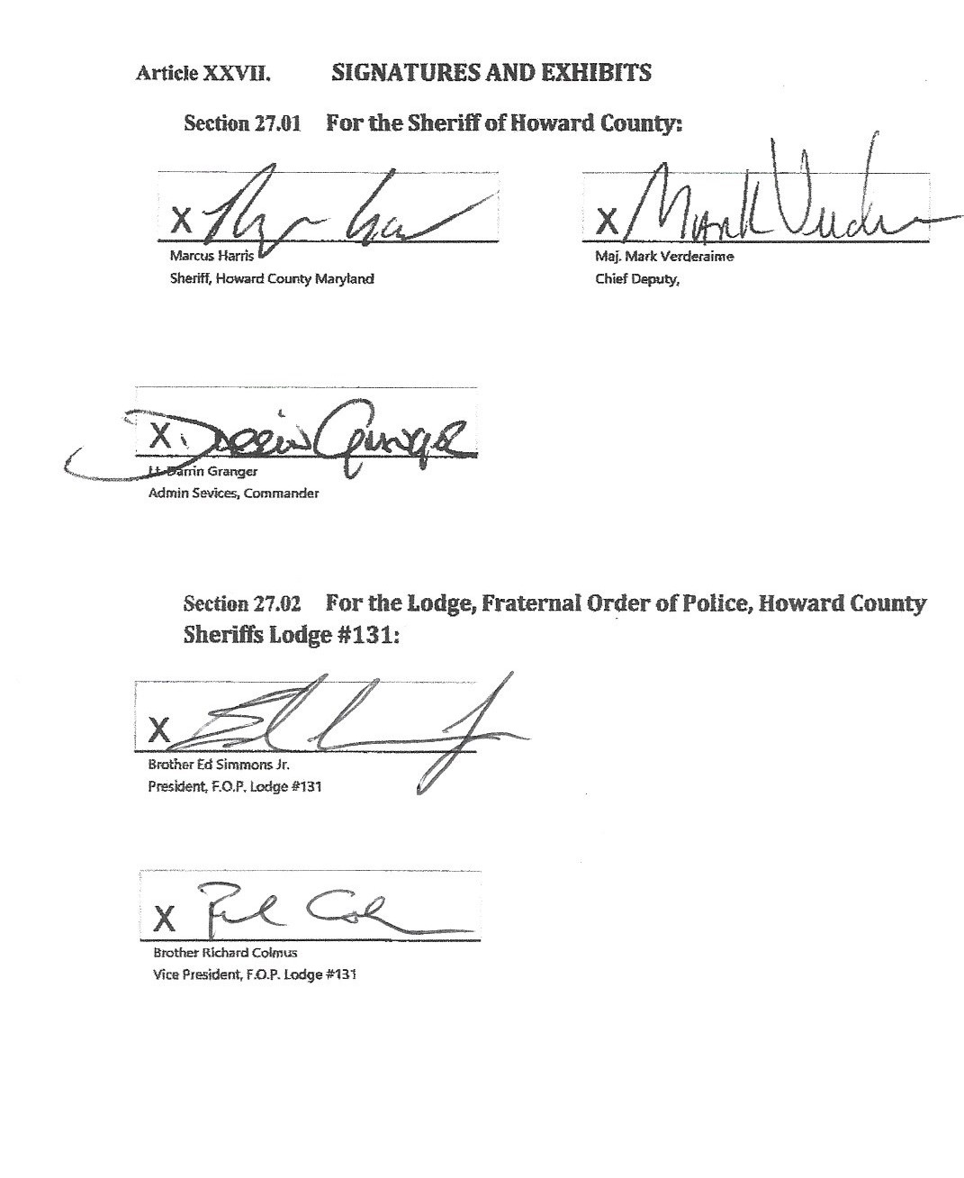

Exhibit A Dues Deduction Form

AUTHORIZATION FOR PAYROLL DEDUCTION

TO: HOWARD COUNTY PERSONNEL OFFICE

FROM: PAYROLL #

I , hereby request and authorized the deduction from my earnings each payroll period an amount sufficient to provide for the payment of monthly lodge dues to be paid to the Treasurer of the Howard County Sheriffs, Fraternal Order of Police Lodge

131. The amount to be deducted shall be certified to the Personnel Office by the Treasurer of the Lodge and will be the lawfully established dues as adopted by the Lodge.

I understand that pursuant to Title I, Section 1.605 paragraph b, of the Howard County Code, this authorization shall be irrevocable for a period of one year and shall be renewable

automatically from year to year thereafter, unless written notice of termination by me is given to the County at least 30 days prior to the anniversary date of this authorization.

Signed: Date:

Exhibit B Section 1.119 Howard County Code

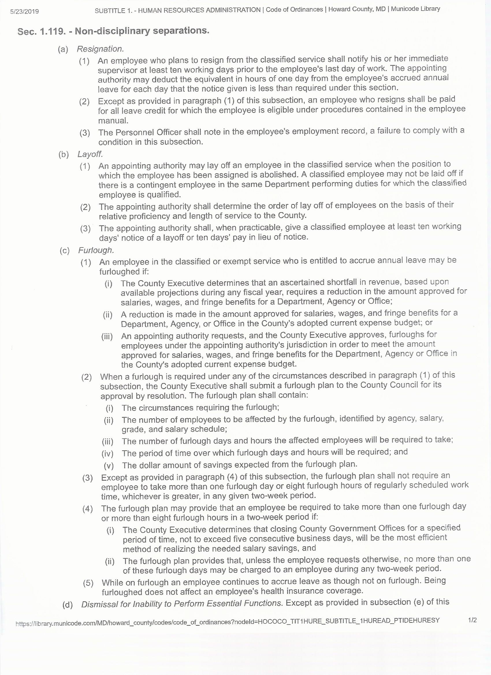

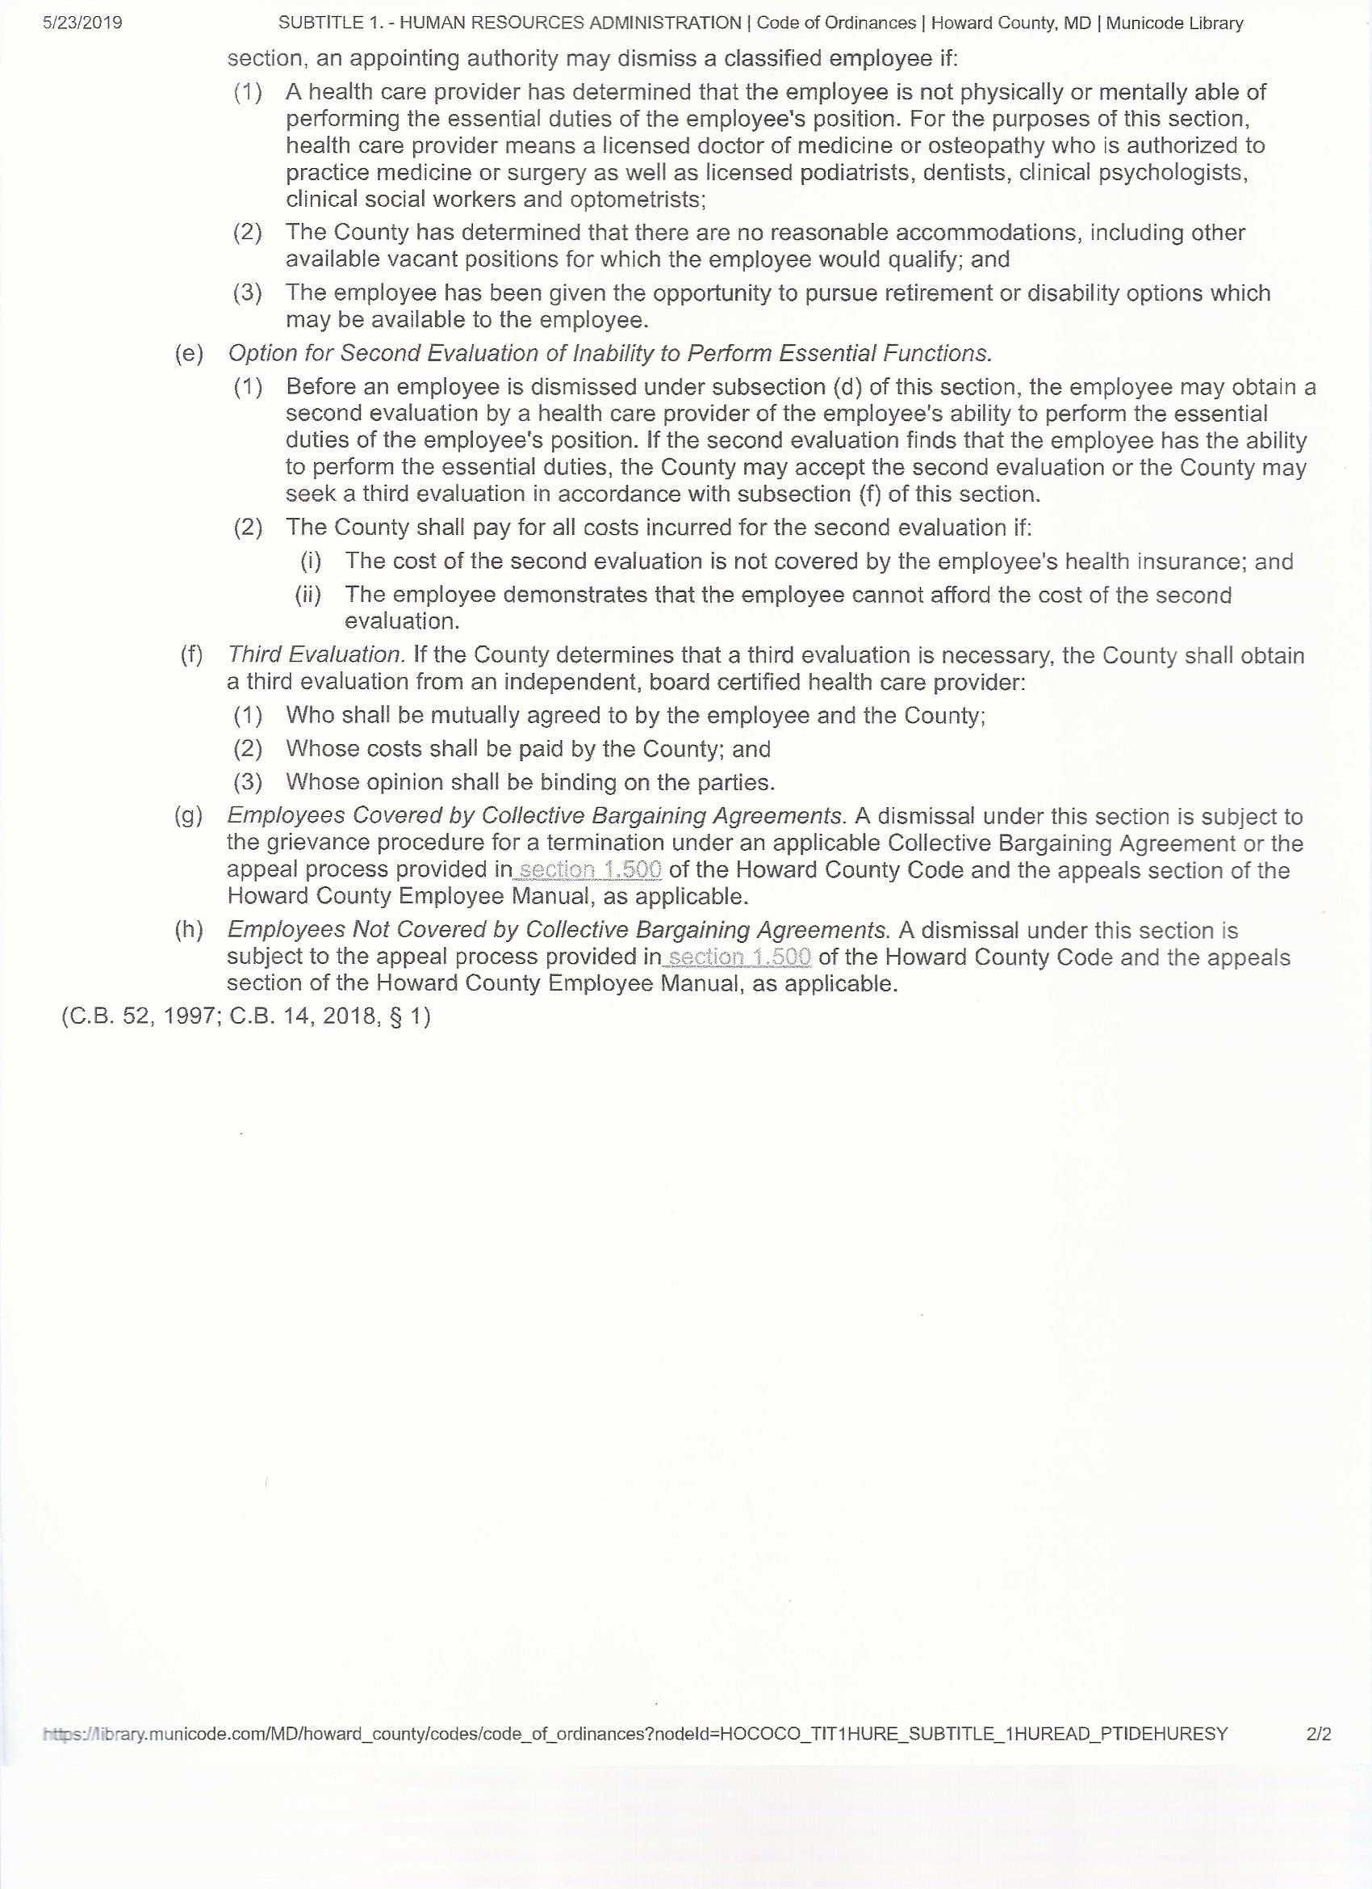

Exhibit C Pay Scale(s)



Exhibit D Family Medical Leave Act

FAMILY AND MEDICAL LEAVE (*Union Employees: Consult applicable bargaining agreement) The following leave applies to leave taken under the provisions of the Family and Medical Leave Act of 1993 (FMLA). All related County leave benefits will be administered in compliance with the FMLA and Department of Labor Regulations. Upon 5 consecutive days of absence, or 40 hours or more of absence from scheduled work within a pay period due to a serious health condition, employees will receive notification of these benefits and be placed on provisional FMLA. • Definitions The following definitions apply to Family and Medical Leave Section: Serious Health Condition - “Serious” health condition is an illness, injury, impairment, or physical or mental condition that requires inpatient care in a hospital, hospice, or residential medical care facility or continuing treatment by a health care provider. It includes any period of incapacity requiring absence from work, school or regular daily activities of more than three (3) calendar days including treatment by a health care provider. Son or Daughter - means a biological, adopted, or foster child, a stepchild, a legal ward, or a child of a person standing in loco parentis, who is either under age 18, or age 18 or older and “incapable of self- care because of a mental or physical disability.” Parent - means a biological or adoptive parent or an individual who stands or stood in “loco Parentis” to an employee when the employee was a child. This term does not include “parents in-law.” Spouse – wife or husband as defined or recognized under State law for purposes of marriage in the State where the employee resides, including common law marriage, in States where it is recognized. The state of Maryland does not recognize common law marriages. Intermittent Leave – leave taken in separate periods of time due to a single illness or injury. Reduced Work Schedule – leave schedule that reduces an employee’s usual number of working hours. Week – for purposes of FMLA leave, a week is equivalent to the employee’s normal assigned work schedule, including shift work. Certification

– official documentation required for the approval of FMLA leave such as the Following forms: Certification of Health Care Provider for Employee’s Serious Health Condition Certification of Health Care Provider for Family Member’s Serious Health Condition, Certification of Qualifying Exigency For Military Family Leave, or Certification for Serious Injury or Illness of Covered Service member for Military Family Leave. Next-of-kin of a covered service member – the nearest blood relative, other than the covered service member’s spouse, SSDP, parent, son, or daughter, in the following order of priority: blood 103 relatives who have been granted legal custody of the service member by court decree or statutory provisions, brothers and sisters, grandparents, aunts and uncles, and first cousins, unless the covered service member has specifically designated in writing another blood relative as her or his nearest blood relative for purposes of military caregiver leave under the FMLA. Eligibility/Entitlement As required by the Family and Medical Leave Act (FMLA), an employee is entitled to 12 weeks of leave (paid and/or unpaid) per year provided that they have worked for Howard County Government for at least one (1) year, and for at least 1250 hours over the previous twelve (12) months. The reasons for FMLA leave are listed below: 1. for the birth of an employee’s child and to care for the newborn child; 2. for placement with the employee of a son or daughter for adoption or foster care; 3. to care for the employee’s spouse, son or daughter, or parent (but not parent-in-law) who has a serious health condition; or 4. for a serious health condition that makes the employee unable to perform the employee’s job. Under the National Defense Authorization Act of FY2010 (NDAA) up to twenty-six (26) work weeks of leave during a single twelve (12) month period may be granted to an eligible employee. A spouse, son, daughter, parent, or next of kin may take the leave to care for a member of the military, or a qualifying veteran, “who is undergoing medical treatment, recuperation, or therapy, is otherwise in outpatient status, or is otherwise on

the temporary disability retired list, for a serious injury or illness”, incurred in or aggravated by the line of active duty. Relatives of service members deployed to a foreign county, relatives of military reservists, relatives of service members of the Armed Forces, or relatives of a veteran may be granted FMLA leave for the care of or to look after the affairs of the family member.

Leave is designated as FMLA leave if it is used for any of the reasons stated above, and is counted toward the total of 12 weeks, whether the employee is on paid or unpaid leave status, except that if the employee uses personal, annual or disability leave and the absence is one week or less, the leave will not be counted as FMLA leave. An employee is eligible to receive 12 weeks of FMLA leave every 12 months on a “rolling” year basis, from the employee’s first leave taken, after August 5, 1993. (EXAMPLE: An employee who takes 12 weeks of FMLA leave beginning on March 1st will again be eligible to take FMLA leave the following March 1st.) Eligibility for FMLA leave under reasons 1 and 2 expires 12 months after the birth or placement of a child. A husband and wife who are both eligible for FMLA leave and are both employed by the County are permitted to take only a combined total of 12 weeks of leave during any 12 month period if the leave is taken for reason 1 or 2. Disability leave taken for reason 1 or 2 may only be used for the period designated by the treating physician Employees may request that they be permitted to take FMLA designated leave on an intermittent basis or may request a reduced work schedule when there is a medical need for such leave. Requests will be reviewed and approved on a case by case basis in conformity with FMLA. Reinstatement Employees taking FMLA leave shall have the same rights as described in the UNPAID LEAVESOF ABSENCE section of this Policy. 104 Health Care Benefits - An employee who is on FMLA leave is entitled to have his/her health care benefits continued on the same basis as he/she would if he/she were not on leave. For that reason, even when the employee taking FMLA leave is on unpaid status, the County will continue to pay its portion of the employee’s medical and dental insurance, in conformity with the employee’s most recent benefit election. To the extent that payroll deductions are necessary to provide the elected coverage, the employee must continue to pay the amount normally deducted from his/her paycheck that is necessary to keep the coverage in effect or the employee may elect not to continue his/her medical and/or dental insurance coverages during the period of his/her unpaid leave. The Office of Human Resources will assist the employee to work out payment arrangements for the employee’s share of his/her health care coverages cost. If employee contributions to coverage are not timely paid by the employee, after a 30-day grace period, the insurance coverage(s) will be canceled. Upon the employee’s return to paid status, his/her insurance benefits will be reinstated to the same level and terms as were provided when the FMLA leave commenced. If the benefit plan provided to employee’s changes while the employee on FMLA leave is on unpaid status, the changes to the coverages will be applied to the employee in the same manner as employees in paid status. Due to the nature of the employee’s job assignment, he/she will be required to furnish a fitness for- duty release to return to work signed by his/her treating physician. Failure to provide the required release may delay his/her return to work. Also, depending on the reason for his/her absence and his/her job assignment, he/she may be required to undergo a County paid fitness for-duty evaluation. Except under limited circumstances specified by the FMLA, if an employee fails to return from unpaid FMLA leave, the County’s expenses in providing health care coverage to the employee while in unpaid status must be reimbursed by the employee to the County. • Employee Requirements - The following requirements or limitations apply to all FMLA leave: 1. An employee must provide 30 days advance notice when requesting FMLA leave for “foreseeable” events; as much notice as possible must be given for “unforeseeable” events. 2. An employee must complete a Certification of Health Care Provider form (available in the Office of Human Resources) to support requests for FMLA leave because of serious health conditions. The County may require, at its expense, a second opinion as to the serious health condition to confirm the validity of the

medical certification provided. 3. While on FMLA leave, an employee may be required to provide periodic reports concerning his/her status and intent to return to work. 4. Paid leave will not be accrued while an employee is on unpaid leave. 5. An employee must exhaust all accrued leaves (annual, disability and/or personal, as defined in this manual) applicable to the reason for which FMLA leave is requested before unpaid FMLA leave is granted. 6. If an employee is absent for one work week or more for any of the reasons listed above as qualifying the employee for FMLA leave, even if accrued paid leave is used to cover that absence, the leave will be treated as FMLA leave for purposes of calculating the total amount of such leave an employee may be granted in one year. The employee will be notified pursuant to the Act when paid leave is to be treated as FMLA leave. 105 7. Employees who are absent due to a FMLA qualifying event are understood to be unable or unavailable to work in any capacity for any employer, including a secondary employer. If an employee’s work ability and/or availability improve in a manner that permits the employee to resume any level of work activity, the employee is required to contact the County to determine if work that is consistent with his or her work capacity is available. If the employee fails to notify the County of the improved ability and/or availability and is found to be working in any capacity for another employer, the employee will be subject to disciplinary action, up to and including termination. Overtime is prohibited while on FMLA.

Exhibit E Tuition Reimbursement

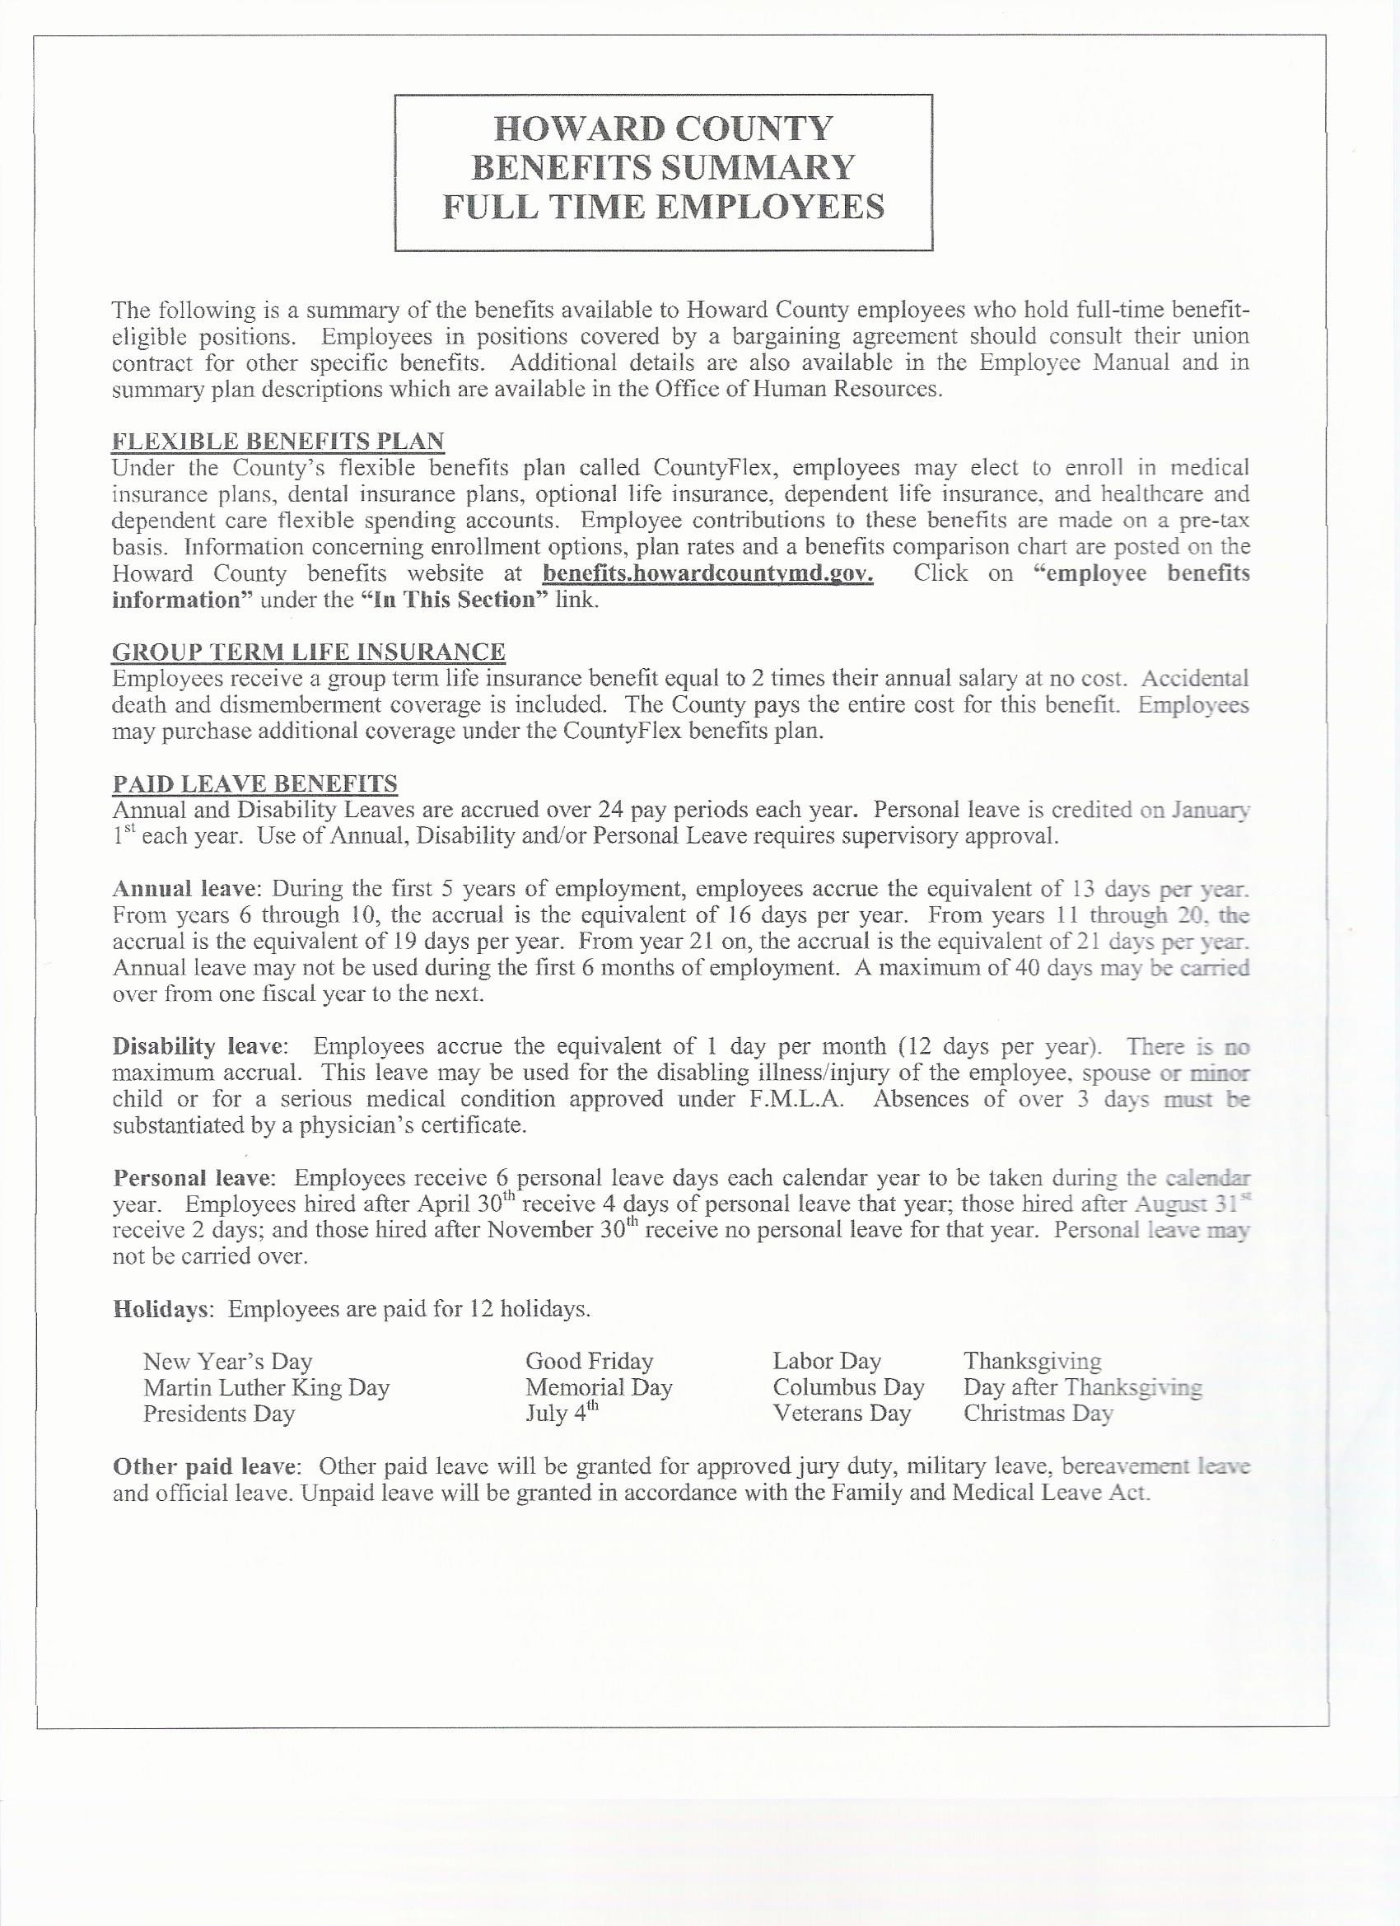

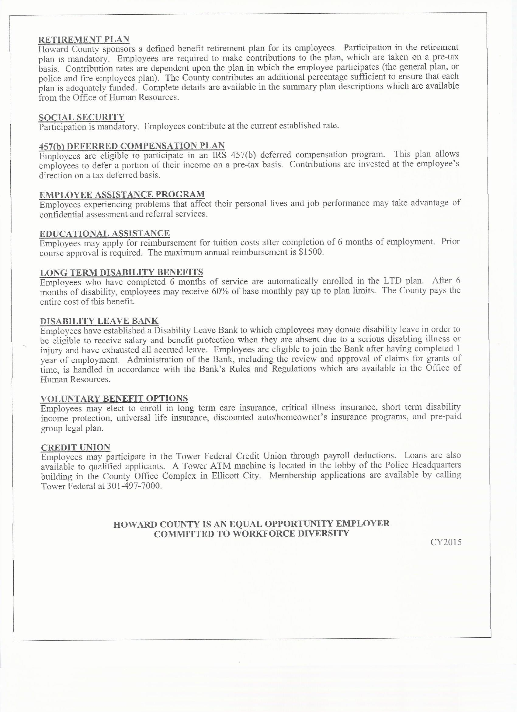

Exhibit F Physical Fitness Testing Standards

|  |  |  |  |  |
| --- | --- | --- | --- | --- |
| Test | Sit-ups | Vertical Jump | Push-ups | 1.5 Mile Run |
| 20-29 | 30 | 12 | 13 | 15:57 |
| 30-39 | 23 | 10 | 9 | 16:58 |
| 40-49 | 18 | 7 | 7 | 17:53 |
| 50-59 | 12 | 5 | 5 | 20:50 |
| 60-69 | 8 | 4 | 4 | 22:35 |