July 2021 | City of Argonia Pool Schedule
 | 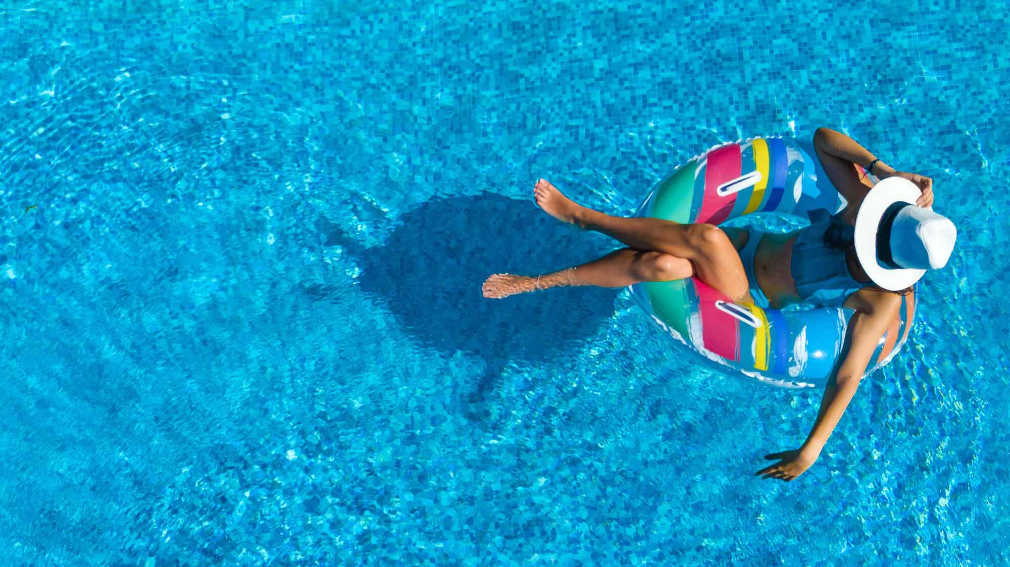
Sunday | Monday | Tuesday | Wednesday | Thursday | Friday | Saturday
 |  |  |  | 1 | 2 | 3
 |  |  |  | Pool Open 11:00-7:00 p.m.  Lap Swim 6:00-7:00 p.m. $2.00 | Pool Open 11:00 a.m. to 7:00 p.m. | Pool Open 11:00 a.m. to 7:00 p.m.
4 | 5 | 6 | 7 | 8 | 9 | 10
Pool Open 11:00 a.m. to 7:00 p.m. | Pool Open 11:00-6:00 p.m.  Water Aerobics 6:00-7:00 p.m. $2.00 | Pool Open from 11:00-6:00 p.m.  Tot Time: 6-7 p.m. $2.00  Lap Swim 7-8 p.m. $2.00 | Pool Open 11:00-6:00 p.m.  Water Aerobics 6:00-7:00 p.m. $2.00 | Pool Open 11:00-7:00 p.m.  Lap Swim 6:00-7:00 p.m. $2.00 | Pool Open 11:00 a.m. to 7:00 p.m. | Pool Open 11-7 p.m.  Night Swim 9-11 p.m. (no passes)
11 | 12 | 13 | 14 | 15 | 16 | 17
Pool Open 11:00 a.m. to 7:00 p.m. | Pool Open 11:00-6:00 p.m.  Water Aerobics 6:00-7:00 p.m. $2.00 | Pool Open from 11:00-6:00 p.m.  Tot Time: 6-7 p.m. $2.00  Lap Swim 7-8 p.m. $2.00 | Pool Open 11:00-6:00 p.m.  Water Aerobics 6:00-7:00 p.m. $2.00 | Pool Open 11:00-7:00 p.m.  Lap Swim 6:00-7:00 p.m. $2.00 | Pool Open 11:00 a.m. to 7:00 p.m. | Pool Open 11:00 a.m. to 7:00 p.m.
18 | 19 | 20 | 21 | 22 | 23 | 24
Pool Open 11:00 a.m. to 7:00 p.m. | Pool Open 11:00-6:00 p.m.  Water Aerobics 6:00-7:00 p.m. $2.00 | Pool Open from 11:00-6:00 p.m.  Tot Time: 6-7 p.m. $2.00  Lap Swim 7-8 p.m. $2.00 | Pool Open 11:00-6:00 p.m.  Water Aerobics 6:00-7:00 p.m. $2.00 | Pool Open 11:00-7:00 p.m.  Lap Swim 6:00-7:00 p.m. $2.00 | Pool Open 11:00 a.m. to 7:00 p.m. | Pool Open 11-7 p.m.  Night Swim 9-11 p.m. (no passes)
25 | 26 | 27 | 28 | 29 | 30 | 31
Pool Open 11:00 a.m. to 7:00 p.m. | Pool Open 11:00-6:00 p.m.  Water Aerobics 6:00-7:00 p.m. $2.00 | Pool Open from 11:00-6:00 p.m.  Tot Time: 6-7 p.m. $2.00  Lap Swim 7-8 p.m. $2.00 | Pool Open 11:00-6:00 p.m.  Water Aerobics 6:00-7:00 p.m. $2.00 | Pool Open 11:00-7:00 p.m.  Lap Swim 6:00-7:00 p.m. $2.00 | Pool Open 11:00 a.m. to 7:00 p.m. | Pool Open 11:00 a.m. to 7:00 p.m.
Pool Manager: Amelia Kollmeyer Swim Lessons Instructor: Amelia Kollmeyer Aerobics Instructor: Natalie Shirley

Admission Prices: Adults - $3.00 Children & Seniors - $2.50 Children Under 3 – FREE

Pool Passes: $55:Single/Senior $65:Couple:$75 Family of 3 $80 Family of 4 $90 Family of 5 $100 Family of 6+ (must reside in same household.

Private Pool Parties – Under 25 people is $60.00/25-49 People is $75.00/ 50 plus is $100. Contact the pool at 435-6520 for information.

