By Dr. Brooke Heather

[Draw your reader in with an engaging abstract. It is typically a short summary of the document. When you’re ready to add your content, just click here and start typing.]
Heal Your Gastrointestinal System
2022
By Dr. Brooke Heather
Hewlett-Packard
1/1/2022
Dr. Brooke Heather (208)232-7149 NaturopathicClinic.info

Contents:
# 1 Product to Soothe and Repair the Gut
# 1 Probiotic to Heal the Root Issue
Options 1 &2
- The Ultimate Healing Diet Summary of the “stepping stones” approach
(The Breakdown of Phase 1-10)
*The application of this option is for severe cases or chronic
Recommended foods
- The “weed and Feed Protocol”
Dos and Don’ts

# 1 Product to Heal the Gut
Okra Pepsin E3 – A “Gut Re-conditioner”
1. Cleanses the “sludge” off the intestinal walls
2. Repairs damaged tissue
3. Enhances gut absorption
Indicated usages:
Malabsorption issues/nutrient deficiencies, colitis, diverticulosis, irritable bowl, constipation (non-related to hypothyroid) ulcers, and cognitive function related to toxic bowl syndrome.
In comparing the use of clay and herbal preparations, I find it more effective for the purpose of detoxification, elimination, and cleansing the GI tract to gain the above three faucets. In my opinion is far superior to cleanse the walls of the gut (re-condition) and repair the lining, thus enhance nutrient absorption than it is to use clay and herbal concoctions. Clay is thought to promote elimination by providing “bulk” to stools by means of an insoluble fiber, it is used to absorb heavy metals and toxins, and thereby have a “cleansing” effect. There are three problems I see with this. One is the fact that a poorly hydrated or already constipated individual may become more constipated by clays. Secondly, clay will absorb the good with the bad. Essential nutrients and electrolytes are absorbed as well! This may lead to a deficiency. Additionally, clay will absorbs, thus decrease the action of medications. And thirdly, the benefits as I seem the in light of the possible side effects/contradictions diminish the benefits of clay. I believe there are better ways to eliminate toxic metals in lieu of clay.
Okra Pepsin E3 is the multi-purpose, or double action product for healing the gut, cleansing it, or to enhance absorption of nutrients!
Cautions:
Do to the nature of healing the gut, this product may cause seemingly “un-related changes” in mood, emotions, and cognitive function. The gut is referred to as “the second brain”. Science now knows that 90% of a “neurotransmitter” (previously thought to only be produced in the nervous system/brain), serotonin is actually produced in the gut!
General Supplements that are well tolerated any time:
- Fish oil and or 3,6,9 omega liquids (Radiant Life’s fermented Cod Liver Oil)
- Body high flax seed meal
- Major Minerals
- Goats’ whey (Radiant Life) – a powerful source of minerals and nutrients!

# 1 Probiotic to Heal the Root Issue
Health in general starts in the gut. Hippocrates said it in 400 B.C. and since then modern science has proven it. Any immune dysfunction (autoimmune, allergies, food sensitivities, rashes, psoriasis, eczema, rheumatoid arthritis, gout, etc.) can be traced back to a dysfunction in the GI. Any inflammatory condition can as well. Now, modern science has shown us that weight control, mood, depression and other mental disorders are also connected to the gut (the second brain). Even chronic diseases such as diabetes, heart disease, cancer, etc. can be traced back to the gut.
2 capsules per day of MegaSporeBiotic appears to be the ideal dosage to stimulate the Peyer’s patches and encourage immune modulation. In acute cases, we have seen 5 capsules per day for 3-5 days prove beneficial in restoring balance to the gut. When treating a patient with severe gut dysbiosis, you would be better served using High Potency Bacillus Subtilis HU58 along with MegaSporeBiotic.

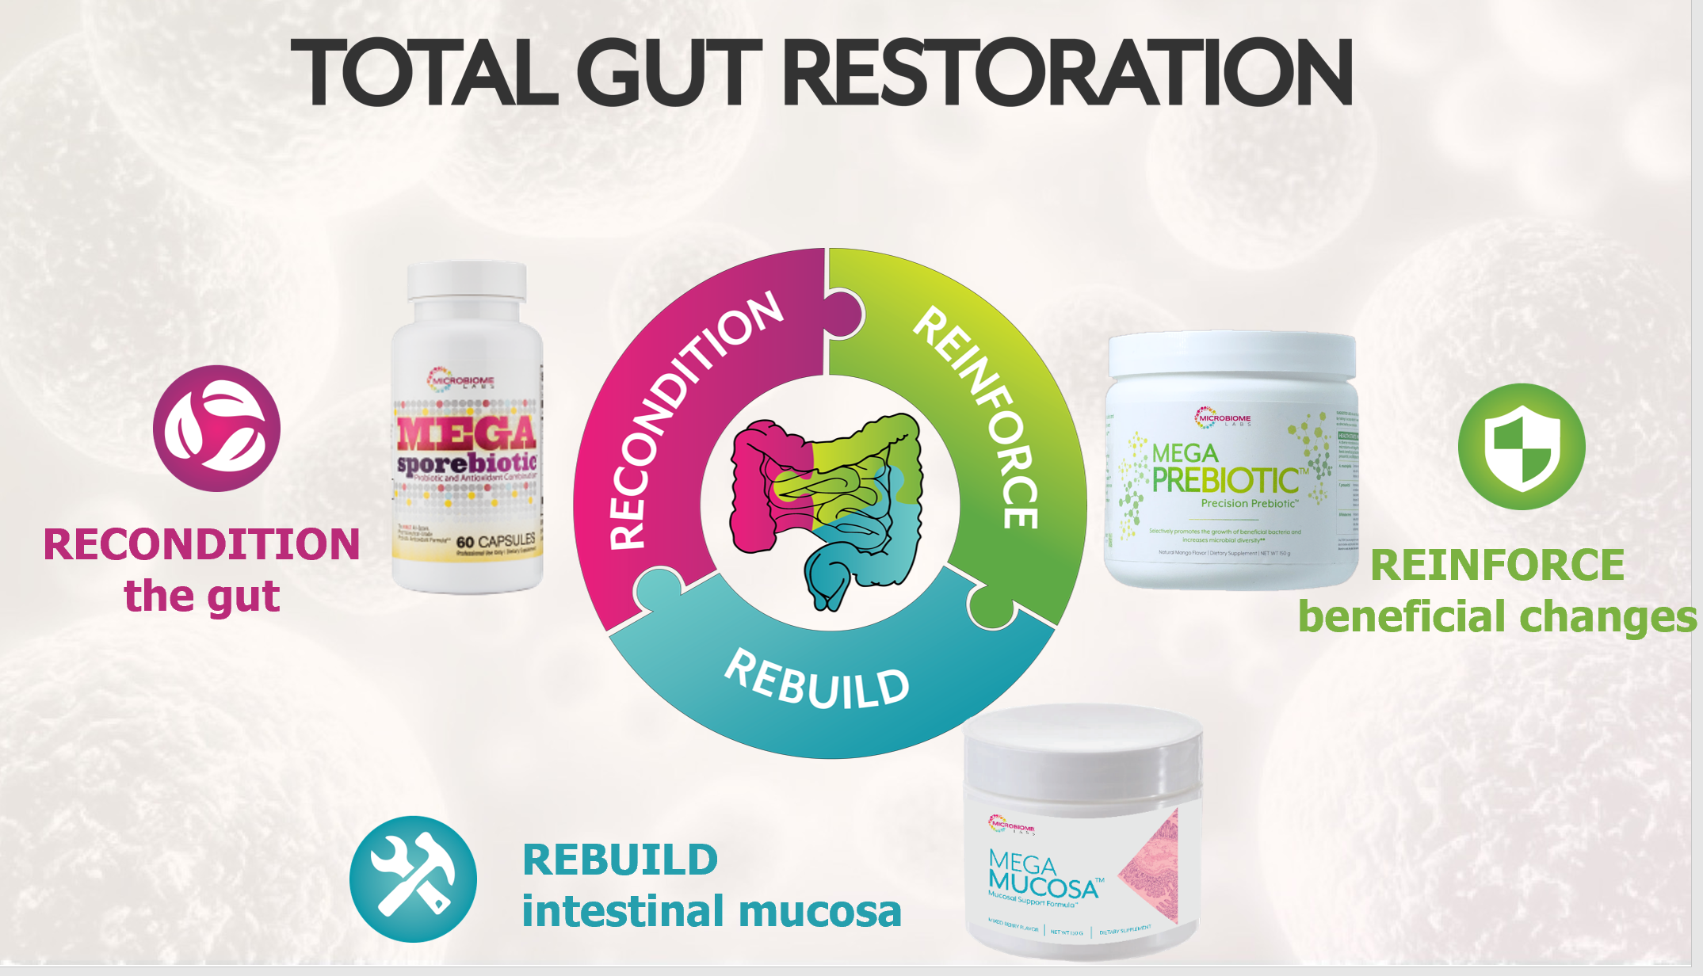

The Ultimate Healing Diet The Stepping Stones Approach:
- Consume solely “mineral broths” 3-4 times per day (a minimum of 1 cup broth per day. Do this for 4-7 days. If your digestion can handle it, cooked down veggies (carrot, celery, leeks, cabbage, etc.) may be added to broth to make more of a soup.
- After about a week, add in a new food every 5 days. Record any changes on the form provided. Eat a combination of cooked and raw veggies. Warm cooked nourishing and hearty foods (soups combined with raw leafy green should be emphasized). An ideal meal would consist of soup/bone broth with a quality animal protein and a salad.
- Significant animal protein is needed in each meal.
- A variety of sweet, salty, and sour tastes are important in each meal of consistent times, but bitters are especially important.
- Eat (the size of your fist in amount of food per meal if adult trying to lose weight) 3-4 times per day). Remember that it takes 20 minutes for the connection to be made from your stomach to your brain, or rather awareness, that you have eaten! So before grabbing for seconds, let this time pass before thinking you’re still hungry! You may also want to record your saliva pH before meals to ensure proper digestion is possible to begin with! See this pH information above the chart.

PHASE 1
In order to heal the gut, specific nutrients are needed. See below. Supplements are not always tolerable; in such severe cases it is necessary to consume a medical food smoothie under professional direction. Begin with mineral broth only up to 7 days.

PHASE 2 Add raw organic egg yolks.
It is best to have egg yolks raw added to every bowl of mineral broth. Start from 1 egg yolk a day and gradually increase until an egg yolk is tolerated with every bowl of soup. Add soft-boiled eggs to the soups (the whites cooked and the yolks still runny). If you have any concerns about egg allergy, do the sensitivity test first. There is no need to limit number of egg yolks per day, as they absorb quickly almost without needing any digestion and will provide your patient with wonderful and most needed nutrition. Get your eggs from a source you trust: fresh, free range and organic.
PHASE 3 Add stews and casseroles made with meats and vegetables.
Continue with the 1 cup of mineral broth each day (and egg at least once during the day). Add ripe avocado mashed into soups, starting from 1-3 teaspoons and gradually increasing the amount.
PHASE 4 Add pancakes, starting from one pancake a day and gradually increasing the amount.
Make these pancakes with three ingredients: 1) Coconut flour 2) eggs; 3) a piece of fresh winter squash, yam or marrow. Fry small thin pancakes using ghee, coconut oil, goose fat or duck fat. Make sure not to burn them.
PHASE 5 Egg scrambled with plenty of ghee, goose fat or duck fat.
Serve it with avocado (if well tolerated) and cooked vegetables. Cooked onion is particularly good for the digestive system and the immune system: melt 3 tablespoons of duck fat or ghee in the pan, add sliced large white onion, cover and cook for 20-30 minutes on low heat.
PHASE 6 Introduce the juice of sauerkraut and fermented vegetables
Start from a small amount, gradually increasing to 1-2 tablespoons with or without meals. If you have a tendency to have heart burn do not take this on an empty stomach but with food.
PHASE 7 Start from a small amount, gradually increasing to 1-2 tablespoons of sauerkraut or fermented vegetables with every meal. Every other meal, or once per week is an option if histamine reactions are a problem.
Carry on with all previous foods.
Gradually add meats cooked by roasting and grilling (but not barbecued or fried yet).
Avoid bits, which are burned or too brown. Eat meat with cooked vegetables and sauerkraut (or other fermented vegetables).
Start adding cold pressed olive oil to the meals, starting from a few drops per meal and gradually increasing the amount to 1-2 tablespoons per meal.
Phase 8 Introduce freshly pressed juices, starting from a few spoonfuls of carrot juice.
Make sure that the juice is clear, filter it well. Drink it slowly or diluted with warm water or mixed with some homemade yogurt. If well tolerated gradually increase to 6 oz a day. When 6oz of carrot juice is well tolerated, add juice from celery and fresh mint leaves. Drink the juice on an empty stomach, so first thing in the morning and middle of afternoon are good times.
Phase 9 Try to bake bread with ground almonds or any other nut and seeds ground into flour.
The recipe (please look in recipe section of the GAPs book). This requires only four ingredients: 1) nut flour; 2) eggs; 3) piece of fresh winter squash, marrow or courgette (peeled, de-seeded and finely sliced); 4) some natural fat (ghee, butter, goose or duck fat) and some salt to taste. Start from a small piece of bread per day and gradually increase the amount.
Phase 10 Add raw vegetables starting from softer parts of lettuce and peeled cucumber.
Watch your stools. Again start from a small amount and gradually increase if well tolerated. After those two vegetables are well tolerated gradually add other raw vegetables: carrot, tomato, onion, cabbage, etc.
If the juice made from carrot, celery, lettuce and mint is well tolerated, start adding fruit to it: apple, pineapple and mango and papaya. Avoid citrus fruit at this stage.
If all the introduced foods are well tolerated try some peeled raw apple. Gradually introduce raw fruit and more honey.
Gradually introduce baking cakes and other sweet things allowed on the diet. Use dried fruit as a sweetener in the baking.

Side notes:
Make your Gee- simply heat butter in the oven on low. Once melted, you will see the separation occur. Scrape the top white colored almost “foam” and discard it. What is left is your Gee!
Try a “cracker” with broth - Chia and/or flax seeds may be made into a “cracker”

The “Weed & Feed” Protocol
- Day 1
  - Fast from food for best results (no food, but water and prescribed medicines/supplements are allowed)
  - If not able to fast:
    - eat light fresh meals of vegetables and salads (as per clinical purification diet plan)
    - omission of yeast, vinegars, sugar & starches
- Day 2 & 3
  - Continue as day 1 (fast or have very light, meals)
  - Twice during the day take one to two cloves of crushed fresh garlic with a copious quantity of water. This has the effect of flushing the fresh garlic quickly into the small intestine. 1-2 MediHerb Garlic tablets can be used as an alternative to fresh garlic
  - On an empty stomach, away from food for at least 30 minutes, take one to two teaspoons of slippery elm powder with plenty of water (8+ oz.) to allow it swell and gel in the GI tract. This acts to feed the GI’s own cultures of beneficial flora (prebiotic) Gastro-Fiber/ Okra Pepsin can be used as an alternative to slippery elm powder
- Day 4 → 15
- Gradually introduce clean, fresh foods and continue with medicines/supplements (especially Megaspore/Hu58) and slippery elm/ Gastro- Fiber/ Okra Pepsin
- Add prescribed herbal into this stage of the protocol to inhibit the regrowth of pathogens
- Drink 2 cups of ginger tea per day or 1-2 teaspoons aloe
REPEAT ONCE EVERY 6 MONTHS FOR OPTIMAL BOWEL FLORA HEALTH
Maintain by committing to an adaptogenic herb to support your over –all wellbeing.

Dietary Dos and Don’ts
DO NOT:
- Overeating can be a cause of digestive trouble
- Eating on the go or at erratic times can cause upset
- Not chewing food well, drinking too much with meals or close to consuming food dilutes digestive juices necessary for adequate digestion
- Eating too late at night or too close to bedtime.
- Stress (mental, emotional or physical) factors into abdominal discomfort and GI disorders. Evaluate and address this accordingly
- Refined sugar and grains, drinking alcohol, coffee or tea, certain medication such as ibuprofen and aspirin and hot spicy foods as sour foods such as citrus and tomatoes are all aggravators of the GI tract when the body is out of balance
DO:
- Follow the Digestion Promoting Guidelines and Food Combining 101 outlined in handbook
- Eliminate fried foods and heavy meals, especially with greasy food
- Cut out GMO foods and seek organic
- Balance the metabolism and constitutional Dosha (Ayurveda medicine)
- This below website will give you a recipe that is generally soothing for the stomach. This website also has a dosha test and a personalized recipe book it offers for your type. https://www.joyfulbelly.com/Ayurveda/recipe/Cabbage-Soup-Diet/2297

