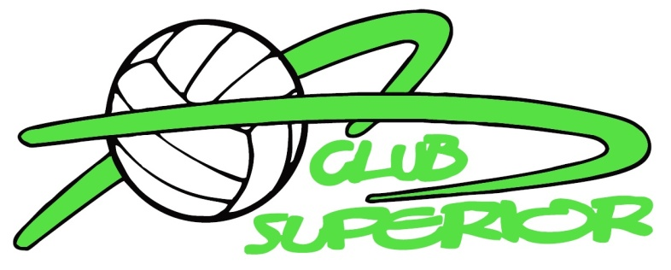

Club Superior Handbook Acknowledgement Form
ACKNOWLEDGEMENT FORM
FOR “CLUB SUPERIOR VOLLEYBALL
HANDBOOK AND CONTRACT FOR PARTICIPATION”

ACKNOWLEDGEMENT OF THE HANDBOOK

I have received and read the Club Superior Handbook and Contract for Participation (“the Handbook”) and understand its contents. I understand that I have an obligation to fully comply with the Handbook and all its contents.

After signing this Acknowledgement Form you must return it with your paperwork to the coach at or prior to the first practice.

No player may practice or participate in Club Superior activities until this form is complete and submitted.

PLAYER NAME AND SIGNATURE PARENT NAME AND SIGNATURE

Player Name__________________________ Parent Name__________________________

Player Signature ______________________ Parent Signature ______________________

Date of Signature _____________________ Date of Signature _____________________

