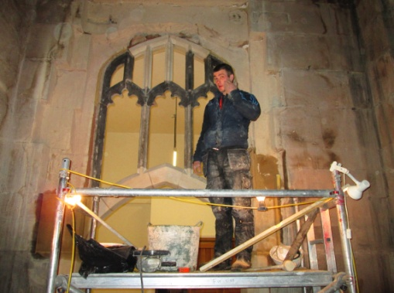
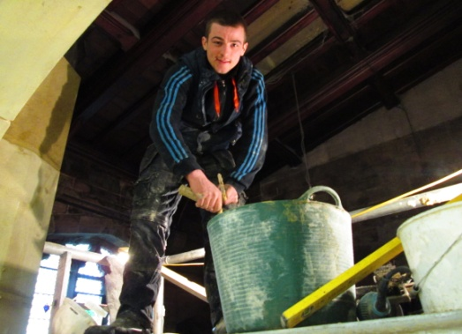
Work continues on the arch to the Choir Vestry – the glass due to be delivered very shortly.

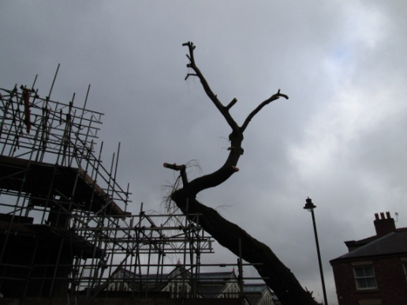
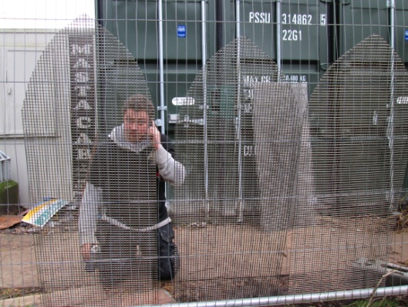
Outside and the grills are being made to sit behind the louvers for the tower – keep those birds under control – we don’t want any Hitchcock here! Then there are those Willow trees -

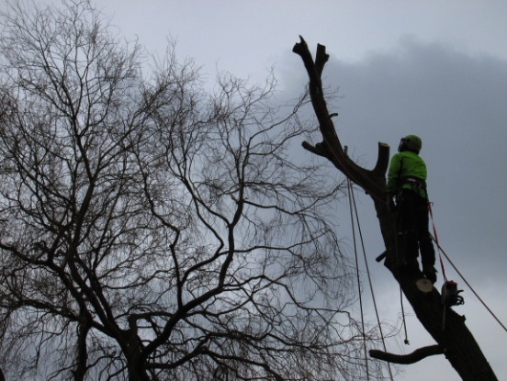

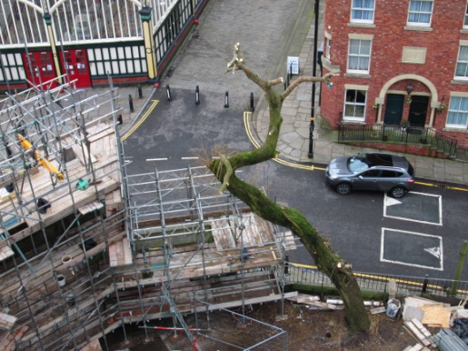

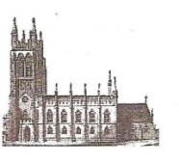
St Mary’s in the Marketplace. .
Securing the future for the next 100 years

News from St Mary’s
[incorporating Building News No 31] 17th February 2013
St Mary’s will re-open on Sunday, 24th February a little later than planned allowing additional time for the tiling to be completed.
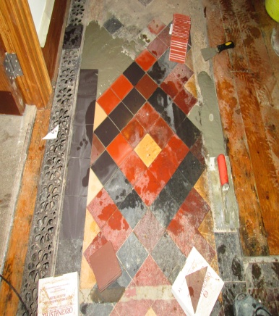
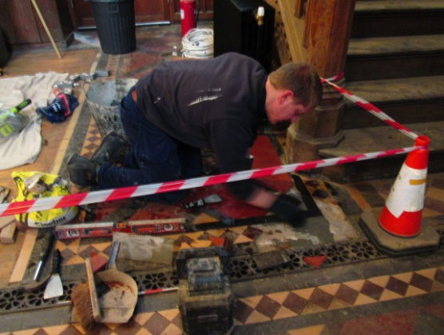
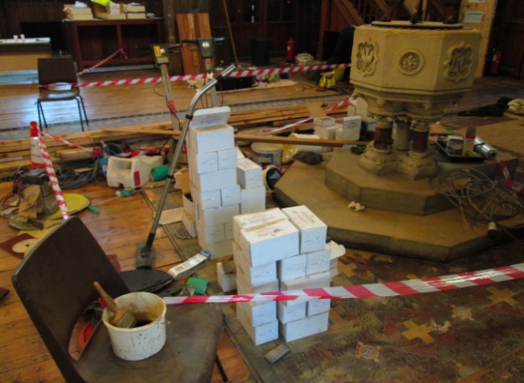
This is of course disappointing but not really surprising considering the amount of work to be undertaken, not helped by the fact that there has been more repair work to be done to the tiled flooring than originally anticipated – but then it was for the most part hidden under the old carpets and lift a broken tile and several others come with it! It’s a question of working on one small area at a time, small tile by small tile – but it will be lovely to see it all restored.

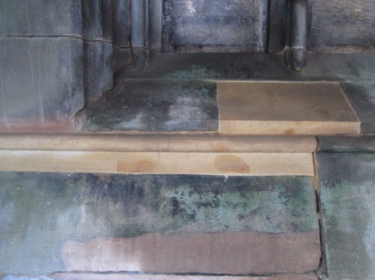
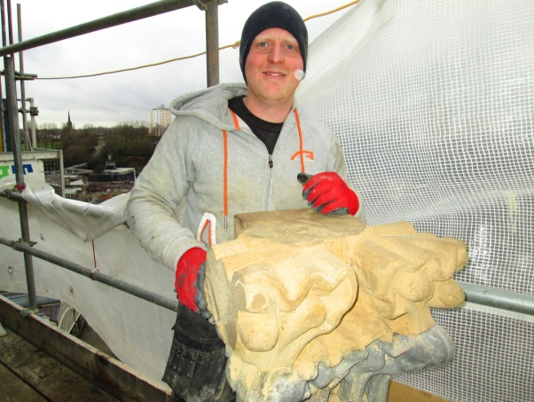
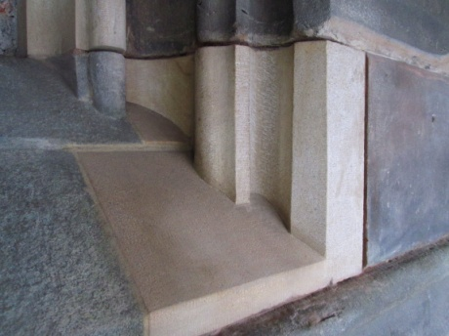
With Roger’s return from holiday we have some up-to-date photographs to show you from the Tower roof and you may have noticed that some of the plastic sheeting is now starting to be removed. Some very impressive stonework continues to be put in place – such a shame in many ways that most of us will never see it this close other than in photos – but it is there for generations to come – beautifully restored.

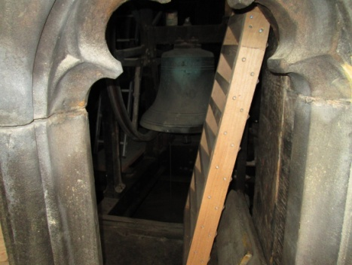
Also out of view to most of us the newly made louvers now ready to be fitted.

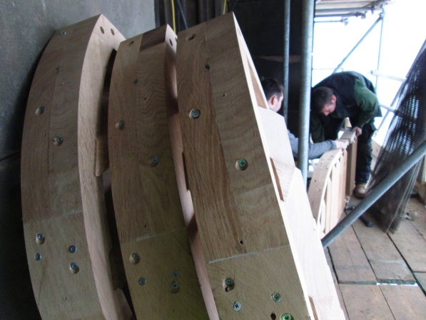

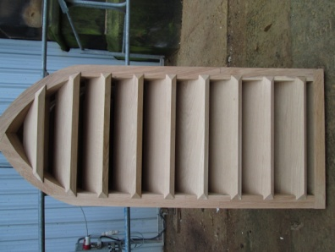

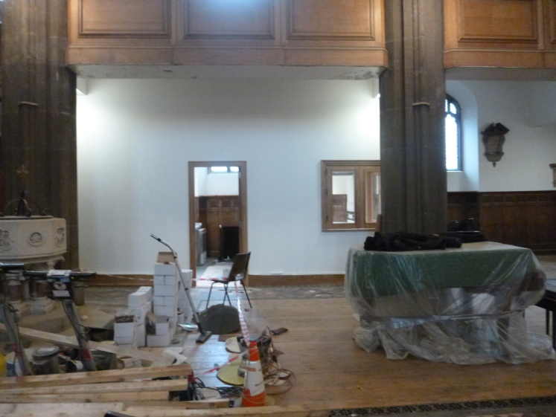
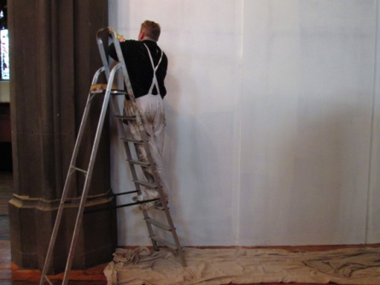

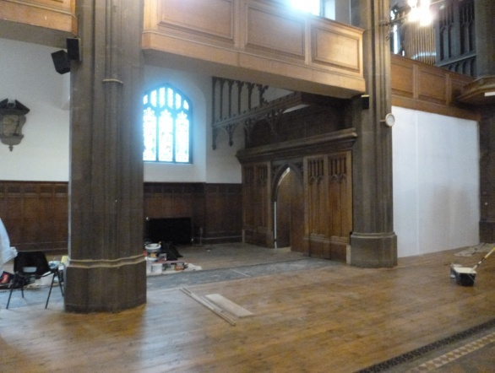
The internal screens are down, light streaming in from both sides now, and our wonderful new kitchen in view for all to see. There is still plenty to do but the end of this Phase is without dount in sight.

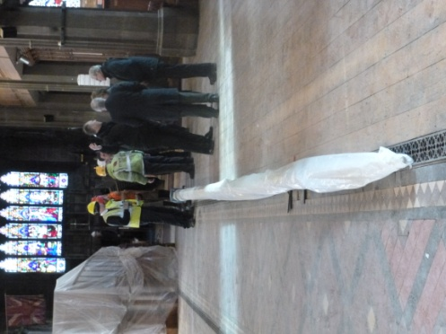
Now what is that you may be wondering – well it’s the new flagpole presently sat in the nave waiting to be taken all the w ay up the tower ready for fitting.
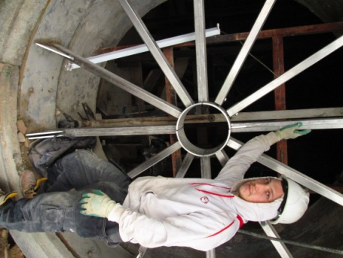
Back on the tower – the framework for the clock face, due to return in a couple of weeks time.

