Carol & Nik White
The Old Vicarage, Station Road
Lowestoft. Suffolk
NR32 4QF
(01502) 450059
www.carolandnik.com

1st April 2021

Hey guys,

The shorts are back, the sunnies have been retrieved from the back of the drawer and Nik is even contemplating digging out his flip-flops. The weather is finally warming up a bit and boy-oh-boy has it been a long time coming.

The Great Outdoors

We wanted to say a massive thank you to you all for your help with selling tickets and supporting our fundraising raffle at Christmas and the many resources that you have all so kindly procured and donated to us, we are so pleased with the artificial grass and Nik has been Bob the Builder-ing like crazy at the weekends to create lots of new fun experiences for the children. You can expect to see many new additions over the coming months all expertly decorated under Carol’s discerning eye.
Over this coming Easter weekend, we are planning to lay a new path up to the playhouse and add a porch in to save you all on those rainy days, please could we ask that at drop-off and collection you encourage your child(ren) to stay to the path with you as there was an incident a few weeks ago where a child tripped and hurt themselves because they were trying to get up onto our patio.

Africa Alive

With the impending re-opening of Africa Alive and Banham Zoo on 12th April could we please ask you all to check that your passes are still in date and valid (Keeping in mind there is a difference in price after children have turned 3). If you are not sure then we would encourage you to give them a call to check as when they closed during the 1st lockdown, they extended everyone’s passes to account for the period that they were closed

Lateral Flow Covid-19 Testing

With the ongoing operation of two Covid-19 Lateral Flow Testing sites in Lowestoft, one at Kirkley & Pakefield Football Club and the other at Waterlane Leisure Centre we are now being tested on a twice weekly basis and we would encourage you all to do the same, it’s a fairly straight forward and hassle-free process. You can register and book appointments at:

https://commisceo-pcs.shiftpartner.com/

Alternatively, you can collect test kits to be used at home by popping down to the test centre in the car park at Belvedere Road

September

If we could just ask you all to think ahead to September, if you know that you are planning to adjust your child’s hours/days and haven’t already spoken to us about it or are maybe thinking of using some of their Early Years funding at a different setting, such as a pre-school, please do let us know as availability is pretty tight at the moment and we have a waiting list for spaces running too.

Early Years Funding

For those of you that are eligible for the 30 hours of Early Years Funding please don’t forget that you have to check and renew your eligibility each term for the following term. You should receive reminders from SCC but we know from experience that these don’t always come through. If you are new to the whole Early Years Funding situation and need any help or advice then please don’t hesitate to ask.

Waterproofs/Outdoor Play

With our love of all things outdoors, the looming summer and Nik’s love of water play we thought it would be a stellar idea for each of the children to have a thin splash-suit to be kept here alongside their wellies. (If we already have one for your child please don’t rush out and buy another!) Also, please could we have the obligatory sun-cream and sun-hat to be kept here for those hotter and sunnier days and once summer kicks in, even if it is a little overcast first thing in the morning, please could the children have a layer of sun-cream applied before they arrive.

.

Illness

We’ve been really impressed with how well you have all done in regards to keeping both the children and us free from illnesses, usually at this time of year it’s an absolute nightmare. It’s important that we all carry on with this particularly in light of the current easing of some restrictions. Please continue to err on the side of caution when deciding whether or not to send your children in and please be mindful that at this time we are still not able to accept children that have been given medicine that morning as this can mask potential symptoms.

Much Love
Carol & Nik.

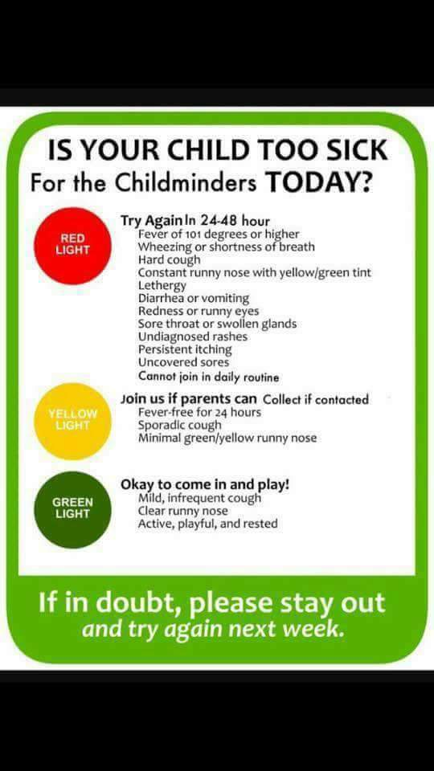

Term Dates (for Early Years Funded Children)

Summer Term Begins – Monday 12th April

Summer Half Term – Monday 31st May - Friday 4th June

Last Day of Summer Term – Friday 16th July

Holiday Dates

Friday 4th June – Friday 18th June (Inclusive)

Monday 23rd – Friday 27th August (Inclusive)

Friday 24th – Monday 27th September (Inclusive)

