Kingston Single Malt Society
A social club for the appreciation of Single Malt Whisky since 1998
NOVEMBER 23, 2009 VOLUME 3; NUMBER 3

----------------------------

This evening's menu in the company of
Single Malts from SPEYSIDE

Soup: Butternut Squash

1st Nosing: TAMDHU FINE SINGLE MALT
(introduced by: Paul Charbonneau)

Salad: Mixed Baby Green
Dressing: Creamy Honey Dijon

2nd Nosing: SPEYBURN 10 YEARS OLD
(introduced by: Anthony Johnson)

Entree: Stuffed Sole with Seafood Stuffing
Vegetables: Seasonal
Potato: Butter Herb Pasta

3rd Nosing: GLEN ELGIN 12 YEARS OLD
(introduced by: Rob Arnoth)

Dessert: Cherry Cheesecake

----------------------------

A toast and thanks go out to Cheryl Hudson, Brand Manager of the Edrington Group Premium Spirits | Beam Global Canada for procuring and then donating the Tamdhu Fine Single Malt for our enjoyment tonight!

----------------------------

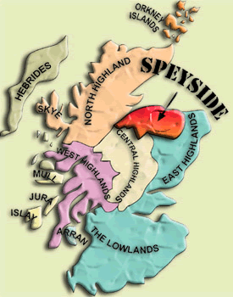
COST OF THE MALTS
I know members are always interested in the cost of the single malts we taste. Plus the $75 Special Occasion Permit and the 16% levy charged by the LCBO for all alcohol served at the dinner.

- TAMDHU FINE SINGLE MALT VINTAGES 157727 | 750 ML bottle Price: $40.00 Spirits, Scotch Whisky, 40.0% Alcohol/Vol.

- SPEYBURN 10 YEARS OLD SINGLE MALT VINTAGES 358333 | 700 mL bottle Price: $ 55.95 Spirits, Scotch Whisky, 40.0% Alcohol/Vol.

- GLEN ELGIN 12 YEARS OLD SPEYSIDE SCOTCH SINGLE MALT VINTAGES 332009 | 750 mL bottle Price: $67.25 Spirits, Scotch Whisky, 40.0% Alcohol/Vol.

----------------------------

Dinner dates for KSMS 2009-2010
January 25, 2010 – Robbie Burns Night
February 22, 2010 – Highland
March 22, 2010 – St.Patrick's (Irish)
April 26, 2010 – Island
May 17, 2010 – Islay
June 21, 2010 – BBQ (Final Exam)

----------------------------

Membership and Dinner prices for 2009-2010
Membership Fees: $40 (singles)
$60 (couples)
One Time Initiation Fee $15
Standard Dinner Fee: $50 (member)
$60 (non-member)
Dinner only - No Single Malt: $45 (member)
$55 (non-member)
Robbie Burns Dinner Fee: $60 (member)
$70 (non-member)
(includes $5 donation per attendee to RMC Pipes &
Drums with Highland Dancers)
June BBQ Dinner Fee: $60 (member)
$70 (non-member)

----------------------------

OCTOBER - KSMS Financial Statement
(Money raised by October attendees) = $2560.00
October dinner 50 persons = $41.00/ea = $2050.00
Special Occasion Permit @ LCBO = $75.00
(Money remaining for buying Single Malt) = $435.00
Cost of Single Malts October: = $812.70
KSMS Monthly operational balance = <-$377.70>
Cost per person (All inclusive) = $58.75
----------------------------
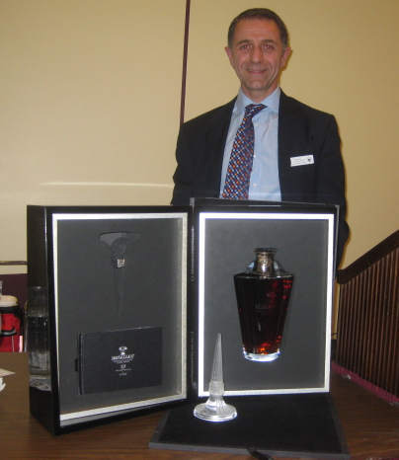
The Classicist: What Makes a Scotch Worth $15,000?
www.luxist.com; by Jared Paul Stern

In this case the answer to the question is an extremely rare single malt in a limited edition decanter: The Macallan 57 Lalique "Finest Cut". Containing an exceptionally rare 57 year old single malt whisky from the famed Speyside distillery founded in 1824, the Finest Cut crystal decanter is valued at $15,000 and will be available by special order beginning in October. The precious bottling comes on the heels of the recent record-breaking £11,750 ($19,000) sale of one of The Macallan's 50th anniversary bottles at an auction in Scotland that my colleague Deirdre Woollard reported on. The Finest Cut is inspired by the fraction of the new make spirit which is filled into casks for maturation. At The Macallan, this fraction is a mere 16%; the best of the best, it's delivered at a very slow rate of distillation to maximize flavor and produce a distinctively rich, fruity, viscous character. Designed exclusively for The Macallan by the legendary French crystal house Lalique, The Finest Cut decanters are individually numbered and produced in a very limited quantity - only 72 of the 400 launched worldwide will be available in the U.S. "In homage to the beauty of Lalique's Finest Cut decanter, we chose a particularly rare 57 years old Macallan single malt whisky," says David Cox, Director of Fine & Rare Whiskies for The Macallan. "It is the second oldest The Macallan whisky ever released, only surpassed in age by the legendary 1926, a 60 year old bottled in 1986." The 57 follows in the footsteps of its two predecessors in the Six Pillars series, a 50 year old Macallan celebrating the exceptional oak casks and a 55 year old inspired by the distillery's insistence on natural color, both coveted collector's items.
The 57 year old has been vatted together from six casks made from two different species of oak; the first, a 1950 American oak sherry butt, and the second, a vatting of Macallan from first fill Spanish oak sherry butts originally filled in 1949, 1951 and 1952. The result is a sumptuous single malt, showing off the classic dried fruits, spice and hints of peat redolent of The Macallan house style of the early 1950's. The age statement of 57 years old is determined by the youngest cask which was filled in 1952. The decanter features the 'stilligoutte' of a perfume bottle, the long piece of pure crystal flowing down to a point from the base of the bottle stopper. A portion of the stopper has been left completely clear and not "satinee," running from the top down to the point. This clear portion represents the 16% "finest cut". Crafted at Lalique's crystal making facility in Wingen-sur-Moder, Alsace, each piece was worked on by up to 15 craftsmen.
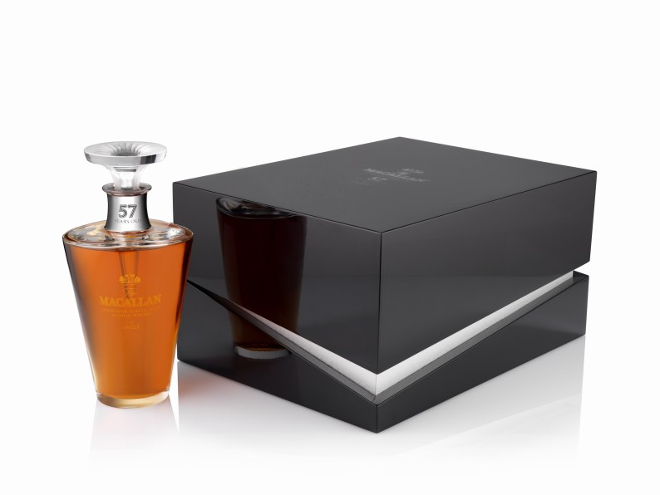
----------------------------

Manager’s Choice, Executive’s Price
http://www.edinburghwhiskyblog.com/
Published on September 7 2009 in Opinions
So … the biggest whisky news of the year has been broken. The Managers Choice selection; 27 single cask whiskies, one from each Diageo distillery, bar the behemoth that is Roseisle.
When I first got wind of this news from one of our very secretive sources, I was really excited. Not only could I try single caskings of some of my favourite whiskies (Mortlach, Lagavulin, Caol Ila) but I could also try some really random single casks (Glenkinchie, Oban, Clynelish). I was also really excited because unlike others, Diageo run distilleries tend to stick to their basic range of 2 or 3 expressions done really well. This, in my view, was going to show something different they have to offer. Look at Glenkinchie. I don’t particularly like either of their bottlings, but I quite liked the 20 year old, so I was hoping to try another expression to see if I could appreciate Pencaitland’s finest.
I am sure I am not the only one that was excited to try a new Cardhu, Linkwood, or whatever your particular Diageo intrigue is. So where is the ‘but’? What’s the problem? Is there a problem at all? Well, in a word, yes.
The problem is that the price of these whiskies is frankly exorbitant. It’s difficult to discuss value. Value differs with every person. But there are some key factors that could show us what the real price of these whiskies should be.
Where should we start? As Rafa Benitez (Liverpool manager) would say, lets start with the facts.
This is what we know from the first 6 releases:
- They are between 9 and 13 years old
- They are cask strength and non-chillfiltered
- They are limited between 240 and 534 bottles
- The full collection would be very rare to have
- The prices for the first 6 are between £200 and £300
- They are barreled in either: Sherry filled European Oak, American Bourbon Oak, Rejuvenated American White Oak or Rejuvenated European Oak.
Lets put this into perspective. If I was to go down to the Scotch Malt Whisky Society today, I could buy a 33 year old bottling, a new release, only 107 bottles in the whole world, distillery 104 which is mothballed, cask strength, non-chillfiltered. The price? £116.
Another point. The average price of a 12 year old whisky is between £20 and £30 pounds. For £300, I could buy a bottle of Old Pulteney 30 (spectacular) and still have enough change to buy Ardbeg 10 (awesome). Or in terms of Diageo, I could buy a bottle of Talisker 20 (my favourite Talisker) and Royal Lochnagar Select Reserve for the same price as a 9 year old bottle of Oban and still have change. ….. Chris
----------------------------
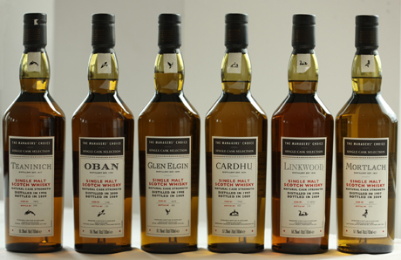
They are out! It’s official. There will be a total of 27 (one from each distillery) over the next year or so. The first batch of six (see the picture) should be available any day now from good retailers.
And now the funny bit. The pricing. Check out what is being asked for the first lot:
1997 Cardhu Managers’ Choice Bottling. Distilled: 1997- Bottled: 2009 57.3% Limited Edition - £250
1998 Glen Elgin Managers’ Choice Bottling. Distilled: 1998- Bottled: 2009. 61.1% Limited Edition - £250
1996 Linkwood Managers’ Choice Bottling. Distilled: 1996- Bottled: 2009. 58.3% Limited Edition- £200
1997 Mortlach Managers’ Choice Bottling. Distilled: 1996- Bottled: 2009. 57.3% Limited Edition- £250
2000 Oban Managers’ Choice Bottling. Distilled: 2000- Bottled: 2009. 58.7% Limited Edition - £300
1996 Teaninich Managers’ Choice Bottling Distilled: 1996- Bottled: 2009. 55.3% Limited Edition - £200
That is all very nice. I’m sure collectors are weeping tears of blood. I was considering a bank loan for a while but when my Royal Bank of Scotland branch manager heard word ‘whisky’ it suddenly appeared I was not eligible. I was kind of relieved… but check out this beauty…
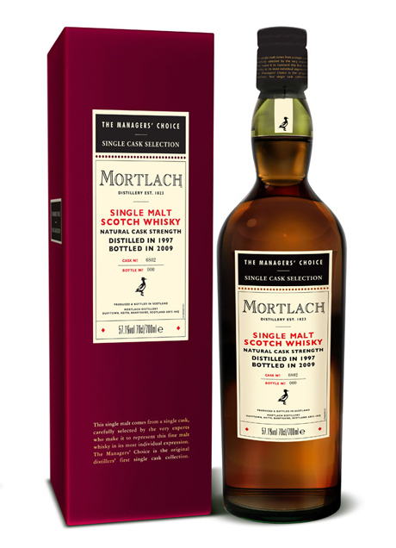
----------------------------

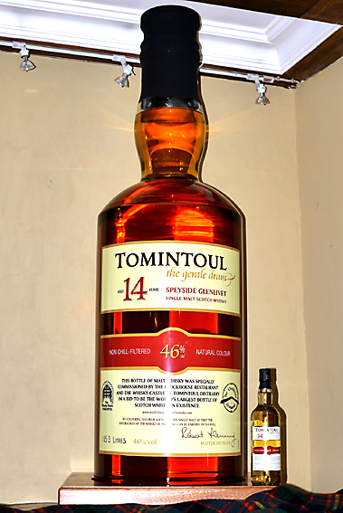
BIG BOTTLE 105.3 LITRES WITH SMALL BOTTLE WITH NORMAL 70CL BOTTLE OF TOMINTOUL 14 YEAR OLD 46% NON - CHILLFILTERED MALT WHISKY.
Late January 2009 Dru McPherson (proprietor with his wife Irene of the Clockhouse Restaurant, Tomintoul) had another idea and told of it over a cappuccino to Mike Drury, co-owner with his wife Cathy of The Whisky Castle Tomintoul.
The idea gestated by Dru McPherson was for Tomintoul to be the first place in the World to have a bottle of Scotch Whisky with a capacity over 100 litres in volume. Never on record as being done before! The ultimate goal for the bottle to be recognised as the "Largest Bottle of Scotch Whisky in the World" by Guinness World Records. - The conspiracy had begun. Secrecy - the ultimate order.
Much of the motivation was generated by the untimely retirement from Terry Wogan's early morning BBC Radio program of the famous Mrs McKay no longer to sweep the snow from the Lecht every Winter. With Terry Wogan not mentioning "Tomintoul", (Highest Village in the Highlands - possibly in Scotland), so often on his radio show, this tiny little village on the A939 between Deeside and the Spey River needed a PR boost! The bottle seemed a perfect solution!
The pair of conspirators managed to convince the Tomintoul Distillery owned by Angus Dundee PLC to provide the malt whisky to fill it with and the very special bottle was commissioned.
6 months later, after many traumatic events simular to those found by any adventurer exploring the unknown, finally a bottle to specs was made by a German glassmaker. A massive cork was made and an oversized label was printed, based upon the superb 14 year, 46% alcohol by volume, non-chillfiltered and naturally coloured, single malt whisky from the Tomintoul Distillery.
On the 27th August 2009 the bottle was installed in a specially made crate, furnished by Dennis Bulmer of Highland Hardwoods and placed in the casking hall of the Tomintoul Distillery. Here an Angus Dundee team of 14 under the leadership of Distilleries Director Robert Fleming , Sales Director Duncan Baldwin and Steven McNeil, Senior Production Manager filled and furbished the bottle under the judicious eyes of Gauger Bob Wilson, witnessed by Judge Alistair Sharpe and Solicitor at Law Catherine Hastings.
All observations and documents concerned with the validity of the contents and volume of the bottle were notorised by Neil Masson.
These documents in evidence were sent to the Guinness World Records Offices in London, where they were ratified six days later as being "The Largest Bottle of Scotch Whisky in The World".
----------------------------

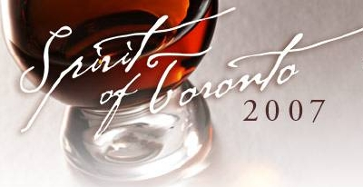

Spirit of Toronto – Saturday April 24, 2010
Spirit of Toronto is Toronto’s Annual Whisky Gala, a spectacular evening featuring more than 100 single malts and premium spirits, tutored tastings, live jazz, gourmet catering, food and whisky pairings, whisky cocktails and an outdoor cigar terrace on the lower level of Roy Thomson Hall.
Come and join KSMS as we travel to the gala event. Next year it will be occurring on Saturday April 24, 2010 at the Roy Thomson Hall in Toronto. I have made arrangements McCoy’s Bus Service to shuttle us there and back. The bus will depart Saturday April 24th, 2010 at 8 a.m. and return Sunday April 25th, 2010 at 2 a.m. The cost of bus will be $40 per person and will be open to the first 27 people who express interest in the form of full payment.

----------------------------

Win Me !!

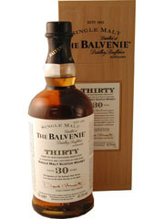

THE BALVENIE 30 YEAR OLD
SINGLE MALT WHISKY
VINTAGES 665091 | 700 mL bottle Price: $640.95
Spirits, Scotch Whisky, 47.3% Alcohol/Vol

Starting September 21st, 2009 tickets can be purchased for a chance to win this bottle. Tickets will be $3 each or two tickets for $5. Tickets will be on sale at each dinner until the January 25th, 2010 Robbie Burns dinner when the bottle will be raffled. The winner must successfully answer the skill testing question: What country does single malt come from?

----------------------------

Reservation policy
- Our contract with the Officer's Mess Kitchen requires that we provide seven (7) business days notice for them to guarantee accommodation for our requested numbers. Each month an invitation will be sent out to all members of the Society in the first week of the respective month in which the dinner will be held. To accommodate the Kitchen's needs and meet our contractual obligation with them; our members are requested to respond to the emailed invitation seven (7) business days prior to the respective dinner to guarantee a seat at the dinner. After that members will be placed on a waitlist.
- For these individuals the process will be as follows, using the September 21st dinner date as an example:
- Dinner invitations will be sent out Saturday August 30th, 2009. Please respond to me (rdifazio@cogeco.ca). I will then acknowledge that you have a seat. Please understand that if you do not receive a response you are not guaranteed a seat at the respective dinner. In such circumstances (e.g., computer glitches) please e-mail me again or call me at (613-634-0397).
- Accommodation at the dinner will be guaranteed for a member who responds by Wednesday September 9th, 2009 midnight.

Cancellation policy
- Using the same example as above, anyone who cancels anytime prior to Wednesday September 9th, 2009 midnight will be removed from the list.
- Anyone canceling between Wednesday September 9th, 2009 midnight and Monday September 21st, 2009 will be expected to pay for the cost of the dinner and scotch ($50). It is the responsibility of the member who cancels their reservation to find a replacement. If I can substitute an individual from the wait-list, then the member will not be asked to pay for their cancellation.
- Anyone who fails to attend the Monday September 21st, 2009 dinner without having cancelled and been successfully replaced will be expected to pay the full cost ($50). The member will be responsible for their guest's cancellation.
- If a member asks to be included at the dinner between Wednesday September 9th, 2009 midnight and Monday September 21st, 2009 , your name will be placed on a wait-list and be accommodated on a first-come first-serve basis.

----------------------------
Just a note because we care.

Please understand that for the purpose of each event you are advised to drink responsibly and refrain from excessive consumption. The dinners hosted by the Kingston Single Malt Society are sampling events. By agreeing to pay and thereby attend the dinner you agree to release from legal responsibility and hold harmless Kingston Single Malt Society, its President Roberto Di Fazio, and any other volunteers from liability or claims arising from these events.

----------------------------
If you have any questions or comments please free to contact me. Thank you for your understanding,
Roberto
