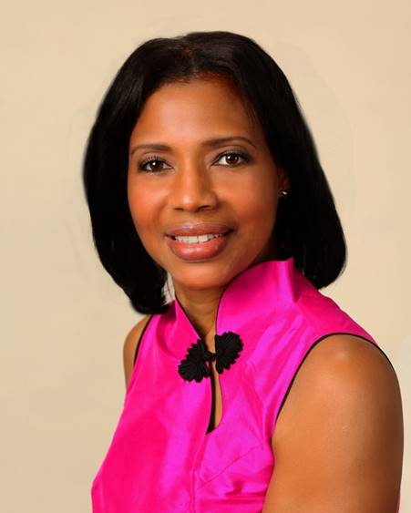

LOVE LIGHT NewsLetter

I am excited to host my VoiceAmerica Empowerment Show-LOVE LIGHT with amazing Guests to cultivate a lifestyle of love and wholehearted connections through worthiness. My show is aligned with my mission to live an altruistic and heart centered life.

MEET LOVE LIGHT GUEST

Susie Briscoe
Chair, Acer Coaching Associates
Legacy Mentor & International Bestselling Author
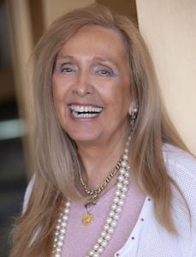

“LOVING TO LIVE YOUR LEGACY”

MAY 1, 2020

ABOUT Susie Briscoe

Susie Briscoe is the Chair, Acer Coaching Associates International and Legacy Mentor, and International Bestselling author for “Color Your Legacy”. She has identified ‘Leading Legacy’ work as a major part of her passion. This is about filling the gap, working with people who still have an empty feeling inside themselves for whatever reason, and finding a way to give back to the world whilst recognizing the importance of not wasting time as the clock continues to tick. Headhunted by the Nightingale-Conant Corporation in 2008, and subsequently by Brian Tracy Intl., to become their freelance Master Coach outside the U.S., Susie runs her international business whilst remaining actively involved in these charities: Action Medical Research for Children, The Battersea Dogs’ and Cats’ Home, The Church Homeless Trust, and The Acer Foundation for Global Education & Welfare, which she founded.

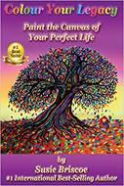
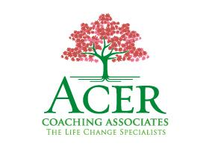

www.acercoachingassociates.com

“An empowered self is a loving self, and keep your love light shining.”

