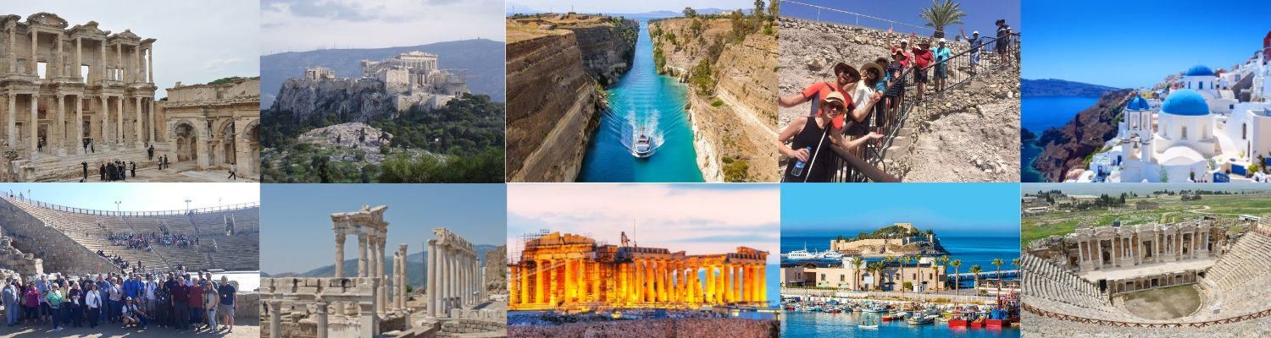
Greece & Ephesus 2021
Follow Paul’s journey on a 4 night cruise through the Greek islands and 5 nights on land following the path of his ministry.

July 5 – July 15, 2021 (11 days including travel)

Schedule based on evening arrival in Thessaloniki and afternoon departure from Athens
DAY 1 MONDAY, July 5, 2021: DEPART US FOR GREECE
DAY 2 TUESSDAY, July 6, 2021: ARRIVE IN THESSALONIKA, GREECE (SKG)
Upon arrival in Thessaloniki, meet the local representative who will assist with your transfer to the hotel. Your journey to the Biblical land of Greece begins! Upon his arrival in Thessalonica, Paul went immediately to the synagogue and for three Saturdays he explained the prophecies of the Old Testament to Jews and Greeks. According to the Book of the Acts many Greeks believed and even many «Greek chief women» (Acts 17:1-4). We go to the upper Old City Walls then drive along the Egnatian Way to see the Triumphal Arch of Galerius and the Rotunda. Check-in and overnight.
DAY 3 WEDNESDAY, July 7, 2021: PHILIPPI – KAVALA - THESSALONICA
On our way to Philippi, we drive by the Lion of Amphipolis (short stop for photos). We visit Philippi, the site where Paul established a strong church. To this congregation he sent his letter (Acts 16:9-33). We see the river where Lydia is said to have been baptized, the ruins of a prison where Apostle Paul and Sylas had been kept, the Agora, 5th and 6th century Basilica and the Theater. After the visit, we continue to Kavala, the ancient port of Neapolis (Acts 16:11) where we enjoy a panoramic tour before returning to Thessalonica for overnight.
DAY 4 THURSDAY, July 8, 2021: BEREA - ATHENS
Check-out from the hotel in Thessaloniki. We start our drive to Athens (Approximate driving distance 7-8hrs including stops). On our way we stop at Berea (Acts 17:10-15) where Paul arrived and according to his custom went to the synagogue where, to his pleasant surprise, he discovered that these Jews were “more noble” than those he had encountered in Thessalonica. We see the Byzantine mosaic in the monument commemorating his preaching (Acts 17:10-11). Arrival in Athens for check in and overnight.

DAY 5 FRIDAY, July 9, 2021: ATHENS – TEMPLE OF PARTHENON – MARS’ HILL
Today we climb up to the marble capped Acropolis Hill and visit the famous Parthenon and Erechtheion Temples. We then walk to nearby Mars' Hill (Areopagus) (Acts 17:22) where Paul delivered his soul-stirring sermon to the giants of philosophy, logic and learning and spoke about the inscription: “to an unknown god”. We continue our tour with a panoramic sightseeing of the city highlights. Enjoy the rest of the day at your own leisure in Plaka, the oldest and most picturesque district of Athens.

DAY 6 SATURDAY, July 10, 2021: ANCIENT CORINTH TOUR
Today we depart for our morning tour out of Athens. On the way, we stop at the historic Corinth Canal. It was Corinth (Acts 18:1-18) where the Apostle Paul lived and worked, established a thriving church, subsequently sending two of his epistles now part of the New Testament. Here, we see all of the sites associated with his ministry: the Agora, the Temple of Apollo, the Roman Odeon, the Bema and Gallio’s Seat. The small local archaeological museum here is an absolute must! Transfer to Piraeus port and embark on cruise for 8:30 p.m. departure.

DAY 7 SUNDAY, July 11, 2021: KUSADASI, TURKEY & EPHESUS 8:00 AM – 6:30 PM
At 8:00 am,. we dock at Kusadasi in Turkey, starting point for our excursion to the ancient city of Ephesus (Acts 18:19-21). The Apostle Paul preached to the Ephesians and lived here for three years. We tour the spectacular ruins where excavations still continue in this once great city. Enjoy this great area until the cruise departs at 6:30 pm

DAY 8 MONDAY, July 12, 2021: RHODES
We shall spend our whole day on this beautiful and enchanting island. Paul sailed to the island of Rhodes (Acts 21:1), home of the famous philosophers and orators, on his homeward journey to Jerusalem. From the port we begin our tour to the Acropolis of Lindos and we explore the medieval town or spend some time relaxing and swimming in one of the many pristine beaches, only a short distance away. The island of Rhodes is in many ways a microcosm of Greece. The Old Town of Rhodes, at the northernmost point of the island, is probably the best-preserved medieval city in all of Europe. Midway down the eastern side, Lindos (some 55 km south of Rhodes town) blends archaeological intrigue with a panoramic town that is more reminiscent of a Cycladic island like Mykonos. The western side, meanwhile, has many orchards and vineyards as well as impressive ancient ruins at sites like Kameiros. The island’s interior is a place of verdant forests, hills and oases of calm like Seven Springs and the Valley of the Butterflies nature park, bringing to mind the countryside of northern Greece, while the beaches you’ll find in Rhodes are among the widest and best in Greece and indeed the Mediterranean.

DAY 9 TUESDAY, July 13, 2021: SANTORINI 7:30 AM – 10:30 PM
Be inspired by the unique beauty of Santorini island. Ride the cable car up to the white-washed town of Thera, perched high on the rim of the ancient volcano. Stroll freely through the cliff hanging villages and admire the breathtaking views. Few islands have the power to captivate the way Santorini does. Gorgeous and cosmopolitan, it’s famous for that classic Greek island look with white painted houses clustered along narrow winding lanes, perched atop reddish-black volcanic cliffs that tumble down more than a thousand feet to the wide caldera. It’s easy to see how this island, the pearl of the Cycladic archipelago, can lay claim to being the source of the legend of Atlantis, either. Santorini, or “Thera” in Greek, is most celebrated for the dramatic views of its volcanic caldera, formed during a massive eruption around 1646 B.C. That eruption shook up the island—making its center actually collapse—but also created some of the most spectacular scenery in the world.At 10:30 pm, set sail for the port of Lavrio.

DAY 10 WEDNESDAY, July 14, 2021: Arrive at the port of Lavrio. Transfer to Athens
DAY 11 THURSDAY, July 15, 2021: DEPARTURE FROM ATHENS AIRPORT
After witnessing a unique visual and historical experience of the Old and New Testament sites in Greece, this Biblical journey in Greece has come to an end. You will be transferred to Athens International Airport for your departure flight home or to Jordan.

HOTELS
Athens - Divani Palace Acropolis
Thessaloniki - Grand Hotel Palace
ALL ITINERARIES ARE SUBJECT TO CHANGE BASED ON SCHEDULING NEEDS AND LOCAL CONDITIONS.

