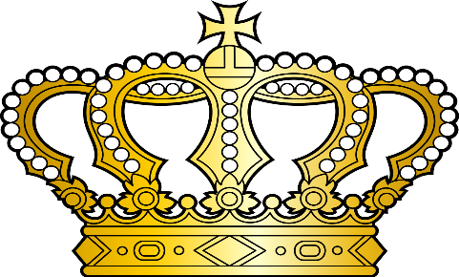
2018 Clermont County Fair
This Photo by Unknown Author is licensed under CC BY-SA
Royalty

King: Louie Novak
Queen: Erin Jennings
Prince: Ethan Pfankuch
Princess: Shelby Highfield

Beef Representative: Faith Stegbauer
Dairy Cattle Representative: Sarah Francis
Equine Representative: Shelby Miller
General Projects Representative: Jetta McCart
Goat Industry Representative: Morgan Miller
Pork Industry Representative: Kassie Stahl
Sheep Representative: Kolbie Brandenburg
Small Animal Representative: Ahja Jones

