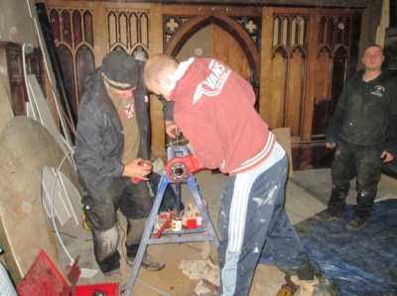
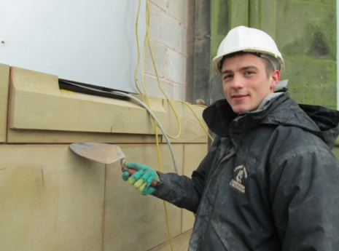

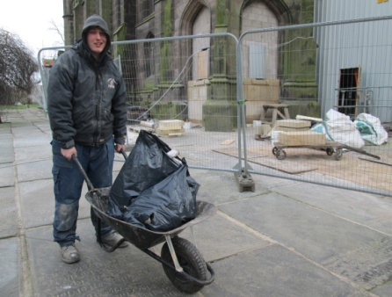
The idea of this weekly
publication is to keep you
informed as to what is
happening behind the
screens – so here goes…
There is still plenty going on both inside and out – both up on the tower and back at ground level. You can see for yourself the progress being made on the stonework to the exterior of the new toilets by just walking round the side of the church. You can’t of course see the work being undertaken down the far end of the north aisle – with floor levels being finally checked before installation of the lift; in the vestry areas, or on the tower roof - but the contractors remain busy in all areas. The plastering continues in the kitchen and the tiles are here ready to be fitted in the next few days. White with a green boarder – in case you were wondering! Individual works are on target (more or less) - we are certainly still on schedule overall. Work on the tower is at a crucial stage now – photos coming later - and our Architect eager to know if we are proceeding with the rest of the internal works, presently on hold for lack of funding.
We’re not quite there yet in raising the additional cash we need to authorise the rest of the work(s) to this phase of the interior. We will have to make a decision soon and need to work hard over Christmas to bring in donations to the appeal and of course towards the general running of St Mary’s.
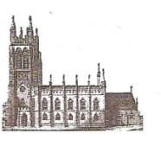
St Mary’s in the Marketplace.
Issue No 21 (9th December 2012)
“Securing the future for the next 100 years”
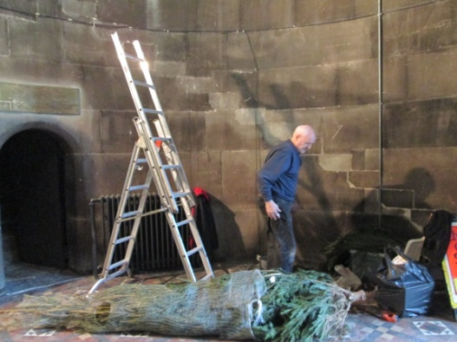
It’s beginning to look a lot like Christmas…..
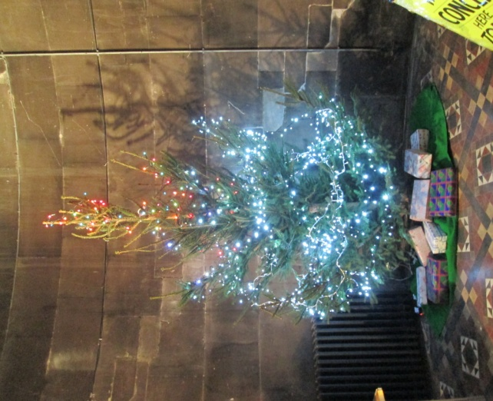

There is something special about
the arrival of the Christmas tree,
a gift to St Mary’s for which we
are most grateful. The crib is in
place, the floral decorations on
the font, and this year the artificial
tree returns from St Andrews to provide the centre-piece for the
”Dickensian Christmas - Carols in the Nave” this being the conclusion of the Charles Dickens 250th anniversary day of celebration. Waiting in the wings, our “tree of light”. If you want to remember someone at the 23rd December service, please complete a card and leave it in the container provided. Everything you need can be found near the west doors. We’ll do the rest!
Our Christmas programme started last Sunday evening with our Advent Carol Service with the Maia Singers. Attended by the Deputy Mayor and Deputy Mayoress, Cllr Anthony O’Neill and Mrs Brigid O’Neill. It was a beautiful service held in candlelight – sorry no photo (too dark…..). The singing was magnificent. We look forward to welcoming the Maia Singers back on the 22nd December along with the Stockport Youth Choir for our “Sing Christmas” Concert.
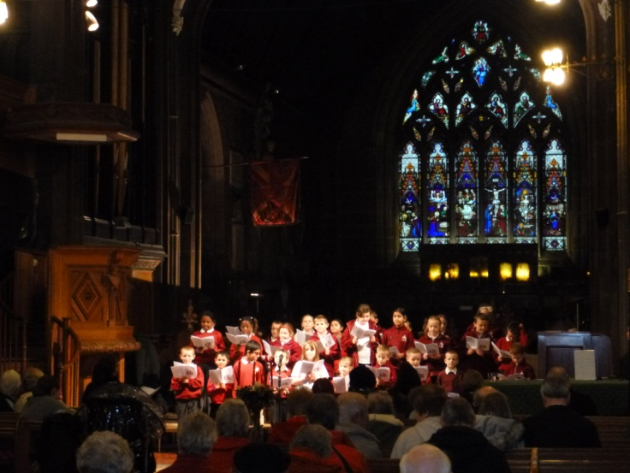
Second on the list, newcomers to St Mary’s, children from St Thomas’ CE Primary School. The children sang and read beautifully. You will recall that Roger is presently taking a weekly assembly at St Thomas’ CE Primary – an experience enjoyed by both Rector and children alike!
We were only able to
have the school
choir with us last
week - next time we
hope that more of
the children will be
able to visit us.
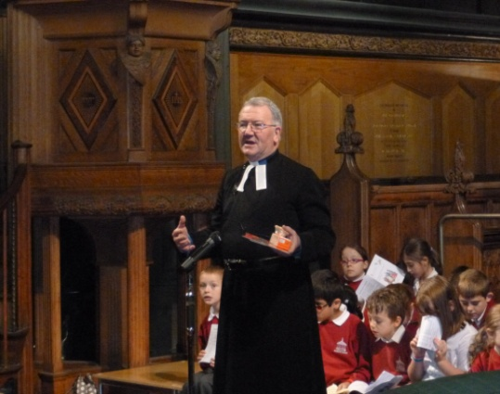

Does anyone still wish to come to the
panto on the 2nd January?
If so we still have tickets available – for
sale at the theatre price of £16 (adult)
£14 (concession) and £10 (child).
Afternoon tea afterwards at St Mary’s Rectory.
Also: names are still being taken for New Years Eve – meal at the Old Rectory prior to the Watch Night Service. Let us know soon please if you want to come so that the booking can be confirmed.
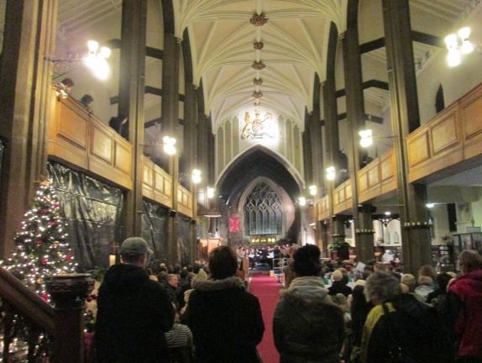
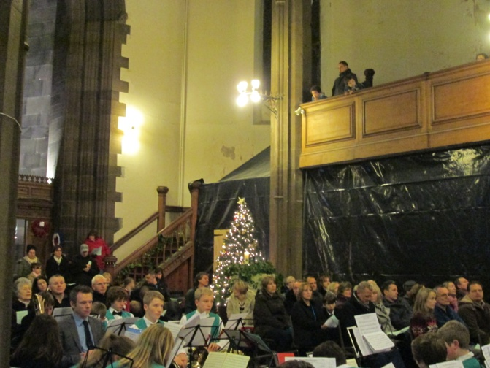
It was standing room only
for the Stockport Secondary
Schools Carol Festival, with
all seats taken, many in the
gallery and late-comers had
no option but to stand at the
back of Church.
It was an awful night weather-
wise (heavy rain), it kept our
duty volunteers on their toes,
(heading towards crowd control) but it was another lovely evening. Very well done to all the schools involved and the organisers of the event from SMBC. It was nice to have them back at St Mary’s and to
see so many there.
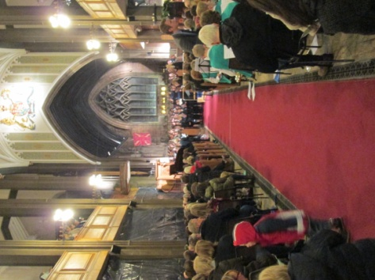

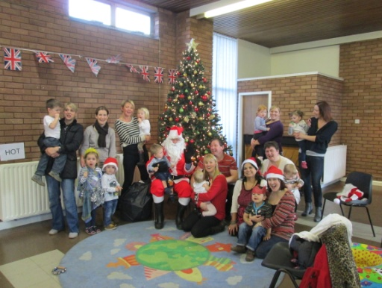
Our second building, St Andrews
and home of the “Mums and Dads
at Home” group has also been
celebrating the start of the festive
season – guess who is playing the
role of Santa! Yes – Roger!
St Andrews is available for hire -
for anyone thinking of arranging
a last minute party.

