God Comes to the Neighborhood

That was the Christmas message two thousand years ago and it is the message today! The neighborhood is hurting. The pandemic haunts our every decision, neighbors are sick and hungry, and yet even this year the message seems transforming: God is with us... with us in it all.
So, the Grace family will welcome “God with us” as we hear the transforming story of a baby’s birth in Bethlehem. We will be a hardy band of believers gathered in the Church yard on Christmas Eve to hear yet again the message of the Angels. Come at 3:00 pm. Dress warmly, bring a chair, and realize that this year we are all Shepherds in the field... excited to hear the story in our time, to gather, to not be afraid, and to become instruments and harbingers of hope in a dark time.

See you there!!!!

Grace is again fortunate to be able to adopt a family of four this Christmas through Fauquier Family Shelter Services. Our family consists of a mother, a father, and two boys: one who is three, and one who is ten.
New rules are in effect this year - please do not wrap the gifts for the children so the parents can be involved in sorting and wrapping for their children. Wrapping supplies, however, are welcome, so you may want to include a gift bag/tag with your gift as well as gift receipt or receipt if for clothes. The other change is that there is no financial limit placed on gift cards and gifts (it was $25 last year) - probably because these families are being housed in individual homes. In addition to the gifts, they also welcome good used clothing - if our adopted family can't benefit, the coordinator shared that there are 44 children who can also benefit. The children have NEEDS as well as WANTS. In the past, if we could get at least one of the WANTS for each child, that would be fine. This year, some of the WANTS are a bit pricey, so in order to get at least one of the wants for the 10-year old specifically, two or three folks could combine their efforts. Many of the NEEDS and WANTS have already been chosen to be donated. Here, you will find the remainder.
For the 10-year old, we know that his favorite colors are red and black, and he NEEDS:
Hat, scarf and gloves (men’s size M/L)
Belt (men’s size 32 or 33)
His WANTS are:
a laptop or large tablet
Nike shoes (size Mens 9-9.5)

For the 3-year old, we know that his favorite colors are red and blue, and he NEEDS:
Socks and Underwear
His WANTS are:
Spiderman/Marvel figurines

The parents NEED:
cleaning supplies and toilet paper
For the mother:
Hat and gloves - large
For the father:
Hat and gloves - Men's medium

Note: some gift cards have already been donated, but they would surely be grateful for more.

Stocking stuffers and fun things are welcomed for both the children and the parents. No need to wrap the gifts for children as parents want to be involved, but please provide gift bag or wrap/ribbon to make it easy for the parents. Wrap anything for the parents - they could use a surprise! Mignonne Spellmeyer will be maintaining the master list. Please contact her by cell phone: 540-272-0014. If she does not answer, please leave a message to include your return phone number. Questions are welcomed as well. Gifts are needed by December 12th. Please deliver to the back row of the church or call Mignonne to deliver directly to her. Also gently used clothes also welcomed, marked as such.

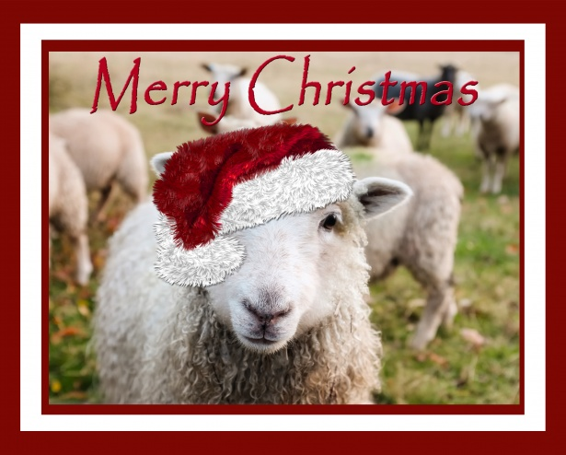
﻿
﻿A Feed My Sheep (FMS) Holiday Message
Here we are in the holiday season and still under COVID-19 restrictions. The one thing that is certain is that our FMS families were able to enjoy Thanksgiving with a bountiful meal. Because of your “gifts,” each family had a turkey or ham plus all the “trimmings”. While there are many wonderful and generous organizations providing food for the underserved in this season, FMS provides food every week, every month, year-round. With the donations our families are also getting fresh meats on a regular basis. I’ve added on coffee, creamer and hot chocolate (a luxury for most.) FMS is run entirely by volunteers. Charlie Miller, our leader, is still present after departing this earth as he left his truck to Bealeton Baptist Church so that we now have a reliable means for delivery. All $$ for gas and repairs is donated by the drivers. 100% of your donations are used for food. In these changing and uncertain times please remember that we are a constant in meeting the needs of so many families. A friendly reminder: donations can be made payable and sent to Grace Episcopal Church with FMS written in the memo section.
Carol Grove

