Elite M.M.A. Center - Demo Event
- Kreidersville Covered Bridge Festival -
Saturday, June 4th - demo team to arrive @ bridge by 1045am or meet at dojo by 1030am. Elite Demo Team to open event @11am. All demo team members, wear Elite Tee Shirt & shorts, socks, sneakers, bring demo uniform and belt. Ask Sensei or Deshi what weapons you need to bring. All combat sabers are mandatory.
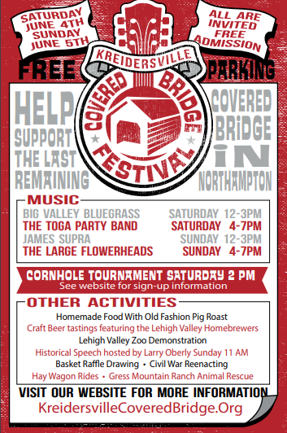

- Parents meeting for Demo Team - Saturday, 5/28/2022 @ 1200noon during demo class. We need help bringing gear to covered bridge.
EZ Up Cooler Snack Bag
Weapons Bag Wood Chairs Promo Box

"Everyone from Elite is invited to attend and support your Elite Demo Team."

