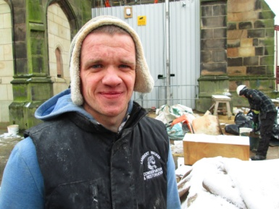
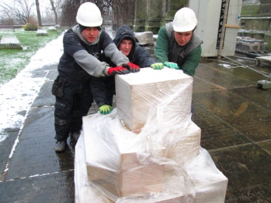
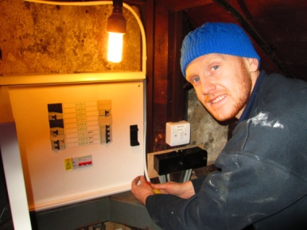

News from St Mary’s
We will be keeping you informed as to what is happening at St Mary’s - behind closed doors (and including anything else we need to inform you about) by issuing a new publication “News from St Mary’s”. This will be available on Tuesday, 5th & Tuesday, 12th February (at St Peter’s) and as requested – sent to you by e:mail or by post (for the cost of a couple of postage stamps). Details will also be posted on our web-page at www.stmarysinthemarketplace.com
A catch-up copy (complete with photos of course) of Building News will be circulated from the 19th February when everyone returns “home” to St Mary’s. By then the screens will be down, the toilets/kitchen should be available for use and some of the work started on the Memorial Chapel. The floors should be sanded and waxed with all the tiles repaired. It will look completely different – but not just yet complete with the new seating - this will follow in due course, as will the cushions in the Chancel seating.
By the time you come back to St Mary’s most the work will be completed on the Tower, although not all of it. However the scaffolding will soon be starting to come down, a sign that things are progressing towards completion.
For those of you who we will not meet for a few weeks, enjoy your visits to other Churches, please remember those working at St Mary’s in your prayers and come back to us ready for a new chapter in the life of St Mary’s in the Marketplace.
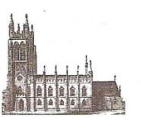
St Mary’s in the Marketplace.
Issue No 28 (27th January 2013)

“Securing the future for the next 100 years”

St Mary’s (the building) will be closed until Tuesday, 19th February 2013 but St Mary’s (the parish) will continue to be fully operative.
Tuesday 10.00am and 12.15pm services will be held at St Peter’s – we very much hope that our regular congregation will be able to travel over to St Peters Square, Petersgate, Stockport to attend these services on the 29th January, 5th & 12th February.
Our Sunday congregation has been invited to attend a number of neighbouring Churches within the Deanery and beyond whilst St Mary’s is closed on the 3rd, 10th & 17th February. We take this as an opportunity to visit other Churches, to tell them about the work we are undertaking at St Mary’s and to “network” making new friends along the way, and sharing new experiences.
Meanwhile back at St Mary’s, there are a record number of craftsmen now on-site, up the tower, behind the black screens and now involved with the task of repairing the archway to the Churchyard.
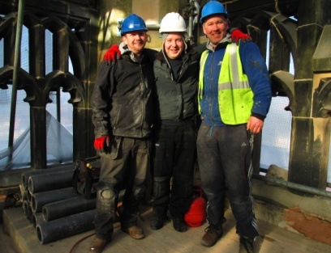
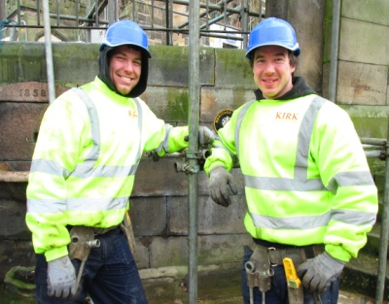
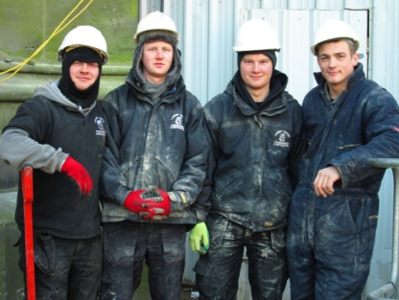

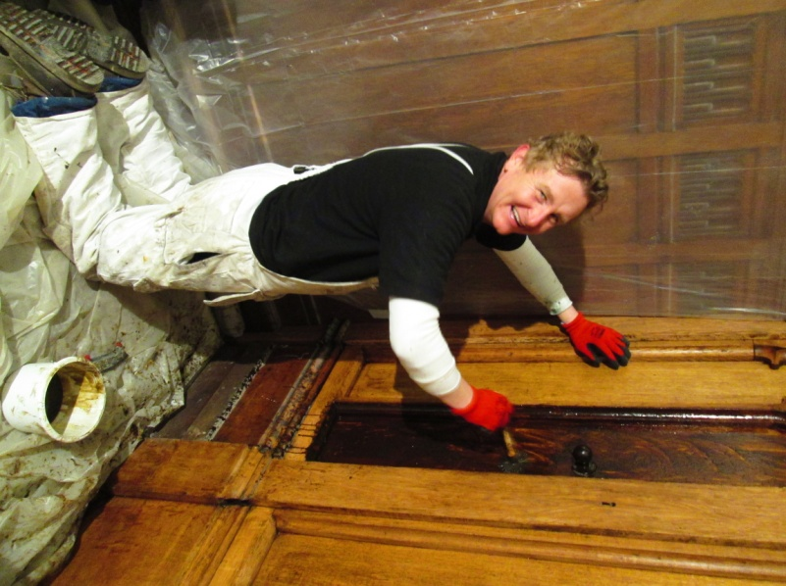
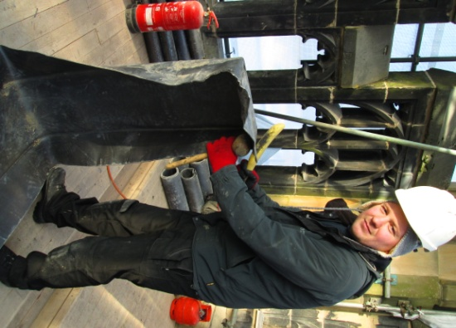
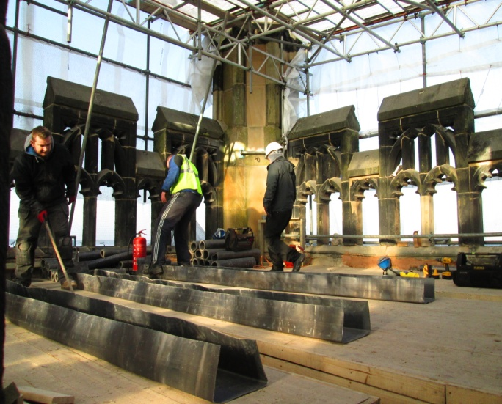
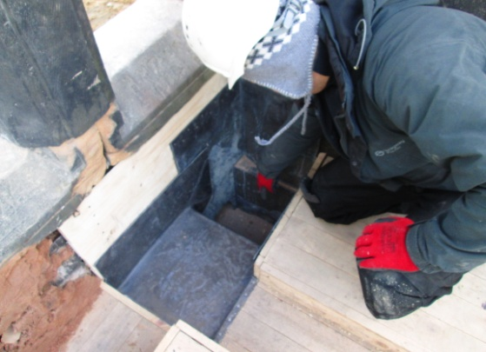
Work on the roof of the Tower and the complexities of getting all that roofing material down. Such attention to detail required to get
the fit just right.
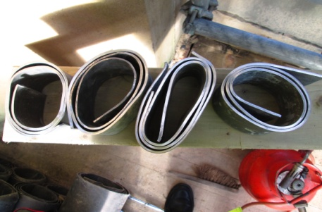

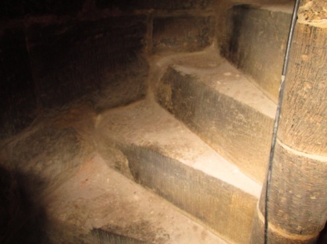
Of course we (well some of us, in particular
Roger) will need to be able to get up and
down (to raise and lower the flag if nothing
else). All the stone steps are worn to some
degree or another but the ones at the very
top have been a concern for some time.
We are therefore delighted that these have
been included in the repair work.
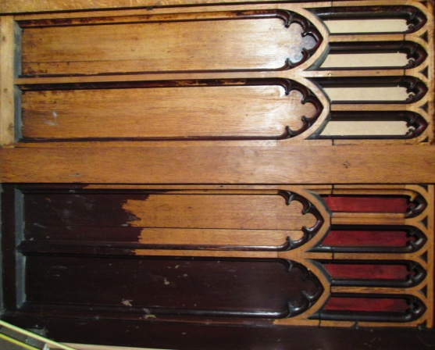
You will be amazed when you see just how beautiful the decorative screen now looks having been professionally striped and cleaned.

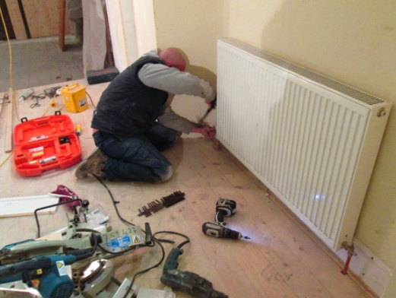
The new archway to the former choir vestry continues to be worked on and will be truly magnificent when completed even if “blocked off” for the immediate future. Presently behind even more sheeting it is quite a task and we can’t wait to see the finished job. Skirting boards are now being fixed in the “Heritage Centre” before the lift is fitted and decorating begins. The kitchen and toilets are coming on with most the equipment now installed (or at least put in place) and varnishing and decorating now underway.
