Ptosis / Blepharoptosis, Drooping Eye
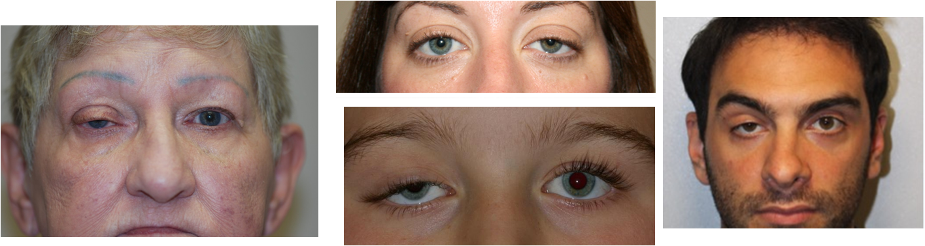

Ptosis (TOE-sis), also known as droopy eyelid or blepharoptosis, is the abnormally low position of your upper eyelid. Droopy eyelids vary in severity, and can range from hardly noticeable to completely covering the pupil, iris, and other parts of the eye. If severe or left ignored, it can lead to amblyopia (lazy eye) or astigmatism.

There are two types of ptosis:
- Acquired ptosis - is the most common type, and is usually due to the muscles that elevate the eyelid becoming weak, thin, or stretched with age.
- Congenital ptosis - is present at birth and is usually due to the lack of development of eyelid muscles called levators. When congenital ptosis affects visual development in children, surgery may be required to prevent the development of amblyopia.

Droopy eyelids interfere with vision and can lead to fatigue from straining to elevate the eyelids.

Ptosis must also be differentiated from dermatochalasis, which is simply extra eyelid skin that can also cause the appearance of a droopy eyelid. The causes and treatment for dermatochalasis are very different than for ptosis.

Symptoms of a Droopy Eyelid?
- The most obvious symptom of ptosis or blepharoptosis is the drooping eyelid itself.
- Other symptoms include difficulty opening the eye or the need to tilt your head back in order to see better.
- Eye fatigue, misaligned eyes, or double vision can also accompany ptosis.

You or your doctor may compare a photo of yourself from ten years ago to a recent one to see if there is a difference in your eyelids.

What Has Caused My Eyelid to Droop?
The causes of droopy eyelid are diverse.
- One can be born with hereditary droopy eyelids, a condition known as congenital ptosis.
- Most cases of acquired ptosis develop as we age and the tendon that helps keep the eyelid open stretches and loosens, usually due to lack of nutrients & quality protein.
- Droopy eyelids can also be caused by trauma, surgery, or by damage to the muscles that raise the eyelids or to the nerves that control these muscles.
- Tumors, neurological disorders, and systemic diseases have also been known to cause ptosis.
- Side effects of some drugs.

Depending on the cause, ptosis may be classified as:
- Neurogenic ptosis: Refers to the condition in which the nerves attached to the muscle are affected
- Myogenic ptosis: Refers to sagging of the lid due to a problem with the muscle that raises the eyelid
- Aponeurotic ptosis: Refers to the stretching and weakening of the tendon responsible for raising the eyelid
- Mechanical ptosis: Refers to a condition in which the weight of the eyelid is too great for the muscles to lift

Suggested Natural Support
- Optimize Protein intake - Life Shake
- Nutrient Smorgasbord - Shaklee Vitalizer or Life Strip
- CoenzymeQ10

Other Supplements of Benefit
- Optimize Vitamin C
- Optimize Vitamin D3
- Optimize Vivix
- Optimize Vitamin E
- Shaklee Physique
- Shaklee Alfalfa

