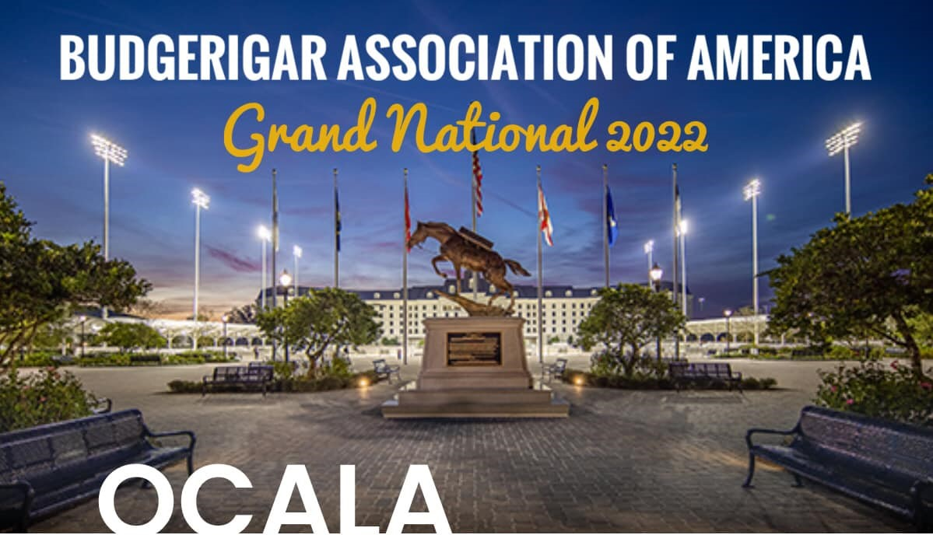

JUDGE: DANIEL LUTOLF

SEPTEMBER 23 AND 24
Show will be held at the World Equestrian Center
1750 NW 80th Ave.
Ocala, Florida 34482

Hotel: Howard Johnson’s by Windham
3951 NW Blitchton Rd.
Ocala, Florida 34475
352-629-7021 Mention BAA Grand National for $79 rate. $25 one time pet fee applies.

For more information see Budgerigar Association of America website

Contact: David Eberst 352-281-2794

