Amelia-Nottoway Technical Center News 10/23/2020
ANTC STUDENT SPOTLIGHT!
Hannah Vaughan, NHS Senior
Cosmetology II
What brought you to ANTC? My passion for doing hair brought me to ANTC.
What is your dream job? My dream job is nursing and having a job through cosmetology
What is your favorite class that you have taken so far? Why? Cosmetology, I enjoy doing hands on assignments and bettering myself with the basic cosmetology
What is the best advice you have been given by your instructor at ANTC? “You never know how much time you will have in front of someone or something so don’t take time for granted.”
What is your favorite memory at ANTC? Personally, I can’t pick a favorite memory because they all have a significant meaning to me. I love doing haircuts, and working as a team. I could not ask for a better teacher or classmates.
What was the first feeling you had when you attended ANTC? One of my first feelings was that this class was going to be stress relieving. In this class, I can truly be myself and put all worries aside.
What words of wisdom do you have for other students? Don’t take your class as a joke; work in class and at home so you can become better. This will help you with your future career.
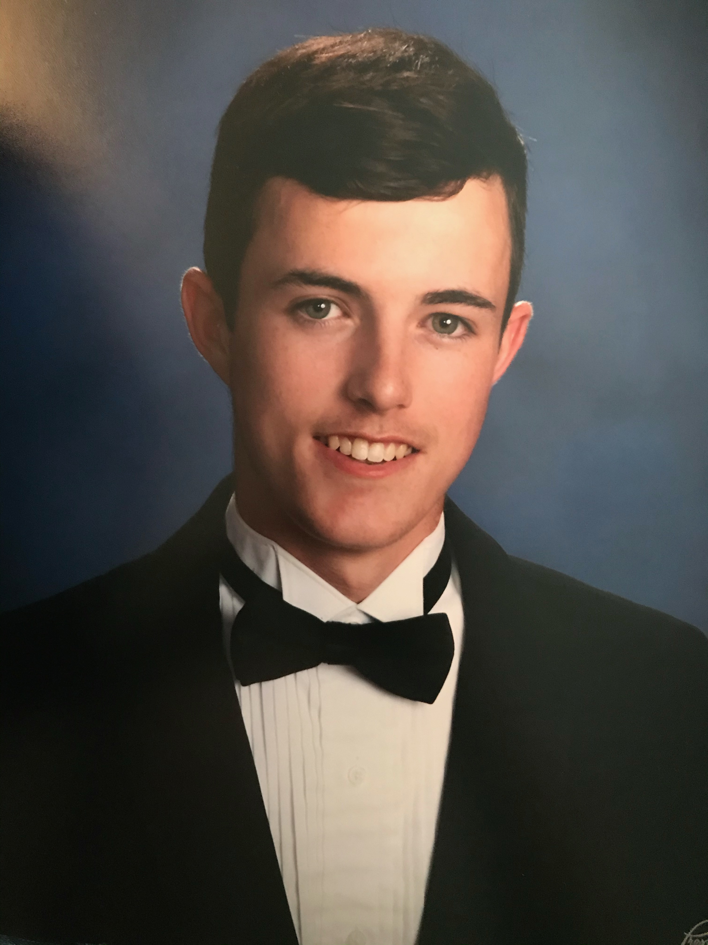
ANTC ALUMNI HIGHLIGHT!
Ryan Harvey
High School: Nottoway High School 2020
ANTC Program: Auto Body
Career: Employed at Fort Pickett; Future Firefighter
Certification: Non-Structural Analysis and Damage Repair
Thoughts: Auto Body has helped me out with projects and in my daily duties at work.
Auto Body: Amelia and Nottoway Students

Skills: Preparing the Surface; Operating Spray Gun and Related Equipment; Mixing, Matching, and applying Paint

Tasks/Competencies: Apply multi-stage (e.g., tri-coat) coats for blending or overall refinishing.

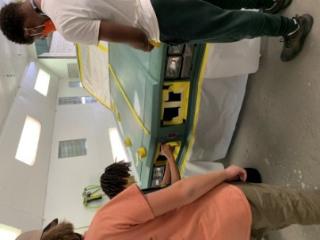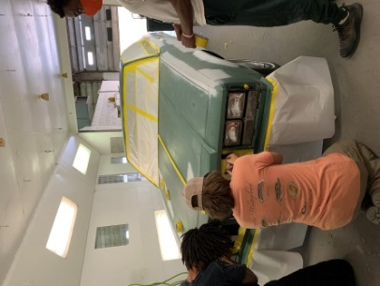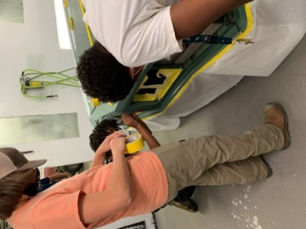

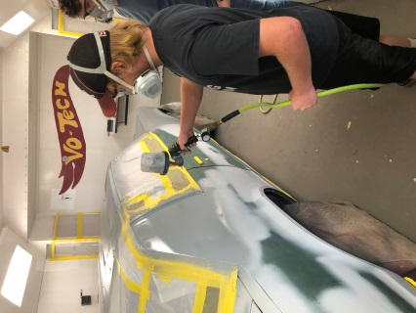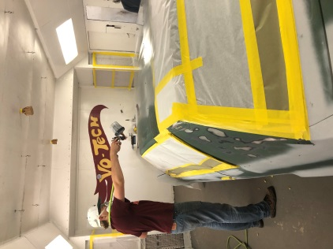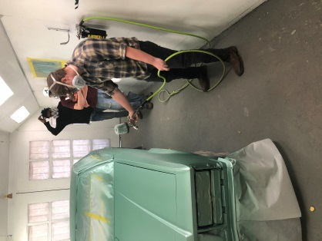

Almost Finished!
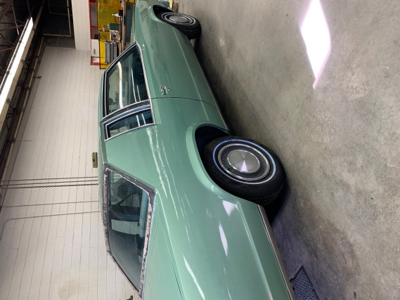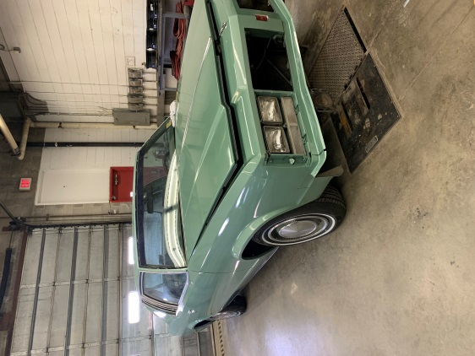

Cosmetology: Amelia, Cumberland, and Nottoway Students

Skills: Styling Hair

Tasks: Create a hair style based a chosen era

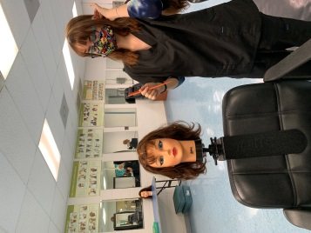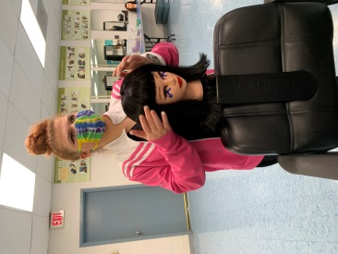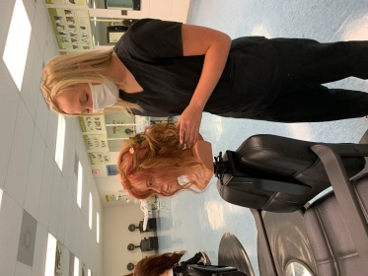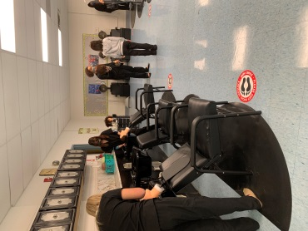

Cosmetology II – State Board Prep
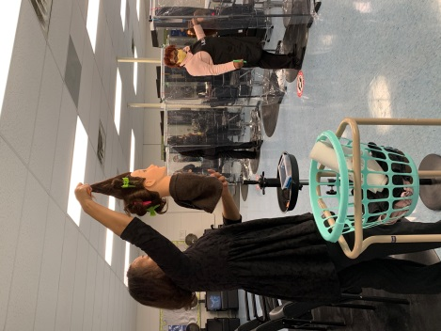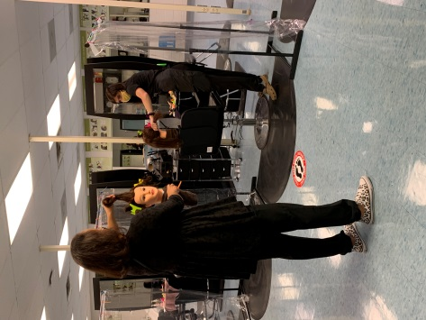
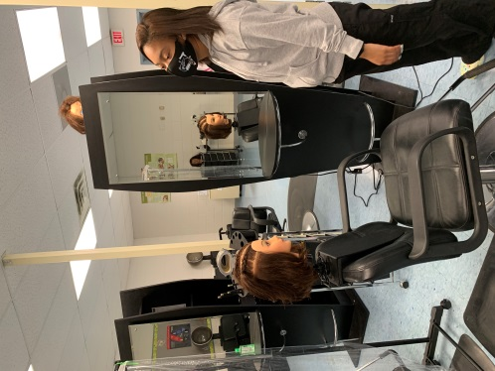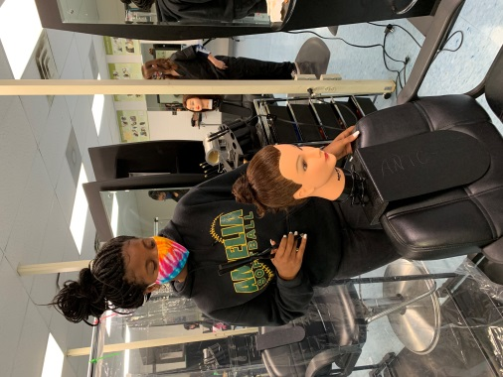

Medical Assistant: Amelia and Nottoway Students

Skills: Assisting in Physical Examination

Tasks/Competencies: Collect specimens such as blood.

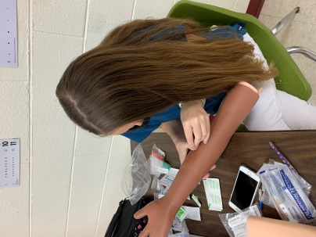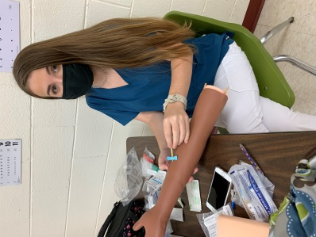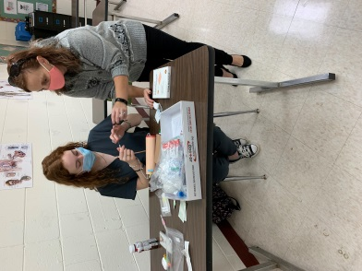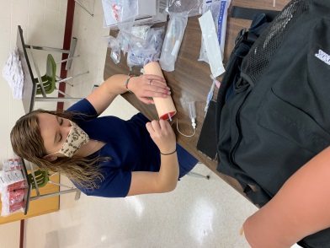
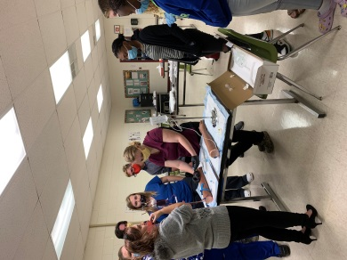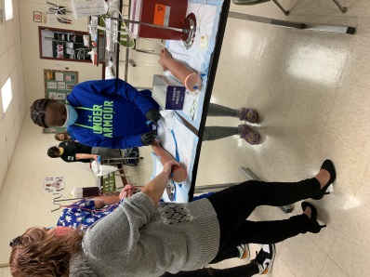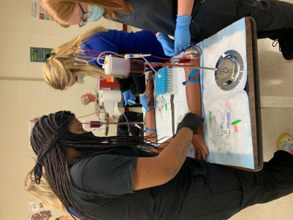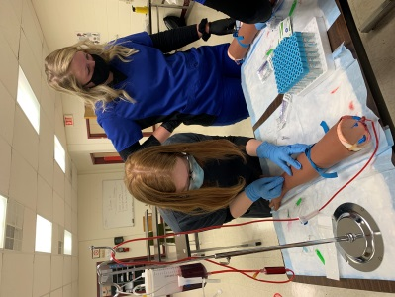

Vein Display Instrument - The Vein Finder
