At four in the morning on 13 January 1866, the Virgin Mary appeared at the sickbed of Magdalena Kade. Mary, dressed in white and wearing a golden tiara, pronounced Magdalena healed from her long illness. Many miraculous healings were subsequently reported. A church (later elevated to basilica-status) and convent were built on the location, which is sometimes called the 'Lourdes of Bohemia'.

The miraculous nature of Magdalena's sudden cure was questioned by her contemporaries. In 2008, German journalist Kerstin Schneider – a distant relative of Magdalena Kade – draws a parallel with the clinical history of her great aunt Lina Marie Schöbel, a schizophrenic who all of a sudden declared she was 'Jesus', and who was exterminated by the Nazis for being insane.

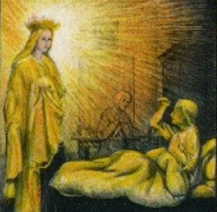

The basilica at Filipov. Image: Kmenicka,

CC BY 3.0