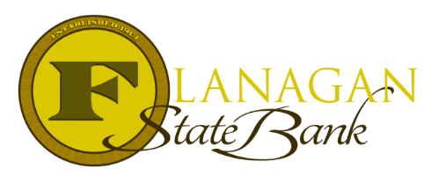
Mortgage Tidbits

Keeping you informed and in the know….

The Veteran’s Guide to purchasing or refinancing during COVID-19
If you are looking to purchase or refinance your home and requesting cash-out:
- VA will not consider a Veteran an unsatisfactory credit risk based on the fact they requested forbearance or deferred payments during the pandemic.
- Borrowers must provide reasons and supporting documentation for the loan deficiency and information to establish the cause of delinquency has been corrected. Example: borrower has returned to work after COVID-related furlough.

If you are requesting an IRRRL:
VA normally requires prior approval on any IRRRL refinance that is currently delinquent (30+ days past due). These loans may go through prior to VA approval provided:
- The borrower has invoked a CARES Act forbearance relating to the loan being refinanced
- The borrower has provided information to establish the borrower is no longer experiencing a financial hardship caused by COVID-19
- The borrower qualifies for the IRRRL under the remaining credit criteria required for delinquent loans (income, residual income, DTI, etc).

What can the loan amount include in an IRRRL?
- Any past due payments on the current VA Mortgage (delinquent loans)
- Allowable late charges consistent with the note (FSB will require a copy of the note and/or modifications)
- The cost of energy efficient improvements
- Allowable closing costs
- VA funding fee

Call us today for the best answers to the mortgage questions!
Insert photo here or delete box when ready to use
~ Provided to you by ~
Name: Phone:
Title: Email:
Address: City, State, Zip
Apply Now Link:

