Our Lady of Lourdes Church
Grab ‘ N ‘ Go Table
(Raising much needed funds)

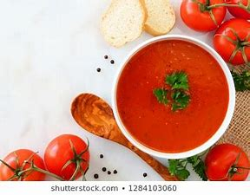
Fresh Homemade Soup & rolls to enjoy at home or at a friend’s.
Pre-order – Pre-pay – Collect
No Mobility – No Problem

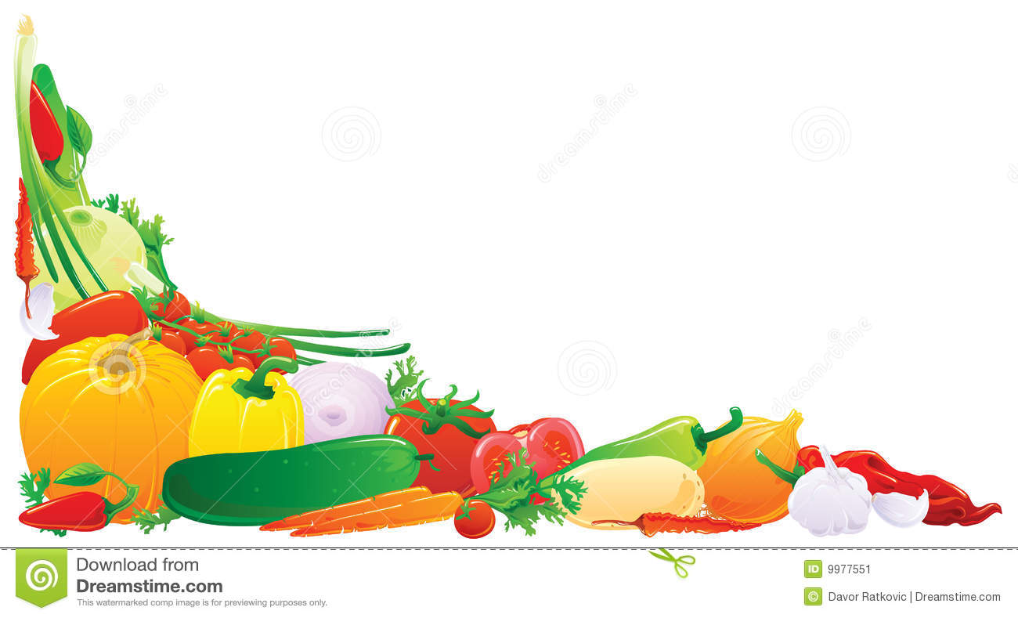
**NUT ALLERGY-Please be advised that Nuts may be present where soups will be made.

Our Lady of Lourdes Church
Order Form
Option 1 : Order now, pre pay, collect from table on the day of choice.

Option 2 – Order now, pre pay, ask for delivery.

Collection days please tick which option: -
Either Saturday 14th November after 6.30pm

Sunday 15th November after mass.

Your name : ……………………..………………………………………………………………
Your contact details : ……………………………………………………………….
ITEM | QUANTITY ORDERED
Carrot and corriander
Curried parsnip
Red lentil and fresh ginger
Spicy roasted butternut squash
Tomato and basil
Winter vegetable
Gluten free option

Two generous portions of the soup of your choice, plus two homemade ciabatta rolls
for £4.00
Please return form and money to Our Lady of Lourdes Church by Sat 7th Nov or
Sun 8th Nov at the latest. Cheques made payable to ‘Our Lady of Lourdes Church’.
Any queries please email : jonathanandjosesharp@virginmedia.com

