## Product Description

### ACHIEVE YOUR GOALS WITH PRODUCTS BASED ON SCIENCE!

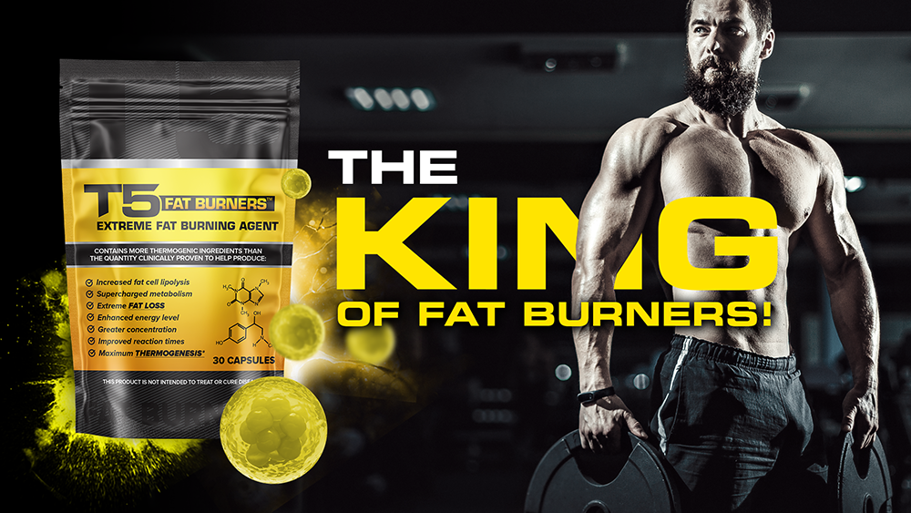

Biogen Health Science have a firm focus on high-quality clinical research in the development of fast acting and focused fat burning formulations. Extensive evaluations have enabled Biogen to draw on the world’s leading scientific research to identify even bigger benefits with our T5 Fat burners formulation!  
  
Biogen’s T5 Fat Burners are a scientifically backed and maximum strength fat loss supplement. Each capsule will enable your body to work harder itself as both a reliable supplement for weight loss and as a pre-workout energiser. If you’re after reliable results and want to achieve optimum efficiency, performance and burn maximum fat – this is the product for you!

### TAKE FAT BURNING TO THE NEXT LEVEL

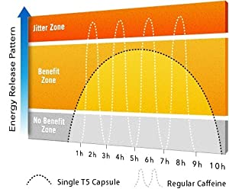

T5 Fat Burners have already gained a strong reputation as being an effective all-natural diet pill amongst those whom have tried them, becoming the diet pill of choice for many. Here are some of the ways T5 Fat Burners might help you as part of your healthy eating and exercise regime:-

* Premium quality ingredients for maximum potency concentration
* 100% natural and safe
* Increase fat loss significantly
* Increase your metabolic rate
* Assist overall energy levels
* Stimulate thermogenesis
* Increase focus and metal alertness
* Boost athletic performance
* Extensive clinical trials and an exceptionally high success rate!

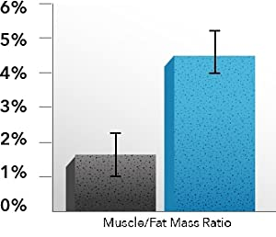

T5 Fat Burners are our strongest Fat Burner/Fat Loss pill providing you with an additional energy boost for when you workout. They are Thermogenic Fat Burners which allow you to burn more calories, as it increases energy and blood flow, boosts metabolism and slightly increases body temperature– all resulting in effective Fat Burning and Fat Loss.

T5 Fat Burners have a vasodilatation effect that increases the rate your blood travels throughout your body and reaches muscle more efficiently. With extra blood flow to your muscles, this helps in achieving strength gains and improved cardiovascular performance. Through our research, it is our opinion that this is an amazing Fat Burner for anyone looking to lose fat, build muscle or improve athletic performance. All the key ingredients have been brought together to work best for you and your body.

### BIOGEN HEALTH SCIENCE: SUPERIOR STANDARDS IN DIETARY SUPPLEMENTS



Maximum Strength   
  
Biogen's premium quality formulation contains 100% PURE and quality graded ingredients far exceeding the dosage proven effective in clinical studies.  
  
Each pill has the absolute maximum potency conecentration allowed for consumption under dietary supplement laws.

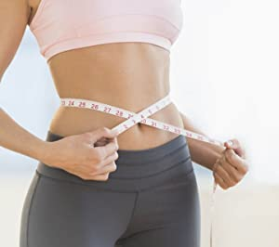

Directions For Use  
   
Biogen pledge an innovative solution for both men and women who want to achieve reliable results.  
  
Each pouch contains 30 capsules – a full month’s supply where 1 maximum potency capsules are taken daily.

This product can be stacked with our #1 selling Fat Burner *"Phentremine 375"* for the maximum fat burning effects achievable through our products.

We strongly recommend a combination of the two products for those desiring superior supercharged fat burning results due to the extreme potency the *Phentremine 375* has to offer in addition!



Side Effect Free  
  
We take every precaution necessary to ensure that these products are 100% safe & herbal in nature. Every bottle is manufactured in the UK in an MHRA licensed, GMP certified and ISO accredited facility for your complete safety.  
  
Rest assured that we would never consider manufacturing an item that did not fully meet these requirements.

## T5 Fat Burners T5 Capsules

The strongest fat burner from Biogen Health Science, providing a host of additional benefits. Fast acting and focused formulation with no prescription required and a customer satisfaction guarantee.

### Directions

Please follow individual product directions carefully. Products may be stacked together and used alongside one another for a highly intense fat burning course. Alternatively, some users may choose to use the products one after another for a longer duration course. Either method is fine, and we encourage users to experiment to achieve the optimum fat burning results for them personally.

The original T5 Fat Burner capsules have been formulated to support a range of different users achieving a range of different goals. From individuals who will find the metabolic boosting capabilities crucial to keeping fat levels down – to those who need maximized fat burning capabilities to fuel exercise without the breakdown of any muscle tissue.

Scientifically backed and proven to enhance the rate in which your body burns off calories, T5 Fat Burner capsules from the first dose enable your body to significantly reduce the number of calories being stored as fat – while simultaneously improving metabolic parameters. This duel powered process is ideal for those wanting to burn up calories rather than storing them as fat!

**Directions:**

Please follow T5 Fat Burner capsule directions carefully!

**How to take T5 Fat Burner capsules:**

Take one serving (1 capsule) of T5 Fat Burners in the morning, on an empty stomach with at least 8fl oz of water.

Like with all fat burning nutraceuticals and supplements, tolerance is commonly encountered after continuous consumption. After tolerance levels are determined - dose should not exceed 2 servings (2 capsules) per day due to potency and strength of the active ingredients.

If desired,  Biogen Health Science products can be stacked together for unparalleled results.

**When to take T5 Fat Burner capsules?**

**Most recommended:** When you combine T5 Fat Burner capsules with exercise the results are highly effective and unparalleled by any other fat burning nutraceuticals. Biogen’s fast acting and focused formulation starts to work in just 30 minutes and ideal for those who want to improve exercise performance by burning fat stores for fuel.

**Tip:** High intensity work outs combined with T5 Fat Burner capsulescanamplify metabolic parameters for up to 19 hours afterwards!

**On non training days:** One dose should be taken upon waking in the morning (ideally before breakfast). You may experience a boost in energy and a raise in body temperature, this is the active ingredients within the T5 capsules stimulating the thermogenic process within the body, usually induced by exercise.  You should continue with your normal daily activities.

**Most effective when:** Consume on an empty stomach or 1 hour after food. T5 Fat Burners capsules are swallowed and absorbed from within the stomach, thus the rate of absorption is decreased by up to 25% due to a delayed passage caused by a fuller stomach. The rate may also slow down when high fluid volume is consumed.

**How do T5 Fat Burners capsules work?**

T5 Fat Burners have been formulated using a blend of ingredients carefully selected for their natural abilities to boost your body’s ability to burn fat. The scientifically proven ingredients enable your body to burn maximum calories while burning fat from stores. As a direct result you will find you are able to obtain energy levels you never knew previously existed.

Each T5 capsule ingested will stimulate and accelerate metabolic rate, the breakdown of fatty acids – which will produce heat (thermogenesis) and a natural yet powerful energy boost, all primary components and indicators that the body is burning ‘stored fat’ and other lipids itself naturally without the use of any dangerous toxins or chemicals.

Furthermore, the human body stores these organic ingredients for a relatively long period of time, allowing your body to remain in fat burning mode for longer periods of time.

**Ingredients**  
Citrus Aurantium, Synephrine (Bitter Orange), 300mg; Caffeine Anhydrous, 110mg; L-Phenylalanine, 50mg; Guarana, 20mg; Green Tea Extract (10:1), 50mg; N-Acetyl-L-carnitine, 10mg;  
Other ingredients: Gelatin, Magnesium Stearate.

**Note(s):**  
• Warning: Dosage should never exceed 2 capsules per day.  
• Not intended for persons under the age of 18  
• Keep out of reach of children  
• Product may cause sleeplessness if taken after 4pm.  
• Manufactured in a MHRA, FDA and GMP approved laboratory for your highest safety

T5 Fat Burner capsules are not intended to be a food substitute