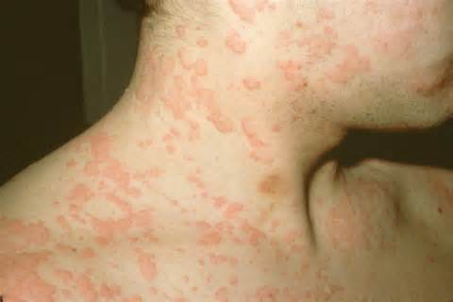
Urticaria
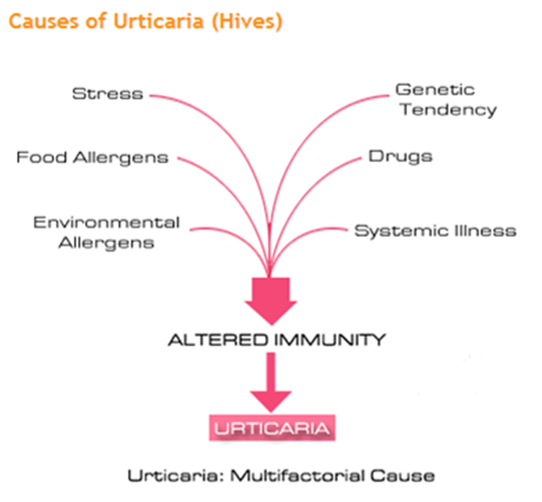

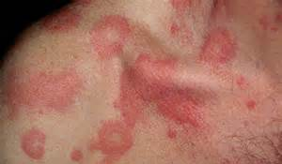

Urticaria is not a skin disease. It is a disease on the skin, due to altered immune system. The treatment for Urticaria has to be at the level of immune system.
Urticaria also called nettle-rash or hives or wheals in a common language, simply means itching with rash. Medically, urticaria may be defined as skin eruption, which is allergic (or non-allergic) in origin and is characterized by profound itching, red circular or irregularly shaped eruptions on any part of the body. Characteristically the skin eruptions are erythematous, raised above the skin level, with intense itching and usually worsened by itching and with a slight local warmth. It can be acute or chronic; largely having a tendency to recur frequently for many months or years.
Urticaria is a sign of antigen-antibody reaction. During this process of antibody-antigen reaction, histamine and/or acetylcholine is
Urticaria is not always allergic in nature. There are allergic and non-allergic causes for chronic urticaria. The non-allergic causes include auto-immunity related, hormonally triggered, stress triggered, exercise, drugs, temperature based and other factors. The most common exciting factors known to induce urticaria (hives), which may be grouped as:
- Allergens: A large number of allergens have been identified as causative agents for some cases of urticaria. It may be noted that urticaria is an individual hypersensitivity and the following factors may not cause urticaria in all urticaria-prone individuals.
- Food allergens: Milk, cheese, egg, protein products, wheat, cereals, nuts, certain daals as used in India, peas, orange, fish, chicken, etc. Synthetic and natural food additives and artificially-flavored food articles.
- Urticaria and alcohol: True anaphylactic reactions to alcohol (ethanol) are rare and most reactions to ingested alcoholic beverages are secondary to other chemicals in the beverage such as metabisulfite, papain, dyes or yeasts. However, there are reports of true allergic reactions in which the offending agent was shown to be the ethanol itself. Generally the symptoms of anaphylaxis occur in such patients following the ingestion of beer and/or wine. Urticaria rashes have been reported with ethanol ingestion; and hives on contact with ethanol have also been reported for some patients of urticaria.
- Environmental factors: Exposure to pollen, house-dust, buffalo dander, fungi, change in temperature, etc. are known exciting factors. Extreme cold, heat, pressure may also induce urticaria.
- Drugs: The major cause for urticaria are man-made drugs such as antibiotics (Penicillin), NSAIDs, anti-inflammatory drugs (aspirin, indomethacin), vaccinations, foreign sera, hormonal preparations, contraceptive pills, etc. Animals treated with penicillin excrete a small amount of it in the milk sufficient to cause urticaria in sensitive individuals.
- Cholinergic factors: Urticaria often gets triggered or aggravated by exercise, pressure on some part of the body as well as change in temperature of body after sweating. Such changes affect nerve ending of skin which lead to development of urticaria rash. In this variety of urticaria one experiences itching, burning and local heat on skin.
- Urticaria and cocaine: There have been reports of morphine-induced hives in some people. Bronchospasm may occur in some patients who smoke cocaine or in those who inject heroin. This may occur more often in patients who have a previous history of asthma. Hypersensitivity pneumonitis to cocaine has also been described and is associated with elevated levels of IgE.
- Infections and infestations: Insect bites, Fungal, protozoal, frequent bacterial infections (Urinary tract), viral infections (Hepatitis), helminthiasis (worm infestations such as round worms, tapeworms), etc. are factors known to cause urticaria. Domestic contact with the pet animals should be examined as cause for urticaria.
- Synthetic products: Use of personal products such as deodorant, perfume, and talcum powder, cosmetic products, animal derivatives, and similar synthetic substances may induce this disorder.
- Emotional factors: Especially in chronic, recurring cases of urticaria the role of emotional factors must be examined. Emotional stresses may directly or indirectly make on susceptible to develop a tendency to urticaria. The psychological factors may work as exciting, aggravating or maintaining cause. Especially, if you are under prolonged stress, anxiety, sadness or insecurity, such intense emotions could alter your immunological state and in turn lead to hypersensitivity.
- Autoimmune causes: Chronic urticaria is now understood to have autoimmune link. Presence of auto antibodies against Immunoglobulin E (IgE), which releases histamine, hence leading to chronic urticaria.
- Systemic and general disease: Urticaria in some cases may present as a sign of other systemic or general internal disease such as hormonal disorders (hyperthyroidism), SLE, polycythaemia, reticuloses, etc. In certain variety of malignancies (cancer) urticaria may present as a precursor.
Traditional Treatment:
Patients with Chronic urticaria are almost always put to mercy of life long use of antihistamine medicines or cortisone by regular doctors. Once started, it becomes almost impossible to stop it even for a couple of days.
- Anti-histamines offer symptomatic relief for urticaria. However, they work superficially, without addressing or correcting the underlying immunity problem. So the effect of antihistamine stays for a short period of eight to ten hours; and you need it almost daily.
- Similarly, cortisone when used for urticaria, works instantly but it is habit forming and it has its own challenge in terms of adverse effects, and more importantly, dependency. Chronic urticaria dependent on the use of cortisone is more difficult to treat over the period of time.
Non-Drug Recommendations:
- Shaklee Protein is a food, and is always recommended as part of the daily diet.
- Remove coffee and alcohol
- Eat an excellent diet, avoid sugar and wheat, and consume lots of vegetables & fruits (eat lots of raw food)
- Get Allergies tested, and eliminate offending foods
- Detoxification is critical: Rejuvenating Body Cleanse, Kidney Cleanse, GI Tract Cleanse, Liver Cleanse, etc.
- Investigate Heavy Metals (a hair analysis is recommended)
- Supplements:
- Step 1:
- Vitalizer
- Vivix
- NutriFeron
Step 2:
- Formula I
- Alfalfa
Step 3:
- DTX
- OmegaGuard

