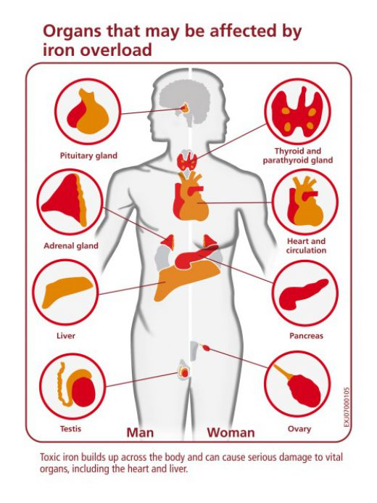
Hemochromatosis
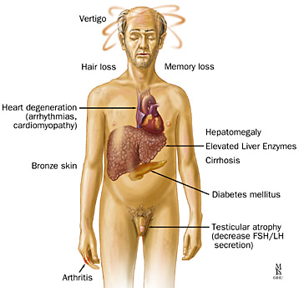

Hemochromatosis is too much iron in the body. It is also called iron overload.

There are two types of hemochromatosis:
- Primary hemochromatosis is a genetic disorder passed down through families. It occurs at birth. People with this condition absorb too much iron through their digestive tract. Iron builds up in the body, especially the liver. You are more likely to get this disease if someone else in your family has or had the condition.
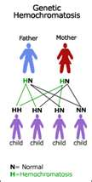
- Secondary (acquired) hemochromatosis is due to other blood-related disorders (such as thalassemia or certain anemias) or many blood transfusions. Sometimes it occurs in people with long-term alcoholism and other health conditions.

Symptoms
- Abdominal pain
- Fatigue
- Generalized darkening of skin color (often referred to as bronzing)
- Joint pain
- Lack of energy
- Loss of body hair
- Loss of sexual desire
- Weight loss
- Weakness

Signs and tests
- Health care professionals will perform a physical exam. This may show liver and spleen swelling, and skin color changes.
- Blood tests may help make the diagnosis. Tests may include: ferritin level, iron level, percentage of transferrin saturation (high)
- Other tests may include: Blood sugar (glucose) level, Alpha fetoprotein, echocardiogram to examine the heart’s function, electrocardiogram to examine the heart’s function, imaging tests such as CT scans, MRI, and ultrasound, liver function tests
- The condition may be confirmed and treated with a liver biopsy or phlebotomy, a procedure that removes blood to lower the amount of iron in the body.
- If a genetic defect is confirmed, other blood tests can be used to determine if other family members are at risk for iron overload.
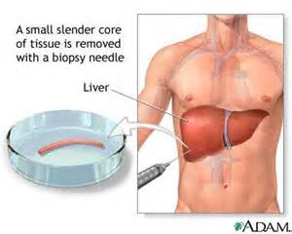
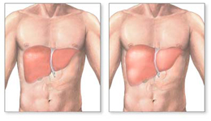

Hemochromatosis - Enlarged Liver
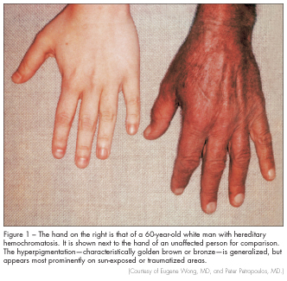

Treatment
- The goal of treatment is to remove excess iron from the body and treat any organ damage. A procedure called phlebotomy is a common method for removing excess iron from the body.
- One-half liter of blood is removed from the body each week until the body iron level is normal. This may take many months or even years to do.
- After that, the procedure may be done less often to maintain normal iron levels. How often you need this procedure depends on your symptoms and your levels of hemoglobin and serum ferritin, and how much iron you take in your diet.
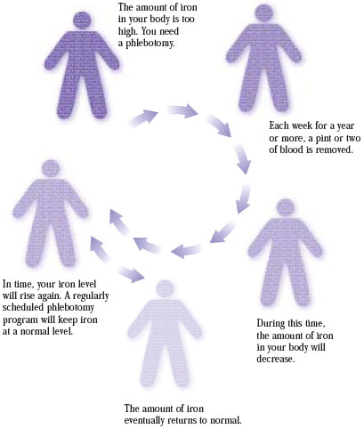

Expectations (prognosis)
- Untreated, iron overload can lead to liver damage.
- Extra iron may also build up in other areas of the body, including the thyroid gland, testicles, pancreas, pituitary gland, heart, or joints.
- Early treatment can help prevent complications such as liver disease, heart disease, arthritis or diabetes.
- How well you do depends on the amount of organ damage. Some organ damage can be reversed when hemochromatosis is detected early and treated aggressively with phlebotomy.

Complications
Complications include:
- Liver cirrhosis
- Liver failure
- Liver cancer
The disease may lead to the development of:
- Arthritis
- Diabetes
- Heart problems
- Increased risk for certain bacterial infections
- Testicular atrophy
- Skin coloring changes
Screening family members of a person diagnosed with hemochromatosis may detect the disease early so that treatment can be started before organ damage has occurred in other affected relatives.

Natural Health Support:
If you are diagnosed with hemochromatosis, you should follow a special diet to reduce how much iron is absorbed from your digestive tract.
- Do not drink alcohol, especially if you have liver damage
- Do not take iron pills or vitamins containing iron
- Do not use iron cookware
- Do not eat raw seafood (cooked is fine)
- Do not eat foods fortified with iron, such as 100% iron breakfast cereals
- It is always important to avoid tobacco, alcohol, coffee, black tea and foods rich in iron (mostly red meat). A more vegetarian diet may be helpful as well as healthful.
- Shaklee Soy Protein or Shaklee 180 Soy Smoothees support a more vegetarian diet
- Shaklee Vivix - Antioxidants are important to support cells, tissue, and organs and are cell protective.
- Shaklee Vitamin E + Selenium + Grapeseed (800 -1200 IU a day also help to manage iron stores in the body).
- Shaklee Gingko Biloba (Mental Acuity) ... properties protective of veins, arteries, brain, and heart.
- Shaklee DTX – (Milk Thistle, Turmeric, and Dandelion has long been known as a liver protector. Schizandra are an adaptogen herb for hemochromatosis protects adrenals liver and respiratory system. Reishi mushroom is an immune protector, liver protector, nerve and heart protective.)
- Shaklee CorEnergy ... Cordyceps mushroom is an adaptogen, liver protective and improves blood quality.

