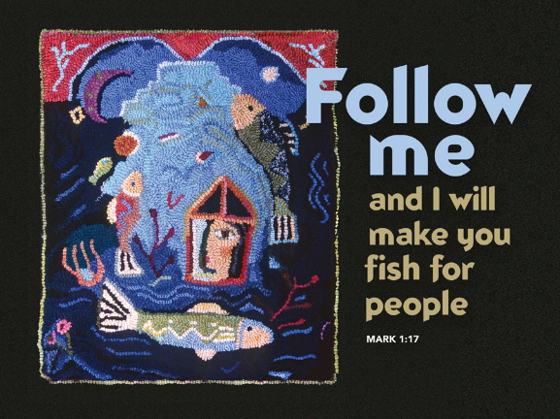

Who's the smartest person in the world?
January 21, 2018
Mark 1:14-20
Grace and peace from God Our Father and from the One who choose you, Jesus Christ our Lord, amen.
Who's the smartest person in the world? Any ideas? You could make a case for Ken Jennings. He's the guy who won 74 consecutive matches on Jeopardy and took home more than $2.5 million. You may be tempted to nominate Sheldon Cooper, the renowned physicist featured on The Big Bang Theory. True, he is smart, but he's a fictional character. Garry Kasparov is a name that's often brought up in discussions about smarts. He's the famous Russian chess player who, at the age of 22, became the world's youngest undisputed chess champion. Critics are quick to point out, however, that Kasparov was later beaten at chess by an IBM computer. Who gets your vote?
If you find it hard to come up with a candidate for “World's Smartest Person,” Dr. Jason Betts can help you out. He's developed the World Genius Directory, which he argues is the definitive ranking of the world's top minds. While other lists exist, Betts claims that his is the only one without a bias, allowing anyone in the world who thinks he or she might be among the smartest of the smart to submit her or his scores. According to the World Genius Directory, the smartest person in the world is Dr. Evangelos Katsioulis, a 36-year-old Greek psychologist. His IQ score is 198. To put that into perspective, his score is 30 points higher than the ranking of “genius,” almost double the score of your average human, and 23 points higher than Ken Jennings' paltry 175. Take that, Jeopardy boy. The bottom line is, no matter how you rank them or whether or not you can name them, there are some incredibly smart people in this world. There always have been. Imagine how helpful it'd be to have a chorus of crazy-smart people at your disposal, say when it's time to craft the church budget or to do research for a sermon that's got you stumped. Access to world-class nerds would have major perks.
At this particular moment in Mark's gospel we see Jesus in recruitment mode. He's actively drafting members of his team, a team he knows will eventually be given the daunting task of igniting a spiritual movement that will spread around the globe and endure forever. If you were Jesus, who would you pick to be members of this elite team? If you were the Son of God, building a cohort of spiritual ninjas, wouldn't you choose the best of the best, the smartest of the smart? Wouldn't you hit up the World Genius Directory, find the biggest brain in Palestine, and recruit him to be in charge of logistics? Maybe you'd round out the team by finding the funniest guy you could, someone who could keep the tone light when ministry got hard, as well as the strongest dude in town for when ministry got dangerous? That's how most of us would build our crew. That's how Jesus should have gone about building his, if he was smart.
Instead, who does Jesus choose? He chooses the unqualified. You may think it harsh to label Simon and Andrew, James and John as unqualified, but it's not. The details given to us by Mark make it clear. These are young men. In a world where the life expectancy was low, James and John were old enough to be established in a trade, but still young enough to have their father, Zebedee, in the boat with them. In first-century Palestine, the ideal career for most young Hebrews was not to be taking over the family business, but to be under the tutelage of a rabbi. The brightest of boys, those who had shined in Hebrew school and who stood out in their memorization of the Torah, would, upon completion, seek a rabbi, and, if they made the cut, they would spend the next few years tagging along as disciples. So, to be a young man, already embedded in the family trade, meant, in all likelihood, you were not the cream of the crop in Hebrew school, and you did not have what it takes to run with the rabbis. They were the leftovers, the kids who didn't get picked for higher religious education. Jesus didn't cherry-pick the brightest kids from other rabbis and build a dream team. Instead, Jesus went on a mission looking for the leftovers, seeking out the also-rans and he drafted them.
Why would Jesus forsake the genius list and deliberately pursue those who belonged at the bottom of the list? Jesus chose the simple and unaccomplished as disciples to follow him so the love of God and the work of the kingdom would be undeniably evident in an unbelieving world. In other words, these simple and unschooled tradesmen would become living, breathing object lessons on the depths of God's grace and the scope of God's power. No one would be able to say they were privileged to walk with Jesus because of their résumés. No one could say the growth of the kingdom was due to their IQ. It was all God.
Why do you think God chose you? Yes, it's ultimately because God loves you and wants to know you, but is there anything in you or about you that made God want to love you? Perhaps it's your IQ. Your mom always said you were smart. Maybe it's your keen sense of style. God thought you could make Him look good. Maybe it’s because you're a type-A go-getter, and God wants a high-functioning, action-oriented winner on the team. Did God call you to Christ through his word and draw you to the waters of baptism, marking you as his own and placing every promise of the cross upon your life, because God recognized just how awesome you really are? No! God called you to Christ for the same reason he called those original 12 disciples: because you make an excellent object lesson on the depths of God's grace and the scope of God's power:
- You, with your rebellious heart.
- You, with your secret struggles.
- You, with your lack of faith and your long list of faults.
- You, who knows deep down that you are unworthy to tie God's shoes let alone be called God's child.
God chose you so the world might look at you and see that God is indescribably merciful and incredibly powerful. That said, the question you may be asking at this point is, “So what?” We can proclaim the truth that God has chosen us completely out of mercy all day long (and we should), but what's the real cash value? How does this truth get lived out in our lives? The answer is found in the actions of the disciples. What do we see them doing the moment after Jesus comes and taps them on the shoulder? What do we see them doing when a rabbi comes and makes it clear that he wants them? They dropped everything and followed. They dropped their nets. James and John left their dad! Why? Because when something you don't deserve, but desperately want comes knocking at your door, you don't tell it to wait five minutes. You answer the door as fast as you can.
We're all disciples. We've each been given something we don't deserve, but desperately need: an encounter with Christ. Our challenge each day is to see this life with Jesus as an undeserved invitation. It's an undeserved invitation to drop our plans and follow him wherever he leads, knowing and trusting that wherever he takes us is better and more beautiful than whatever else we had planned.
So, when Jesus calls me tomorrow morning to love my annoying neighbor, I’ll try to see it as a gift of grace and a chance for God's power to shine through my weakness. After all, I'm not the best at loving unlovable people. When Jesus calls us to invite a coworker to church, it's a gift of grace and a chance for God's power to shine through our weakness, since often we're not comfortable with that kind of thing. When Jesus calls us to follow him into illness or endure a burden, it, too, is a gift of grace and a chance for God's power to shine in our weakness. It isn't easy to believe in God's goodness and the triumph of Christ when chemo is pumping through your veins. Trust me I’ve been there… Every day there is an opportunity, as a disciple, for the world to watch in astonishment as ordinary, unschooled, undeserving people live as examples of God's mercy and proof of God's power.
God didn't have to choose us, but God has chosen us. God doesn't have to use us, but God uses us anyway. The end result is not just blessing for us and those God calls us to serve. The end result is glory for God's name… Who is the smartest person in the world? Sure, the World Genius Directory claims to have an answer for you, but that's only if you define “smart” in terms of puzzle solving and IQ scores. Maybe what makes one smart isn't the ability to give the right answer. Maybe what makes you smart is your ability to recognize a good thing when it comes your way. Plenty of “smart” people have passed on Jesus, but not James and not John, not Simon and not Andrew. They got picked and then they gave up everything else. Sure, they may have been the leftovers, but that decision was pure genius.
May you be the genius and be smart enough to recognize a good thing when you see it as well. May you throw down your nets and follow Jesus no matter where He leads and may people see God’s glory and the power of the Most High God shine in you when you do. Amen.

