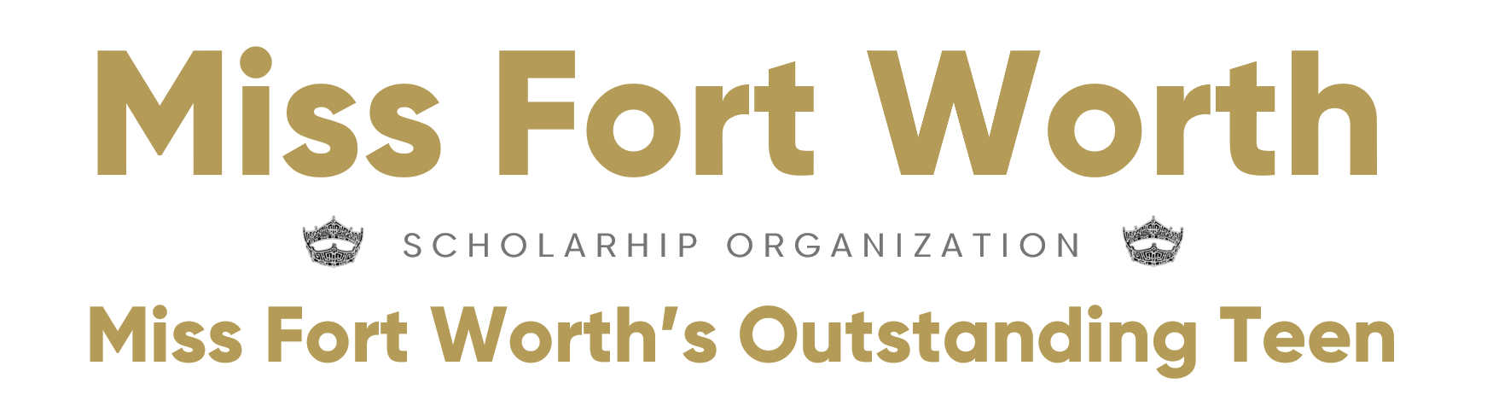

Candidate’s Name: _______________________________________________________

Mailing Address, City & Zip: ______________________________________________

Email Address: _______________________ Home Phone: __________________

Cell Phone: ____________________________________________________________

Parent’s Name(s) _______________________________________________________

Parent’s Home Phone: ________________ Parent’s Cell Phone: ________________

Parent’s Email Address: ___________________________________________________

I am Interested in entering the following division:
______ Teen
Age
Must be thirteen (13) years of age on the first day of the State Competition;
Must not be older than eighteen (18) years of age on December 31 of the year of the State competition,

Residency
Must fulfill one of the following:
Must reside in the state of competition
Be successfully enrolled in and physically attending classes on a full-time basis at an accredited public or private school, or home schooled within the state of competition.

Citizenship
Must be a citizen of the United States of America

______ Miss
Age & Education
(1) must be at least nineteen (19) years of age by December 31st of the year of the state competition (2023),
(2) Must not be older than twenty-six (26) years of age on December 31st of the year of the state competition (2023).​

Residency
Must fulfill ONE of the following:
Must reside in the state of competition,
Or be enrolled in and physically attending classes on a full-time basis at an accredited college or university,
Or be employed on a full-time basis in the state in which she intends to compete.

Citizenship
Must be a citizen of the United States of America

Social Impact Issue ______________________________________________________

Talent: (type of talent) ________________ Music Selection:_____________________
(No 2 girls may use the same music doing the same Type of talent)

Birthdate: ____________________________ Age As of Pageant Date:________________

School:______________________________ Graduation Date:____________________

College:______________________________ Classification:______________________

____________________________________ ________________________________
Candidate Signature Date Parent Signature (if under 21) Date

- COVID Info ~ At this point, bring a mask with you. You may have to wear it in the dressing room or any other area that will have many people. When on stage, you will remove your mask for your event and then put it back on when you are finished. If the facility rules change or if you have been vaccinated within two weeks prior to the pageant, you may go without a mask. As of right now though, plan on a mask. If you have had COVID or tested POSITIVE in the past two weeks, you must present a NEGATIVE COVID test.
- Please bring a lunch/snacks for yourself. We will fill in with fruit, chips, etc.
- Bring a bottle of water that can be refilled.

- TEEN - $150 entry fee is required. Please make checks payable to ECSO or you can pay online at www.MissFortWorthPageant.org A $5.00 fee will automatically be added for using a Credit Card. Teens must also pay the $35.00 fee at this link______ to be eligible to compete.

- MISS – there is no initial entry fee. You must raise $35.00 and pay at this link to be eligible to compete. Upon receipt of the $35.00, you will pay $75.00 to Miss America at this link.

- A $100.00 REFUNDABLE deposit in the form of a check payable to ECSO will be required which will hold your place and will be returned to you at the completion of the evening or will be shredded.

- Additional paperwork available at www.misstexas.org is required after verification of your application. All paperwork MUST be RECEIVED BY AUGUST 24, 2022.

- Once your $35.00 and entry fee (Teen) or copy of your $35 & $75 payment (Miss) and deposit is received, your slot will be secure for the 2023 Competition.

- By submitting this application, you understand each item above.

- Entries will be numbered by first in, last out. Talent will be accepted, first received by date and time.

- 2023 Theme is “Denim & Diamonds”

- Miss & Teens will wear Dark Blue Jeans with boots. Miss wear a black top and Teens wear a white top. Your choice of crystal earrings.

- Plan to arrive at 9:00 AM and ready for meeting at 9:30 AM SHARP!!

Miss & Teen Fort Worth/Coppell Competition
* 326 Shadowwood Trail * Ovilla, TX 75154 *
Elliscty@sbcglobal.net or Firewalker706@sbcglobal.net
214-693-9064 * 214-707-5873

