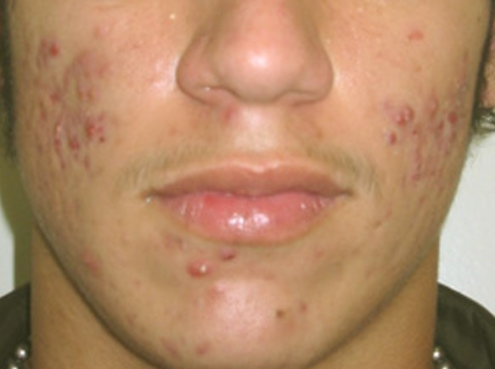
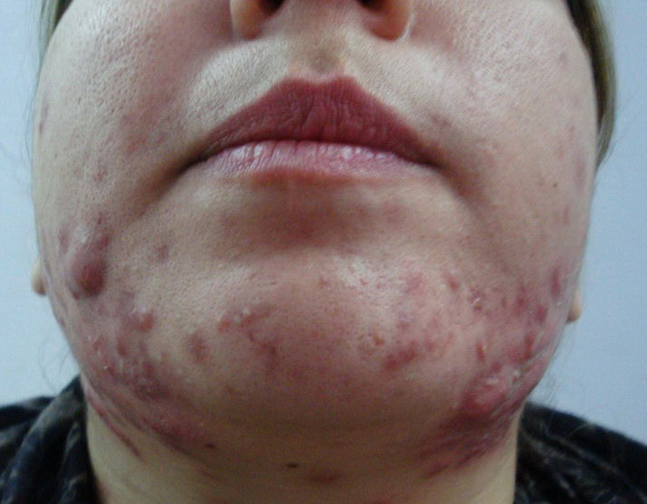
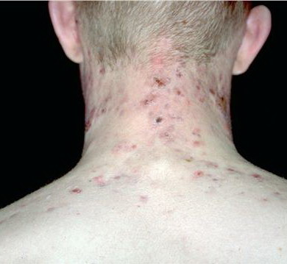

Cystic Acne

- Also called nodulocystic acne, cystic acne is an intense form of acne that results in large, inflamed cysts and nodules that appear on the skin.
- Unlike other milder forms of acne, cystic acne is noticeably painful and occurs when oil and dead skin cells build up deep down in hair follicles or pores.
- Cystic acne is most common during puberty for young boys, but sadly, it can continue into the adult years, especially when there is a hormonal imbalance. For women, it’s common to experience cystic acne around their menstrual cycles
Causes
- most common cause is HORMONAL imbalance ... that can cause higher levels of sebum to be made
- greasy cheap cosmetics that block the pores of the skin
- constipation
- deficiency in nutrients
- a great amount of humidity or sweating
- certain drugs & chemicals
- accumulated toxins
- lack of probiotics
- use of antibiotics
- candida

Supplements that help:
- Probiotics are essential
- Vita Lea - Double the normal daily amount to increase Vitamin A & double the Zinc intake (Zinc is essential for glandular health (and glands manufacture hormones)
- CarotoMax - the carotenoids are essential for healing the skin
- Vitamin C ... 1000 mg of vitamin C can be taken 3 times a day. If this dose should cause loose stools, cut back on the amount you take.
- Herb Lax - a body detoxifier
- Alfalfa - a blood purifier and liver support
- Curcumin (Turmeric) supplements - brings down swelling & eases pain, & helps kill infections
- Additional Zinc - temporarily, some need 30 mg of zinc 2x per day until the acne has disappeared.
- Essential Fatty Acids - Omega-3 helps reduce inflammation and support hormone balance. You can also consider gamma-linolenic acid (GLA) found in evening primrose and borage oil for hormonal balance.

Other Natural and Safe Aids
- Use a Skin Care System that is totally toxin-free and one that is loaded with anti-oxidants. We recommend Shaklee YOUTH Skin Care.
- Use toxin-free laundry products - Something you might not think about is what else touches your face daily, like towels and pillowcases. To reduce the chances of irritation and sensitivity, it’s a really smart idea to avoid washing these items with strong detergents and bleaches. Instead, opt for natural and unscented laundry products
- Apple Cider Vinegar ... can be used externally or internally for cystic acne. To use it externally, dab a q-tip in raw apple cider vinegar and then onto your cysts. This should be done twice a day. If this seems too strong for you, dilute the apple cider vinegar with water using 1/2 of each. Apple Cider vinegar added to a glass of water makes a tonic that helps to alkalize the body, reducing a number of health problems, including cystic acne. Mix one tablespoon of apple cider vinegar into a glass of water and sip throughout the day.
- Tea Tree Oil ... absorbs into the sebaceous glands, cleans pores, and dries up the acne ... apply a few drops with cotton ball, and leave on overnight (NOTE: if you have sensitive skin, mix 1 part tea tree oil with 3 parts water to dilute ... then apply). Some people are allergic to tea tree oil, so test on a less visible area of skin before you put it on your face.
- Baking Soda ... can pull extra oil out of blocked pores and cleans away dead skin cells. It also evens out the acid level of your skin. Make a thin paste in water and apply. Let sit for a few minutes, and then wash off with warm water. Do this once or twice a week. Make sure to moisturize your skin after with a quality non-toxic moisturizer
- Raw honey can be used topically for cystic acne a couple of times a day. Honey is a wonderful "medicine" because it of its strong antiseptic and antibacterial effects. Look for a raw and local honey at health food stores and farmers' markets.
- Neem (also called Indian lilac or margosa) ... kills germs and bacteria. Make a paste with water and apply 2x a day

Diet for Cystic Acne:
- Drink a lot of water every day to flush harmful poisons out of your body.
- Avoid Dairy Products ... Dairy products may be an issue for those with cystic acne. Try eliminating dairy products for two weeks and see if you notice an improvement. If dairy is the cause, you can try out cultured dairy products or raw dairy products instead. If the processing of dairy is the problem, cultured or raw products may agree with you even if most dairy products do not.
- Stop Coffee ... Whether it is the caffeine or the acidifying affect on the body that coffee has, eliminating coffee solves the cystic acne problem for some. Coffee consumption has a direct impact on your hormonal balance. You may drink Shaklee Energy Tea instead.
- Cut Back on Sugar ... Sugar is consumed in astonishing amounts through foods and drinks. Sugar provides no nutrition but plenty of calories. It also can cause inflammation. Dramatically reducing sugar consumption can make a big difference in the frequency and severity of out breaks.
- Keep Processed Foods to a Minimum ... Processed foods are readily available, inexpensive and convenient. Unfortunately, they lack nutrition and often contain a lot of chemicals. Look for whole foods to eat instead. If you need convenience, reach for a banana.
- Eat Liver-supportive foods: Since hormones are processed in the liver, eating liver-supportive foods can help clear up acne. Eat more cruciferous vegetables like broccoli and cauliflower as well as leafy greens and high-fiber fruits, such as pears and apple, for improved liver function.
- Avoid oily, spicy and fatty foods that can make the acne worse
- Eat nuts and seeds that are full of Vitamin A & E.
- Juicing ... Freshly made juice is a powerhouse of nutrition. It contains enzymes and micronutrients and quality calories. Green juices, carrot juice, and vegetable juices can be healing and delicious.

