In the Mortgagebot file, click on “Forms & Docs”, then click “Vendor Info”
The following vendors need to be entered:
-Listing Realty Co
-Listing Agent
-Selling/Buyers Realty Co
-Selling/Buyers Agent
-Hazard Insurance Company
-Flood Insurance Company (If applicable)
-Termite Company (If applicable)
-Title Company/Settlement Agent

The Appraisal Department will enter the Appraiser Company and Appraiser.

To search for the vendor, click in the search box and begin typing the name, or address of the vendor and select from the list. Sometimes you may need to try multiple ways to get the needed vendor, for instance you may try: agent last name, street number from address, street name, company name.

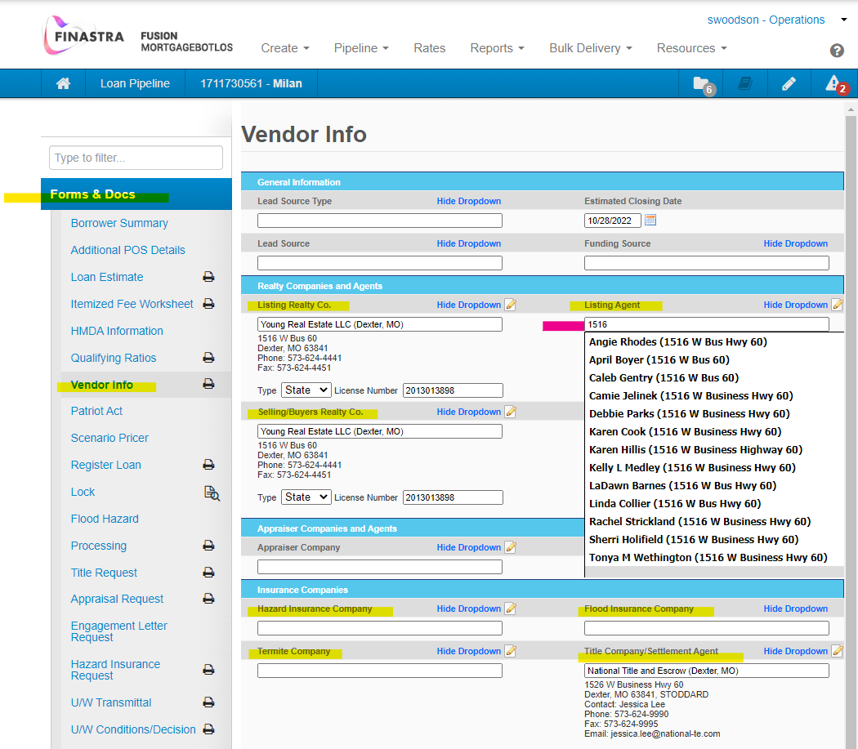

If the vendor you need is not available in the drop down selections (again, please try multiple searches-such as last name, company name, street name, address number) please complete the Vendor Screen Request for Add or Update of Vendors form and email to vendors@flanaganstatebank.com. On the request form, please note that all asterisked fields are needed for compliance purposes. If a Real Estate Agent needs to be added and the Real Estate Company is already in Mbot, please include the company name as this information is needed for the entry. Our Appraisal Department handles all the appraisal company & appraiser vendor entry. (Link to Vendor form: https://uploads.documents.cimpress.io/v1/uploads/a56eddaa-ff7e-4445-a3f8-f007034a326e~110/original?tenant=vbu-digital )

