Modifying the Source Template
Remember that some of the details may be different depending on what operating system you use. We use Windows 7 for this tutorial as it is the most popular at the time of writing this document. I will try to point out any notable differences in red as I go along.
Although this may look complication once mastered it can be done in less than a minute.

  - Step 1: Locating your primary hard drive
This is usually your (C :) drive unless you have specified otherwise.
First open your start (as in figure 1) and locate and click “Computer” or “My Computer”.
Windows 8 has a different logo from windows 7 (as in figure 2).

Figure 2

Figure 1: Windows 7 start menu
You should be presented with a folder containing your hard drives (as in figure 3).
You may have more or less hard drives then seen in figure 3.
Figure 3: My computer folder

figure 3.

Click your primary hard drive, for me that is (C:)

  - Step 2: Finding you builders mate template
Figure 4 is the screen you should now see, deepening on your system you could have one or two folders called “Program Files” and “Program Files (x86)”, search both for a folder called Builders Mate.
Figure 4: My primary hard drive

Once you find the folder, open it up by double clicking.
Figure 5: Builders Mate folder

  - Step 3: Backing up your template (optional)
This step is recommended in case you would like to revert to a previous version in the future or you make a mistake.
Pick an easy to recognise name that is different from the original name like: Builders Mate backup

To do this right click the Builders Mate version in the folder and click copy (as in figure 7).
Figure 6: Builders Mate folder

Figure 7: Right click menu

Right Click on your desktop and click paste. On your desktop you should now have this file, possibly with a different version number (as in figure 8)

Figure 8: Desktop copy

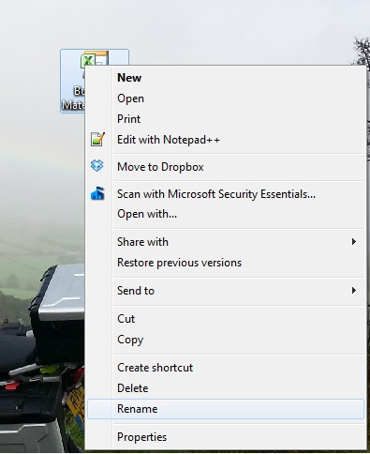
Now you should change the name of that file by right clicking the file and selecting Rename (as in figure 9)

Figure 9: Right click menu

You should now have an icon that with the name you just inserted (as in figure 10).
Figure 10: Desktop copy

Now you can store this where ever you would like to on your computer. Personally I copy my backups back into the Builders Mate folder shown in figure 6.
If you are on Windows 8 you must drag and drop files into the Program Files folder, which is why I moved the file to the desktop.

  - Step 4: Editing the template
Now we have created a backup, let’s open the master template, named Builders Mate v2.3.4 (shown in figure 6). Your version number may be different.
You will be presented with the Builders Mate program like you normally would.
You can make any changes to the document you would like from small settings and materials changes to changing every element of the program.
I am just going to change the overheads (as in figure 11).
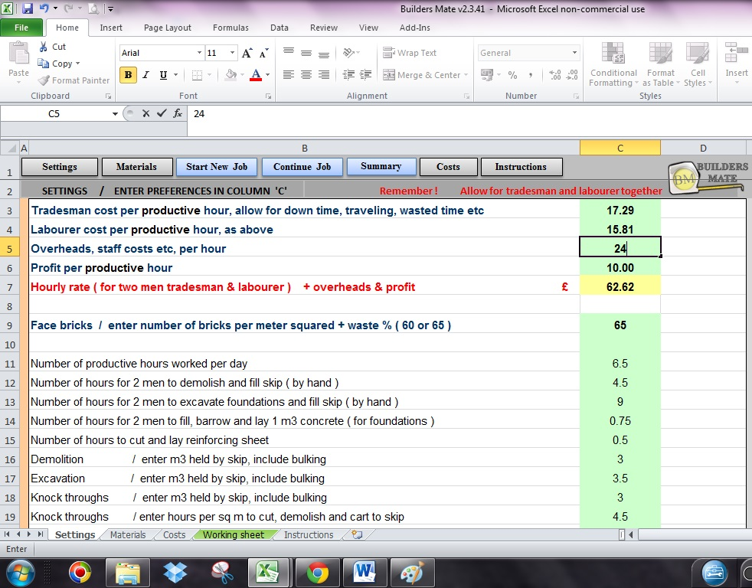

Figure 11: Changing the settings

Once you have made all the change you would like to make, save the document to the desktop as a Microsoft Excel template (as in figure 12).
First in Microsoft Excel go to File.
The icon to get to the File menu may look different depending on your version of Microsoft Excel.

Figure 12: Excel file

Click Save As (as shown in figure 13).
Figure 13: Save As

You will be shown this window (as shown in figure 14), first change the Save As type to Excel Template. Then navigate to a folder were you would like to save the file to, I have moved to the Desktop.
Now change the file name to match the one in the Builders Mate Folder (figure 6), so when we drag and drop it over it replaces the old template. This is why we created a backup.
Matching the files name with the original file (shown in figure 6) is the most important step.

Figure 14: Save As settings

  - Step 5: Overwriting the old template
Now you have created a new template and saved it to a folder, you must replace the Template shown in (figure 6).
To do this, drag and drop the file to the Builders Mate folder (as shown in figure 15).
Figure 15: Overwriting the old template

A window like this should pop up to ask you if you want to replace the old file (as shown in figure 16).
Figure 16: Overwriting the old template 2

If this window does not show, something has gone wrong.

Click Move and Place in (in figure 16).
Figure 17: Overwriting the old template 2

This window may also pop up, if it does click continue and you have successful created a new template congratulations!

When you open Builders Mate the updated template will now be opened.

