Swale Indoor BowlInG Centre

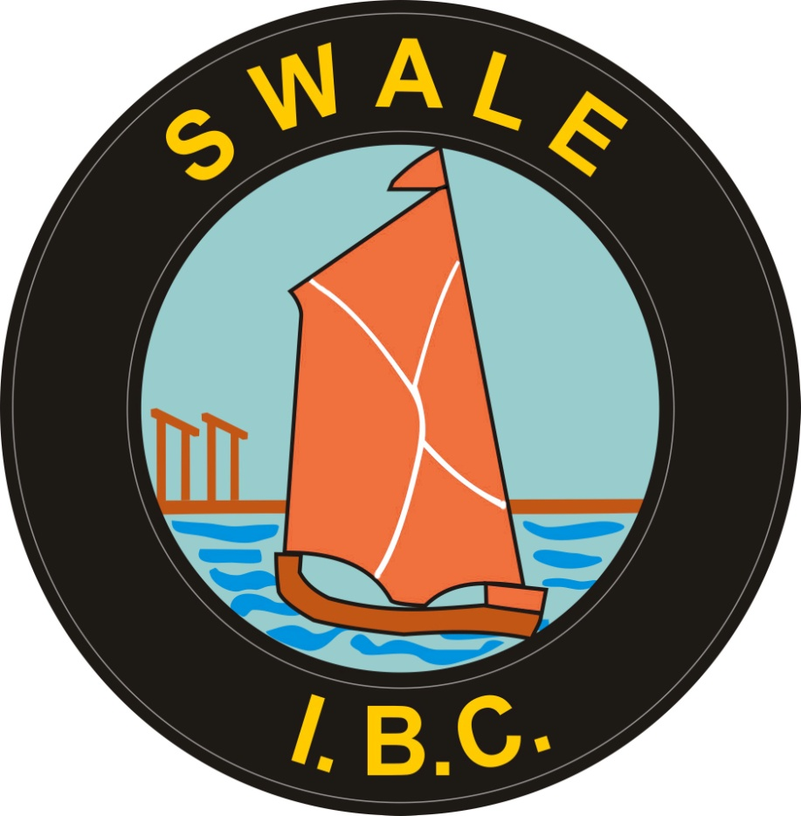
Grievance Policy and Procedures

1 Introduction
This document sets out the Swale Indoor Bowling Centre (SIBC) grievance policy and procedure and provides guidance to staff, managers and directors on the principles for handling grievance situations at work.
Legislation supporting this document is:
- The Employment Act 2008
- Equality Act 2010
The principles of the ACAS Code are used as guidance in creating this document.
2 What is a grievance?
A grievance may be a complaint an employee has about pay, working conditions, issues with colleagues or unfair treatment at work. If you have a grievance arising out of your employment with SIBC or believe you have been the subject of discrimination in the workplace you may complain under the SIBC grievance procedure.
3 Timescales
A time limit of one month will normally apply on the eligibility of an employee to initiate a grievance unless there are exceptional circumstances, e.g. a particularly serious allegation, a delay in submitting a complaint due to sick absence, evidence of differential treatment becoming apparent after that date or the recurrence of a previous complaint. Further timescales will also apply during the formal grievance procedures and these are explained below.
4 Grievance Procedure Stages
There are three stages to the grievance procedure:
- Informal discussions.
Firstly, you should try to resolve your grievance informally through discussion. Informal grievances should normally be raised, in the first instance, with your manager, or the person who was responsible for your grievance. Formal grievances will not normally be considered unless the opportunities for informal resolution have been fully explored or are clearly inappropriate.
- Formal grievance.
If the informal approach is inappropriate, or if you are dissatisfied with the outcome of an informal grievance, then you may raise the matter formally in accordance with these procedures. A grievance form should be completed. This is required in order for you to set out, clearly in writing, the grounds for your grievance and the redress that you seek. The formal procedure at this stage is as follows:
You should submit your grievance using a copy of the Grievance Form, on page 3 of this document, through your manager to a director who becomes the Grievance Deciding Officer. You must set out clearly and precisely on the form the grounds of your complaint and the remedy that you seek.
The Grievance Deciding Officer must offer you an interview at this stage and this should normally take place within 10 working days of receipt of your grievance. A summary record of the interview is to be produced by a note taker within 5 working days of the interview and a copy handed to you for agreement or amendment as necessary. You will be allowed a further 5 working days to comment. The Grievance Deciding Officer will then give you the final record, the decision and a written explanation within a further 10 working days. The outcome of a formal grievance should be documented on the grievance form and submitted to the Chairman.
- Grievance appeal.
If you are dissatisfied with the response to your formal complaint, you may appeal, normally within 5 working days of receipt of the written outcome. If you need longer to prepare your appeal or to seek advice you should give notice of your intention to appeal within 5 working days, explaining when your appeal will be submitted.
You may appeal against the formal grievance outcome using Part 3 of the grievance appeal form, to the Chairman who will set up an independent Grievance Appeal Panel. You will be offered the opportunity of an interview normally within 10 working days of the receipt of your appeal. You may be accompanied by a colleague or an external Trade Union representative.
If you choose not to attend, the Grievance Appeal Deciding Officer will come to a decision based on your written submission. The manager or director who considered your grievance may also attend the interview. A summary record of the interview is to be produced by a note taker within 5 working days of the interview and a copy handed to you for agreement or amendment as necessary. You will be allowed a further 5 working days to comment. The Grievance Appeal Deciding Officer will then give you the final record, the outcome and a full written explanation within a further 10 working days. The outcome of this appeal will be final.

Confidential (once completed)
Grievance Form
This form is designed to track grievances through the process and to record the outcomes. It should be completed at each stage. If more space is required, you should attach a separate piece of paper to the form. The original form is returned to the complainant and copy should be retained on file.
Personal details | Date of complaint
Name
What is your grievance? Explain your grievance below:
What is your desired remedy? Financial compensation cannot be awarded unless you suffered direct financial detriment.
What was the result of the informal grievance procedure?
If applicable, what was the outcome of the formal grievance procedure?
If applicable, what was the result of the grievance appeal?
Signature of grievance  deciding officer |  |  | date

