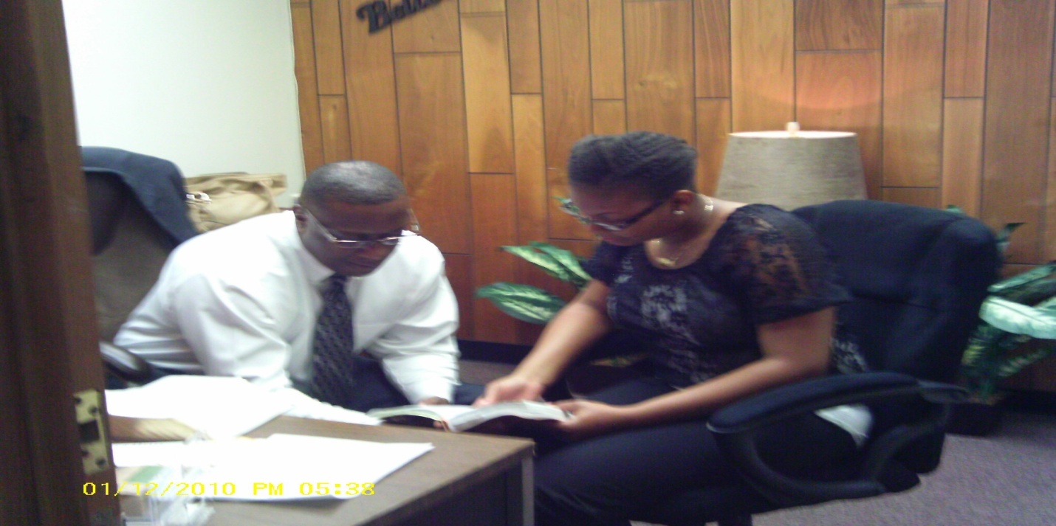

November 15, 2012
Devotional # 2
“ Obedience ”
Read Genesis 2:15-17
God gave Adam responsibility for the garden and told him not to eat from the tree of the knowledge of good and evil. Rather than physically preventing him from eating, God gave Adam a choice, and the possibility of choosing wrongly. God still gives us choices, and we, too, often choose wrongly. These wrong choices may cause us pain, but they can also help us learn and grow, and make better choices in the future. Living with the consequences of our choices teaches us to think and choose more carefully.
Here’s a question; Why would God place a tree in the garden and then forbid Adam from it ? ( Simple) God wanted Adam to obey. But God gave Adam the freedom to choose. See, without choice, Adam would have been like a prisoner, and his obedience would have been hollow.
The trees provided an exercise in choice, with rewards for choosing to obey and sad consequences for choosing to disobey. So when you are faced with the choice, always choose to obey God !

Increasing In Him
Pastor Suttles

