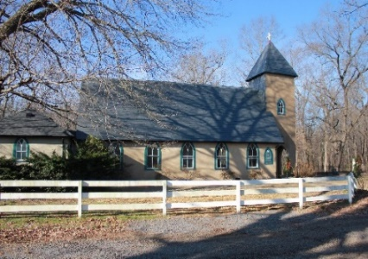**Grace Episcopal Church**



**Casanova, Virginia 20139**

**e-mail: graceChurchcasanova@gmail.com website:** [**www.graceChurchcasanova.org**](http://www.gracechurchcasanova.org)

***For to us a child is born,  
    to us a son is given,  
    and the government will be on his shoulders.  
And he will be called  
    Wonderful Counselor, Mighty God,  
    Everlasting Father, Prince of Peace. Isaiah 9:6***

**Ever wonder how Isaiah, from the 8th century BCE, could have written something that foretold the coming of Jesus Christ eight centuries later? Some attribute the Bible’s telling of the coming of our Lord to a tale created by eccentric folks, excited about reading all that was foretold – that it didn’t really happen the way the gospels explain it – that all of the New Testament was written to match other areas of the Old, or even to repeat fables – that there may have been some special man, or even a prophet, but no more than that. Read on…**

**Food for Thought**

**“He was born in an obscure village, the child of a peasant woman. He grew up in still another village, where He worked in a carpenter shop until he was thirty. Then for three years He was an itinerant preacher. He never wrote a book. He never held an office. He never had a family or owned a house. He didn’t go to college. He never visited a big city. He never traveled two hundred miles from the place where he was born. He did none of the things one usually associates with greatness. He had no credentials but himself. He was only thirty-three when the tide of public opinion turned against him. His friends ran away. He was turned over to his enemies. And went through the mockery of a trial. He was nailed to a cross between two thieves. While he was dying, His executioners gambled for his clothing, the only property he had on Earth. When he was dead, He was laid in a borrowed grave through the pity of a friend. Twenty centuries have come and gone, and today he is the central figure of the human race, and the leader of mankind’s progress. All the armies that ever marched, all the navies that ever sailed, all the parliament that ever sat, all the kings that ever reigned, put together have not affected the life of man on Earth as much as that One Solitary Life.” (By Dr James Allen Francis)**



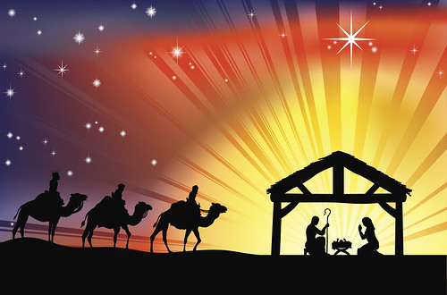

**SENIOR WARDEN’S REPORT – NOVEMBER 2021**

**Dear Grace Family,**

**The celebration of our Savior’s birth is upon us! We have been truly blessed this year despite COVID-19 continuing to interrupt what we used to experience as “normal.” As we look forward to this Advent, our Vestry met for its November meeting with much to discuss and lots of fantastic ideas.**

**We are thankful for Fr. Michael’s arrival and welcomed him at our Vestry meeting and will be receiving a special mailing from him soon! Since he is supporting both Grace and St. Luke’s, we will be having joint services on Special Holy days, such as Christmas, Easter, Pentecost, et al. The first of those joint services will occur on Christmas Eve! Our Christmas Eve service will take place at St. Luke’s Episcopal Church in Remington at 6:00 PM.**

**Grace Church has again volunteered to provide Christmas gifts for individuals at the Fauquier Family Shelter. If you would like to participate, please contact Mignonne Spellmeyer, 540-272-0014 or** [**MignonneSpell@gmail.com**](mailto:MignonneSpell@gmail.com)**.**

**Our prayer list (displayed in the bulletin) is being updated. We will start with a fresh slate and ask that prayer requests be added to the notepad located in the back of the Church.**



**Blessings and love on behalf of the Vestry,**

**Mary**

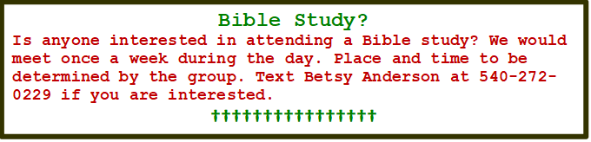





**TREASURER’S REPORT – OCTOBER 2021**

Income for the month of October was $6,553.59 (budget $6,267.00); expenditures totaled $4,000.34 (budget $4,543.00), resulting in income for the month of $2,553.25.

The book value of our endowment fund is $60,073.49; market value as of September 30,2021 is $70,075.19.

Please continue to pray for Grace Church that it will grow spiritually, financially and numerically. If you have any questions about this report or any financial matter, please contact me.

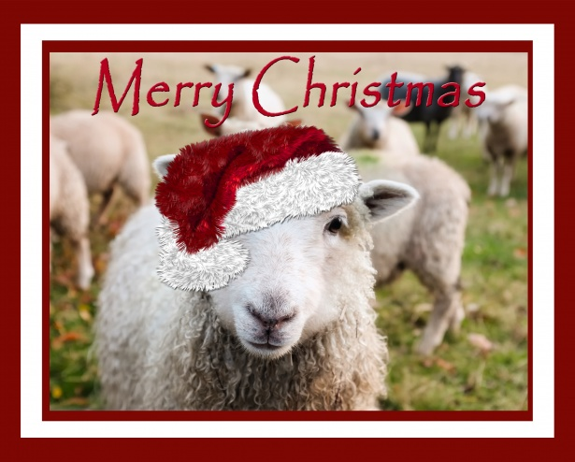

**Judy Ball**, Treasurer

**FEED MY SHEEP (FMS)**

***“For we are God’s handiwork, created in Christ Jesus to do good works, which God prepared in order for us to do.” Ephesians 2:10 NIV***

The holiday season is upon us and the long dark days of winter in close pursuit. Your continued generosity has insured that our families will have a bountiful  holiday meal. We will see that they have warm comforting foods through the winter.   You can rest assured that you have contributed to alleviate our local food insecurity. Pray for the many other providers throughout the country.

Gods Peace, Carol Grove 😇

**“How can I contribute to “Feed My Sheep?” you ask?**

**Cash can be put in the collection plate in an envelope. Checks should be made out to Grace Church with a notation FMS and sent to Judy Ball or Grace Episcopal Church, PO Box 18, Casanova, VA 20139.**

**DECEMBER BIRTHDAYS & ANNIVERSARIES**





|  |  |
| --- | --- |
| **Carolyn Martin** | **8-Dec** |
| **Jose Escorcia** | **10-Dec** |
| **Melba Hendrix** | **19-Dec** |
| **James Ottevaere** | **25-Dec** |
| **Carol Grove** | **26-Dec** |
| **Carol Cordell** | **28-Dec** |
| **Penny DePompa-Davis** | **28-Dec** |
| **Lora Moline** | **28-Dec** |
| **Jim Ruffner** | **30-Dec** |
| **Jennifer Coates** | **31-Dec** |
| **Greg McLeod** | **31-Dec** |

**REMEMBER THESE DATES, TIMES, LOCATIONS!**

**December 24th, 6:00 PM at St. Luke’s Episcopal Church, 400 N Church St, Remington, VA**

**December 25th, all day at your home - celebrate Jesus’ birthday!**



**DECEMBER SERVING SCHEDULE**

|  |  |  |  |  |
| --- | --- | --- | --- | --- |
| **Day** | **Readings** | **Altar/ Flowers** | **Reader/ Acolyte** | **Ushers** |
| **5TH**  **Second Sunday of Advent** | **Baruch 5:1-9**  **or Malachi 3:1-4**  **Philippians 1:3-11**  **Luke 3:1-6**  **Canticle 4 or 16** | **Pam Ruffner** | **Bryan Jacobs** | **Mignonne Spellmeyer/ Sharon Sweeney** |
| **12th**  **Third Sunday of Advent** | **Zephaniah 3:14-20**  **Philippians 4:4-7**  **Luke 3:7-18**  **Canticle 9** | **Sharon Sweeney** | **Judy Ball** | **Sue Ballentine/ Barbara Eanes** |
| **19th**  **Fourth Sunday of Advent** | **Micah 5:2-5a**  **Hebrews 10:5-10**  **Luke 1:39-45, (46-55)**  **Canticle 15 (or 3)**  **or Psalm 80:1-7** | **Barbara Jacobs/ Diane Gulick** | **Mary Neal** | **Betsy Anderson/ Carol Cordell** |
| **24th Christmas Eve** | **Joint service with St Luke’s, held at St. Luke’s Episcopal Church, 400 N Church St, Remington, VA at 6:00PM** |  |  |  |
| **26th**  **First Sunday after Christmas** | **Isaiah 61:10-62:3**  **Galatians 3:23-25; 4:4-7**  **John 1:1-18**  **Psalm 147 or 147:13-21** | **Betsy Anderson/ Mignonne Spellmeyer** | **Betsy Anderson** | **The Jacobs** |

*https://lectionary.library.vanderbilt.edu*



**ANNOUNCING:Openings are upon us! Our congregational meeting will take place in January at which time we will celebrate the contributions of three members of the Vestry who are stepping down. So, this is your chance to be a part of a great team! Please join us! We already have one volunteer, so this means two more lucky folks will have the opportunity to serve the Lord in this way. Please contact a Vestry member if you are interested in being on the Vestry. First come, first served, so don’t delay!**

**☺☺☺☺☺☺☺☺**

**AMAZON SMILE**

**FOR GRACE CHURCH**

Don’t forget to sign up with Amazon Smile to have 0.5% of the purchase price of eligible items given to Grace Church at no cost to you! You can also go to the Grace Church website home page and click on the link there.

#### *******AmazonSmile Shopping App for Android Users Now Available******

You can now support Grace in the Amazon shopping app on your Android device! Simply follow these instructions to turn on AmazonSmile and start generating donations to Grace from your Android device.

* If you have the latest version of the Amazon Shopping App, open the App on your Android device.
* View Settings and select AmazonSmile.
* Follow the in-App instructions to complete the process.

AmazonSmile is not currently available for IOS users – we’ll let you know when it becomes available.

