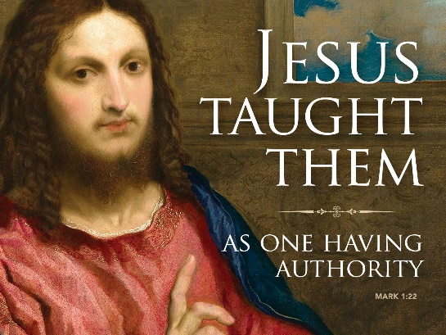
Jesus’ Word of Authority, Power, Hope, and Love
Mark 1:21-28
January 28, 2018
Grace and peace to you from God Our Father and from the One who still speaks with authority, Jesus Christ, Our Lord, amen.
We live in a world of words. Words are all around us, words on TV, words on the radio, spoken words by family and friends, words printed in newspapers, books, on computers, and words on the Internet. The world of words has turned us into a people who have been overwhelmed, suffocated, and buried in the mounting pile of words. With so many words around us, they tend to lose their meaning, they become unimportant, they no longer have any real value or influence in life.
There are some words which have more power than others.
The following story is fiction. This never happened when I was preaching… It was in the early years of this Pastor’s ministry, when one Sunday, while really getting deep into his sermon, a baby started to cry down in one of the front pews. The mother, very much embarrassed, snatched up the baby and started out the side aisle. The Pastor stopped right in mid-sentence, and said, ‘Madam you don’t have to take that baby out. He isn’t bothering me.’ She said, ‘No?’ ‘Well, you’re certainly bothering him…’ Words do have power… …sometimes.
In today’s gospel lesson, we learn how Jesus spoke God’s word and how that word had authority, power, hope for living, and most importantly, love. First authority. The Greek word usually translated as “authority” is exousia, which means that which stems out from one’s being. It’s not the kind of authority laid upon us from above, but that which comes from the depths of our being; from the ground of our being: from the mystery of God’ own Holy Spirit.
The following story, attributed to Mohandas Gandhi helps show what I mean by exousia authority. A mother approached the Teacher for assistance with a domestic matter. “My son has horrible eating habits,” she said. “Please, he will listen to you if you tell him to stop eating foods with so much sugar.” The Teacher listened sympathetically. “I ask that you come back next week and make the request again.” The mother agreed and returned seven days later. “My son’s problem continues,” she said. “I am greatly concerned about his health. He rarely eats vegetables or fruits. Please, won’t you talk to him about the danger of eating too much sugar.” “Please, come back and see me in a week,” the Teacher said simply. Though the mother was disappointed, she left and returned one week later. Once again, she made her plea. This time the Teacher agreed to talk with her son. When the conversation was completed, the mother thanked the Teacher. “I am grateful that you took the time to talk to my son, but I don’t understand why it took three requests for you to do so.” The Teacher looked at the woman and said, “I didn’t realize how hard it would be for me to give up sugar.”
Our text says, “And they were astonished at his teaching, for he taught them as one who had authority, and not as the scribes.” There was something very special about Jesus’ words. They were different from the scribes who usually taught in the synagogue. They would quote sayings from the past learned men, but would never offer any new truth, or new idea. The scribes simply would always reinforce what had been said before. But Jesus came and He spoke to people about their Sin and about repentance with authority. He didn’t quote any past teachers of the Law, nor did he attempt to describe what sin is or create any loopholes to get out of the consequences. As the only one ever to live a sinless life, he was the sole authority and it comes from within himself, not conferred upon him by Trinity Seminary or any other institution. He had the authority of God himself. Jesus was and is God’s word, the word that God used to create. Jesus is the authoritative word of God that brought things into existence. That very same Word of God was incarnate in Jesus. Jesus spoke with the authority which was present from the beginning of time.
The first recorded words of Jesus in Mark’s Gospel come from Mark 1:15 where Jesus says, “The time is fulfilled and the kingdom of God is at hand, repent, and believe in the gospel.” Jesus announced through his presence, God’s kingdom is now present in this world and because of His presence you could repent or return to God without shame, without guilt, knowing your forgiveness was assured. So, come home, there’s nothing stopping you. Those words stood tall among the people, because Jesus had the kind of authority, the kind of presence, which allowed people to believe his kingdom was indeed God’s kingdom.
Next, we see the power of Jesus as he spoke God’s word. In this story when Jesus speaks, stuff happens. All he has to do is utter the word and the demon flees the possessed man. There was a power in Jesus’ words--a power to bring healing strength and forgiveness into the life of that man. Also, with his words, Jesus brought that man into a relationship with himself. The power of Jesus’ words still affects lives and relationships today. These words of Jesus still wield power to cast out our demons. When I announce to you in the words of absolution that through the authority of Jesus Christ all your sins are forgiven, the power doesn’t come from my words, but from The Word, Jesus Christ. Through my words, Jesus’ action of forgiveness reaches into your lives.
I read somewhere that “Each week we assemble as the ones who carry the disease of sin. We cry out ‘Son of God, have mercy on us,’ and Christ’s own powerful Word says, ’Arise, go forth and live. The demons obey him, they are out and away. The grip of sin and death is broken. We are free to live as a new people of God.” The cosmic battle of sin has been fought and the really great good news for us today is that Jesus won! Unfortunately, this battle continues day in and day out for each of us. The scourge of Sin still sticks to us like our own shadow. We can’t get rid of it. It’s only through the powerful word of Christ we can hope to win. It’s only through His word and His word alone that victory for a fleeting moment is ours on this earth. That brings us to the word of Hope.
Because Jesus has authority, because he has power, because his words do affect our lives, then we are people who can and do live with hope. Hope that things can be changed, things can be different, things, lives, people can be made whole through the authority and power of Jesus Christ. Even as we speak the word of God the authority, power, and hope works through us to affect those around us. We live life as survivors instead of victims because of the hope we have in Jesus Christ to redeem lives and bring forth his Kingdom into our everyday lives.
In this world of words, there is one clear, loud, gracious word that stands out against all others, and that’s Jesus’ word of love. Mark tells us in our gospel that Christ’s teaching was different from that of any other teacher, because he taught as one having authority. His was an authority flowing out of his love for you and me. Love that placed no limits on reaching out to people of all walks of life; love that forgives, heals, frees and accepts even the worst of sinners and outcasts; unconditional love—breaking down dividing walls and barriers of all kinds. Christ’s was the authority on love who poured out his life on a cross for sinful humankind—making no distinctions, accepting everyone; building them up into his people.
May we be imitators of Jesus as we speak words of love in into other people’s lives. May those words of love be spoken with authority that comes from deep within, from the stream of living waters that flows up in us from Christ Himself. As we speak words of powerful grace, may God’s love affect our lives and the lives of all the people we know. Dear God, increase your Word of authority, Power, Hope, and especially Love in our lives. Bless us and strengthen us to we speak your Word into our world. Amen.

