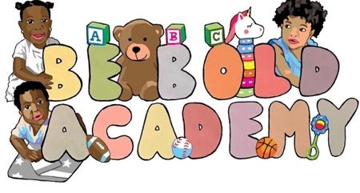
BE BOLD ACADEMY UNIFORM REQUIREMENTS

Be Bold Academy requires every Scholar from the age of 18months-5 yrs. to wear uniforms.
Uniform
TODDLER & PRESCHOOL: Turquoise polo shirt, black bottoms. Students are permitted to wear any enclosed shoes that fit their desire.
FOOTWEAR- Students are welcome to wear any closed toe shoe that they desire. Any student who attends school with open toe shoes must provide a pair of closed toe shoes as well. Closed toe shoes are required for safety purposed. Any open toe shoes that are worn to school must have a heel strap.
When wearing dresses or skirts, it is a must that all ladies wear shorts or stocking that are not see through for privacy purposes.
GET FRESH FRIDAY! - Children are allowed to express themselves through their clothing. Every Friday students are welcomed to wear any appropriate clothing that they desire with any closed toe shoe.
The following is a list of stores where you may purchase the uniforms.
1. Target
2. Forman Mills
3. Kids City
4. Walmart
5. Children’s Place
6. Old Navy
7. Kids Town

