FANKASCOE NEWS

The Retiree’s Newsletter

JULY NEWS

JULY 2014

OFFICERS FOR 2014-2015:

R

Connie S. Roberts, President

Susan DeWitt-Champion,
PRESIDENT

Emerson Rider,
Vice President

Joyce Logsdon, Newsletter Editor

Laura Howell,
Sec/Treasurer
Joyce Logsdon,
Newsletter Editor

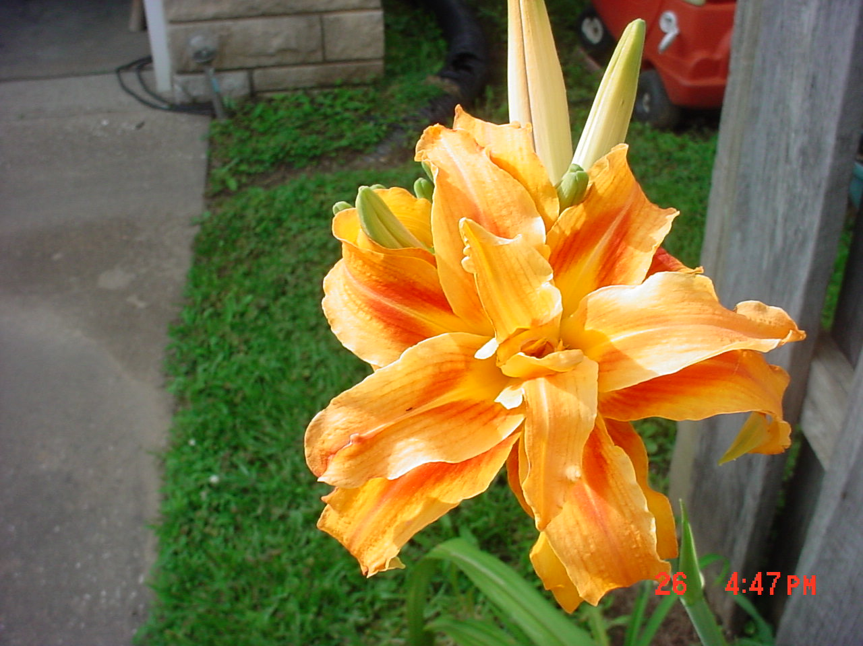

FROM THE PRESIDENT
I want to take this opportunity to introduce myself. In 1986 I was hired as a Program Assistant in the Union Co. Office. After completing the COT Program I was hired as the CED in Livingston Co. Shared Management was implemented in 1998 & I was hired as the CED of Crittenden & Livingston Co’s. The two counties were consolidated in 2009 & I became the CED of the Salem Service Center. After 25 yrs of service, I gladly accepted an offer for an early-out in December 2011. I was elected president of FanKascoe in October 2013.
I first heard about an employee organization from Helen Willet, the CED in Union Co. Helen took the time to talk to me about the purpose of the organization. Rita French & Susan Girten two of the other employees in the office also helped me understand the importance of becoming a member of KASCOE. As a CED, I followed the example Helen set & was proud to say that all the employees in my office were paid members of KASCOE.
FanKASCOE & RASCOE are the organizations that need our support now. The purpose of RASCOE is to promote the welfare of the association’s members by alignment with other organizations & actively lobbying to maintain the integrity of the retiree benefits. We need to remember that when congress talks budget cuts our benefits seem to be at the top of the list. RASCOE works hard to ensure we are informed of legislation that could affect our benefits.
Currently FanKASCOE is working diligently to promote our association. Here are just a few examples:
Determined to send a letter to all new retirees inviting them to join the organization.
Agreed that new retirees receive their first year membership free.
Other things are listed in Sec/Treas minutes of 5/22 which the group is working on.
Also, I want to acknowledge the dedication of our Newsletter Editor, Joyce Logsdon. She does an excellent job on the newsletter. She makes personal contacts to remind people it’s time to pay their dues. And, she keeps us “in the know” through her e-mail messages.
Hope to see you at the next retiree meeting. SUSAN
VICE PRESIDENT NEWS
Susan has done a great job of explaining how important it is to pay dues, which are due 7/1. We encourage everyone to pay their dues & to take part in their organization. If I can be of any help, fell free to call me @ 859-824-5341 or send snail mail to: Emerson Rider 1445 Barnes Rd Williamstown Ky 41097. Thanks Emerson
SEC/TREAS REPORT
It’s time for your 2014-2015 membership dues. Dues are only $25.00 so please Make your check PAYABLE to FanKASCOE. Mail to: Laura Howell 799 Doug Hill Rd Island Ky 42350
Minutes of 5/22/14 -FanKascoe committee met at Elizabethtown with the KASCOE directors. FanKASCOE members attend-ing were: President Susan DeWitt-Champion, Vice-President Emerson Rider, Sec-Treas Laura Howell, Newsletter Editor Joyce Logsdon, & Past President Henry Ford.
In an effort to partner with our sister association, FanKASCOE made a $250 donation to the KASCOE scholarship fund.
FanKascoe also offered to host hospitality one night for the KASCOE convention if it worked out that the associations could have a joint meeting.
FanKascoe members stated that they are willing to help in anyway that we could. Just let us know if we could be of service by calling our congressman, or any other assistance we might provide.
Laura Howell gave the directors a copy of the NARFE magazine, & encouraged members to join &/or follow NARFE. There is a link to their website on the NASCOE homepage, & there is also a facebook page.
By meeting with the KASCOE association, & helping with their needs, FanKascoe hopes to gain members as they retire.

Joyce Logsdon
3845 E 4th Street
Owensboro KY 42303

President Susan reviewed & approved the financial report.
All items were discussed prior to meeting with KASCOE, & all present agreed that a good working relationship with KASCOE would be beneficial to both associations. LAURA
Greetings from the Editor
It has been a very busy summer so far, sorry I have not gotten the newsletter out sooner. I hope Ky can be # 1 or 2 of all the States in paying dues, we can if you give your support too. If you have any news you want to share feel free to email me: joyce.logsdon@gmail.com or call 270-302-0719.
The committee has made a decision that anyone who does not pay their dues will be taken off email & mailing list, SORRY
Rita Barlow, CED Clark Co. retired 6/30/14.
Jeanie Williams, CED Meade Co retired 6/30/14
Sara Voet, husband Jim passed away 9/27/13. Sara retired in 1994 was a CED in Campbell then a DD in Northern Ky.

Harold Hale, former CED Menifee Co passed away 10/24/13.
Faye Rakestraw, former PA Webster Co passed away 1/27/14.
Donald Dunn, District Director, mother Kay Dunn of Cadiz passed away 1/25/14.
Wayne Thompson, former CED Caldwell/Lyon passed away 1/30/14.
Roland Stephens 89, former CED Butler Co & DD passed away 2/1/14.
Joe Brown 82, former DD of Campton, Ky passed away 3/19/14.
Barry Allen, CED Morgan Co, father Jack Allen, 83 of Salyersville, Ky passed away 2/16/14.
David Duke, CED Fayette Co. father Glen Duke, 81 of Owenton passed away 2/19/14.
Charles “Chick” Huber 72, passed away 6/24, he was CED in Bath Co for 32 yrs.
TIP – If you have a sore throat eat a handful of marshmallows & it will soon go away. I tried it myself & it works.

