Red, White, and Blue Fun  The Sun | 1  Stars and  Stripes  Craft  Baseball Instruction | 2  Sun and shadow Scientists  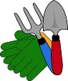  Sun and our Solar Panels | 3  Make a Giant Flag  Water Play  in the 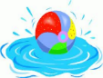Garden | 4  Fourth of July  Little Friends Preschool Closed | 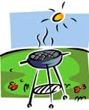  5  Show your talent  Baseball Game
Nature Explorers  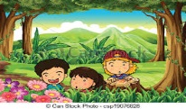  Plants and Water | 8  Park Ranger  Visit  Soccer Instruction | 9  Field Trip  Mohonk Preserve Children’s Forest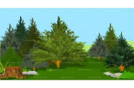 | 10  Water Play  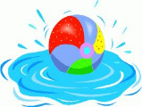  Planting Plants and  Cooking Show | 11  Nature Songs  Dance  Making Water Catchers | 12  Show your talent  Soccer Game
Animal/Bugs/Insects Exploration  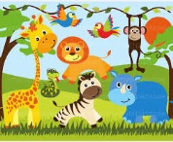  Animals | 15  Animal Masks  Kickball Instruction | 16  Animal Songs and Dance | 17  Nature Wagon Visit  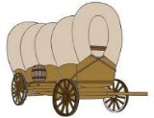 | 18  Water Play | 19  Show your talent  Kickball Game
Space is the Place  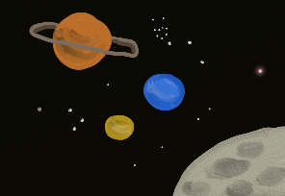 | 22  Spaceship Crafting  Football Instruction | 23  Water rockets from recycled bottles | 24  Making Stars, planes, planets and Aliens | 25  Space songs, dance and skits  Football Game | 26  Visit to the  High School Planetarium
At the Circus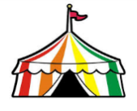  Water | Circus Craft and Games  Basketball Instruction | 30  Circus Games  Practice  Ice cream Making | 31  Little Friends Carnival Day  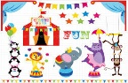 | 1  Tumble Bus Visit  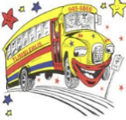 | 2 Show your talent  Basketball Game

Community Helpers  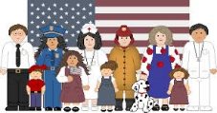  Healthy Bodies | 5  Set up Emergency centers to demo community helpers  Volleyball and Badminton Instruction | 6  Waterplay  Cooking Show with food from our garden | 7  Community Helpers Field trip  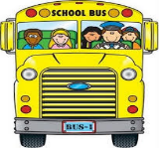  Post Office  Library  D.O.T.  Police Station  Town Park | 8  Songs, dance and skits for community helpers  Thank you notes to our Community Helpers | 9  Show us your talent  Volleyball and Badminton Game
Under the Sea  Pirate Week  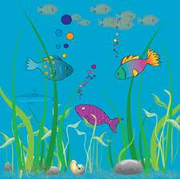  Animals and Insects | 12  Create an Ocean with sea animals  Treasure Maps  Martial Arts Instruction | 13  Bring in your Sea Shell Collections  Pirate Costuming  Walk the Plank | 14  Water Play with Sea creatures  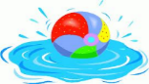  Float Your Boats | 15  Shark Songs, Dance and Skits  Sand Sculptures | 16  Show us your talent
Going Green  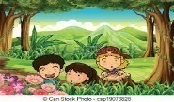  Wind | 19  Nature Arts  and Crafting | 20  Visit From a Park Ranger | 21  Mohonk  Preserve Field Trip  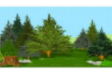  Split Rock Site at the Coxing Trailhead | 22  Nature songs, dance and skits | 23  Show us your talent
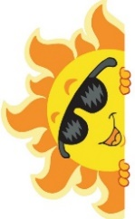 | 26  Memory Books | 27  Plant bulbs for the fall | 28  Waterslide | 29  Cleaning out the garden | 30  Talent Show

