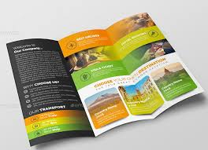 PBL: TRAVEL BROCHURE
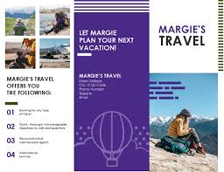
Within your flexible groupings…
ROLES: Designate who is going to be responsible for various tasks.
RESEARCH: What is the purpose? What does it look like? What information is to be
provided? How is it to be distributed?
RECORD: Itemize a list of specifics for your final product; materials, resources?
RESPOND: Make a plan of action to create your travel brochure. Steps, timeline,
duties, etc… Create!
DELIVER: Present your final product.
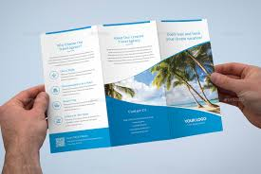
Get to it! You are going to be working together to create a travel brochure that would be applicable for the setting (time & place) of your topic. Keep in mind your historical context! What awesome adventures may be available and what major challenges may present themselves? How about transportation, food, climate, shopping, entertainment, and accommodations for your potential client? What about additional marketing and business opportunities?

Scoring Rubric Guidelines: Accuracy, Completeness, Neatness, Originality, Presentation

