CONTINUING EDUCATION

Conference outcome:

Participants will be able to describe how they can apply grief therapy in their own lives and to the lives of their clients.

CNE Opportunity:

The Virginia Association of Community Psychiatric Nurses is approved as a provider of continuing professional development by the Virginia Nurses Association, an accredited approver by the American Nurses Credentialing Center’s Commission on Accreditation.

Up to 7 contact hours will be awarded.



DIRECTIONS
Shrine Mont is located in Orkney Springs, VA about 13 miles west of Mt. Jackson, VA.

Directions (Shrine Mont recommends these directions rather than relying on GPS devices or mapping software):

From Washington, DC:
Shrine Mont is located 1 hour south of Winchester and approximately 2 hours from the Washington DC metro area. To reach Shrine Mont, follow Route 66 West to I-81 South to Mt. Jackson (Exit 273). Turn left onto Rt. 703 (East), then right (South) on US 11, follow through town, turn right on Rt. 263 and follow approximately 13 miles to Orkney Springs.

From Richmond, VA:
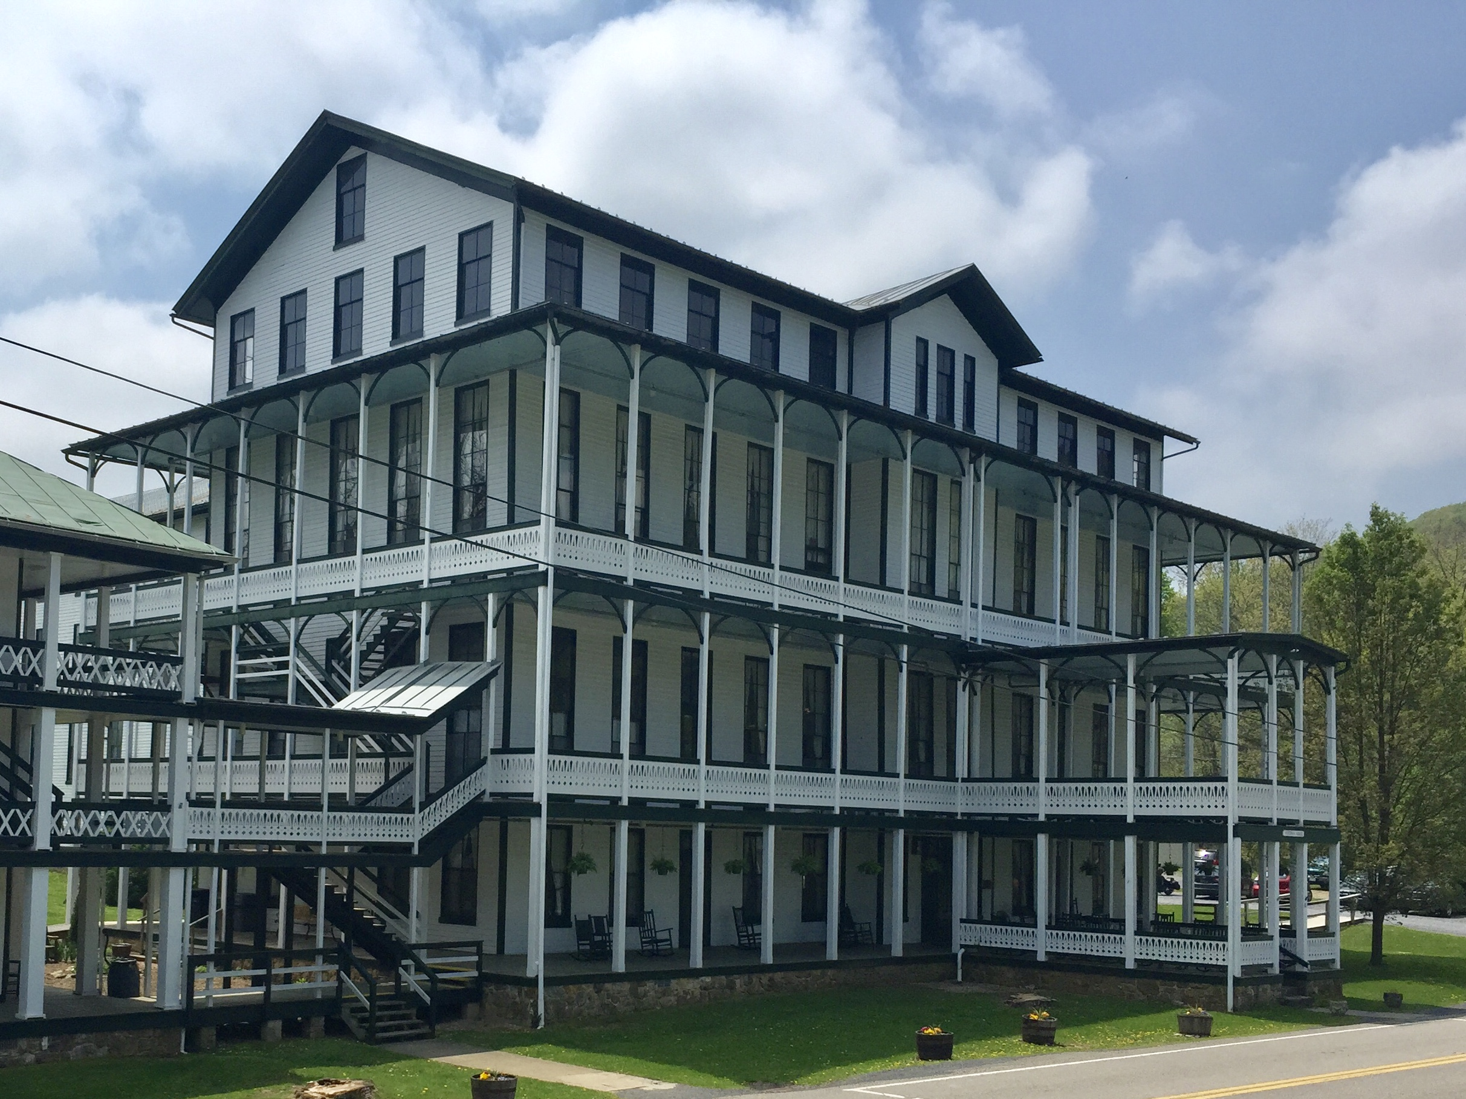
Shrine Mont is located 1 hour north of Harrisonburg, and approximately 3 hours from the Richmond metro areas. To reach Shrine Mont, follow I-81 to Mt. Jackson (Exit 273). Turn right onto Rt. 703 (East), then right (South) on US 11, follow through town, turn right on Rt. 263 and follow approximately 13 miles to Orkney Springs.

For questions/information, please contact
VACPN Co-Presidents:

Nina Beaman
Nina.Beaman@aspen.edu

Lisa Babilon
lmbabilon@hanovercounty.gov



Spring 2023 conference

april 26th, 27th & 28th, 2023

Walking Through
Grief

Conference outcome:
Participants will be able to describe how they can apply grief therapy in their own lives and to the lives of their clients.

.
Shrine Mont
221 Shrine Mont Circle
Orkney Springs, VA 22845

REGISTRATION

1. You must first fill out the online registration form on our
website at:
http://www.vacpn.net/Spring-Conference-Event.html

2. The conference fee is $350 for members & $380 for non-members. This includes room, conference program, meals, and CPD hours.

This fee can be paid either online via PayPal or mailed to:
Charlie McDonough
VACPN Treasurer
9212 Shady Grove Road
Mechanicsville, VA, 23116

We are unable to accept payment at the door.

Registration deadline is
April 10, 2023.
Payment also must be received by this date. We are unable to offer refunds after this deadline.

Non-nurses are welcome to attend our conferences, however, please note that our business meetings are only open to VACPN members.

PROGRAM AGENDA

Wednesday, April 26th

3:45 PM: Check-in begins

5:30-6:30 PM: Dinner at the
Shrine Mont Dining Hall

6:30 PM into the evening: Games, music & networking in lobby.

Thursday, April 27th

8:00-9:00 AM: Breakfast in the
Shrine Mont Dining Hall

8:45-9:00 AM: Registration & vendors

9:00-9:15 AM: Welcome - VACPN Co-Presidents, Lisa B & Nina B

9:15 -10:30 AM: Senator Creigh Deeds. “State of Mental Health in Virginia”.

10:30-10:45 AM: Break & Vendors

10:45 AM-12:00 PM: VACPN Business Meeting

12:00-1:00 PM: Lunch in the
Shrine Mont Dining Hall & Vendors

1:00-1:15 PM: Introduction to “Walking Through Grief”, Michele Zehr

1:15-2:15 PM: “Walking Through
Grief” Session One, Michele Zehr

2:15-2:30 PM: Break
2:30-3:30 PM: “Walking Through Grief” Session Two, Michele Zehr

3:30-3:45 PM: Break

3:45-4:45 PM: “Walking Through Grief” Session Three, Michele Zehr

5:30-6:30 PM: Dinner at the Shrine Mont Dining Hall

6:30 PM into the evening: Games, music & networking in lobby.

Friday, April 28th

8:00-9:00 AM: Breakfast in the
Shrine Mont Dining Hall

9:00-9:15 AM: Announcements - VACPN Co-Presidents

9:15-10:30 AM: “Walking Through Grief Session 4”, Michele Zehr

10:30-10:45 AM: Break

10:45 AM-11:45 PM: “Walking Through Grief Session 5”, Michele Zehr

11:45-12:00 PM: Closing & evaluations.

12:00-1:00 PM: Lunch in the Shrine Mont Dining Hall

