TRINITY UNITED METHODIST CHURCH
The Rev. Charles Wilbanks ___ Minister
May 2, 2021 Color: White
FIFTH SUNDAY OF EASTER
"We welcome you to our service this morning and pray that your time with us will be a blessing to you"
THE ORDER FOR WORSHIP
Prelude Mr. Eddie Welborn
The Prelude is a time for silent preparation for worship.
Welcome and Announcements Rev. Charles Wilbanks
The Chiming of the Hour Mr. Eddie Welborn
The Lighting of the Candles
The Processional of the Cross
The Call to Worship Rev. Charles Wilbanks
Opening Prayer Rev. Charles Wilbanks
The Children’s Time Rev. Charles Wilbanks
The Hymn of Adoration: “Love Divine, All Loves Excelling” Page 384
*Responsive Reading: Psalm 22:25-31 Page 752
*The Apostles Creed Page 881
*The Gloria Patri: “Glory Be to the Father”
Prayer Concerns and Praises Mr. Grady Senn
The Pastoral Prayer Rev. Charles Wilbanks
Tithes and Offering Ushers / Mr. Grady Senn
*The Doxology: “Praise God From Whom All Blessings Flow”
*The Hymn of Preparation: “Lord, I Want to Be a Christian” Page 402
First Reading: Acts 8:26-40 Rev. Charles Wilbanks
Second Reading: 1 John 4:7-21 Mr. Grady Senn
*Gospel: John 15:1-8 Rev. Charles Wilbanks
Musical Transition Mr. Eddie Welborn
The Sermon: Sometimes Less is More Rev. Charles Wilbanks
Sacrament of Holy Communion - All are Welcome at the Lord’s Table - See Pew Card
*The Hymn of Service: “For the Beauty of the Earth” Page 92
*The Returning of the Light

*The Benediction Rev. Charles Wilbanks

*Three-Fold Amen Mr. Eddie Welborn
*The Postlude Mr. Eddie Welborn
*All who are able stand. The altar is open for prayer during the last hymn.
Technician: Mr. Josh Pitts

The Altar Flowers are to the Glory of God.

Next Sunday – May 9

Altar Flowers: Open; Technician: Josh Pitts
Thank you to Marie Somers for providing the beautiful silk flowers.
Feel free to sign up for altar flowers if you wish.

Our Faithfulness
Live Streaming, April 18: 86
Live Streaming, April 25: 143
Worship Attendance for April 25, 2021: 30
Total Budget for 2021: $ 149,647.00
Weekly Offering Needed: $ 2.877.83
Offering Received April 18, 2021: $ 637.00
Offering Received April 25, 2021: $ 2,052.00
2021 Average Weekly Offering YTD: $ 2,313.00

The Concerns of Trinity
Our Known Hospitalized:
Recent Hospitalizations and/or Surgeries:
Nursing Home:
Continued Prayers: Jane and Robert Pollard, James and Jeanette Poag, Cheryl Longshore, Shirley Berry, Jim Waldrop, Gloria Brehmer, Rebecca Bundrick,, Alice and John Longshore, Frieda Kesler, Crystal Waldrop, Beverly Pitts, Joan Morris, Johnny Marlowe

Family and Friends of Trinity: Blake Hendrix, Jennie O’Shields. Phillip Sanders, Richard Douglas, Wilson Bowles, Charlotte Berry, Sal Welborn, Harriett Connelly, Merle Simpleton Reynolds, Megan Wainwright, Jessica Griffen

JOIN THE CHOIR!
The Bishop has authorized churches to assemble choirs again.
If you would like to add your voice to the Voices of Trinity,
please let Jane Pollard or the Pastor know.
Help us to make a Joyful Noise to the Lord!

UPDATE!
Trinity UMC’s weekly bulletin and bi-monthly newsletter, Trinity Times,
can be found on our website. You may access this information by visiting
www.trinityumcnewberry.net. Visit our website frequently
for updated information.

Administrative Council will meet Monday, May 10, at 6:30 p.m.
in the sanctuary.

WELCOME VISITORS

Thank you for coming today! We are delighted you are here! We hope
you will join us again as we continue to discover the difference God’s love makes in our lives. If you have questions or desire to become a member of Trinity UMC, please speak to pastor. We’re blessed because you’re here.

Trinity United Methodist Church Please visit our website:
1160 Trinity Church Road www.trinityumcnewberry.net
Newberry, SC 29108
Rev. Charles Wilbanks, Pastor
803-276-1245 (Church Office)
803-768-7687 (Church’s cellphone)
803-206-4623 (Pastor’s Cell)
clwilbanks@bellsouth.net

Trinity
United
Methodist
Church

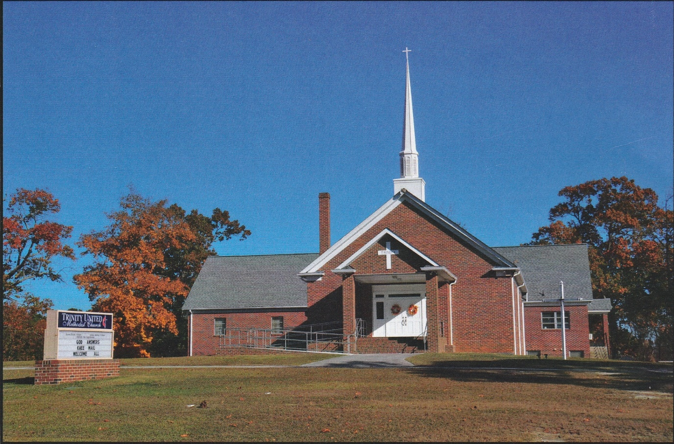

1160 Trinity Church Road
Newberry, SC 29108
Trinityumcnewberry@gmail.com

