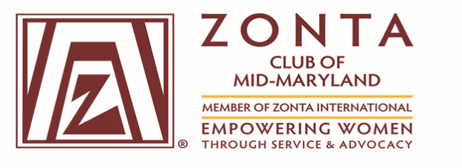
(Chartered May 5, 2016)

Executive Board Meeting Minutes
Virtual Zoom Meeting
Wednesday, December 2, 2020

Attendance:

President Virginia Moore, 1st Vice President, Tammie Edwards, 2nd Vice President, Nicole Barnes, Assistant Treasure Erma Barron, Recording Secretary Doris Winston; Directors: Alice Rose, Amanda Welch, and Terri Wills; Total - 8 Members

Call to Order: President Virginia H. Moore called the meeting to order at 7:05 pm

Agenda Review: The agenda was reviewed, no comments or corrections.

President’s Opening Remarks:

President, Virginia Moore congratulated the following members for their outstanding advocacy initiatives:

Service Committee: Alice Ross and Cleopatra White (Family Justice Center – Food Drive)

Fundraising Committee: Gloria Smith-Hill and Maureen Braimbridge – Virtual Shopping Event with Forever’s Treasures)

Tammie Edwards and Erma Barron (Zing Event and Membership)

Treasurer’s Report: Forthcoming TBD.

Membership Committee Report:

Tammie Edwards provided an overview of the number of Zonta Mid-Maryland Club Members that attended the Virtual Zing event as well as Patricia Latona, Zonta District 3 Governor.

Tammie reported three new members: Brenda Fuller, Charlotte A. McDowell, and Patricia Hill. One returning member, Dr. Peggy Dolet. Tammie provided an introduction of the new members.
Tammie proposed that members provide their votes by Zoom for each candidate on December 10, 15 minutes before the General Body Meeting. Each candidate’s questionnaires and applications were provided.

Advocacy Report:

Nicole Barnes provided an overview of 16 Days of Activism. ZMM members participated in an exercise and gave 30 seconds blub on what Activism means to them and how they would change the world. Sixteen ZMM members participated that represented one day of Activism.

Service Committee Report:

Alice Ross and Cleopatra White provided a report on “Free the Girls Bra Campaign.” Because of COVID-19 an alternative plan is being considered to collect bras for next year.

Young Women in Public Affairs, applications will be distributed to young women from the ages of 16 to 19. The applications are due to the governor/regional representative by April 1, 2021. In, January 2021, information for distribution of applications will be determined.

ZMM Club Scholarship for Prince George’s Community College is being considered. Committee members are seeking contact information for college representatives to address proposed scholarships.

Family Justice Center Food Donations for Families Impacted by Domestic Violence. ZMM members collected food donations and distributed them to the Family Justice Center prior to Thanksgiving. Additionally, gift cards were contributed as well.

Fundraising Committee Report:

Virginia Moore, President presented the fundraising report, and it was read by ZMM members.
NEHE MOU was distributed to members for review.

Old Business – MOU NEHE

New Business – The ZMM Club website will be updated to include current activities.

Next Meeting: General Membership Meeting – 12/10/20 at 7 pm.

Meeting Adjourned: 8:26 pm

Minutes submitted by Doris Winston, Recording Secretary

2

