Nutrition Plus, Inc.
121 Mays Rd., Winfield, KS. 67156
Emily Roark Patti Brenn Susan Morrell
(620) 221-2777 (620) 218-1811 (785) 230-7441
roark2@cox.net pattibrenn@cox.net smorrell12@gmail.com
www.nutritionplusinc.com
July is:
National Baked Bean Month
National Blueberry Month
National Grilling Month
National Hotdog Month
National Ice Cream Month
National Peach Month
National Picnic Month

Important dates:

July 15th – Zoom training on Feeding Infants in the CACFP – 6:30 pm-8:30 pm
July 30th – Checks/Direct Deposit go out

Award Winning Recipes
(from Team Nutrition)
Chicken Alfredo with a Twist
2 ½ cups-Pasta, rotini, whole grain
2 cans (10 ¾ oz cans)-Cream of chicken soup, low-fat, reduced sodium, condensed
1 1/3 cups-Half and half, fat-free
¼ teaspoon-White pepper
1/8 teaspoon-Garlic powder
1/3 cup-Parmesan cheese, grated
3 cups-Cooked diced chicken, cut in ½ inch pieces
*In large pot, boil 2 quarts of water, add pasta and cook uncovered about 8-10 minutes until tender. Drain.
*Mix all remaining ingredients into a large pot. Cook for 5 minutes over medium heat, stiffing often, until 165°F or higher for 15 seconds. Combine with pasta and serve hot. 1 cup provides 2 ¼ oz meat/alternate and 1 ¼ oz grain equivalent.
JULY 2021
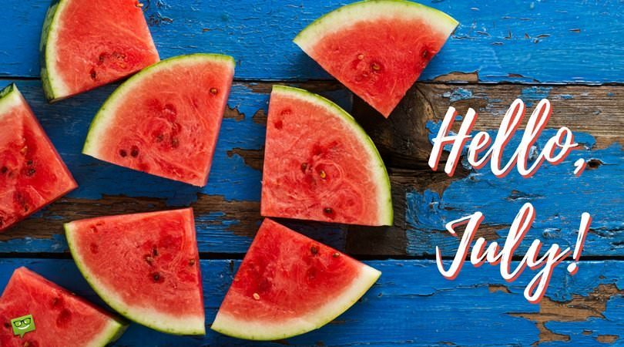

Porcupine Sliders

1/8 cup brown rice, long-grain, regular, dry
1 tsp canola oil
1 ½ Tbsp fresh onion, peeled, diced
¼ cup fresh celery, diced
1 ½ tsp fresh garlic, minced
1 lb. raw ground turkey, lean
1 egg, beaten
5 Tbsp dried cranberries, chopped
¾ cup fresh baby spinach, chopped
1 tsp Worcestershire sauce
½ tsp salt
½ tsp ground black pepper
1 dash ground white pepper
6 (1 oz each) mini whole-wheat rolls (small dinner roll size)
*Preheat oven to 350 °F. Combine brown rice and ½ cup water in a small pot and bring to a boil. Turn heat down to low. Cover and cook until water is absorbed, about 30-40 minutes. Fluff with a fork. Cover and refrigerate until completely cooled. .
*Heat canola oil in a small skillet. Add onions, celery, and garlic. Cook over medium heat for 5 minutes or until tender. Remove from heat. Cover and refrigerate until completely cooled.
*In a medium mixing bowl, combine turkey, egg, cranberries, spinach, Worcestershire sauce, salt, peppers, brown rice, and sautéed vegetables. Mix well. Shape into 6 patties.
*Line a large baking sheet with parchment paper and lightly coat with nonstick cooking spray. Place patties evenly spaced on baking sheet.
*Bake uncovered for 20-25 minutes at 350 °F to an internal temperature of 165 °F or higher for at least 15 seconds. Do not overcook. Remove from oven and serve on a mini whole-wheat roll. Serve immediately. May be served with onion, lettuce, tomatoes, ketchup, and mustard. Makes six sliders (1 slider provides 2 oz equivalent meat/meat alternate and 1 oz equivalent grains)

Tasty Tots

5 cups- sweet potatoes, fresh, peeled, coarsely shredded
2 1/3 cups- Garbanzo beans, canned, low-sodium
½ cup- green onions, finely chopped
2 tablespoons- vegetable oil
½ teaspoon- salt
½ teaspoon- garlic powder
¼ teaspoon- black pepper
½ teaspoon- onion powder
½ teaspoon- cinnamon
2 ½ oz- enriched, all-purpose flour

Preheat oven to 350°F
Place shredded sweet potatoes on a large baking pan-lightly coated with cooking spray. Bake for 20 minutes until slightly tender. DO NOT OVERCOOK.
Increase temperature to 400°F.
In a food processor, puree garbanzo beans, including the liquid, until smooth.
Combine sweet potatoes & garbanzo bean puree, with all remaining ingredients and mix well. Cover and chill for 40-45 minutes to make tots easier to form.
Spray large baking sheet with cooking spray. Use spoon or scoop to roll 36 tots. Place 1 in. apart. Lightly flatten tots with a spoon or fork.
Bake at 400°F for 10-12 minutes until lightly brown.
6 tots provide ¾ cup vegetable serving equivalent.

Bok Choy Wrappers
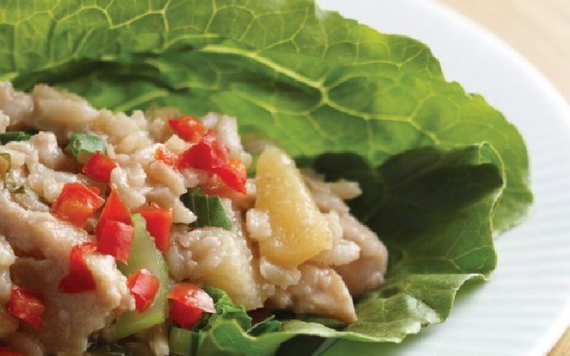

1 ½ cups- Brown rice, long-grain, regular, dry
1 ¾ cups- Bok choy, fresh, sliced ¼ inch
1 ¾ cups- Pineapple tidbits, canned, in 100% juice
3 cups- Chicken strips, cooked
¾ cup- Sweet and sour sauce
1 teaspoon- Soy sauce, low-sodium
12 leaves- Romaine lettuce, fresh, outer leaves, rinsed, dry
Preheat oven to 350°
Combine rice in 3 ½ cups water in a large pot and bring to rolling boil. Turn heat to low. Cover and cook until water is absorbed, about 30-40 minutes. Fluff with fork.
Combine brown rice, bok choy, pineapple, chicken, sweet and sour sauce, and soy sauce.
Pour mixture in 8 x 8 inch baking dish, lightly sprayed with cooking spray. Bake for 30 minutes and until internal temperature reaches 165°F for at least 15 seconds.
Place 2 lettuce leaves on a plate. Top each with ¾ cup of filling. Fold sides of lettuce in toward center; roll up like a burrito. Place seam side down. Serve warm. 2 wraps provide 1 oz. meat, ¾ cup vegetable, 1/8 cup fruit and 1 ½ oz. grains equivalent. 1 wrap provides ½ oz. meat, 3/8 cup vegetable, and ¾ cup grain equivalents.

The idea in this newsletter, is to introduce the kids to new things, by trying new recipes. Many providers find themselves bored with their usual menu items. The new colors and flavors may become a favorite treat in some households!

Thanks for being the best part of Nutrition Plus! Emily, Patti & Susan

