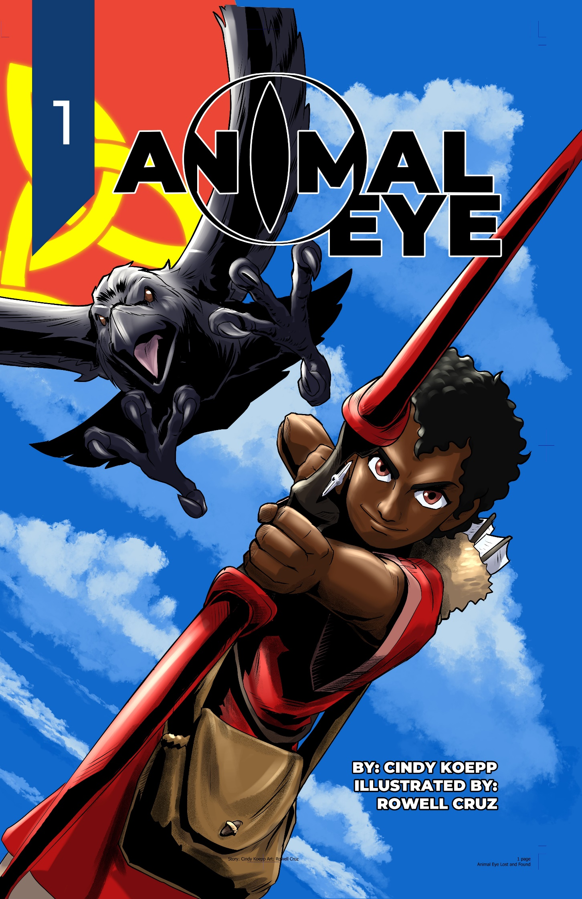

Contents
Cover Art
Quotes
Finished (mostly) pages 1-5
What’s the Story?
Character Concept Art
Unfinished pages 6-10
Where Did This Story Come From?
Character Concept Art
Conversion to a Comic Book
Character Concept Art
From Novel to Script to Preliminary Art to Final – Tracking Page 5, Panels 3-7 Through the Process.
Character Concept Art
What’s Next?
Contact Links for Rowell, Travis, and Cindy
Acknowledgements
Back Cover Art

Quotes
“Animal Eye is my first big project and I am excited to be involved in it. Its action scenes, animal characters, and unconventional environment is a great challenge to work with.” – Rowell Cruz, artist

“Rowell really did a sensational job of bringing [the] script to life. And his design sense and storytelling skills are way strong.” – Brian K Morris

“Animal Eye was fun to write as a novel, a fascinating challenge to turn into a script, and an amusing read with the snazzy artwork. Check it out!” – Cindy Koepp, author

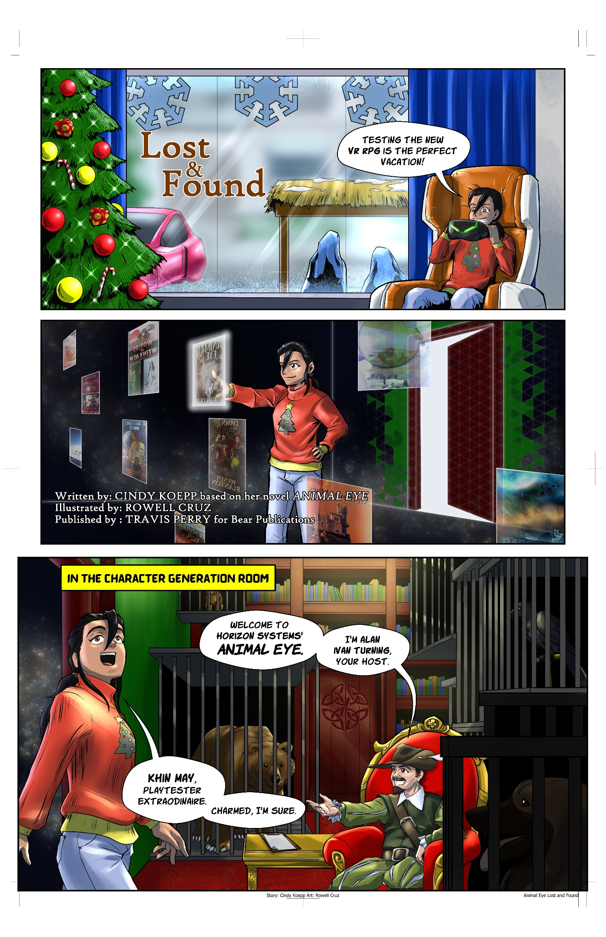
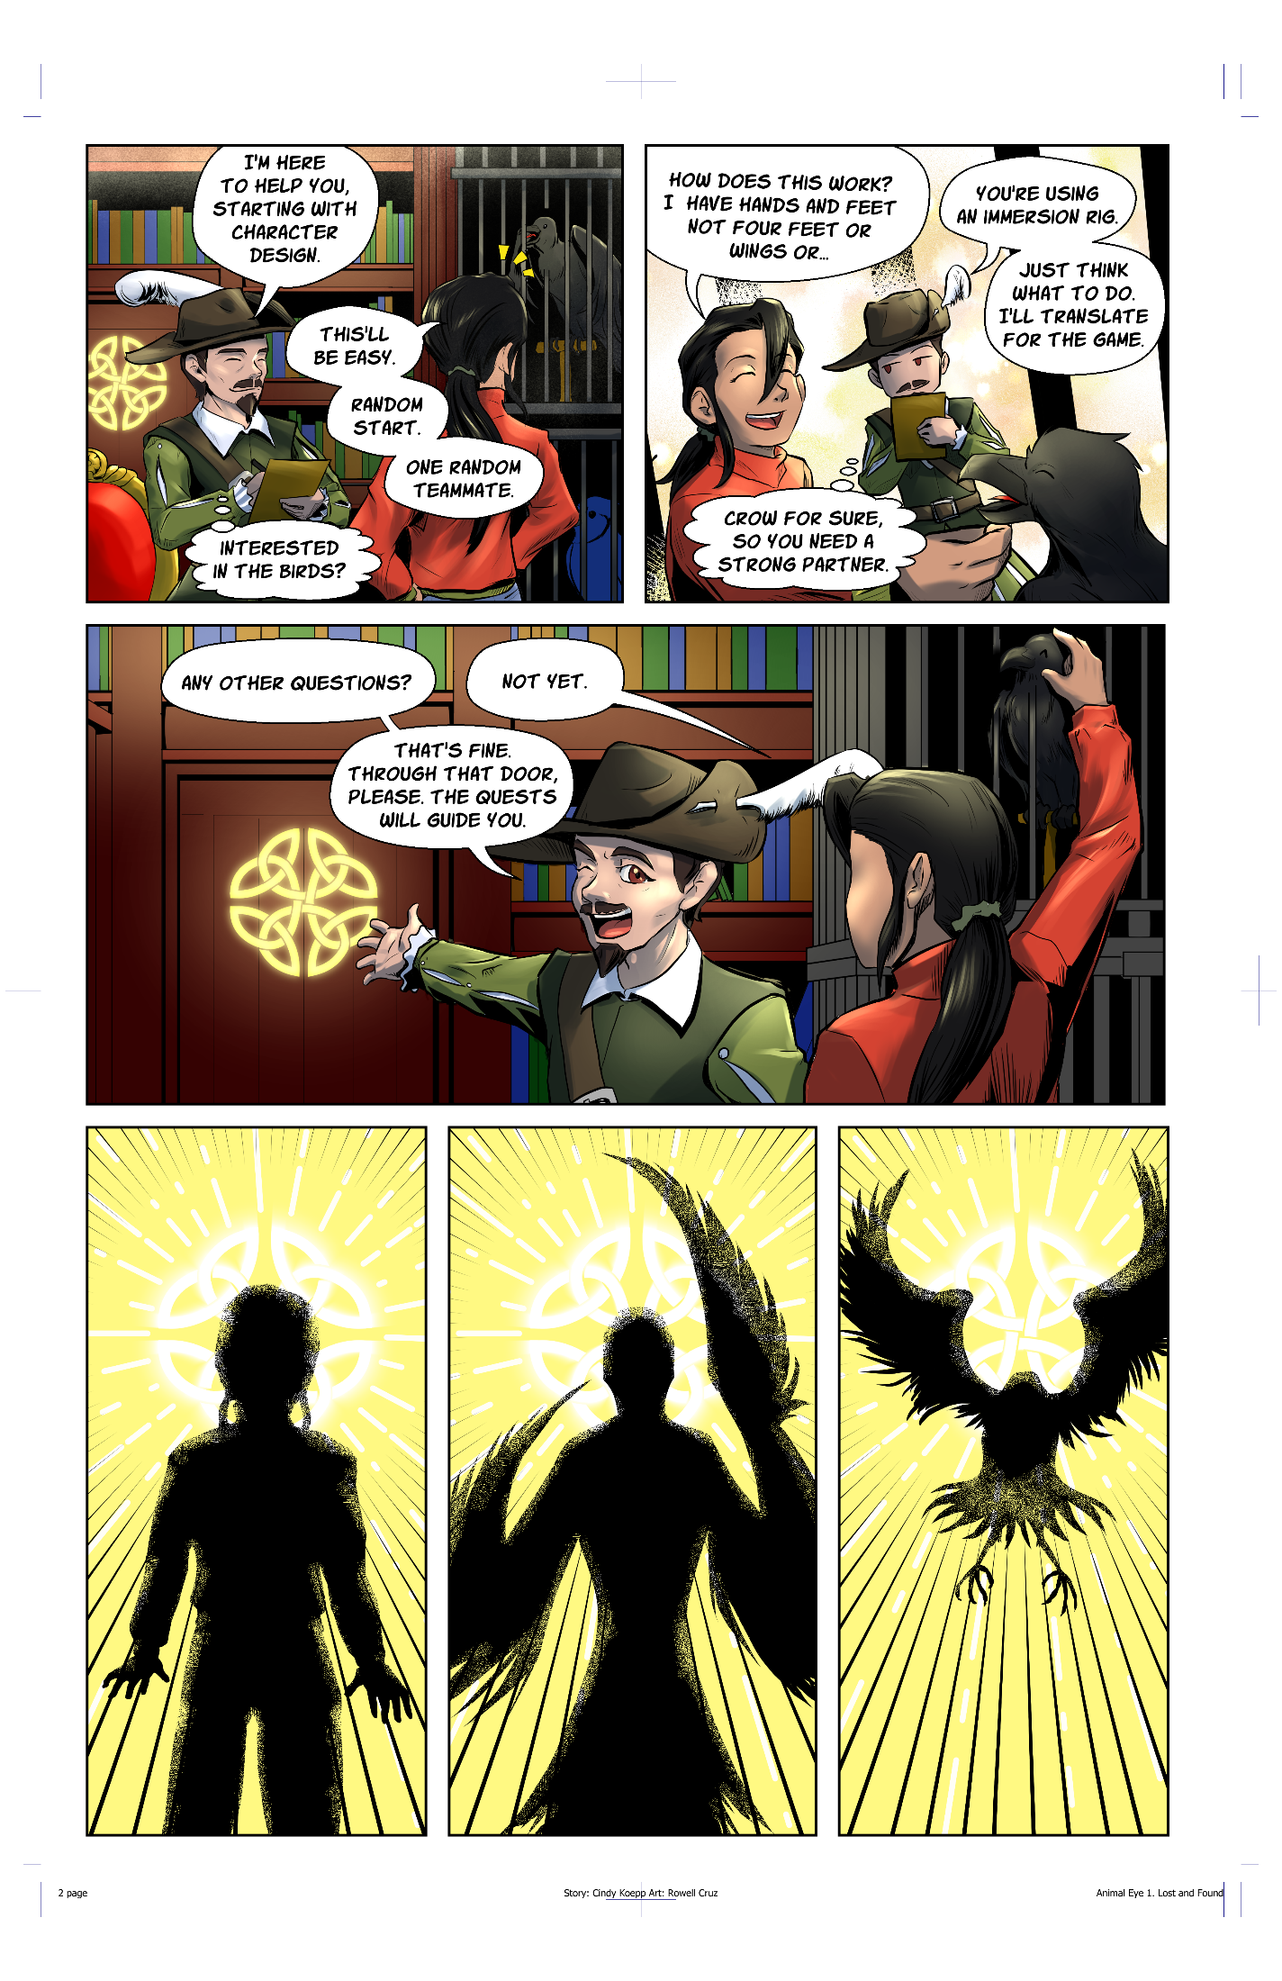
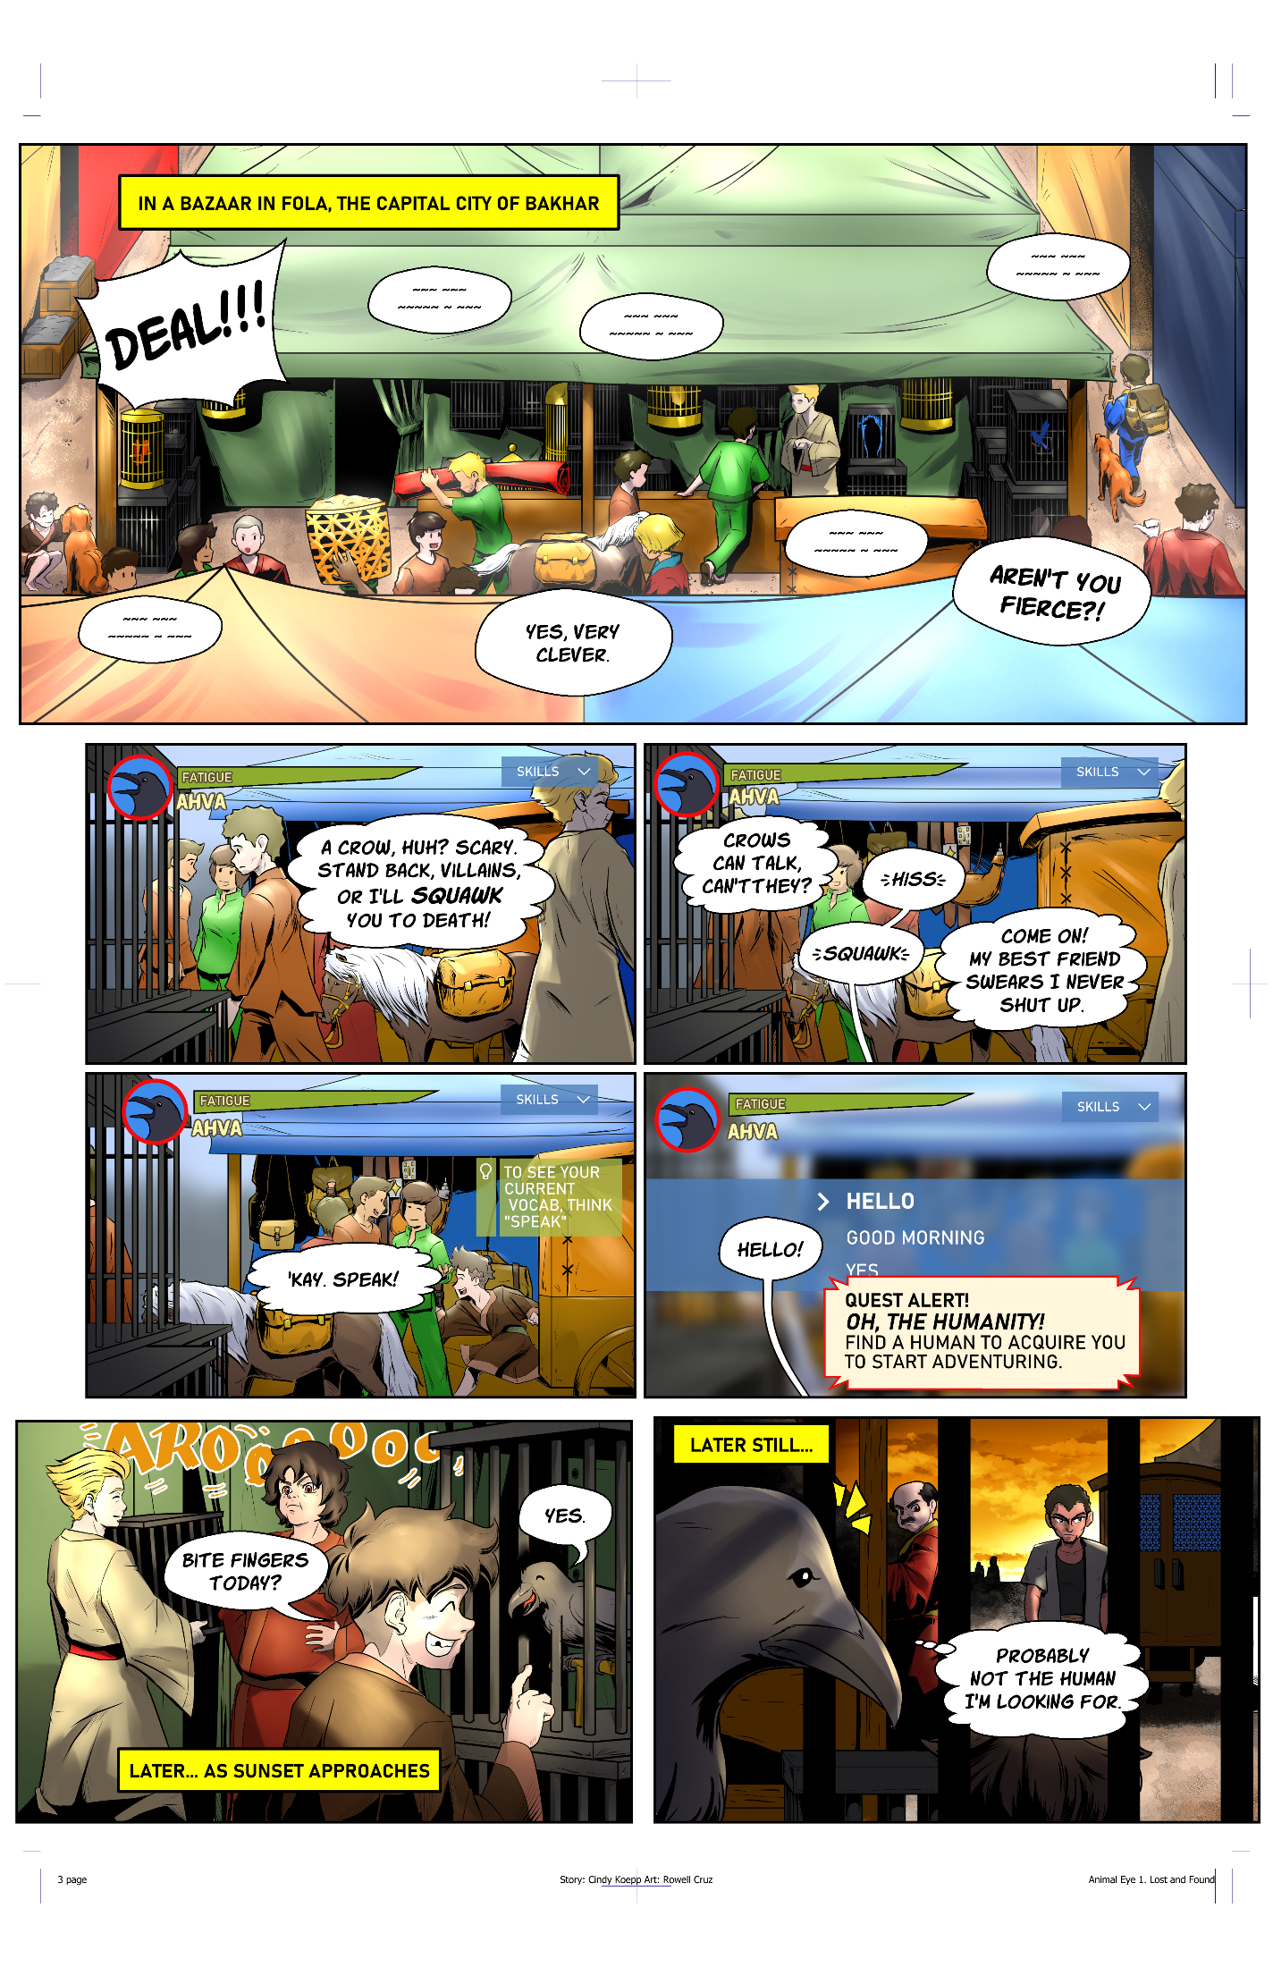
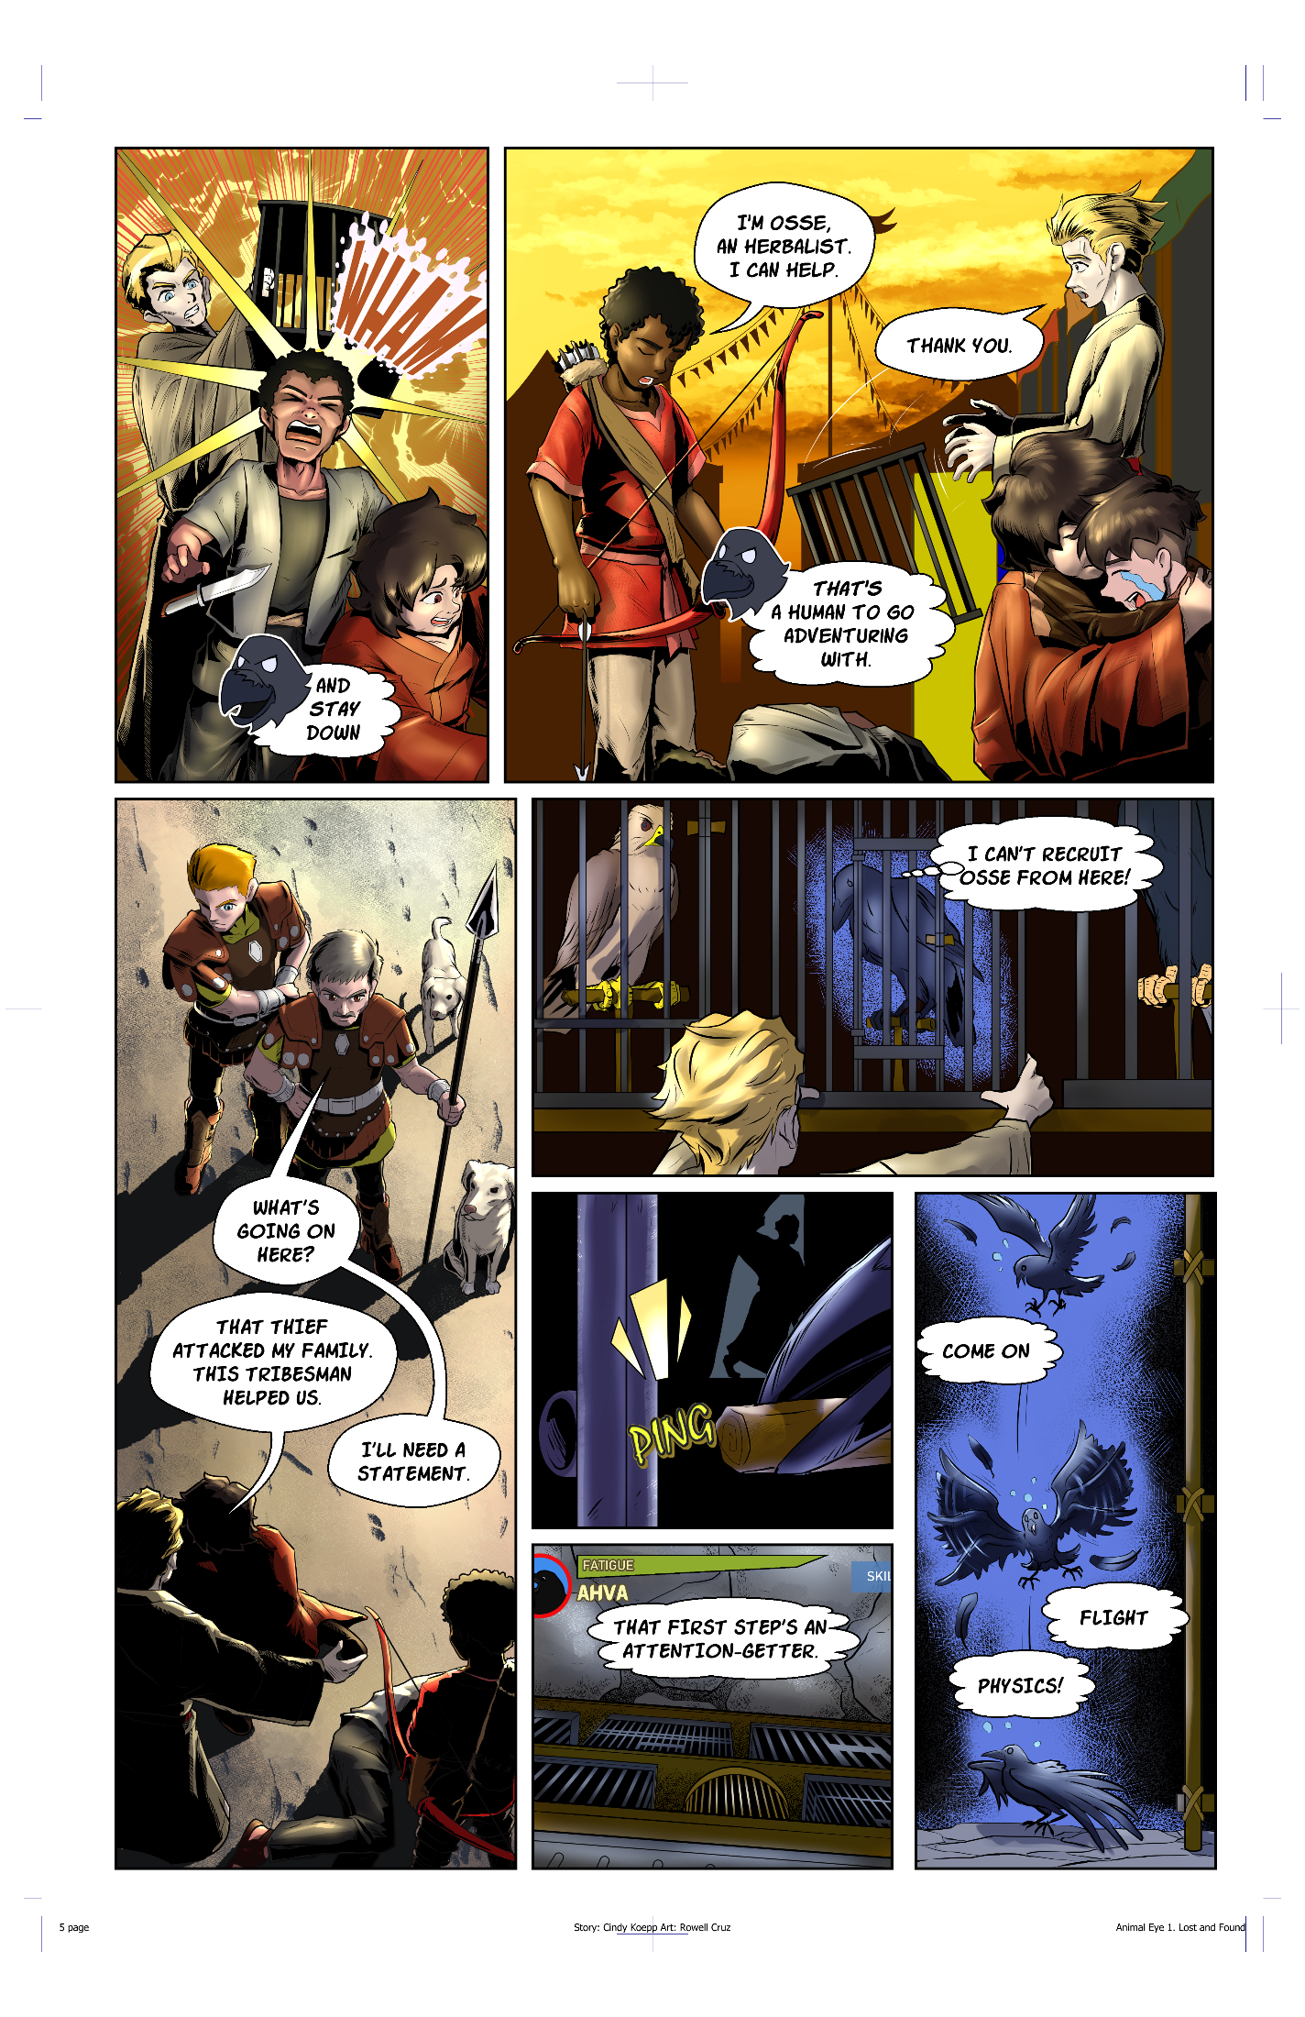

What’s the Story?
In Animal Eye, the newest AI-controlled VR-RPG from Horizon Systems, Khin May and Jake sign on as testers for a game that lets them play as animal companions to human NPCs. In a world that seems Renaissance-era, with swords and muskets, strange beasts lurk in the wilderness, pressing their attacks harder into civilized lands, laughing maniacs that can’t be killed by ordinary means.
Khin May as a sassy crow named Ahva and Jake as Nagheed, a Nethanyan mountain shepherd, along with their humans, learn the history of the game world and set out to stop the twisted mastermind behind the attacks…

Character Concept Art
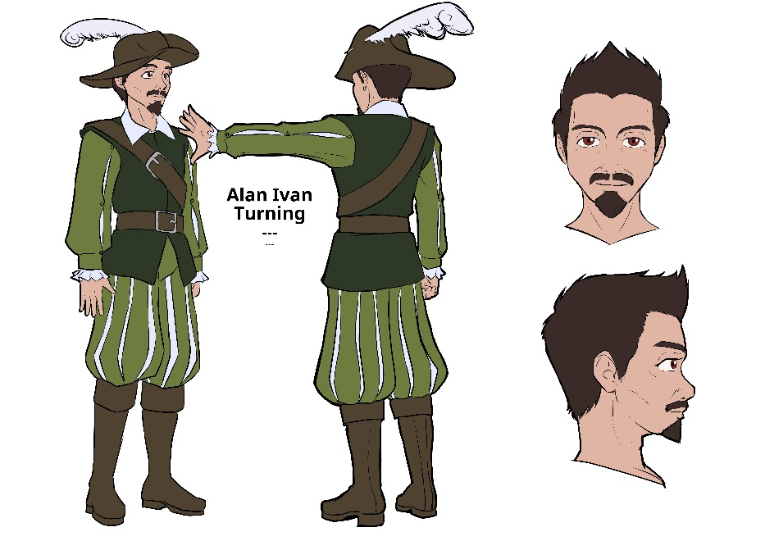
Alan Ivan Turning is the AI running the Animal Eye game. He helps the players design their characters and answers questions as things come up.
Although he can be a little stern at times, he does enjoy good jokes and expresses his weird sense of humor in the names he gives the quests.

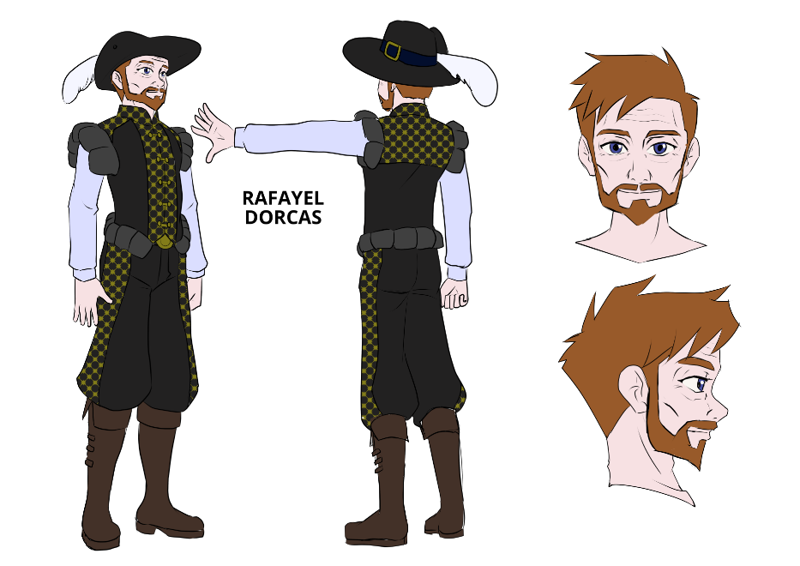
Baron Rafayel Michael Nicolaos Dorcas is in charge of the Barony of Yavne in Nethanya, the western-most country on the continent squished between a mountain range and the ocean coast.
He becomes Nagheed’s human while in the market looking for a large dog to protect his home while he’s traveling. His wife, however, has other ideas, and insists that Nagheed travel with him to even out any bad odds.
Rafayel is an expert with a rapier and very skilled with his black-powder pistol.
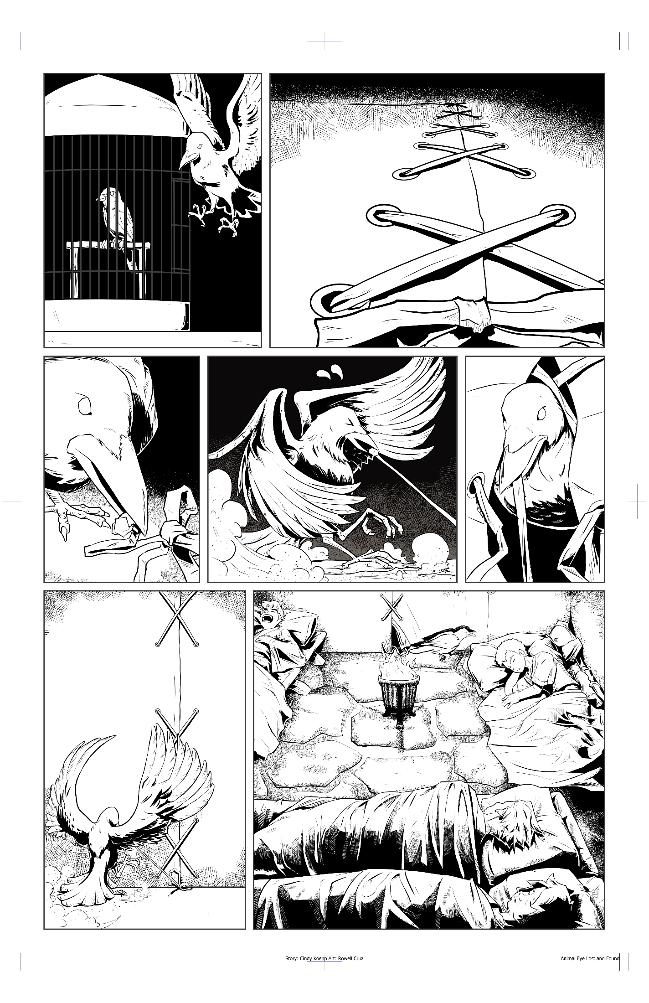
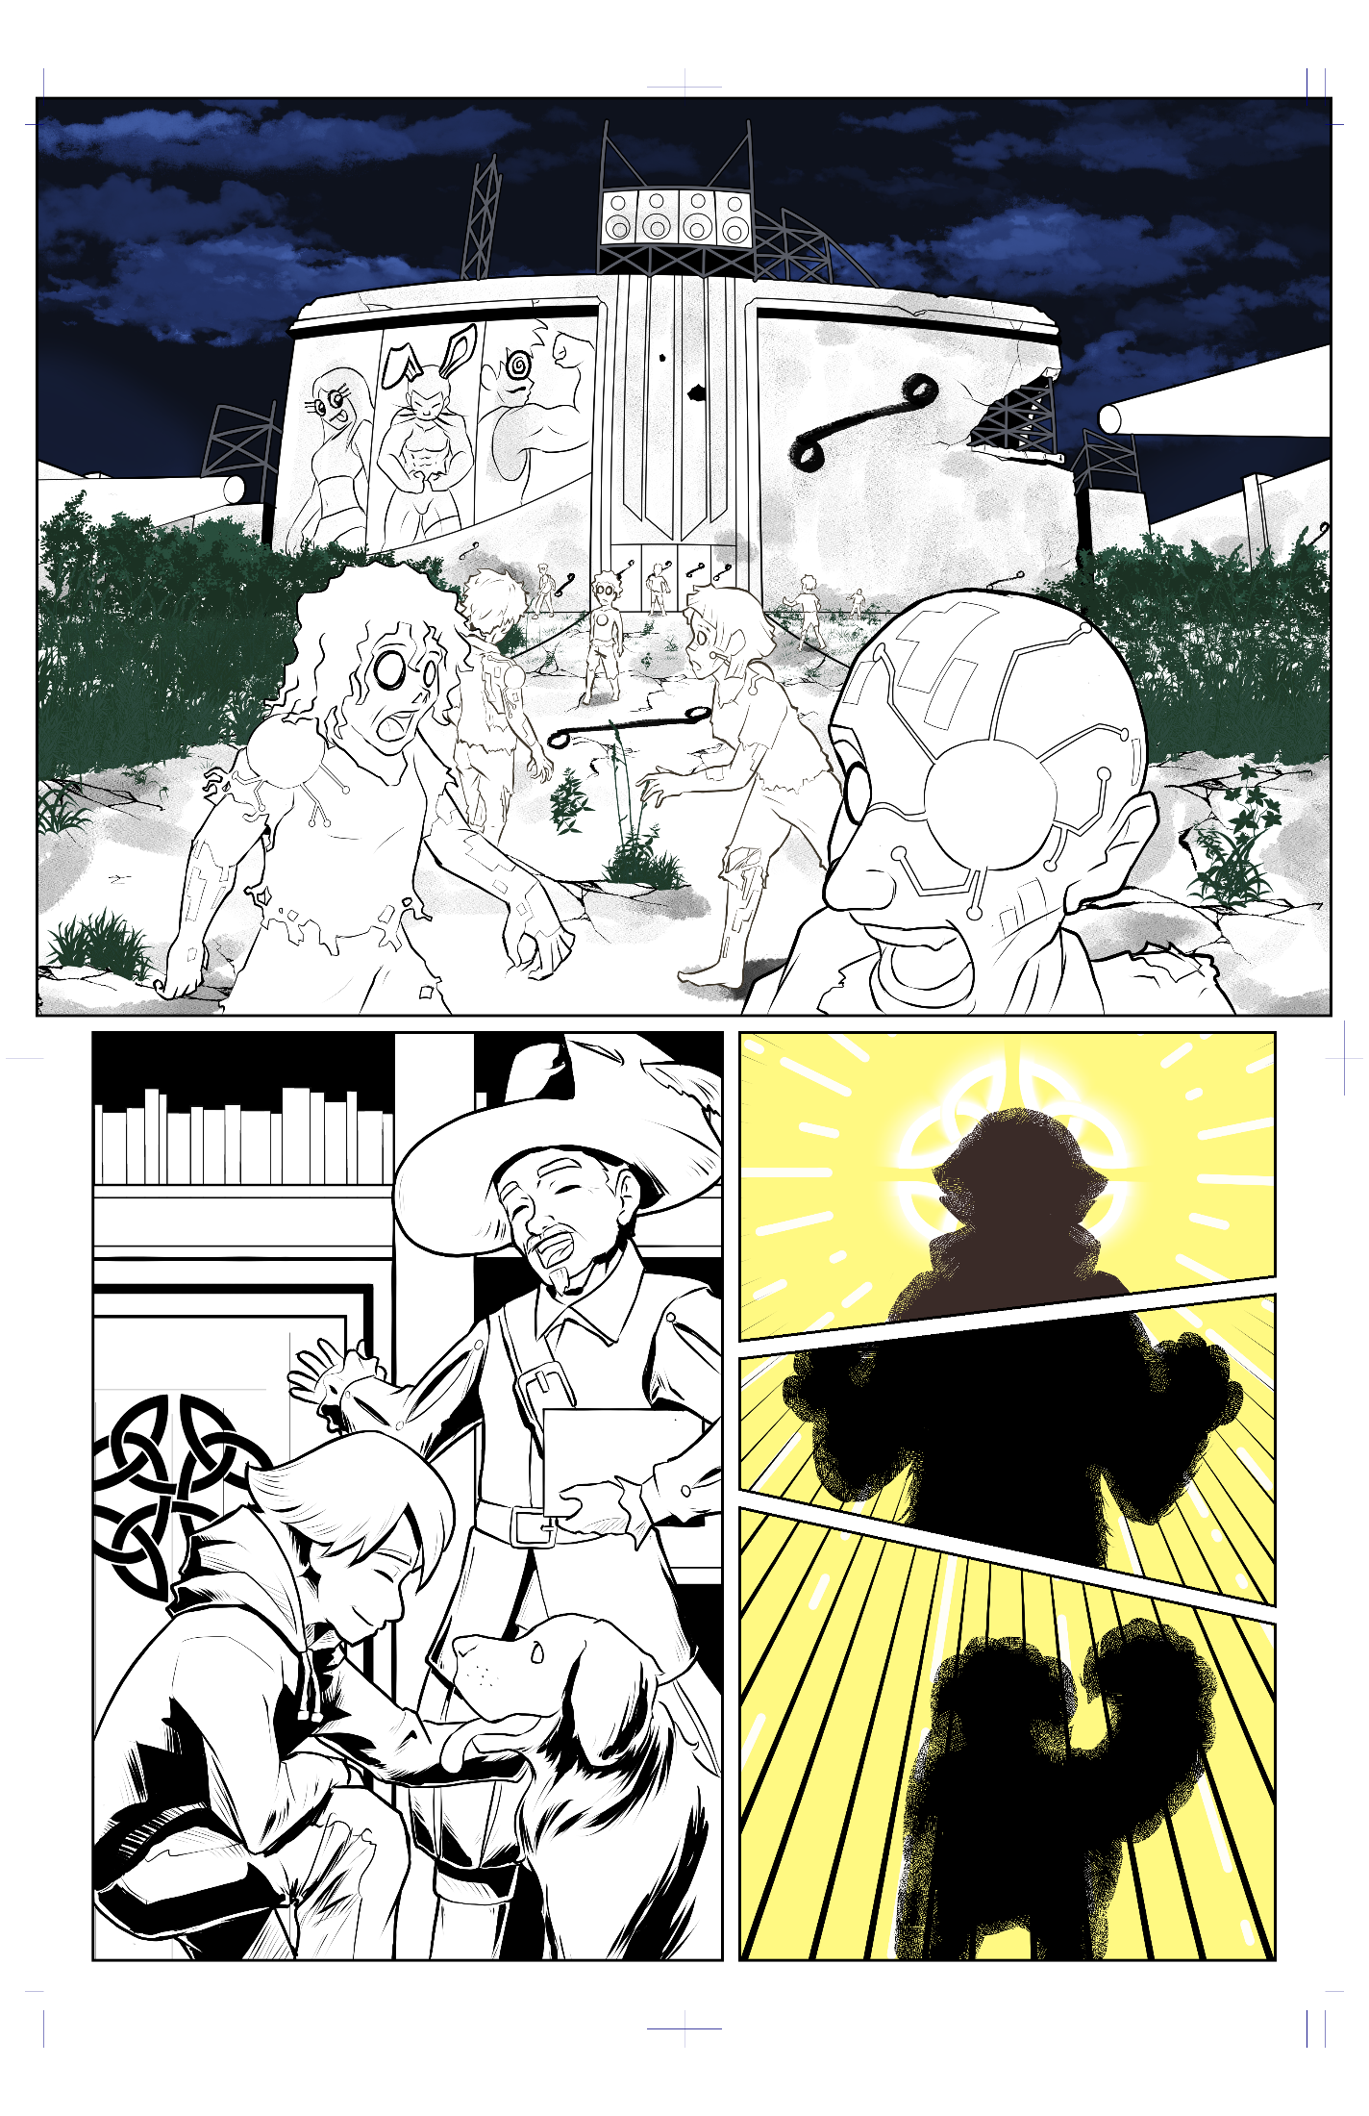
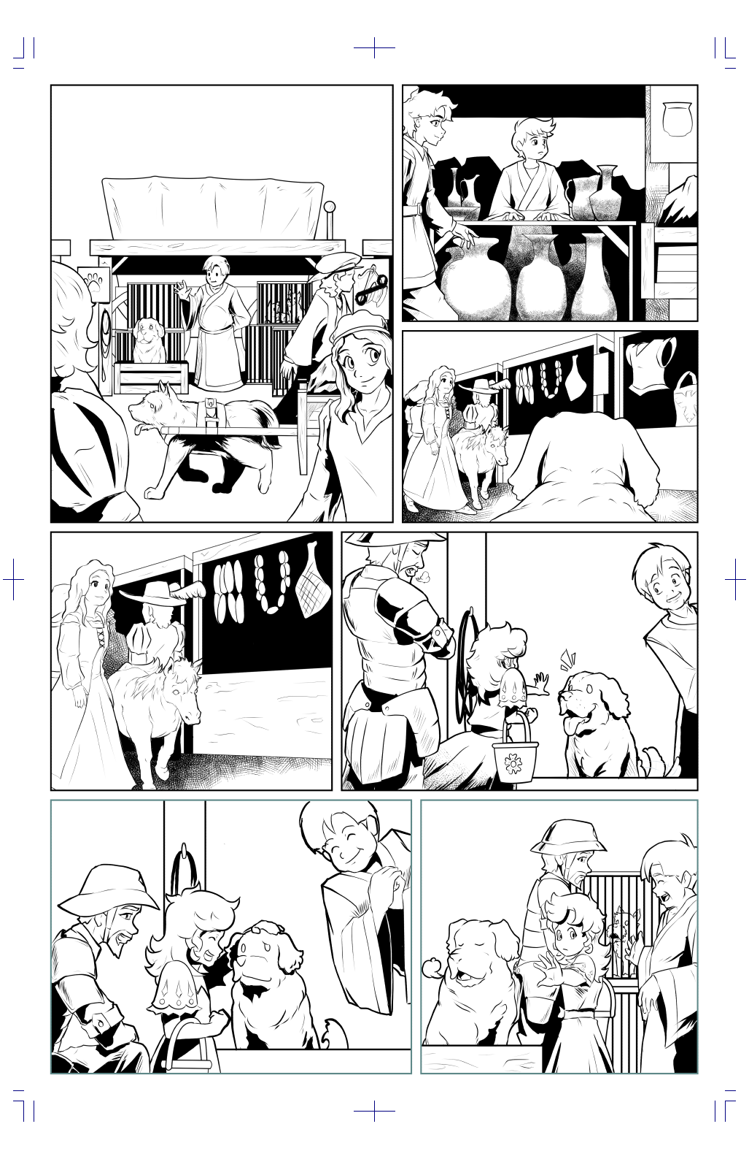
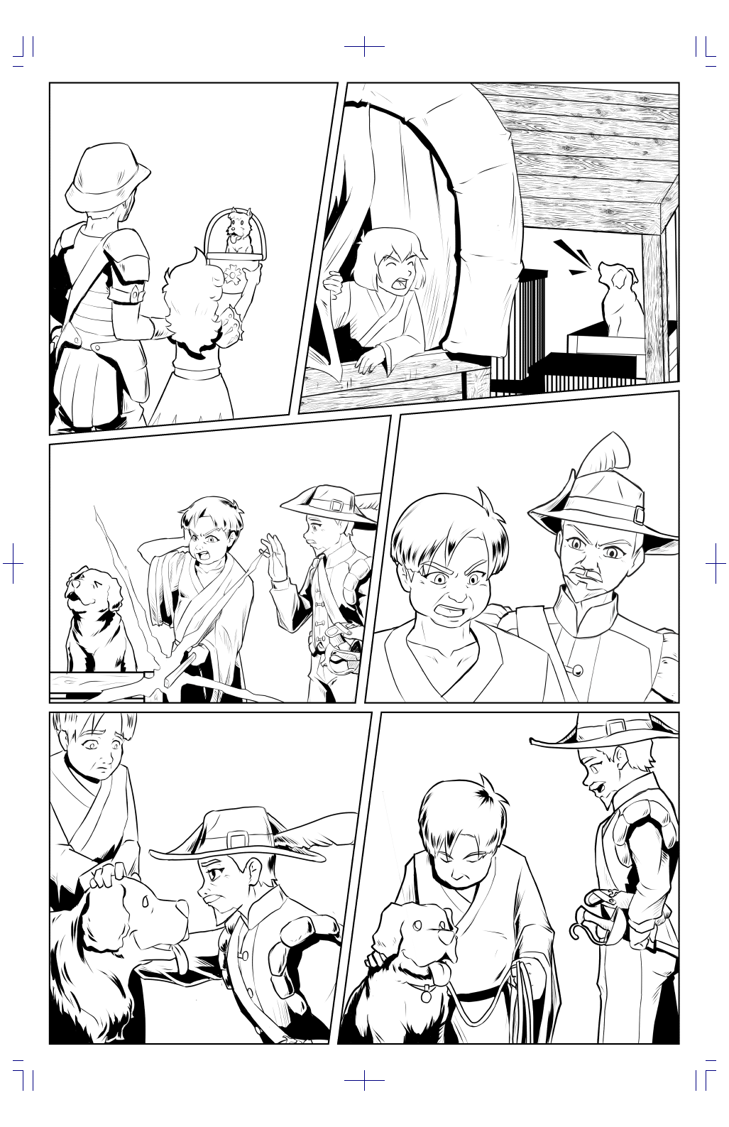
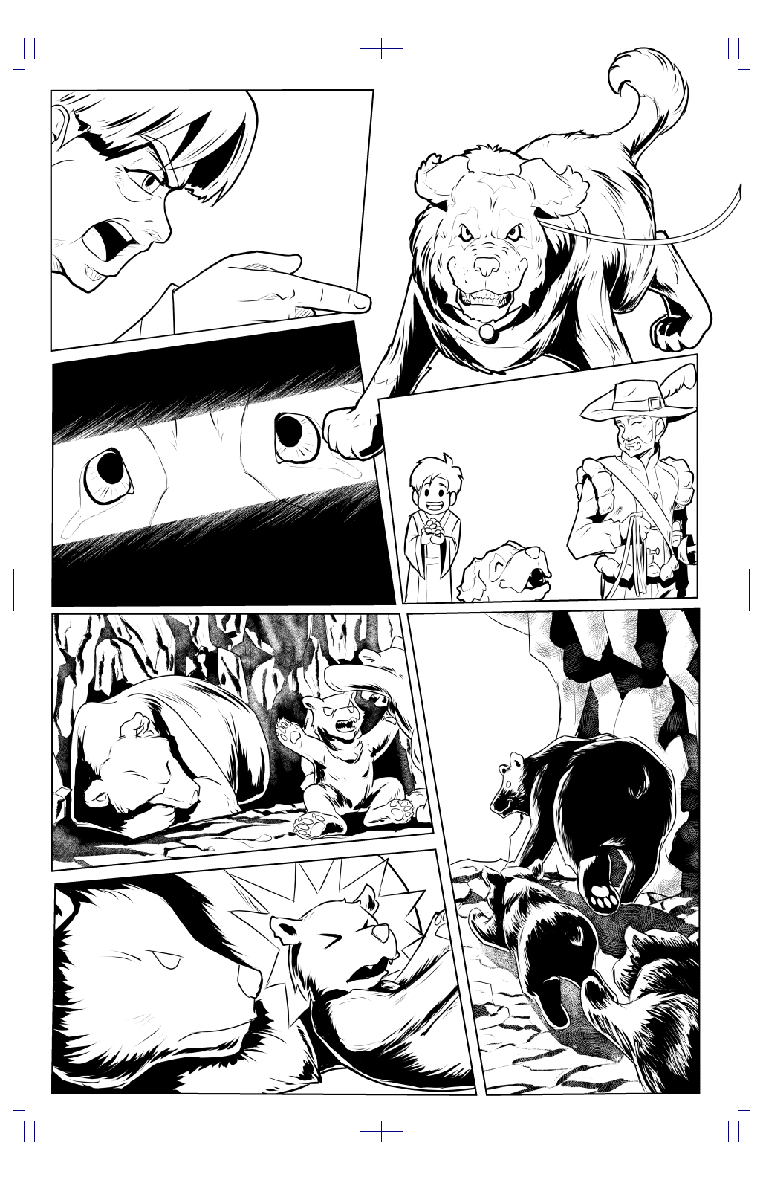

Where Did It Come From?
Animal Eye did not start out as GameLit. Nope. I wanted to write a story from the point of view of Masika, my African Grey. Not a story about an anthropomorphized parrot, but as an actual parrot, who interacted with the world as a parrot. I wrote it that way as Bird's Eye: The Novel in Need of a Better Name. As I plotted it out, it ended up being very quest-based, a string of individual tasks that each furthered the characters on their way to the goal.
In the midst of writing, rewriting, revising, editing, mutating, and otherwise trying to get this thing straightened out properly -- it had issues, man, serious issues -- I wrote "The Fall of the Invincible Man," one of my stories in Avatars of Web Surfer. It took place within a game scenario. (So does Heather Titus's story in that anthology, but a different game). Avatars of Web Surfer went through a convoluted path to publication and eventually landed with Bear Publications.
A pal of mine, who knew the plot of "The Fall of the Invincible Man," pointed me toward a podcast about a relatively new speculative fiction genre called LitRPG or GameLit. Like my novella, GameLit stories take place within a game scenario. I didn't even know that was a thing!
I contacted Travis Perry at Bear Publications and suggested that Avatars might work as GameLit with some tweaking. I mean, 2 of the stories already qualified. The rest wouldn't take that much of an overhaul to make it work. The publisher was game. The primary owner of the anthology, however, was not. In the discussion, I mentioned that I had a work of my own that I planned to convert to GameLit. After all, it was most of the way there already. It was already quest-based. I just needed to add the game mechanics and good to G.O.
Travis contacted me outside that discussion and offered me an agreement for Bird's Eye if I could get the rework done. The two of us worked together to build the game mechanics, and then I got to work reshuffling the story to make Animal Eye. It was retitled because the parrot was not the only critter involved. There were a dog and a bear, too.
As a sort of proof-of-concept for myself, I wrote "Seeking What's Lost," which is the origin story for Jael, the grizzly bear. "Seeking What's Lost" appears in Mythic Orbits, vol. 2.
Even after I finished the revision of Animal Eye, it sat for a long time in Bear Publications' queue. Other projects needed to be cleared out ahead of it. Eventually, it had its time to shine, and now it's there for all the world to see.
Most recently, Travis had the cool idea of having Animal Eye: Issue 1 translated into French, Spanish and Portuguese! Watch for those coming soon, too.

Character Concept Art
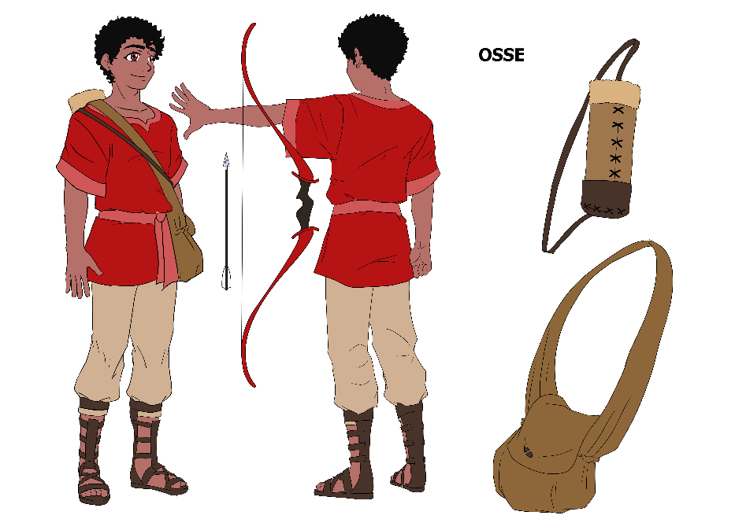
Osse Bente is a Bakhari tribesman from the southern part of Bakhar, in the center of the continent. He comes from a village near Kamali, the 2nd largest city in the country.
While running an errand to Fola, the larger city in the northern part of Bakhar, he helps out a merchant being robbed. In return, they give him Ahva.
Osse is a highly skilled archer.

Conversion to a Comic Book
A little more than two months after the release of Animal Eye, Travis contacted me and asked if I thought Animal Eye would fly as a comic book miniseries. Since I tend to visualize what I write, I knew it could work, but I didn’t know how. Fortunately, I have friends – like Brian K. Morris of Rising Tide Publications – who have published comic books before. He pointed me to some excellent resources and provided me with a few sample scripts.
I got busy. After perusing some of the resources and his sample scripts, I dove into breaking the novel first into 6 issues. Each issue had to have some significant plot action and end in a way that encouraged the reader to go get the next one. Some of the break points were obvious. Others were a bit trickier.
Once I had those major divisions established, each of the six issues needed to be broken into 24 pages. Pages need to end in a mini-cliffhanger so the reader feels the need to flip the page.
Next, each of those 24 pages has to be broken into panels. Each panel tells just one bit of the story. This was actually much trickier than it sounds. Writing a comic book script isn’t just copying the text of the novel and having it illustrated. Each panel has to tell a critical part of the story, and it has to involve things that the artist can portray. In a comic book, the art tells the story more than the words do although both are needed. Those in the know tell me that two consecutive pages shouldn’t have the same number of panels, and there is such a thing as too many panels on a page.
The last phase is to take each of the planned panels and write the description for the artist, the dialogue, the sound effects, the captions, and any other text on the panel. This was by far the hardest part. Each and every word on the panel hides art. Art is what tells the story, mostly. The trick was to include the smallest number of words I could to support the story and fit the characters. That was an exercise in tight writing.
When I had that script finished, Brian gave me his professional feedback on the first and the second draft, and then it was back to Travis for editing.
Meanwhile we looked for an artist. My own art skills are not entirely horrible, but they’re not nearly up to the speed needed to draw a comic book, even if I knew what the process was supposed to look like.
After putting a call out for artists, we held an audition for the half-dozen people who responded. I gave them Page 1 of the draft script to see what they could do with it. There are some very talented artists out there. That’s for sure.
At the end of the tryouts, Rowell Cruz, an artist from the Philippines, signed on. The artwork for Issue #1 is finished now and work on Issue #2 will begin soon.

Character Concept Art
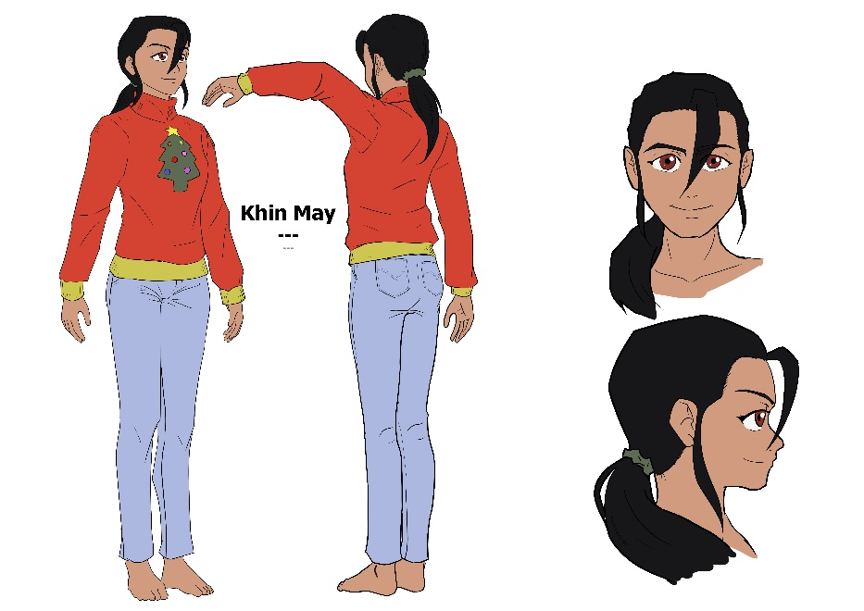
Khin May is a 3rd generation Burmese refugee. She has a week off from her day job just after Christmas and plans to spend that week playtesting Animal Eye.
Not interested in a lot of complicated character-building, she tells the AI to give her a random character with one partner. Alan sets her up as Ahva, a crow.
Khin May is a pop culture fan and loves a good joke.

From Novel to Script to Preliminary Art to Final

Tracking Page 5, Panels 5-7 Through the Process.
The first part of this adventure was learning how comic books do their thing. It’s not just a bunch of pretty pictures with text. There’s actually a purpose and some time-honored strategies for organizing everything. Converting the novel was not simply parsing the novel’s text into 3-7 panels per page.
Check out this process!

Here’s the text from the Animal Eye novel as it relates to page 5, panels 5-7.

Gotta get that door open.
Her Cleverness and Agility attributes were good. Maybe they’d work together with the Sneak skill and do something worthwhile.
With her beak and feet, Ahva pulled herself around the cage to the door. The locking mechanism was a simple inverted cone-shaped peg crammed through the holes in the two metal plates that lined up when the door closed. Not exactly complicated. A smart, resourceful bird would have such an easy lock sorted out quickly. Social media was full of videos of parrots, ravens, and crows solving complex puzzles more robust than the “get the peg out” type.
Using her foot hadn’t worked so well. Maybe her beak would be a better choice. Ahva tried first from the space between the bars on one side of the peg then the other. She could tap the peg, but her beak would need a hinge to be able to grab it. Next, she tried biting around the bar but her beak wouldn’t close enough to get a purchase on the peg.
She huffed and hopped back to her perch. She had to get the peg out! Getting it from the top was no good.
Could nudge it from the bottom, maybe.
She hopped back to the front of the cage then slid down the vertical bars until her head was below the bottom of the peg.
Ahva reached through and smacked the bottom of the peg with the top of her beak. After sliding up a centimeter, the peg dropped back down to its original spot.
Okay. This can work!
Ahva pushed the peg up until the bottom was almost to the top of the rings on the cage and door. She twitched her head up.
For just a moment, the peg nearly flew free, but it lost momentum too fast. It tilted slightly and caught on the edge and wobbled side to side.
At least it didn’t fall back in. Ahva nudged the door with her shoulder, and the hinge gave the smallest squeak as it slid open.
She hopped into the opening and squawked. “Done!”
The notebook turned blue, and Ahva opened it. New skill: Problem-solving.
She checked the other bird cages. They, too, had simple pegs securing the doors. Should I spring them, too?
Some of the larger birds eyed her with a combination of suspicion and disgust.
Nope. Don’t need that headache. If they want out, I just showed them the way. Hope they were watching.
Ahva crept to the edge of her cage and peeked over. Naturally, her cage had been one of the highest, and the floor might as well be a few kilometers down to packed dirt. The confines of the cage hadn’t given her a chance to figure out flying.
No time like the present!
Ahva climbed up to the top of the cage and held onto the bars with her toes. She spread her wings and flapped like mad. Her grip was harder to maintain but not because she was getting any vertical force.
What was she not doing?
Flight looks so easy when birds do it.
Ahva folded her wings and paced the diagonal of the cage top. Months ago, she’d watched a documentary on the miracle of flight. Whether bird, bat, plane, or helicopter, the concept was the same. Flight physics mattered. Her lift had to exceed gravity and thrust had to exceed drag. She needed more airfoil, the curve difference between the top and bottom surfaces of her wings.
She strutted to the cage edge again. Ahva flapped hard, tipping her wings at different angles to find the best one. When the beating of her wings created an upward pull, she let go of the cage and lifted off.
I’m flying! I’m actually flying!
She looked down at the floor below for just a moment then back up again at the canvas wall of the tent filling her entire forward view.
Brakes! Whoa!
She closed her eyes and turned her head as she smacked straight into the canvas above the cage opposite her own. When she thudded onto the top of a bluejay’s cage, the occupant fluffed up and hissed.
“Sorry. Sorry!”
Ahva twisted around as the jay climbed up the bars with murder in his eyes. Flapping like crazy, she took off again as the jay’s beak closed on the bar where Ahva had been a moment before.
Grouch!
The far wall of cages raced closer.
Flight physics. Reduce lift on one side to turn.
She adjusted the angle of one wing slightly and started to roll but continued in a straight line.
Rudder!
Ahva swished her tail to one side and banked sharply, missing a falcon’s cage by a couple centimeters. The wind ruffled her feathers and the cages swept past her at a phenomenal rate. A rush of warmth through her had her laughing out loud, a passable imitation of Callen’s chortle.
WHOO!
She continued flying around until her fatigue bar had dropped to halfway. By then, she had figured out all the necessary maneuvers, including landing, with some measure of competence better than accidental humor.
Next step. Get next door and get that human’s attention.

The script came next.
Notice how much less text is involved. Comic books are much simpler in that regard because the picture carries much of the story.
PANEL FIVE: CALLEN is leaving through the tent flap. AHVA’S cage is held closed by a peg through a hole in the door and the frame. She smacks it loose with her beak.
10 SOUND EFFECT (FROM THE PEG): PING!
PANEL SIX: Looking down from AHVA’S POV at the edges of the shelves and cages below her and the stone floor.
AHVA’S fatigue meter is showing full (green).
11 AHVA (THOUGHT): THAT FIRST STEP’S AN ATTENTION-GETTER.
12 GAME OVERLAY LABEL (LEFT, NEAR THE CROW ICON): AHVA
13 GAME OVERLAY LABEL (CENTER, ABOVE THE FATIGUE METER): FATIGUE
14 GAME OVERLAY LABEL (RIGHT, ON A DROP-DOWN): SKILLS
PANEL SEVEN: Back to Omniscient POV. AHVA is flapping like mad.
15 AHVA (THOUGHT): COME ON FLIGHT PHYSICS!

Rowell’s Preliminary Art for That Text
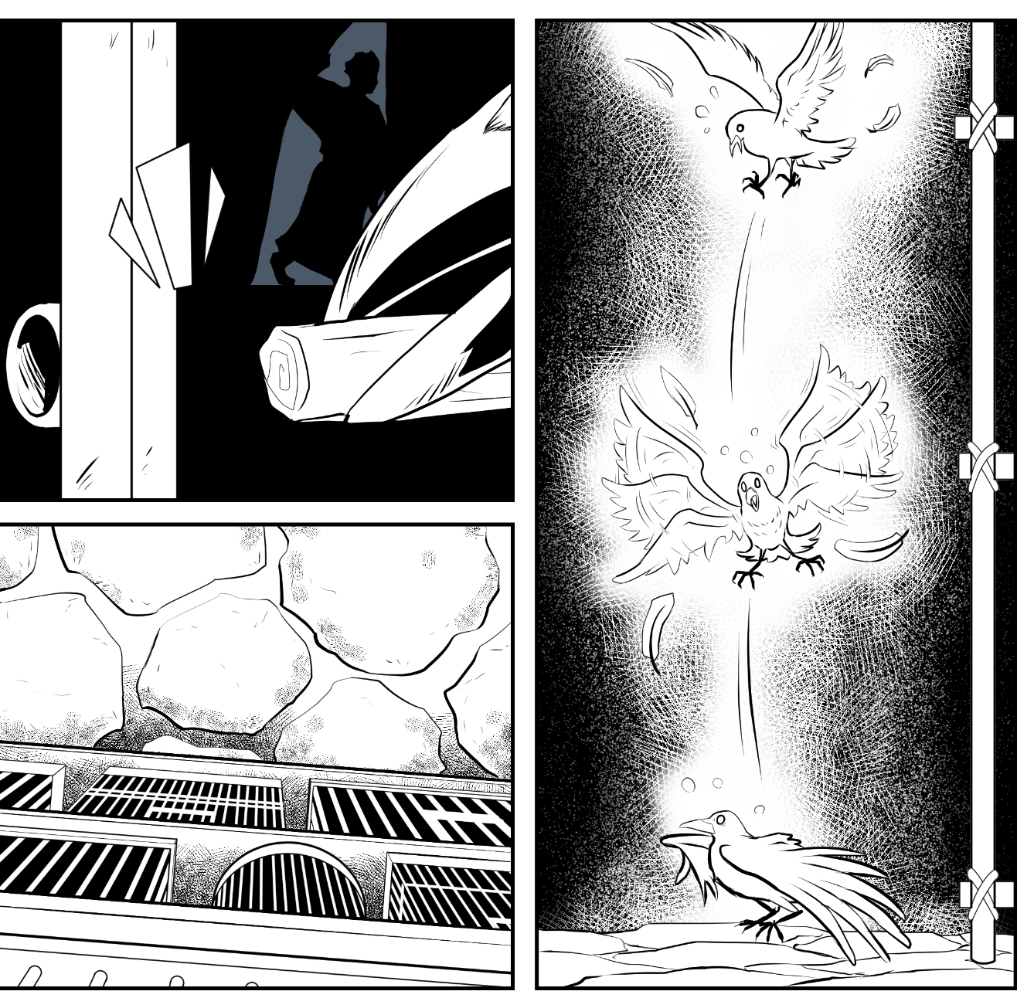

And the Final Art
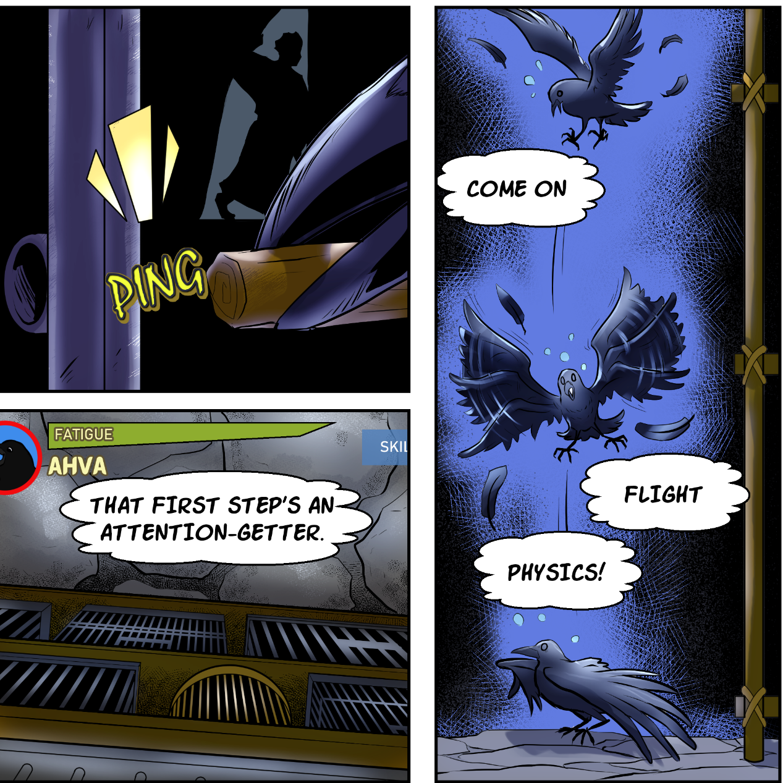

Character Concept Art
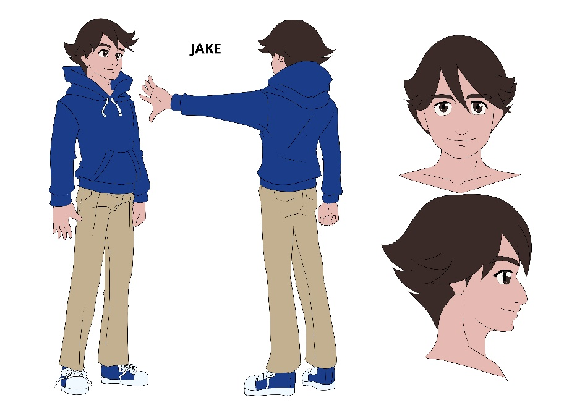
Jake is Nagheed’s player. He’s a college student studying history. He chose to play a Nethanyan mountain shepherd because the appearance was similar to his much smaller half-chow, half-shepherd Prince.
Nagheed’s breed is based on the Russian ovcharka, a huge, fuzzy dog.

Contact Links for Rowell, Cindy, and Bear Publications

Rowell Cruz
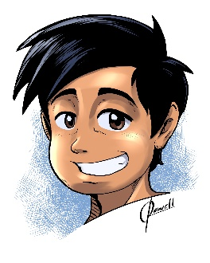
Rowell Cruz is a self-taught digital illustrator from the Philippines. He specializes in a fusion of Japanese Animé and American Comic Book art styles. He has an ongoing digital webcomic entitled Kali, which is free to read on Tapas and Webtoon.

www.deviantart.com/rowell-cruz
www.facebook.com/rowellcruzart
www.artstation.com/rowellcruz

Travis Perry
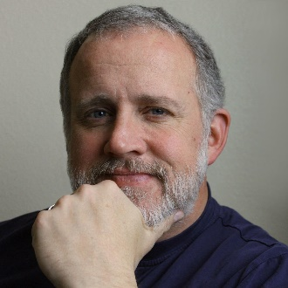
Travis Perry is an Army Reserve officer, a veteran of the Gulf War and the wars in Iraq and Afghanistan who writes about warfare, science fact and fiction, and other assorted topics both on the Speculative Faith blog and his own personal blog. And he's a short story writer and novelist and owner of Bear Publications. (He also likes video games and thinks Animal Eye would make an awesome video game--but first, let's get the comic out!)
https://speculativefaith.lorehaven.com/
https://travissbigidea.blogspot.com/

Cindy Koepp
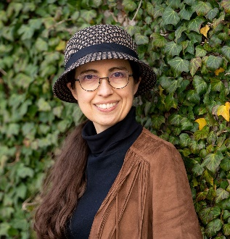
Originally from Michigan, Cindy Koepp combined a love of pedagogy and ecology into a 14-year career as an elementary science specialist. After teaching four-footers – that's height, not leg count – she pursued a Master's in Adult Learning with a specialization in Performance Improvement. Her published works include science fiction, fantasy, and GameLit novels; a passel of short stories; and a few educator resources. When she isn't reading or writing, Cindy is currently working as a tech writer, hat collector, quilter, crafter, and strange joke teller.

Ckoepp.com
Patreon.com/CKoepp
Facebook.com/KoeppC
Bit.ly/CKoeppAmazon

Acknowledgements
The creative crew for Animal Eye would like to thank these fine folks for their help and support. Check out their work!
Promotional Help

Brian Rodman
Nicholas Anthony Tockert
Christian Basel
John B. Pyka
Eric Hawkins
Luke Stone
Ryan Permison
Pops Van Zant
David Tilley

Promotional Help, Editing, and Feedback Coloring Assistant
Brian K. Morris Denver Martirez

Translators
Spanish: Travis Perry and Tabatha Catalan Guerrero
French: Annie Morris and Kendra LaLonde
Portuguese: Magda Bizinha, Ivani Greppi, Alexsandro Mariano
