Le Petit Infant Toddler Academy, LLC



1001 Pennington Road • Ewing, NJ 08618

(Office) 888.315.5666 (Fax) 888.303.0131. www.LePetitinfanttoddler.com

Parent/Guardian Handbook

Website: www.lepetitinfanttoddler.com
Located in historic Ewing, New Jersey on the beautiful campus of Ujima Church Ministries, Le Petit Infant Toddler Academy, LLC was founded in 2019 with a burning desire to have a positive impact on the development of students during the critical and ever so important foundational years. Our objective is to Educate Precious Minds for Bright Futures. We strike the right balance for our students with a student-centered approach to learning that is built on fundamentals, a Spectrum Curriculum, and a positive environment for Personal and Social interaction.

Educating Precious Minds for Bright Futures
Dear Families:

It is an honor to be given the opportunity to serve your child and I would personally like to welcome your family to Le Petit Infant Toddler Academy, LLC. We are thankful you have chosen the academy for your child’s well-being and early learning education.

It is the desire of our hearts to provide all our students with a loving environment where they are given exceptional care. It will be extremely helpful and I encourage you to review the Academy Handbook carefully to ensure the best education and care for your child. It is important that each parent review the policies and practices that are followed at Le Petit Infant Toddler Academy. The Academy’s Parent Policy Handbook has been prepared with the purpose of serving as a guide and information resource for our families as well as staff. Please familiarize yourselves with the enclosed information, as I am sure it will be useful in the future.

It is an honor to once again be given the opportunity to serve your child. We realize that the handbook may not cover every aspect of the student’s day, so please feel free to contact me with any suggestions and comments you may have. Your participation in the school is very important to me as it strengthens our commitment to serving your family. I look forward to the many memories that will be shaped as the student enjoys their early learning years.

If you should have any questions, comments, or concerns, please don’t hesitate to let me know. My door is always open, and I am here to help make your Academy transition a smooth one. Le Petit Infant Toddler Academy teachers and staff are here to work together with you to make these magical early learning years special!

Again, thank you for enrolling your child in our Academy and becoming a part of our Le Petit Infant Toddler Academy family.

Fondly,

Dr. Ruby Burrows-Smith
Table of Contents
Mission Statement 6
Philosophy 6
Hopes/Core Values 7
Children Behavior & Expectations 8
Teasing and Bullying 10
Positive Guidance & Re-directing 12
Levels of Consequences 14
Non-Discrimination Policy 17
Sexual Harassment Policy 17
Mandated Child Abuse & Neglect Reporting 17
Curriculum & Instructional Practice 17
Classroom Daily Schedule 47
Field Trips 23
Measuring Student Progress 23
Goals for Family Involvement 24
Early Childhood Development & Health Services 25
Policy on Methods of Parental Notification 27
Custodial & Non-Custodial Parents 26
Academy Calendar 26
Academy Holiday & School Closing Calendar 26
Confidentiality Statement 29
Department of Children & Family Services (DCFS) 29
Complaint Process 30
Notes Sent Home 24
Change in Home Routine/Contact Information 25
Parent Concerns/Complaints/Comments 31
Arrival & Departure/Classroom Information 33
Dismissal Time/Late Fee Assessment 26
Attendance Policy 18
Policy on use of Technology & Social Media ..…………………………………… 33
Emergency School Closing Procedures 35
Return to school after Absence 36
Health Policies 37
Chronic Health Conditions 38
Immunization Requirement & Records 38
Absences Due to Illness 39
Medication 39
In-School Illness 40
In-School Injury 40
In-School Health Services 41
Safety & Security 41
Building Security 41
Lunch & Snack 41
Bedding & Nap Time 42
Toys 42
Bathroom Policy 43
Potty Training Policy 43
Birthday Celebrations 43
Transportation 42
Policy on the Release of Children 44
Department of Children and Families Information to Parents 44
Expulsion Policy 15
Policy on the Management of Communicable Diseases 37
Reporting Requirements for Communicable Diseases 46
NJ Dept of Health COVID-19 Operating Child Care Program…………………………………47 - 55
Public Playground Safety Checklist 47
School Closings Calendar 48
Tuition Payments & Fees 49
Tax Statement 50
Withdrawal Policy 45
Acknowledgement of Receipt of Handbook 51

MISSION
- To provide high quality individualized educational experiences to a diverse student body;

- To support the development of the child as a whole – intellectually, physically, socially, morally and spiritually;

- To prepare each child to be successful in their secondary education;

PHILOSOPHY
- We believe that children are born with the potential to grow, develop and learn and that they have the right to have this potential nourished.

- We believe that each child is an individual with special gifts that should be celebrated and special needs that should be met.

- We believe that families are the first and most important teachers for the child and that schools and families must be partners

- We respect and welcome cultural, racial, ethnic and religious diversity among our children, families and staff.

- We believe that children do their best when they are in a caring environment with clear guidelines and high expectations

- We believe that making mistakes and learning from them is how we gain wisdom and maturity.

- Le Petit Infant Toddler Academy, LLC believes in giving children a chance to grow up happy, healthy, and confident by providing them with the educational, social, medical and nutritional services they need. Our philosophy respects parents/guardians as partners in promoting the student’s development according to the individuality of the student.
- We provide children-oriented classrooms. A children-oriented classroom is one in which the space and activities are appropriate for all students according to their development. The activities, equipment and materials must represent the interests of the student, be appropriate to their developmental levels, and be culturally sensitive.

- In addition, many support services are offered to families. The program supports parents/guardians in their roles as the primary educator of the child. Workshops and training sessions that address issues of parenting and child development are available. Information regarding support services in the community is provided in an effort to help meet the needs of the family.

HOPES FOR OUR STUDENTS

- Children will develop an enthusiasm for learning;

- Children will strive to achieve their fullest potential;

- Children will respect the dignity and rights of others;

- Children will develop into positive leaders.

- Children will contribute to the well-being of our school community and welcome opportunities to help others.

WE ARE COMMITTED to providing a variety of experiences for children and parents that will enhance the child’s development.

WE ARE COMMITTED to working with the family as a whole.

WE ARE COMMITTED to nurturing, self-sufficiency, positive self-images, and respect for cultural diversity.

OUR CORE VALUES

Core value: Being brave
“Courage is not simply the mastery of fear through physical strength; it is that quality that springs from a certain type of spirit, honor and integrity.” Michel de Montaigne

Core value: Being a friend
Loyalty involves duty, a sense of commitment and community, knowledge that each of us is a part of something greater than us.

Core value: Being fair
Justice is the quality of being guided by truth, reason and fairness. Justice encompasses respect and understanding.

Core value: Showing respect
Respect involves patience, open-mindedness and regard for differences among us – whether these differences are related to traditions, age, gender, race, religion, native language, economic level, or whatever distinguishes one human being from another.

Core value: Wishing/Having hope

Hope is linked to faith and aspiration. It elevates one beyond selfishness to nobility as it looks to the future for all people.
Core value: Telling the truth

Honesty, the quality of being honorable, is a fundamental condition for friendship and community. “For he who is honest is noble whatever his fortune or birth.” Alice Carey

Core value: Caring

Love, like compassion, is a virtue of action as well as emotion. Love is the one thing we can continuously give and become increasingly rich in the giving.
CHILDREN BEHAVIOR & EXPECTATIONS

Good Manners at School

Children at Le Petit Infant Toddler Academy are expected to use good manners and show respect for themselves, fellow students, academy staff, and visitors. Children will be taught and encouraged to:

- Say “please” and “thank you;”
- Not interrupt a conversation;
- Greet adults with a “hello” or “good morning;”
- Use an “inside voice” in a building;
- Walk, don’t run, in a building;
- Say “excuse me” and wait for someone to move aside rather than pushing past;
- Use the appropriate title for adults, such as “Ms.” or “Mrs.,” “Mr.,”
- Raise their hand to be called on in class, rather than shouting out the answer;
- Use correct English and avoid using slang in school;
- When asked a question or to do something, answer verbally by saying “yes;”
- Be respectful in word, act and attitude.

Dress Code & Clothing Policy

Our goal is to have boys and girls dress in a God-honoring manner. The Bible uses the term “modest” to describe such fashion. Le Petit Infant Toddler Academy want to see its boys and girls grow up to be fine young gentlemen and ladies. It will take your cooperation to promote the type of atmosphere we desire to have at Le Petit Infant Toddler Academy.

In this regard, parents have the responsibility for sending their children to school with correct dress and grooming. Therefore, academy students are required to always be in appropriate dress attire.

Our curriculum includes playtime and floor exercises, so we strongly recommend that the children be dressed in comfortable play clothes.

It is important that children are dressed in clothing that they can manage. The child should be able to toilet without requiring staff assistance and be able to dress for the outdoors. Please do not put “onesies”, shirts that snap at the crotch, on your child. Children have a hard time unsnapping them quickly when rushing to go to the bathroom.

The children will spend time outdoors and should have clothing that is suitable for the weather. When it is cold, they will need coats, gloves and hats.

We want to keep every child safe while they attend our program. Therefore, we request that families observe the following rules about clothing and attire:

- Children should not wear clothing that has stringed hoods that can be a strangling hazard.
- Children should not wear jewelry such as rings, beads or earrings that can fall off and become a choking hazard.
- Children should not wear necklaces, bracelets or other chains that can be a strangling hazard.
- Children should not wear beaded clothing or hair beads because of a possible choking hazard.
- The Le Petit Infant Toddler Academy is not responsible lost or misplaced jewelry. Do not send your child to school wearing jewelry.

All parents should provide the following items on your child’s first day at Le Petit Infant Toddler Academy:

- Sheet & Blanket for Naptime.
- A complete change of clothes (at least 2 sets is appropriate for our youngest children)
- EVERYTHING MUST BE LABELED with your child’s name. All clothing may be kept at the center until it becomes soiled at which time it will be sent home.

Children show self-respect and respect for others by dressing appropriately and being clean and neat.
Children are expected to keep themselves clean at school, by washing their hands, and faces as necessary, after eating, after using “messy” supplies such as paint, and after recess. (Of course, younger students are reminded and assisted if necessary.)

Footwear
For health, safety and hygienic purposes, socks and appropriate footwear must be worn, which provides a firm walking surface and good balance. Therefore, loose or untied laces or straps that pose a safety hazard are not permitted. Children are not permitted to wear open toed shoes, sandals, slipper or flip-flops to school.

EXPECTATIONS FOR CHILDREN BEHAVIOR IN VARIOUS CIRCUMSTANCES

In the Classroom

- Follow directions of the staff
- Speak in conversational voices
- Walk, do not run
- Use provided paper products
- Eat food while sitting at a table
- Keep food on plate until it is eaten
- Clean up their eating area when finished

On the playground
- Follow directions of the staff
- Play in assigned areas only, in sight of playground staff
- Do not throw harmful objects like rocks or sticks
- Speak respectfully to each other and the staff
- Include all classmates in play activities
- Line up quickly when recess is over
- Enter the school quietly
Staff
All qualified individuals will go through an application process and then be interviewed by the Director. Staff will need three (3) professional references. In addition, all staff applicants are required to have a police criminal background check/fingerprint completed and proof submitted to the center that they have no criminal record. All staff must also have a C.A.R.I. (Child Abuse Record Information) check done. Depending on the position applied for and the Center’s needs. Head Teachers and Teachers must have the appropriate degree, certificates and experience in working with children in the field of Early Childhood.

During Special Events
Children must follow directions of the staff, whether from the Academy or from the presenting organization.

On Public or Leased Transportation
- Go to or be assigned to a seat and remain there until the destination is reached
- Keep arms, other parts of the body, and all possessions inside the vehicle at all times
- Make sure the aisles are kept clear
- Obey the vehicle driver or conductor

Open Door Policy (DUE TO COVID – THE OPEN DOOR POLICY IS ON HOLD UNTIL FURTHER NOTICE)
Parents and legal guardians are always welcome to visit the academy classroom. As a safety feature, parents and visitors will enter through the designated doors, which remains locked at all times. A buzzer is in place to assure safety. Visitors are asked to please use discretion with regard to bring babies and toddlers to school as young children may disrupt class sessions. Please check in with the office staff and sign the visitor’s log.

Teasing & Bullying
Children want to be liked and accepted by their schoolmates. Children are very vulnerable to being teased. The Academy strictly enforces its “No Teasing, No Bullying” Policy.
Children are expected to learn to be sensitive of others’ feelings.
Academy staff are responsible for teaching and modeling kindness and respect and for responding to any situation where teasing or bullying appears to be occurring. Children are encouraged to bring their concerns to Academy staff so that appropriate action can be taken.

Children, who engage in teasing or bullying, particularly when this behavior does not respond to warnings, will result in an immediate conference with the student’s parents.

Respect for Academy / Church Grounds & Property

Children are expected to use the available trash containers and dispose of trash that they see. They are also expected to help clean up any spills they make.

Le Petit Infant Toddler Academy, LLC does not Discipline. Discipline is an important part of the learning experience within our Early Learning Development Center. However, Positive Re-direction helps children learn self-control and respect for others while setting age-appropriate boundaries. LPITA is here to guide, be consistent and loving, yet firm. Examples of Positive Re-direction being used at the academy is, stickers, stamps, words of praise and notes of encouragement. If the behavior of a child becomes inappropriate, aggressive or disruptive, a parent will be notified. A conference may be requested by the teacher or principal for repetitive actions. Teachers are trained to handle behavioral matters in the classroom; however, there may be times when it is in the best interest of the child (and class) that the parent is called. Staff will always encourage the student to have a better day. An improved attitude and appropriate apologies are necessary for the student to return to class. On occasion, a parent is called to pick up their child due to repeated behavioral or emotional circumstances, but that is after every attempt has been made by staff to redirect or comfort the child (based on their needs). Rarely is a child asked to be withdrawn from the Academy due to extenuating issues or needs that we are unable to meet.

Le Petit Infant Toddler Academy does not Discipline Students nor does the academy use the “Time Out Chair”. Discipline is replaced with Positive Reinforcement & Redirection of the student.

The purpose of Positive Reinforcement & Re-direction is to encourage the development of Positive Behaviors and Habits. It is intended to guide the attitudes of children so that they can achieve the highest standards of courage, loyalty, fairness, respect, hope, honesty, and compassion. Positive Reinforcement & Re-direction rules must be reasonable, consistent, and legal.

Positive Reinforcement & Re-direction at Le Petit Infant Toddler Academy is part of the child’s learning and our teaching, not for purposes of punishment or retribution. Therefore, application of Positive Reinforcement & Re-direction must respect the dignity of every individual and include action that promotes the physical, emotional and social well-being of each child.

10:122-6.6 Discipline

Guidelines For Positive Re-directing
Positive Re-directing is a process of teaching children how to behave appropriately. Positive Re-directing respects the rights of the individual child, the group, and the adult. Methods of positive Re-directing shall be consistent with the age and developmental needs of the children, and lead to the ability to develop and maintain self-control.

Positive Re-directing is different from punishment. Punishment tells children what they should not do; positive Re-directing tells children what they should do. Punishment teachers fear; positive Re-directing teaches self-esteem.

You can use Positive Re-directing by planning ahead:
- Anticipate and eliminate potential problems.
- Have a few consistent, clear rules that are explained to children and understood by adults.
- Have a well-planned daily schedule.
- Plan for ample elements of fun and humor.
- Include some group decision-making.
- Provide time and space for each child to be alone.
- Make it possible for each child to feel he/she has had some positive impact on the group.
- Provide the structure and support children need to resolve their differences.
- Share ownership and responsibility with the children. Talk about our room, our toys.
You can use Positive Re-directing by intervening when necessary:
- Redirect to a new activity to change the focus of a child’s behavior.
- Provide individualize attention to help the child deal with a particular situation.
- Use time-out by removing a child for a few minutes from the area or activity so that he/she may gain self-control. (One minute for each year of the child’s age is a good rule of thumb). The Academy does not use “Time Out”.
- Divert the child and remove from the area of conflict.
- Provide alternative activities and acceptable ways to release feelings.
- Point out natural or logical consequences of children’s behavior.
- Offer a Choice only if there are two acceptable options.
- Criticize the behavior, not the child. Don’t say “bad boy” or bad girl.” Instead you might say “That is not allowed here.”

You can use Positive Redirecting by showing love and encouragement:
- Catch the child being good. Respond to and reinforce positive behavior; acknowledge or praise to let the child know you approve of what he/she is doing.
- Provide positive reinforcement through rewards of good behavior.
- Use encouragement rather than competition, comparison or criticism.
- Overlook small annoyances, and deliberately ignore provocations.
- Give hugs and caring to every child every day.
- Appreciate the child’s point of view.
- Be loving, but don’t confuse loving with license.

Positive Re-directing is NOT:
- Disciplining a child for failing to eat or sleep or for soiling themselves
- Hitting, shaking, or any other form of corporal punishment.
- Using abusive language, ridicule, harsh, humiliating or frightening treatment or any other form of emotional punishment of children.
- Engaging in or inflicting any form of child abuse and/or neglect.
- Withholding food, emotional responses, stimulation, or opportunities for rest or sleep
- Requiring a child to remain silent or inactive for an inappropriately long period of time
Positive Redirecting takes time, patience, repetition and the willingness rot change the way you deal with children. But it’s worth it, because positive discipline works.

The use of Corporal Punishment is STRICTLY FORBIDDEN by New Jersey State law in both Private and Public schools and is contrary to the Academy’s values. Parents and guardians will be notified by note or telephone call of any behavior problems, and/or incidents.

Levels of Consequences

Children who choose to behave inappropriately by biting, hitting or kicking that involves physical contact that could have or did inflict injury may result in the child’s dismissal for the day and depending on the severity of the incident requirement that the child stay out of school one additional full school day.

If the behavior continues or does not improve a meeting will be scheduled with the child’s parents.

The classroom teacher is available to discuss problems or concerns about a child’s behavior and/or actions. Please call or email the office to make an appointment to meet with the teacher in-person.
Please be advised, the teacher cannot leave her classroom without prior arrangements or discuss issues during class time.

Expulsion Policy

Unfortunately, there are sometimes reasons we have to expel a child from our program either on a short term or permanent basis. We want you to know we will do everything possible to work with the family of the child (ren) in order to prevent this policy from being enforced.

The following are reasons we may have to expel or suspend a child from this center:

IMMEDIATE CAUSES FOR EXPULSION:
- The child is at risk of causing serious injury to other children or himself/herself.
- Parent threatens physical or intimidating actions toward staff members.
- Parent exhibits verbal abuse to staff or in front of enrolled children.
- Parent does not follow the academy’s Policies & Procedures
- Parents writing negative comments on any Social Media Form
- During the student’s enrollment and thereafter, the parent/guardian & staff agrees to take no action (written, oral or image) which is intended, or would reasonably be expected, to harm the Academy or its reputation or which would reasonably be expected to lead to unwanted or unfavorable publicity to the Academy. Such actions and behaviors will be grounds for immediate dismissal of the student and will result in legal action against the parent/guardian & staff. NOT OPEN FOR DISCUSSION – IMMEDIATE DISMISSAL

PARENTAL ACTIONS FOR CHILD’S EXPULSION:
- Failure to pay/habitual lateness in payments
- Failure to complete required forms including the child’s immunization records.
- Habitual tardiness when picking up your child.
- Verbal abuse to staff.
- Other (explain)

CHILD’S ACTIONS FOR EXPULSION:
- Failure of child to adjust after a reasonable amount of time.
- Uncontrollable tantrums/angry/outbursts.
- Ongoing physical or verbal abuse to staff or other children.
- Excessive biting.
- Other (explain)

EXPULSION:
If after the remedial actions above have not worked, the child’s parent/guardian will be advised verbally and in writing about the child’s or parent’s behavior and permanent expulsion.

A CHILD WILL NOT BE EXPELLED IF A PARENT/GUARDIAN:
- Made a complaint to the Office of Licensing regarding a center’s alleged violations of the licensing requirement.
- Reported abuse or neglect occurring at the center.
- Questioned the center regarding Policies and Procedures.
- Without giving the parent sufficient time to make other child care arrangements. This exception is made only if the parent pays the full 2 weeks tuition payment in advance and that there is no previous balance.

PROACTIVE ACTIONS THAT CAN BE TAKEN IN ORDER TO PREVENT EXPULSION:

- Try to redirect child from negative behavior
- Reassess classroom environment, appropriateness of activities, supervision.
- Always use positive methods and language when addressing the children.
- Praise appropriate behaviors.
- Consistently apply consequences for rules.
- Give the child verbal warnings.
- Give the child time to regain control.
- Document the child’s disruptive behavior and maintain confidentiality.
- Give the parent/guardian written copies of the disruptive behavior that might lead to expulsion.
- Schedule a conference including the director, classroom staff, and parent/guardian to discuss how to promote positive behaviors.
- Give the parent literature of other resources regarding methods of improving behavior.
- Recommend an evaluation by professional consultation on premises.

OOL/EXPULSION POLICY

Non-Discrimination Policy
Le Petit Infant Toddler Academy admits children of any race, color, religion, national and ethnic origin to all the rights, privileges, programs and activities at the school. The Academy does not discriminate on the basis of race, color, religion, and ethnic origin in the administration of its educational and admissions policies.

Sexual Harassment Policy
Le Petit Infant Toddler Academy prohibits all forms of sexual harassment by all members of the school community and such behavior will not be tolerated. Such behavior shows disrespect and is contrary to the values we seek to live by. Sexual harassment is also against the laws of the United States and of the State of New Jersey.

Sexual harassment refers to offensive sexual advances, propositions or flirtations. Unwelcome sexual overtures and conduct, either physical or verbal, and regardless of the gender of the person or persons involved, are harassment. These include unwelcome intentional touching, discussion of sexual activities outside of an educational setting, repeated remarks with sexual implications, and display of lewd or sexually suggestive pictures, cartoons or other such material. Obviously, harassment also includes any pressure or coercion for sexual activity.

Anyone who believes they have been subject to or witnessed sexual harassment must immediately report this to the Academy Director, who has the authority and responsibility to investigate all allegations. All actions during such an investigation will be documented and kept confidential.

Mandated Child Abuse & Neglect Reporting
If sexual, physical, or verbal abuse is suspected by or brought to the attention of any adult member of the Academy, he or she is required by law to report the situation to the New Jersey Department of Children & Family Services Hot Line (800-331-3937 or 800-843-5437). The Academy Director will be informed of the situation prior to a report being made.

Spectrum Curriculum, Instructional Practice, & Supervision

The Spectrum Curriculum for the Academy is a comprehensive, scientifically-based curriculum, linked to an assessment system that addresses teacher’s need to know what to teach and why and how students learn best. It specifies the literacy, math, science, social studies, arts, and technology content to be taught, based on published standards. It relates directly to the subject area curricula used in elementary schools, so student’s learning in the early years forms the basis of all of the learning that will follow. Its distinguishing features are a framework for decision making and a focus on interest areas. The Spectrum Curriculum is inclusive of all students - those developing typically, students with disabilities, and English Language learners. We use the Spectrum Curriculum in our classrooms. This provides a framework for developmentally appropriate practices. Young students plan some of their play activities each day. They work in small groups, large groups, and individually. The students play in the classroom areas (Family, Table Toys, Art, Blocks, Sensory Table, and Reading), and they play outside everyday.
Parents often ask why we “let children play.” Children play at Le Petit Infant Toddler Academy because they learn about the world around them through typical play experiences. When young children play with blocks, they are developing their understanding of how symbols fit together and this assists their acquisition of reading skills. When young children play in the family area with dolls, they learn how to nurture others. As young children play with table toys, puzzles and art supplies, they learn to problem solve with materials. Children develop self-esteem because they get to make decisions everyday about where they play, what they want to play with and with whom. Children construct their knowledge of the world through the concrete and hands-on play activities they participate in during the Le Petit Infant Toddler Academy Day. Academy children are supervised at all times and are not left alone.

We encourage students to solve their problems with their classmates through words and the teachers consistently role model these behaviors. The children are encouraged to be creative with materials so that they grow in their self-esteem, and learn to value their own thoughts and ideas and those of their classmates.

We keep celebrations in Le Petit Infant Toddler Academy to a minimum. Because children in groups can get overly excited, it is our philosophy that it is more developmentally appropriate to keep holidays low-key in the classrooms. This helps children of those families who do not follow typical celebrations. We always welcome parents to join us in the classrooms and share their family celebrations with the children and teachers. We also find that children have a richer understanding of a holiday after the family has celebrated it at home. Therefore, the children’s play themes after a holiday will assist teachers in knowing how to support the child’s play. For instance, after the winter recess, many children will talk about boxes, wrapping paper and ribbon. Materials like these will be available in the classroom to better support child’s interests. Children’s interests are the starting points for the teacher’s daily planning.

The Academy’s program follows a developmental curriculum that focuses on building each children’s skills and strengths in all areas, including fine and large motor skills, language and pre-reading, numbers and geometric shapes, social behavior and emotional growth. The teachers present opportunities and experiences for hands-on activities and play as the best way to encourage learning in young students. Greater emphasis is placed on motor skills, language development, and use of classroom materials, social behavior and emotional growth with three-year old. The four-year-old children are building kindergarten-readiness skills: letter recognition, number recognition, pre-writing skills, and pre-reading. A daily schedule for the academy is shown on the next page.

Attendance Policy
Good attendance and being at school on time are vital and are a requirement to remain enrolled in the academy program. Repeated absences and tardiness are likely to cause children to fall behind and are a matter of great concern to the academy. The student’s teacher and the Director will contact you to discuss such situations.
The Academy’s Policy is that No Credit will be given for Absences due to Vacations, Illness, Snow Days, School Closings, and Holidays. Your Tuition payment will remain the same amount unless your payment is late.

American Sign Language

American Sign Language is a real language that mainly requires using the hands, but facial and body expressions play a huge part as well. American Sign Language is taught in both of the classes. For the Infant classroom, American Sign Language is taught daily. They learn basic sign language which consists of manners, mom, dad, colors, I love you, want, more, food, and any vocabulary that will help a student to communicate little things that they want or need. An introduction to the alphabet is also included.

In the Toddler classroom, American Sign Language is taught for 15 minutes daily. They learn what the students in the Toddler classroom is taught, but the difference is we focus more on learning the alphabet, teaching the student how to spell and recognize their name in American Sign Language, family members, emotions/feelings, introduction (what is your name, my name is, how are you, etc.), days, commands (sit, stand up, eat, etc.), and more. As they pick up on these things, they will learn how to say small sentences (I like…He likes…My favorite color is…etc.). Every Friday, we review what they have learned to make sure they do not forget what is taught to them, and they have a chance to ask what they want to learn how to say in American Sign Language so they can have an input on what they learn. You will be surprised at how much they will know!

Spanish

As there are increasingly more and more Spanish speaking individuals in our area, it is only appropriate that the student learn how to speak some Spanish as well. It is our desire that the student will learn basic Spanish in order to make the facilitation of learning Spanish in their future schools possible. Not only is it proven that learning another language is best accomplished at a young age, but it also helps students to progress in other subjects, sculpts creative thinking, and even improves the ability to understand the English language. Spanish is taught in both of the classrooms. In the Yale classroom, Spanish is taught for 15 minutes daily. They learn basic Spanish, such as greetings, colors, commands, manners, and Spanish songs. Through the songs, they learn the alphabet, parts of the body, days of the week, and some miscellaneous Spanish vocabulary (pencil, window, floor, etc.) When they grasp these things, they will then move to learning how to say “I want…” and “I need” as well as names of different kinds of drinks and foods. In the Toddler classroom, Spanish is taught for 30 minutes daily. They learn the same things as the younger kids, but they also learn the months of the year, emotions/feelings, animals, toileting, and introduction of self (My name is…How are you…I feel…etc.) On Fridays, just like with American Sign Language, we review what they have learned to make sure that they do not forget anything. We also ask the student what they would like to learn to say in Spanish. The students really enjoy learning Spanish, and it is a great experience for them to have.

The academy hires teachers that are certified by the State of New Jersey and/or pursuing their Degree in Early Childhood Education as well as continuously involved in professional development to enhance their knowledge and skills. The teacher assistants are required annually to take educational courses and must receive 12 hours of Professional Development to develop their understanding of early child development and good classroom practice.
INFANT CLASSROOM SCHEDULE
(6 weeks – 17 months)

6:30 - 9:00 ARRIVAL/FREE CHOICE/QUIET ACTIVITY
9:00 - 9:15 MORNING PRAYER/OPENING CIRCLE
9:15 - 9:40 OUTDOOR PLAY
9:50 -10:30 CENTERS/SMALL GROUP
10:30-10:45 STORY TIME
10:45- 11:00 MUSIC AND MOVEMENT
11:00- 11:15 SIGN LANGUAGE
11:15- 12:00 LUNCH TIME (INFANTS WILL EAT PER SCHEDULE)
12:00 - 2:00 NAPTIME (INFANTS NAP PER SCHEDULE)

2:00- 2:30 “TUMMY TIME”
2:30- 3:15 OUT DOOR PLAY
3:15- 3:40 SPANISH
3:40 - 5:00 FINAL DISMISSAL

TODDLER CLASSROOM SCHEDULE
(18 MONTHS – 2 1/2 Year Old’s)

6:30 - 9:00 ARRIVAL/FREE CHOICE/QUIET ACTIVITY
9:10 - 9:40 SNACK/BATHROOM/BRUSH TEETH
9:45 -10:15 MORNING PRAYER/OPENING CIRCLE/SIGN LANGUAGE
10:20- 11:00 OUTDOOR PLAY
11:10- 11:45 BATHROOM/LUNCH TIME/STORY
12:00 - 2:00 NAPTIME

2:00 - 2:30 WAKE UP/BATHROOM/SNACK/BRUSH TEETH
2:35 - 3:00 CHOICE TIME/SMALL GROUPS (math, reading, art)
3:05 - 3:20 MUSIC & MOVEMENT
3:25 - 3:40 SPANISH
3:45 - 4:15 OUTDOOR PLAY
4:20 - 5:00 CLEAN UP/FINAL DISMISSAL

Field Trips (Due to COVID Field Trips are on HOLD
Written signed permission forms are required before a student can participate in a trip. Permission forms are sent home for parent or guardian signature well before the trip. Students who have not turned in the signed form will not be allowed to participate in the field trip. Telephone calls will not be accepted in lieu of the written permission.

Parents have the right to determine whether the student should participate. If a student will not be participating in a field trip or special event, the parent/guardian must notify the principal in writing. A verbal message is not acceptable.

Students who do not attend a field trip that includes the entire class must not come to school that day, as all academy staff will participate in the school-wide trip.

In some instances, additional adult chaperones will be needed. If there are not enough chaperones, the trip may be cancelled. Other parents are welcome to participate in field trips. However, they will be expected to cover their own expenses and, in some cases, arrange their own transportation. In general, other family members are not permitted on class or school trips.

Field trips are an important part of the curriculum and include walks around the neighborhood to interesting and educational sites. Walking field trips require the parent/guardian to sign only one permission slip for the year.

Measuring Student Progress – Assessment

Assessment is the ongoing process of documenting evidence of early learning in order to make informed instructional decisions. This evidence may include anecdotal records of student’s conversations and behaviors in individual, small- and large- group situations, samples of artwork and drawings, and photographs, recordings or other records of children engaged in activities and play. Discussions and decisions about student’s learning should be directly linked to a set of clearly defined learning goals (Standards).
Our commitment is to work with each student to ensure that she or he has the skills and knowledge to achieve their potential as they progress in school. To do this, the teachers observe students to understand their learning strengths and needs and provide parents and guardians with periodic reports on each student’s progress. Parents and guardians are strongly encouraged to attend conferences with the teachers when they are offered four times during the year. Also, parents and guardians should feel free to schedule appointments with the teachers to discuss more immediate issues or concerns by email or phone.

Goals for Family Involvement

Students do their best in school when their parents or guardians are involved. Being involved in the student’s education can mean many things. The student will feel supported and proud when you become involved. He or she will know that you care about learning and want them to do well in school.

The most important way for you to be involved is through your encouragement and support for the student’s development and learning. Here are ten (10) tips for helping the student do well in school:

- Show You Care. The student needs hugs and words of support. Ask the student about school daily.

- Read, Read, & Read. Read with the student or have him or her read every day. Make it fun – talk about what you’ve read.

- Make Home A Place For Learning. Help the student practice the skills he or she is learning in school. Encourage the student’s creativity.

- Build Healthy Habits. Make sure the student gets plenty of sleep and exercise and eats well-balanced meals, especially breakfast. Schedule regular health checkups.

- Be a Role Model. The student learns from you. Be positive about education and show you enjoy learning.
- Encourage Independence. Allow the student to make mistakes and learn to accept consequences. Give the student responsibilities – like household chores -- that are right for his or her age.

- Create A Routine. Help the student adjust to the routines at school by having a routine at home.

- Get Involved. Meet the student’s teacher, attend school events, and help out at school if you can.

- Make Success A Reality. Help raise the student’s self-confidence by setting reachable goals and praising the student’s efforts, not just the results.

- Make School Important. Insist on good attendance and punctuality.

There are many other ways you can be involved in the student’s education. Anyone who volunteers to assist in the classroom or office, help arrange for special events or trips, chaperone trips, serve as classroom parent, help with the paperwork for fundraisers, or share their special talents or experiences with the students will be given full public credit for doing so.

Early Childhood Development & Health Services

These goals recognize and promote:

- Parents and staff working together to make a solid foundation for the student’s education and development
- Student’s learning in the home, at school, and in the community
- Parent’s learning about the student’s development and sharing knowledge about the student’s development
- Activities and attitudes to encourage social, emotional, physical and intellectual development of the student according to their individual needs
- Ensuring that each family is participating in a health care system (known as “medical home”)
- Monitoring, following up, and making referrals about medical, dental, nutritional, and mental health concerns
- Conducting height, weight, vision and hearing screenings
- Working in partnership with parents and staff
- Connecting with other health services in the community to improve student’s health

Home-School Communication

Open communication between students’ families and the academy’s staff is vital to our partnership on behalf of the students. If you have an idea, question, or concern about the student or a classroom activity, please contact the student’s teacher. If you have an idea, question or concern about a school policy or activity, contact the director. We welcome and encourage your involvement.

Please send all notes to the academy in sealed envelopes and labeled with the student's name and the name of the staff member you wish to open the envelope. The envelopes will be signed by the academy’s school staff and returned to you to indicate that the note or payment has been received.

DUE TO COVID THIS POLICY IS ON HOLD UNTIL FURTHER NOTICE Parents are welcome to visit the academy and the student’s classroom at any time. Advance notice is always appreciated but is not necessary. (Other visitors must make arrangements in advance with the director). When visiting, parents and guardians must stop at the office to sign the visitors’ log and sign out before they leave. Visitors are expected to show courtesy and respect to the staff and students and to be as unobtrusive as possible.

Tadpoles Teaching Strategies

Provide families with important updates about their children’s day with a daily report that securely shares photos, videos, and up-to-the-minute information about their children’s routines. Two-way communication enables instant messaging between school and home for families, teachers, and administrators.

Enable families and teachers to work together to provide meaningful education and care without compromising health and safety.

Build meaningful partnerships and strengthen the connection between home and school with equitable, high-quality resources.

Connect classroom management and authentic, ongoing assessment and differentiated instruction with transformative digital and formative assessment tools.

Teachers are always glad to speak with parents and guardians about individual students and classroom practice. However, these conversations must take place at times and in places that are appropriate. Parents and guardians should not expect to have personal discussions with the students’ teacher in the hallways, on the playground, or other public places.

Teachers are not able to meet with parents and guardians before school starts or during the school day, unless prior arrangements have been made. The best way to schedule time with a teacher is through the director. Please indicate the date and time you would like to meet. The director will reply and confirm the date and time for the meeting.
Teachers and the Director will also contact you via tadpoles, email and/or telephone if there is anything they would like to discuss with a parent or guardian. Look for emails from academy staff as well as notes placed in Tadpoles.

Custodial and Non-Custodial Parents

Federal law – the Family Educational Rights and Privacy Act (FERPA) – allows the non-custodial parent the right to free access to school records of his or her child (ren). Teachers, and the director do not need the permission of the custodial parent to discuss a student with or provide copies of student records to the non-custodial parent, unless a court order stating otherwise on file in the academy office.

The director should be made aware of any special custody considerations. For legal reasons, a copy of the Custody Agreement must be placed in the student’s file.
Academy Handbook (available on website): www.lepetitinfanttoddler.com

The Le Petit Infant Toddler Academy Handbook is an important source of information about the operations and expectations of Le Petit Infant Toddler Academy. Parents should carefully review the information in the Handbook and discuss appropriate sections with the student.

Parents and guardians must sign the “Acknowledgement or Receipt of Handbook” form included in their enrollment application indicating that you have received the Parent Handbook located on the academy’s website www.lepetitinfanttoddler.com. You agree that you have reviewed, understand, and accept its contents. The Handbook should be kept as a reference guide concerning the academy.

Academy Calendar (Given to parent at registration)
The Academy Calendar shows by month special events, school closings, early dismissals, progress report distribution dates, and so on. Please post the calendar in an easy-to-see and –use place in your home and refer to it often. Calendar updates will be issued as necessary through the Tuesday folders. The Academy calendar is presented in the back of your policy handbook.

Academy Holiday & School Closing Calendar (Given to parent at regisgration)

The Academy Calendar shows by month Holiday’s and School closings. Please post the calendar in an easy-to-see and –use place in your home and refer to it often. The Academy Holiday calendar is presented in the back of your policy handbook. Please remember, it is the Academy’s Policy that No Credit will be given for Absences due to Vacations, Illness, Snow Days, School Closings, and Holidays. Your Tuition payment will remain the same amount unless your payment is late.

Policy on Methods of Parental Notification

Introductory Statement:

The purpose of this statement is to provide information and guidelines to parents and teachers on Parent/Teacher Meetings and Parent/Teacher Communication at Le Petit Infant Toddler Academy, LLC. The home is central to the development of the child and the nurturing of Christian values. The school and the family strive to be mutually supportive of each other so that the child’s education can be effective.

Parents are encouraged to:

- Develop close links with the school.
- Collaborate with the school in developing the full potential of their children.
- Share the responsibility of seeing that the Academy remains true to its values and distinctive character.
- Become actively involved in the school/Parent Association.
- Participate in Policy and Decision-making processes affecting them.

Structures in Place of facilitate open Communication & Consultation with Parents

- Parent/Teacher meetings.
- Meetings with parents of children with special needs.
- Consultation throughout the year.
- Written Communication.

Parent Teacher Meetings

The aim of Parent/Teacher Meetings:

- To let parents, know how their children are doing in school.
- To inform the teachers how children are coping outside school.
- To establish an ongoing relationship and communication with parents.
- To help Teachers/Parents get to know the children better as individuals.
- To help children realize that home and school are working together.

Informal Parent/Teacher Meetings
Communication between parents and teachers are to be encouraged.
However, meetings with class teachers at the class door to discuss a child’s progress or a concern are discouraged on a number of grounds.

- A teacher cannot adequately supervise her class while at the same time speaking to a parent.
- It is difficult to be discrete when so many children are standing close by.
- It can be embarrassing for a child when his/her parent is talking to the teacher at a classroom door.

Formal Meeting:

- Formal Parent/Teacher meetings are scheduled. However, if a parent wishes to arrange a meeting at any stage during the year to discuss their child they may do so by prior appointment.

Tadpoles (Notes Sent Home via Tadpoles)

It is the policy of the Academy to send a note home to the parent or guardian of a student if something out of the ordinary took place during the day. Certain events, described above, will require a telephone call.

The following are kinds of situations that may result in a note being sent home:

- The student had a minor injury (such as a bump or scrape) that was appropriately handled at the school.

- The student made a major accomplishment or did something particularly kind, honest or respectful.

- The student had a significant disagreement with another student or was rude to an adult.

- The student’s behavior was “off” – he or she was unusually tired, hungry, sad, angry or overexcited.

In the case of an injury treated at school, the parent or guardian will receive a report that describes the injury, how it happened, what was done at school, and any suggestions for treatment or observation at home.

In the case of a disagreement with another student or rudeness to an adult, the parent or guardian will receive a report that describes the behavior of each of the persons, involved, how the situation was resolved, and suggestions for follow-up action by the family and/or the Academy.

Update Information

Please notify the school immediately if there is a change in your address, telephone number, or person to contact in an emergency. This information is very important in case your child becomes ill or injured.
PLEASE BE SURE THAT THE ACADEMY ALWAYS HAVE THREE (3) EMERGENCY CONTACT NUMBERS THAT ARE CURRENT. It is important that we can reach you or someone you have authorized to be contacted in case of an emergency. Help us to keep the student’s records up to date.

Confidentiality Statement

All information pertaining to the student, family and yourself will be kept in confidence and will only be shared with appropriate staff if it is necessary in providing services to you, the student or your family.

Le Petit Infant Toddler Academy records pertaining to you, the student or your family are open to you. You can make an appointment with the academy director to review your records.

Department of Youth & Family Services (DYFS)

Le Petit Infant Toddler Academy staff is mandated reporters to DYFS. This means if staff suspects abuse or neglect of a student, this academy is required by law to file a report with DYFS. Le Petit Infant Toddler Academy staff can be arrested, fined or both if there are issues or concerns about the health or safety of a student in this academy and it is not reported.

It is our responsibility to assure that each student is safe and healthy and to work closely with families to help them find services to meet their needs. If staff is concerned about a student or family, a decision may be made to report to DYFS. Le Petit Infant Toddler Academy is not an investigative agency. Information regarding the concern is given to DYFS. It is that agency’s responsibility to investigate. DYFS has many services and resources to assist families.

Department of Children & Families Office of Licensing & Institutional Abuse Investigation
The Academy must cooperate with all DCF Inspections and Investigations.

DCF office of Licensing and/or DCF Institutional Abuse Investigations Unit may interview both staff members and students.

If the Investigator requests your contact information, the academy will give out your name and phone number. The academy will not give out your address. When the Investigator contacts you, you may give your address if you wish.

Complaint Procedure
Most problems within the Academy are not life threatening and can be resolved by:

- Discussing the problem with the classroom teacher.
- Discussing the problem with the Director.

At any time, parents/guardians have the right to contact the Department of Youth and Family Services (DYFS), as indicated in the “information to parents” statement.

Changes in Home Routine or Contact Information
The student’s teacher should be informed if there have been or will be any significant changes in the home routine. These might include an extended absence of a close family member, especially a parent or guardian; a severe accident or illness of a close family member; change in household membership; or a change in job routine (such as a parent working longer hours or at different times). This will help the teacher understand and appropriately respond to the student’s behavior and school performance.

Parent(s) and guardian(s) MUST keep the school office informed of any changes in address, workplace, and/or telephone numbers. Please provide your cell phone or pager number, if you use one. The school office must also be kept informed about changes in emergency contacts and/or persons authorized to pick up the student.
Telephone Calls from the Academy Office

It is not our practice to call parents or guardians during the school day unless there is an important reason to do so.

You will receive a call by the Academy office when:

- The student is ill or injured and needs to go home or receive medical attention;
- The student engaged in certain behaviors (for example, physical fighting or hitting or biting, serious insubordination to an adult, actions that may be dangerous to the student or to others such as head banging or throwing objects, cursing, making threats of violence). Such behaviors may also result in a meeting at the discretion of the Director.
- An unauthorized person has come to pick up the student.

Academy Governance

The Director has the responsibility for daily operations and for ensuring adherence to all Academy Policies and Procedures and legal and contractual requirements applicable to the Academy. Among the Director’s other duties, the director has the responsibility for supervising all Academy staff, administering the Academy’s student behavior code and Re-directing Policy and for handling student, parent and teacher concerns.

Family Concerns/Complaints/Comments

Please see the student’s teacher first regarding the student’s performance, behavior, eating habits, etc. The teacher will arrange a time to address your concerns as quickly as possible. If necessary, the parent and/or teacher may request a meeting with the director to discuss the matter further.

Grievance Procedures

It is expected that most, if not all, parent/guardian/student concerns will be handled through discussions between the parent or guardian and the appropriate staff member, beginning with the teacher and as necessary including the director. Families are strongly encouraged to have private conversations with the teacher to resolve issues quickly. It is expected that all reasonable attempts will be made by all parties to resolve the issue in a mutually satisfactory way.

There may be times where this process does not result in solutions that are agreeable to all parties. Should an issue remain unresolved, it may be entered as a formal grievance using the following procedure:

- The parent/guardian shall bring his/her grievance in writing to the director of Le Petit Infant Toddler Academy within five (5) working days of the unsuccessful meeting with staff.

- The director will consult with both parties individually and set a date and time to meet collectively to discuss and resolve all issues and concerns.

Parental/Guardian & Academy Staff Non-Disparagement (IMMEDIATE TERMINATION)

During the student’s enrollment and thereafter, the parent/guardian & staff agrees to take no action (written, oral or image) which is intended, or would reasonably be expected, to harm the Academy or its reputation or which would reasonably be expected to lead to unwanted or unfavorable publicity to the Academy. Such actions and behaviors are grounds for immediate dismissal of the student and will result in legal action against the parent/guardian & staff.

Policy on the use of Technology & Social Media

This Social Media Policy applies to Parents, Staff, and Volunteers at Le Petit Infant Toddler Academy, LLC.

This policy includes (but not limited to) the following technologies:

- Social Networking (Facebook, Twitter, Snap Chat, etc.)
- Blogs
- Discussion Forums
- Collaborative Online Spaces
- Media Sharing Services (i.e., YouTube
- Micro-Blogging (i.e., Twitter)
It is our duty to safeguard students at the Academy, it is essential to maintain the privacy of all our families. Therefore, it is required that:

- No photographs taken within the academy setting or at the academy events and outings with the students are to be posted for public viewing, except those of your own child. Parents are advised that they do not have a right to photograph anyone else’s child or to upload photos of anyone else’s children. This excludes those photos taken by staff of children doing various activities, which are sometimes used for the use of Le Petit Infant Toddler Academy’s website, and Facebook page if parental permission is given.

- No public discussions are to be held or comments made on social media sites regarding the academy students, staff or business (except appropriate use for marketing fundraising events) that could be constructed to have any impact on the academy’s reputation or that would offend any member of the staff or parent using the academy.

Policy on the use of Technology & Social Media

- Staff are advised to manage their personal security setting to ensure that their information is only available to people they chose to share information with.
- Staff should not accept children and parents as friends’ due to it being a breach of expected professional conduct, unless they already knew them in a personal capacity before the child started the academy.
- Staff should avoid personal communication, including social networking sites, with the children and parents with whom they act in a professional capacity.
- In the event that staff names the academy in any social media they do so in a way that is not detrimental to the organization.
- Staff should observe confidentiality and do not discuss any issues related to work.
Any member of Staff, Parent, or Volunteer found to be posting remarks or comments that breach confidentiality, post/publish photograph setting will face disciplinary actions in line with Le Petit Infant Toddler Academy, LLC disciplinary procedures up to including termination and/or expulsion, and legal actions.

Classroom Information
The following policies have been established to help provide the best possible program for the student. In order for the program to run smoothly, it is important that we all work together to ensure the safety and well-being of the Academy students.

Academy Arrival (8:30) Policy
It is very important that students arrive at school on time (on or before 8:30). Students miss valuable “work” time when they arrive late after 8:30 a.m. and often find it difficult to become involved with the group.

Late Arrival after 8:30 a.m.
Students who arrive after 8:30 a.m. are considered to be late. Teachers will not be available to ssist you or speak with you if you are late and class has already started. NO STUDENT WILL BE ALLOWED TO ATTEND SCHOOL AFTER 9:00 AM. THERE WILL BE NO EXCEPTIONS

DUE TO COVID THIS POLICY IS ON HOLD. NO ONE IS ALLOWED INSIDE THE BUILDING EXCEPT STUDENTS & STAFF. For safety reasons, parents/guardians must accompany the student into the classroom so that a teacher knows that the student is there. The adult (must be 18 or older) must sign the student in and out each day, as required by licensing.

NOTE: Child Care Connection Recipients – Students must be Signed In and Swiped In upon arrival. There are no exceptions to this rule. If you do not Swipe your child In and Sign your child In, under no circumstance will you be allowed to leave your child at school. You must also Swipe and Sign your child Out daily as well. This Policy is strictly enforced.

Academy Departure/Dismissal Policy (5:00)
Students must be picked up from the Academy classroom no later than 5:00 pm.

Dismissal Time/Late fee Assessment
There will be a $2 per minute per child Late Assessment Fee if your child has not been picked up by 5:00 pm.

The late fee must be paid before the student returns to school. There are no exceptions. The New Jersey State law requires that DCF be notified at 7:30 p.m. if the student has not been picked up.

Policy on The Release of Children

Each child may be released only to the child’s parent(s) or person(s) authorized by the parent(s) to take the child from the center and to assume responsibility for the child in an emergency if the parent(s) cannot be reached.
If a non-custodial parent has been denied access, or granted limited access, to a child by a court order, the center shall secure documentation to that effect, maintain a copy on file, and comply with the terms of the court order.
If the parent(s) or person(s) authorized by the parents(s) fail to pick up a child at the time of the center’s daily closing, the center shall ensure that:

- The Child is supervised at all times;
- Staff members attempt to contact the parent(s) or person(s) authorized by the parents(s); and
- An hour or more after closing time, and provided that other arrangements for releasing the child to his/her parent(s) or person(s) authorized by the parent(s), have failed and the staff member(s) cannot continue to supervise the child at the center, the staff member shall call the 24-hour State Cent4ral Registry Hotline 1-877-NJ-ABUSE-(1-877-652-2873) to seek assistance in caring for the child until the parent(s) or person(s) authorized by the child’s parent(s) is able to pick-up the child.
If the parent(s) or person(s) authorized by the parent(s) appears to be physically and/or emotionally impaired to the extent that, in the judgment of the Director and/or staff member, the child would be placed at risk of harm if released to such an individual, the center shall ensure that:

- The child may not be released to such an impaired individual;
- Staff members attempt to contact the child’s other parent or an alternative person(s) authorized by the parent(s); and
- If the center is unable to make alternative arrangements, a staff member shall call the 24-hour State Central Registry Hotline 1-877—NJ-ABUSE (1-877-652-2873 to seek assistance in caring for the child.
For school-age child care programs, no child shall be released from the program unsupervised except upon written instruction from the child’s parent(s).

The Academy feels that protecting the student is very important. Therefore, staff will release the student only to those Individuals authorized by the parent/guardian in writing. The individual picking up the student must be listed on the student’s Authorization to pick up list in the student’s file.

If the person picking up the student’s name is not on the pick-up list, under no circumstance will the student be released. Verbal authorizations are not acceptable. The adult will be required to show identification. The authorized individual must be 18 years or older. Again, we will not release the student to anyone who is not on the Student’s Authorization to pick-up list.
We will not release the student to a parent, guardian, or authorized adult who appears to be intoxicated by alcohol or dugs. In this event, the staff would contact another authorized adult to pick-up the student. These are state regulations. If you have difficulty arranging for an adult (18 or older) to pick up the student, please speak to the director. Make sure that you keep the list of authorized release people current. Please call the Academy office if you will be late due to an emergency (609) 883-1272.

Emergency Procedures

Emergency School Closing
Inclement weather or other emergency conditions may require an unscheduled school closing, delayed opening, or early dismissal: In almost all cases, we follow the Ewing Public School closings schedule in cases of Inclement Weather.

It is imperative that the Academy has your current and correct cell phone number and email address on file at all times.

IMPORTANT: The Academy’s Closing Announcement and/or delayed opening announcement will be sent to you via Tadpoles & Email. This will be the only notification you will receive.

When the Academy must close after the student has arrived for the day, the academy staff will call parents at the emergency number(s) provided, as well as the closing announcement may be sent to you via Text Message and to your Email. Please do not call the Academy office to inquire about an early closing, as our phone lines must be kept open for the notification system.

Fire Drills or Other Emergency Practices
All teachers will discuss with their students the directions that must be followed during fire and evacuation procedures. These directions are placed in a conspicuous place in each classroom and posted next to each Exit sign of the school. For your own safety and that of your fellow students, follow all instructions carefully. Obey the following simple rules during all drills.
- Do not talk from the time the alarm is sounded until you have returned to your classroom or place of instruction
- Move quickly: DO NOT PUSH OR RUN.
- Form lines without any confusion.
- Meet unusual situations with calmness and clear thinking.
- In case an exit is blocked, proceed in orderly formation to the nearest exit.
- In the event of smoke, stay close to the floor.
- Teachers are required to bring along with them their attendance book.

Bomb Threat Procedures
Parents and students should be aware that Le Petit Infant Toddler Academy has in place a procedure for students to follow should a bomb threat be made at our school. Be aware, also, that our school’s plan is specifically designed to provide the optimum safety for our students. The plan addresses a primary evacuation plan and a secondary evacuation plan while emphasizing again, safety, communications with local authorities. *The second location for the academy students to relocate will be the Parker Elementary School.

Return to School after an Absence
Occasionally, valid circumstances such as illness, a death in the family, or a religious obligation make it necessary for a student to be absent from school. On the day the student returns to school, a note stating the date and reason for the absence, signed by the parent or guardian, must be submitted to the director.

Absences Known Ahead of Time
If you know in advance that the student will be absent from school, please give the director a note stating the reason for the planned absence and time period it will cover.

*Please be advised. It is the Academy’s Policy that No credit will be given for Absences due to Vacations, Illness, Snow Days, School Closings and Holidays. Your tuition payment will remain the same amount unless your tuition payment is late.

Health Policies
If the student is visibly ill, has a fever, a communicable disease or other serious health concern, he or she must be kept home. If you send the student to school with these conditions or with vomiting or diarrhea, you will be required to pick up the student immediately.
Please do not send the student back to school after an illness until:
- The student has been free from any fever for twenty-four (24) hours
- If the student is being treated for an infection, the student has been on antibiotics for twenty-four (24) hours
- The student has not vomited or had diarrhea for twenty-four (24) hours

New Jersey Department of Health COVID-19 Public Health Recommendations for Operating Childcare Programs

Masks
Wearing masks is an important prevention strategy to help slow the spread of COVID-19 when combined with everyday preventive actions and physical distancing in public settings.

Masks must be worn indoors by staff, children age 2 and older, and visitors indoors in all situations except as delineated in Executive Order No. 264.

Physical Distancing and Cohorting
Maintaining physical distance is often not feasible in childcare programs and among younger children in general. When it is not possible to maintain physical distance in this setting, it is especially important to layer multiple prevention strategies (i.e., cohorting, masking indoors, handwashing).

Cohorting is used to limit the number of children and staff who come in contact with each other, especially when it’s challenging to maintain physical distancing, such as among young children. The use 4 of cohorting can limit the spread of COVID-19 between cohorts but does not replace other prevention measures within each group.

Children and staff are placed into distinct groups that stay together throughout an entire day
.
• Groups include the same children each day, and the same staff remains with the same group of children each day.
• Limit mixing between groups such that there is minimal or no interaction between groups or cohorts.
• Maintain at least 6 feet between children and staff from different cohorts.
• Stagger child arrival, drop-off, and pick-up times or locations by group, or limit contact between groups and to limit staff’s direct contact with parents, guardians, and caregivers.

Hand Hygiene and Respiratory Etiquette
Staff teach and reinforce handwashing with soap and water for at least 20 seconds and increase monitoring of students and staff. Detailed information and resources can be found on CDC’s When and How to Wash Your Hands webpage.
o soap and water are not readily available, hand sanitizer that contains at least 60% alcohol should be used (for staff and older children who can safely use hand sanitizer).
• Staff encourage students and staff to cover coughs and sneezes with a tissue if not wearing a mask.
o Used tissues are thrown in the trash and hand hygiene as outlined above is performed immediately.
• Staff have adequate supplies including soap, hand sanitizer with at least 60 percent alcohol (for staff and older children who can safely use hand sanitizer), paper towels, tissues, and no-touch trash cans.
• Staff assist/observe children with handwashing, including infants who cannot wash hands alone. After assisting children with handwashing or helping them put on or adjust their mask, staff immediately wash their hands.

Cleaning, Disinfection and Air Flow
The academy follows standard procedures for routine cleaning and disinfecting with an EPA registered product for use against SARS-CoV-2. This means at least daily disinfecting surfaces and objects that are touched often, such as desks, countertops, doorknobs, computer keyboards, hands-on learning items, faucet handles, phones and toys. Information on cleaning and disinfecting can be found at https://www.cdc.gov/coronavirus/2019-ncov/community/disinfecting-building-facility.html Increasing the frequency of cleaning when there is an increase in respiratory or other seasonal illnesses is always a recommended prevention and control measure.

• If a sick child has been isolated in the center, surfaces in the isolation area are cleaned and disinfected after the sick child has gone home.
• If COVID-19 is confirmed in a child or staff member:
If there has been a person with COVID-19 compatible symptoms or someone who tested positive for COVID-19 in the facility within the last 24 hours, spaces they occupied are cleaned and disinfected.
o We will close off areas used by the person who is sick and will not use those areas until after cleaning and disinfecting
o We will wait as long as possible (at least several hours) and increase ventilation in the area.
o Open outside doors and windows to increase air circulation in the areas.
o Clean and disinfect all areas used by the person who is sick, such as offices, bathrooms, and common areas with an EPA-registered product for use against SARS-CoV-2.
o Staff cleaning the space will wear a mask and gloves while cleaning and disinfecting.
o Once area has been appropriately disinfected, it can be opened for use Outdoor surfaces, including outdoor playground equipment, should undergo normal routine cleaning, but do not need to be disinfected between uses.

Symptom Screening
The academy will follow screening and admittance requirements for children and staff. Parents/caregivers should be strongly encouraged to monitor their children for signs of illness every day as they are the front line for assessing illness in their children. Children and staff who are sick should not attend school. The academy will strictly enforce exclusion criteria for both children and staff. The academy has provided clear and accessible directions to parents/caregivers and staff for reporting symptoms and reasons for absences.

The Academy Daily Screening Process & Procedures
The Le Petit Infant Toddler Academy Staff will:
- Do a temperature check before entering the school, and ensure that it is below 100.4F
- Clean/Disinfect frequently touched surfaces thoroughly and regular intervals.
- Wear our masks at all times.
- Maintain a safe distance at all times.
- Accommodate a limited number of children in each class to ensure physical distancing.
- No outside visitors or sources of any kind will be allowed in our building.
- Additional time will be scheduled between student arrival and dismissal times.
- Provide sanitizers in the administration office and other locations within the premises.

The Le Petit Infant Toddler Academy is requesting that each of our students:
- Allow us to check each child’s temperature before entering the premises.
- Children 2 years & older to wear a face mask at all times within the building.
- Maintain a safe distance from others at all times.
- Wash/Sanitize their hands when entering, throughout the day and while exiting the school.

Preparing for Illness
Daily reports of staff and student attendance is kept and closely monitored.

• We have a designate classroom away from others to isolate individuals who become ill.
o We ensure there is enough space for multiple people placed at least 6 feet apart.
o We ensure hygiene supplies are available, including a cloth or disposable mask, facial tissues, and alcohol-based hand rub.
o Staff are assigned to supervise children waiting to be picked up do not need to be healthcare personnel but should follow physical distancing guidelines.
• Established procedures are in place for safely transporting anyone who is sick to their home or to a healthcare facility.
If we are calling an ambulance or bringing someone to the hospital, we will call first to alert them that the person may have COVID-19. We are ready to follow CDC guidance on how to disinfect the building if someone is sick.

COVID-19 Symptoms
Some children have developed multisystem inflammatory syndrome (MIS-C). Currently, information about this syndrome is limited.

According to the CDC, children do not seem to be at higher risk for getting COVID-19. However, some people, including children with special health care needs, may be at higher risk. Those at increased risk include:

Signs and symptoms of COVID-19 in children may be similar to those of common viral respiratory infections or other childhood illnesses. The overlap between COVID-19 symptoms and other common illnesses means that many people with symptoms of COVID-19 may actually be ill with something else. This is even more likely in young children, who typically have multiple viral illnesses each year. It is important for pediatric providers to have an appropriate suspicion of COVID-19, but also to continue to consider and test for other diagnoses.

Individuals with COVID-19 have had a wide range of symptoms reported – ranging from mild to severe illness. There is not a single symptom that is uniquely predictive of a COVID-19 diagnosis. A COVID19 viral test is needed to confirm if someone has a current infection. Symptoms may appear 2-14 days after exposure to the virus and include the following:

Fever or chills
Cough
Shortness of breath or difficulty breathing
Fatigue
Muscle or body aches
Headache
New loss of taste or smell
Sore throat
Congestion or runny nose
Nausea or vomiting
Diarrhea

Exclusion Criteria
Parents should not send children to school when sick. Academy staff have plans to isolate children with overt symptoms of any infectious disease that develop during the day while at school. Any child that develops a single symptom not including cough, shortness of breath, difficulty breathing, or new taste or olfactory disorder should follow the NJDOH School Exclusion List to determine the exclusion timeframe.

Children with the following symptoms will be promptly isolated from others and excluded from school:
At least two of the following symptoms: fever 100.4, chills, rigors (shivers), myalgia (muscle aches), headache, sore throat, nausea or vomiting, diarrhea, fatigue, congestion or runny nose; OR
• At least one of the following symptoms: cough, shortness of breath, difficulty breathing, new olfactory disorder, new taste disorder.

For children with chronic illness, only new symptoms, or symptoms worse than baseline should be used to fulfill symptom-based exclusion criteria.

COVID-19 Illness, Exposure and Exclusion:
Children and staff (regardless of vaccination status) with COVID-19 compatible symptoms will be isolated away from others until they can be sent home. If a mask is not worn by the ill child or staff due to an exemption or exception described in EO 264, other staff will be sure to adhere to the universal mask policy and follow maximum physical distancing guidelines (6 feet away).

• If a mask is not tolerated by the child, staff will follow social distancing guidelines to the extent practicable (6 ft. away).
• Individuals will be sent home and referred to a healthcare provider. Testing for COVID-19 is recommended for persons with COVID-19 symptoms.
• When an individual tests positive for COVID-19, the facility will immediately notify local health officials, staff and families of the COVID-19 case while maintaining confidentiality.
• The academy be prepared to provide the following information when consulting public health:
- The identity of the person with COVID-19 or probable COVID-19 (i.e., staff, child in care, household contact);
- The date the person with COVID-19 or probable COVID-19 was last in the building;
- The date the person developed symptoms and/or tested positive;
- Types of interactions the person may have had with other persons in the building or in other locations;
- Names, addresses, and telephone numbers for ill person’s close contacts in the center;
- Any other information to assist with the determination of next steps;
- If other persons in the academy have developed any symptoms; and
- Any other information to assist with the determination of next steps.

Children and staff who are COVID-19 positive must not return until they have met the criteria for discontinuing home isolation.
COVID-19 exclusion criteria for persons who have COVID-19 compatible symptoms or who test positive for COVID-19:

Ill individuals with COVID-19 compatible symptoms who have not been tested and do not have an alternative diagnosis from their healthcare provider or individuals who tested positive for COVID19 should stay home until:

• At least 10 days have passed since symptom onset AND
• At least 24 hours have passed after resolution of fever without fever reducing medications AND
• Improvement in symptoms. Exception: During periods of low community transmission (green), ill individuals with COVID-19 compatible symptoms who are not tested and do not have a known COVID-19 exposure may follow NJDOH School Exclusion List to determine when they may return to childcare.

Persons who test positive for COVID-19, but who are asymptomatic should stay home for 10 days from the positive test result.

Outbreaks
An outbreak in school/childcare settings is defined as three or more laboratory-confirmed COVID-19 cases among students or staff with onsets within a 14-day period, who are epidemiologically linked1, do not share a household, and were not identified as close contacts of each other in another setting during standard case investigation or contact tracing.

Contact Tracing
Staff will help in identifying close contacts of positive COVID-19 cases. This will be done in conjunction with the LHD.

Contact tracing is a strategy used to determine the source of an infection and how it is spreading. Finding people who are close contacts to a person who has tested positive for COVID-19, and therefore at higher risk of becoming infected themselves, can help prevent further spread of the virus.

Closure
The academy may need to temporarily dismiss children and staff for 2-5 days, if a child or staff member attended school before being confirmed as having COVID-19.
o This initial short-term dismissal allows time for the local health officials to gain a better understanding of the COVID-19 situation impacting the facility, perform contact tracing and cleaning and disinfecting the facility.
o the academy will follow CDC guidance on how to clean and disinfect the building if someone is sick.
• the academy will work with the local health officials to determine appropriate next steps, including whether an extended dismissal duration is needed to stop or slow further spread of COVID-19.

Testing
NJDOH recommends that facilities work with their local health departments to identify rapid viral testing options in their community for the testing of symptomatic individuals and asymptomatic individuals who were exposed to someone with COVID-19. CDC has information on types of COVID-19 tests currently available to diagnose current infection. Having access to rapid COVID-19 testing for ill children and staff can reduce unnecessary exclusion of ill persons and their contacts and minimize unnecessary disruptions of childcare and the educational process. Pursuant to EO 264 all covered workers who are not fully vaccinated are required to submit to testing at a minimum of once to twice per week on an ongoing basis until fully vaccinated.

In childcare settings, home-based tests:

• May be used for screening asymptomatic staff/attendees with no known exposure.
• Should not be used to determine whether symptomatic individuals may return to childcare (unless performed with direct healthcare oversight or performed in a testing laboratory)
Should not be used to shorten quarantine from 10 to 7 days after exposure to a COVID-19 case (unless performed with direct healthcare oversight or performed in a testing laboratory).

More information on home-based testing is available at
https://www.cdc.gov/coronavirus/2019- ncov/testing/self-testing.html.
Until more evidence about protective immunity is available, serologic test results should not be used to make decisions:

• Regarding the need for personal protective equipment.
• To discontinue social distancing measures.
• About grouping persons residing in or being admitted to congregate settings, such as childcare, schools, dormitories, or correctional facilities.
• About returning persons to the workplace.

COVID-19 Resources

COVID-19 Resources NJDCF COVID-19 Resources for Licensed Childcare Centers
CDC Toolkit for Child Care Programs
CDC Childcare Schools and Youth Programs
CDC Schools and Day Camps
CDC Considerations for Youth Sports
NJDOH COVID Information for Schools
CDC Cleaning and Disinfecting Your Facility
CDC Information on Cleaning School Buses
AAP Guidance Related to Childcare During COVID-19
NJDOH General Guidelines for the Prevention and Control of Outbreaks in School Settings
People of Any Age with Underlying Medical Conditions
Transmission of SARS-CoV-2 in K-12 Schools and Early Care and Education Programs

Policy on the Management of Communicable Diseases
If a Child exhibit any of the following symptoms, the child should not attend the center. If such symptoms occur at the center, the child will be removed from the group, and parents will be called to take the child home.

- Severe pain or discomfort
- Acute Diarrhea
- Episodes of Acute Vomiting
- Elevated Oral Temperate of 101.5 degrees Fahrenheit
- Lethargy
- Severe Coughing
- Yellow Eyes or Jaundiced Skin
- Red Eyes with Discharge
- Infected, Untreated Skin Patches
- Difficult or Rapid Breathing
- Skin Rashes in Conjunction with Fever or Behavior Changes
- Skin lesions that are Weeping or Bleeding
- Mouth Sores with Drooling
- Stiff Neck

Once the child is symptom-free or has a health care provider’s note stating that the child no longer poses a serious health risk to himself/herself or others, the child may return to the center unless contraindicated by local health department or Department of Health.

EXCLUDABLE COMMUNICABLE DISEASES
A child or staff member who contracts an excludable communicable disease may not return to the center without a health care provider’s note stating that the child presents no risk to himself/herself or others.
Note: If a child has Chicken Pox, a note from the parent stating that all sores have dried and crusted is required. If a child is exposed to any excludable disease at the center, parents will be notified in writing.

COMMUNICABLE DISEASE REPORTING GUIDELINES
Some excludable communicable diseases must be reported to the health department by the center. The Department of Health’s Reporting Requirements for Communicable Diseases and Work-Related Conditions Quick Reference Guide, a complete list of reportable excludable communicable disease, can be found at: http://www.nj.gov/health/cd/documents/reportable_disease_magnet.pdf.

Chronic Health Conditions

If the student has chronic condition such as allergies, diabetes, asthma, or epilepsy, this must be indicated on the enrollment application as well as on the physical examination records from your doctor. You are expected to discuss what school staff should expect and what to do in case of an emergency with the director and the classroom teacher. If the student requires regular medical attention or medication during school hours (such as an inhaler or nebulizer for asthma), the Academy must receive written directions for administration from the student’s doctor.

The Academy’s medical records are confidential. Staff/Administration directly concerned (Director) with the student’s health need to know about any chronic condition.

Physical Examinations – Universal Child Health Record (CH-14) Form

Physical examinations by a licensed health practitioner are required for all Academy students each year. We will provide the Universal Child Health Record (CH-14) form that must be completed by your physician.
Immunization Requirements & Records

The State of New Jersey requires that all students must show proof of Immunization before entering school. The required vaccines and schedule for administration will be provided to you. The Academy’s student Immunization records are audited annually by the State of New Jersey Department of Health.

Flu Vaccine

The State of New Jersey Department of Health requires all children from the age of 6 months to 5 years of age to receive the Flu Vaccine each year.

The students Immunization record or proof that he/she has received their Flu Vaccine for the year must be in the student’s file before the state’s audit. The State of New Jersey Department of Health will audit the student’s file for proof by December of each year for verification purposes.

Absences Due to Illness

When the student is absent for three (3) or more days, a doctor’s note will be required to return to school. Certain contagious diseases will require a doctor’s note even if the student is out of school for fewer than three (3) days.

Any student who becomes ill with one of the diseases listed below will not be permitted to return to school for the indicated time period. Upon return, the parent/guardian must submit a doctor’s clearance note for any of these conditions:
- Chicken Pox: May return six days after the first appearance of rash, or after lesions become dry.
- Conjunctivitis (“pink eye”): May return when under treatment one (1) to three (3) days after any discharge has ceased.
- Impetigo: May return twenty-four (24) hours after beginning antimicrobial therapy and when lesions are dry.
- Lice/Pediculosis: May return when all nits/lice are eliminated.
- Measles: May return four (4) days from the first appear of rash.
- Mumps: May return after nine (9) days, or when all swelling has disappeared, whichever is longer.
- Ringworm: May return while under treatment.
- Scabies: May return when free from infection.
- Streptococcal infection (Strep throat, scarlet fever, Scarlantian): May return after two (2) days if under medical treatment or upon clinical recovery with signed permission.

Medication
Medications include all medicine prescribed by a physician for a student including prescription and non-prescription drugs such as pain relievers.

No medication shall be administered to students. The student may self-administer the medication, but only under the supervision of one of the above staff persons.

Medication (over the counter and prescription) must be given to the Academy Office in its original container with a written statement from a prescribing physician (for prescription medication) or a signed permission from the parent or guardian. Please ask for these forms at the Academy Office.

Both the Physician Form and the Parent Permission to Administer Medication form ask for the following information:
- Name and strength of medication
- Dosage to be administered
- Time of day to be administered
- Any special instructions for administration
- Length of time for which the medication is used
- Possible side effects of the medication

Parents or guardians are invited to come to school to administer the medication if so desired.

In-School Illness

Students may be sent home if any of the following signs of illness are noticed:

- Flushed face and hot, dry skin or unusual paleness or coldness;
- Extreme drowsiness, especially at times when the child is usually wide awake;
- Watery, glassy, yellow or red eyes with or without a discharge;
- Running nose, sneezing, sore throat or severe coughing;
- Rash or breaking out on the skin or infected or draining skin patches;
- Pain in ear, head, chest, abdomen or joints;
- Nausea, vomiting or diarrhea
- Convulsions, dizzy spells or fainting;
- Swollen elbows, knees or neck or stiff neck
- Blood in urine or stool
- Fever

If a student is sent home with the same symptoms more than once in a two-week period, you will be asked to take the student to the doctor. The student cannot return to school without a doctor’s note. This is to ensure that no serious undiagnosed illnesses are developing and to protect all students at the school.

If a student should become ill at school, the teacher or the director will notify the parent or guardian and request that the student be picked up as soon as possible. The student can be released only to the parent or guardian or to an adult who has written authorization from the parent or guardian. It is critical that families keep the school informed of any changes in telephone numbers or of emergency contact persons.

In-School Injury

When a minor injury occurs, the following actions are taken by the Academy:

- Immediate first aid is applied
- If an injury is to the Head (Bump or Bruise), the parent or guardian is notified immediately by telephone
- Incident is documented in Tadpoles with photo if needed
- The parent or guardian determines whether first aid is sufficient and the student will stay in school
- A written Accident/Injury report is completed, with copies given to the parent or guardian at pick up and kept one copy placed in the student’s file, describing the injury, how it occurred, action taken by the Academy’s staff, results of parent/guardian consultation, final decision about keeping the student in school

In-School Health Services

If illness or injury occurs during school hours, the care that the Academy can provide is limited to first aid only. Follow-up care is the responsibility of the parent/guardian. In order to protect the student and his/her classmates, we ask that students be kept home if they display any symptoms of illness, especially vomiting, diarrhea, or fever. Students demonstrating these symptoms should be kept until they are symptom free for twenty-four (24) hours.

Building Security

Safety & Security

Do not park in the parking lot behind the church. Parking is permitted for Drop Off and Pick Up ONLY directly in front of the Academy’s entrance into the school. Otherwise, parents must park in the Academy’s designated parking area (parking lot).

Academy students must be accompanied into the school building by an authorized adult (must be 18 or older) and signed in each morning. If you do not sign your child in, the child will not be allowed to attend school that day. The same rule applies at school dismissal. Students must be signed out each day as well (must be 18 or older).

Security
Our philosophy inspired us to create a circle of security that I unparalleled in the child care industry. Your child’s safety and well-being is our highest priority, and we’ve invested in the latest and state-of-the-art technology to ensure that Le Petit Infant Toddler Academy is always safe and secure.

Check in on your child at any time during the day from work, home or anywhere Internet monitoring enables you to see your child in real-time over a secure password protected internet connection.

Surveillance Monitoring
The Director observes the activity in each classroom by video so they can mentor and support teachers while also ensuring policies and procedures are being properly implemented.

Silent Alarm Systems
Silent alarm can be engaged at a moment’s notice. Our procedures are reinforced through regularly scheduled emergency drills.

Indoor Sprinkler System
Just another layer of protection to help put you at ease. State-of-the art Sprinkler Systems and routine fire drills help ensure safety so every child, staff member and teacher know exactly what to do in the event of an emergency.

Safe & Secured Surveillance Outdoor Playground
Our outdoor play areas are designed with safety in mind. They’re developmentally appropriate and children play on clean, padded safety surfaces. Our playground is shaded, fenced and secured.

Lunch & Snack

Children are required to bring a lunch from home. Healthy snacks only: “cheese sticks, ready-to-eat fruit (such as apple sauce, apple slices, strawberries, bananas, grapes, etc.), trail mix, granola bars, etc. A pitcher of water is kept available in the classroom. It is extremely important that the student’s name be printed clearly on the outside of his or her lunchbox and also on any containers inside the lunchbox. Academy students are not allowed to eat “Junk Food”. Please do not send soda, candy bars, chips, cookies, donuts, and juices loaded with sugar, glass jars or bottles. These items will be returned home.

A healthy snack is served midmorning and mid-afternoon daily. Two food groups will be represented at each snack time as outlined in USDA guidelines. The academy serves a wide variety of nutritional snacks and encourages students to expand their tastes by at least trying a portion of the food offered. Snack and meals are at least 2 hours apart but no more than 3 hours apart.

Please inform the Academy in writing before the student’s first day of school of any and all allergies the student may have. Also, all allergies must be listed on the student enrollment application and discussed with the Principal before registration is completed.

Bedding & Naptime
Students ages 2 ½ - 3 have a daily 2-hour afternoon rest period from 12:00 p.m. – 2:00 p.m. Students 4 years and older are not required to take the 2-hour rest period. The school will provide cots; however, you will need to provide a sheet to cover the mat and blanket (this also needs to be marked with the student’s name). These covers are to be taken home each Friday to be laundered and returned on the following Monday.

Toys
Please refrain from sending in toys with the student. We have many choices for them here, and they understand the concept of sharing much easier than a toy brought from home. However, there may be days for “Show & Tell” opportunities, and the student’s teacher will inform you in advance.

Please bring one wallet-sized photograph or snapshots of the student the first week of school for the student’s teacher. Once a year, a professional photographer will take pictures of the students, which will be offered to you for your purchase.

Television
Academy students do not watch television.

There may be times when there is a video pertaining to the lesson that the students are learning and the teacher may incorporate the video into the lesson. If so, you will find the information on the lesson plan posted in the classroom. Nevertheless, students do not watch the video more than 10 minutes per day.

Transportation
The Academy does not provide transportation.

18 Months – 2 1/2 Year-Old Bathroom Policy

The following are allowed:
- Pampers/Diapers/Pull-ups
- Sippy Cups

We work with students in a relaxed atmosphere, with proper supervision, to take care of their bathroom needs.

Students are required to have a complete change of clothing, including underclothes, pants, socks and shirt in case of emergencies. Most students will have an accident once in a while. Students are encouraged to clean themselves and change their clothes in these instances. Adults assist students if they are upset or need help. Soiled clothing goes home in a plastic bag. Please send in another complete change of clothing should this happen.

Potty Training Policy
Students must have already begun the Potty-Training process at home. We do expect you to work with the student at home as we work with your child at school. Parents will be expected to supply training pants (ex. Pull-ups), wipes, and an extra academy uniform of clothing. The teacher will take the student to the bathroom multiple times during the day as well as before going outside and before and after nap to help the student become comfortable with potty training. No potty-training chairs will be used.
Changes will occur on a sanitized changing mat. Soiled training pants and wipes will be removed from the classroom after changing. Both teacher and student will wash hands after changing.

Please let the teacher know if there are any specific methods you are using at home to assist the student with potty training as the staff would like to try to reinforce those concepts with the student to create consistency.

Birthday Celebrations

It is important to recognize birthdays as a celebration of the student’s life. Students having birthday celebrations in school may have cupcakes, cookies, cookie bars and other items that are in individual portions and do not have to be cut or scooped. These can be shared at recess or lunchtime. Plans for these celebrations are to be discussed with and approved by the classroom teacher at least one week beforehand.

Please contact the classroom staff to determine if any student in the classroom has a particular allergy to a birthday snack you are considering baking. Please, no other celebration items, as students can get overly excited. Balloons are restricted from the classroom, since they present a choking danger to young students.
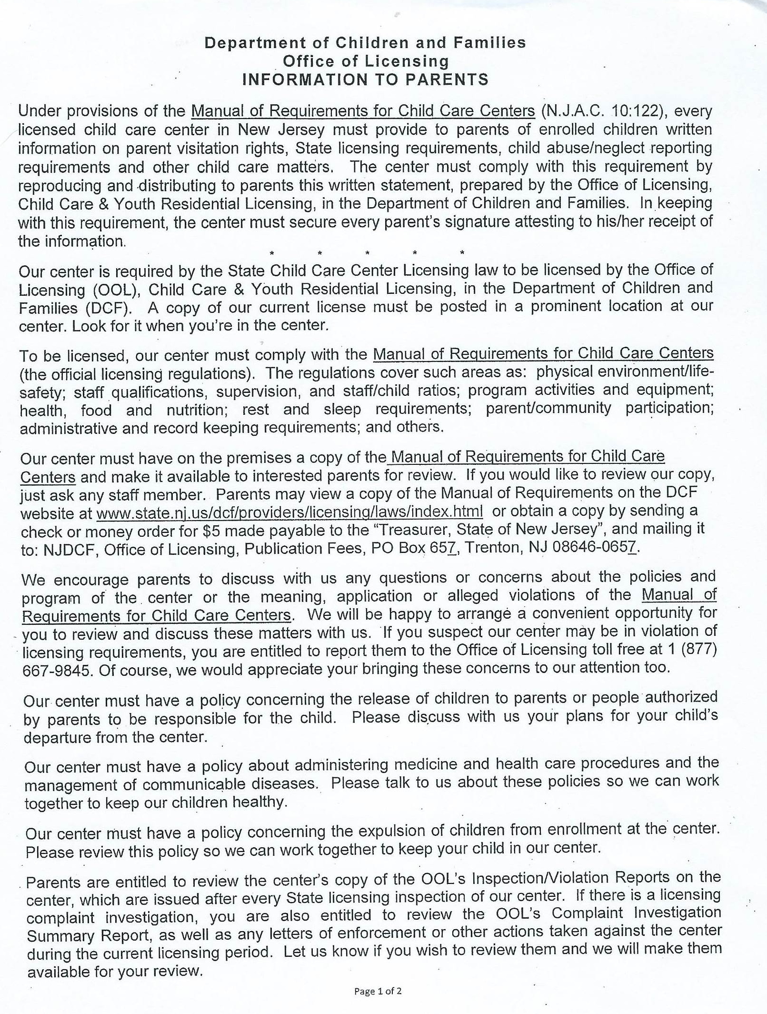
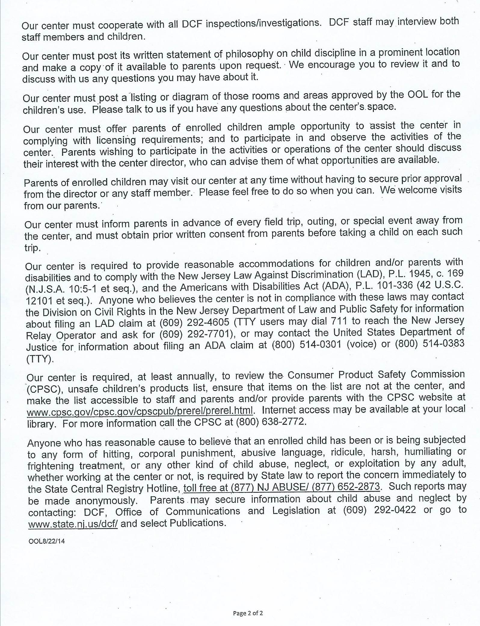
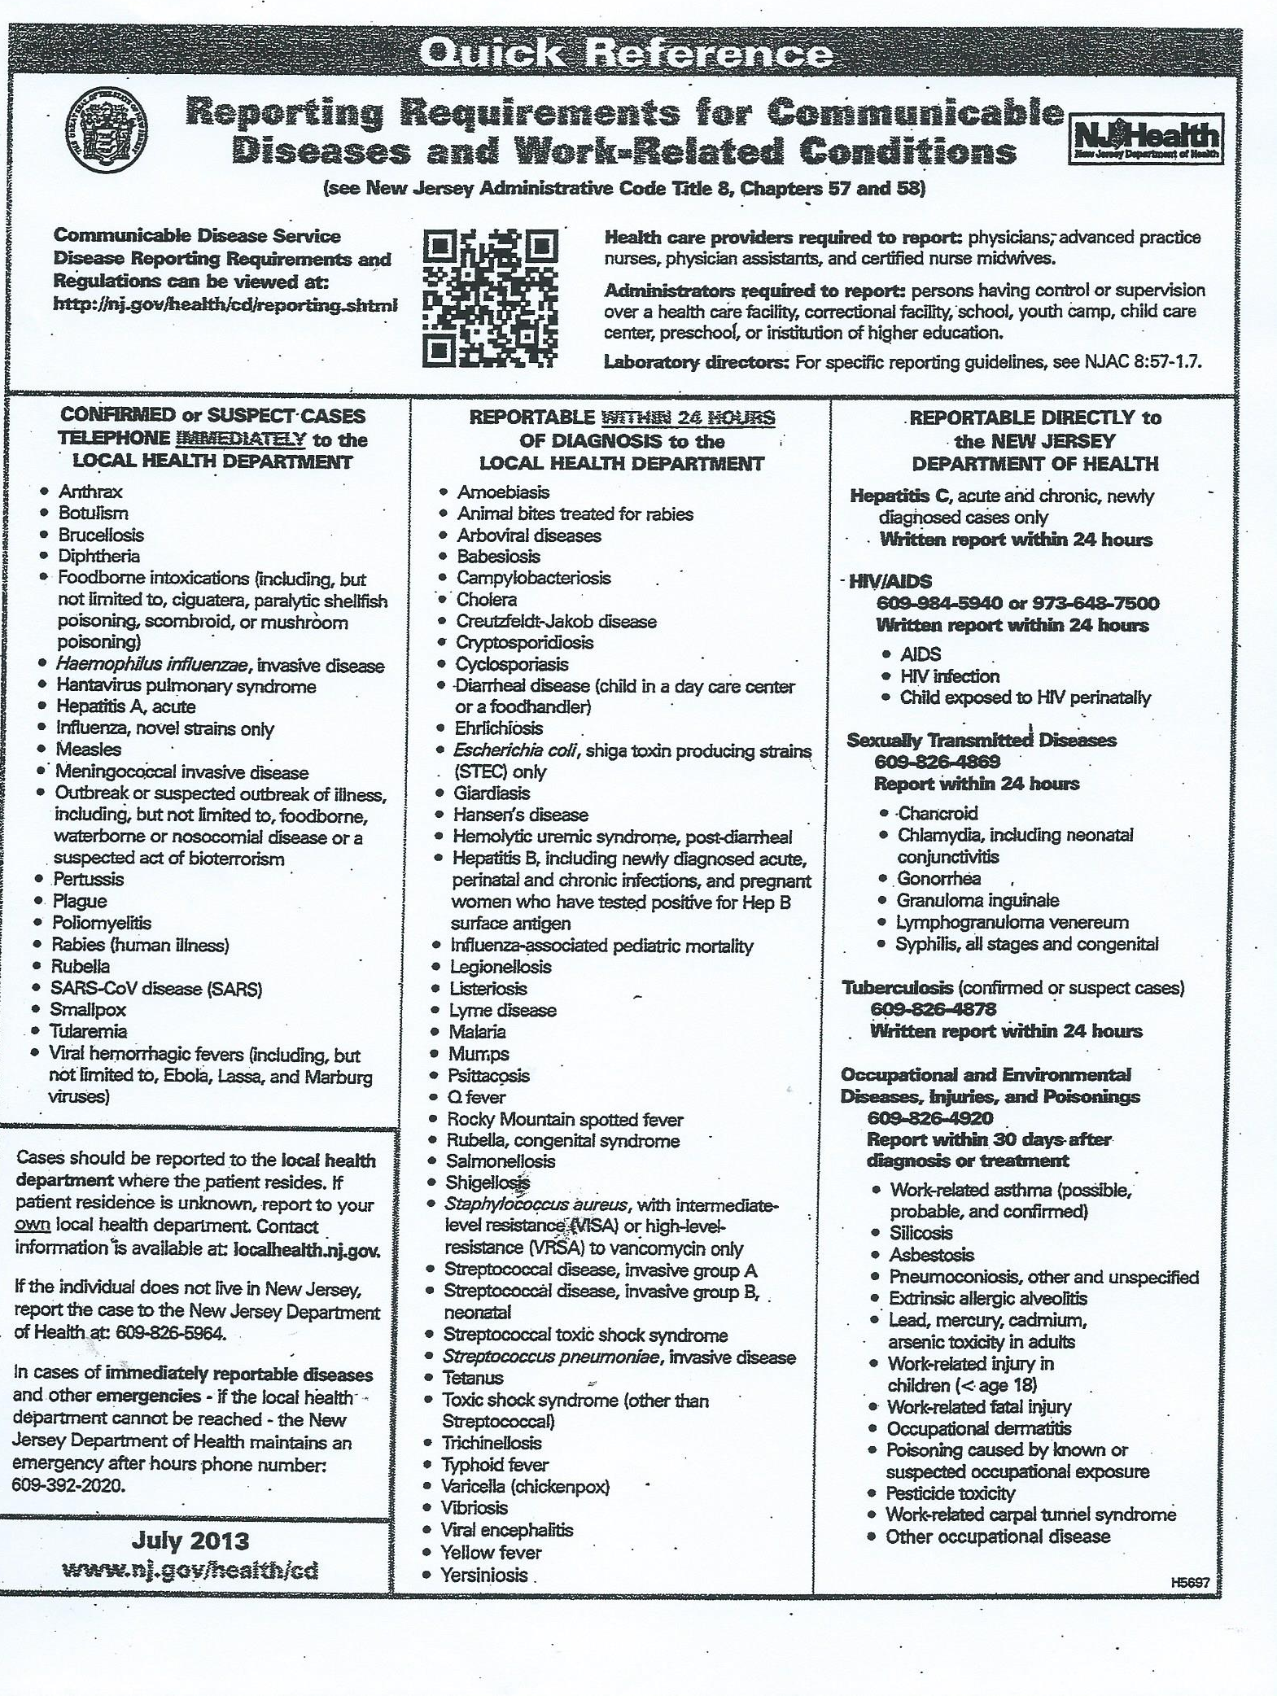
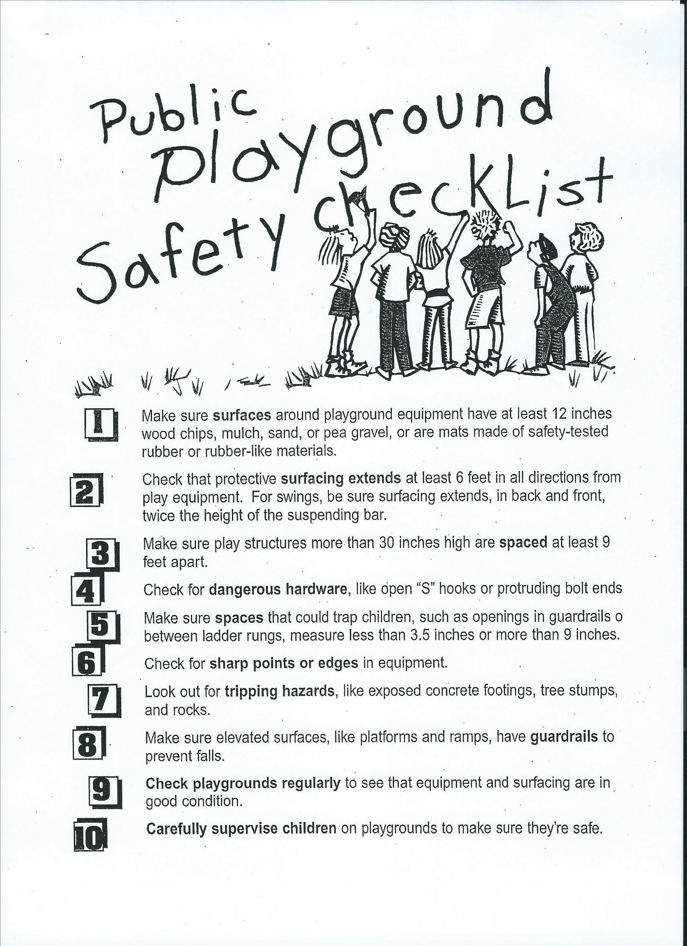
Holiday’s

The Academy is closed in observance of the following Holidays:

New Year’s Day
Dr. Martin Luther King Jr
Good Friday
Memorial Day
Juneteenth
Independence Day
Labor Day
Thanksgiving Day
Day After Thanksgiving
Christmas-Winter Break

In the event of an Emergency, Inclement Weather, School Closings and Delayed School Openings, please follow the Ewing Public School System Schedule
Tuition & Fees Policy

Bi-Weekly or Monthly Payment through ETF Requirements

The options for making Tuition payments via ETF are Bi-weekly or Monthly. On occasion and with prior approval from the Director the academy will accepts Cash, Money Order, Cashier Checks. Payments would be made in the Administration office or directly withdrawn from your checking account. Please make Money Order & Cashier Checks payable to Le Petit Infant Toddler Academy.

*Tuition Payments must be received on or before the due date even if the Student will not be attending.

A $25.00 late fee is charged if your payment is not received by the due date. Services will be suspended immediately if your tuition payment and late fee is not made by the second day of the week.

- The $100 registration fee is due at the time of registration: It is non-refundable and non-transferable. This fee must be paid at the time of enrollment.

- The Tuition Payment will remain the same amount unless your payment is late.

- It is Academy Policy that no Credit be given for Absences due to Vacation, Illness, Snow Days and Holidays.

- The Initial Tuition payment must be received one week before the student begins school.

- Tuition payments may be paid Bi-weekly or Monthly.

- The Academy does not accept Check Payments

- Tuition payments must be made in the form of a Cash, Money Order, Cashier’s Check or Credit Card.

- Late payments will incur a $25.00 Late Fee and must be paid the next day or before the student returns to school.

- No Tuition balance can be carried forward into the next week

- Overdue accounts will result in the student not being permitted to attend school until the account is made current.

- A cash receipt is given when payment is made in cash. Please keep your receipt so you have a record of your payment.

Tax Statements

As a courtesy, tax statements will be mailed by January 31st for the previous year. If tax statements are needed at other times, please email your written request to the Academy Principal. Please include your name, address and where you would like your statement to be mailed. Please allow one week for processing.

Academy Withdrawal Policy

The Parent or Guardian are required to give 30 days (30) written notice to the Director before withdrawing their child from the Academy.

- The 30 days (30) written notice must be giving to the Director in the Administration Office before the final day of attendance.

- If the 30 days (30) written notice has not been given to the Director, the parent/guardian will be responsible for paying the Full two (2) weeks Tuition before the students last day of attendance. There are no exceptions.

- If the student is withdrawn without giving the required notification, the Director will file the claim with the NJ Small Claims Courts for the full two weeks tuition, filing fees, and all court cost being paid by the parent/guardian.

Acknowledgement of Receipt of Parent/Guardian Handbook & Acceptance of Academy Policies, Procedures, Rules & Regulations

I/We, the parent(s) or guardian(s) of ____________________________ who is/are enrolled at Le Petit Infant Toddler Academy, LLC, acknowledge that, I/We have read, and agree with the contents of the Parent/Guardian Handbook.

By sending my child to Le Petit Infant Toddler Academy, LLC, I/We agree that the Academy has the right to expect my child to do so as well. We also agree that I/We and my child will accept the decisions made by the Academy’s Administration. By signing this agreement, you acknowledge and accept the following:
- You have fully read, reviewed and understand the Policies, Procedures, Rules & Regulations set forth in the academy’s Handbook.
- Any questions as to your rights and responsibilities under this Handbook have been fully and completely answered.
- You have the ability to and will fully and completely comply with the terms of this Handbook.
- You have received a copy of this Handbook.

_______________________________ ___________
Parent/Guardian Signature Date

_____________________ ________
Principal/Director Date

