Monday | Tuesday | Wednesday | Thursday | Friday | Saturday
Aquatic Aerobics:  9:00-9:50am | Family Swim:  9:00-9:50am | Aquatic Aerobics:  9:00-9:50am |  | Aquatic Aerobics:  9:00-9:50am | **Precompetitive clinic**  9:00-9:50am
Water Walking/ Lap swimming:  10:00-11:00am  Family Swim:  11:00am-12:00pm  Water Walking/ Lap swimming:  12:00-1:00pm  Swim Lessons:  4:10-4:40  4:50-5:20  5:30-6:00  6:10-6:40  In Water PILATES  7:00-7:50pm | Water Walking/ Lap swimming:  10:00-11:00am  Express Deck HIIT:  12:15-12:45pm  Water Walking/ Lap swimming:  1:00-2:00pm  Swim Lessons:  4:10-4:40  4:50-5:20  5:30-6:00  6:10-6:40  **Precompetitive swimming clinic**  6:00-6:50pm  Aquatic Aerobics:  7:00-7:50pm  Water Walking/  Laps Swimming:  8:00-9:00pm | Water Walking/ Lap swimming:  10:00-11:00am  **Chair Yoga**:  11:00-11:30 (Coming soon)  Water Walking/ Lap swimming:  12:00-1:00pm  IN WATER PILATES  1:15-2:15pm  Family Swim:  3:00-4:00pm  Swim Lessons:  4:10-4:40  4:50-5:20  5:30-6:00  6:10-6:40  **Express Yoga**  7:00-7:40pm  *Aqua Meditari™ *  8:00-8:45pm | Water Walking/ Lap swimming:  10:00-11:00am  Family Swim:  11:00-12:00pm  Express Deck HIIT:  12:15-12:45pm  Water Walking/ Lap swimming:  1:00-2:00pm  Swim Lessons:  4:10-4:40  4:50-5:20  5:30-6:00  6:10-6:40  Aquatic Aerobics:  7:00-7:50pm  Water Walking/  Laps Swimming:  8:00-9:00pm | Water Walking/ Lap swimming:  10:00-11:00am  Swim Lessons:  4:10-4:40  4:50-5:20  Family Swim:  5:30-6:30pm | Swim Lessons:  9:00-9:30am  10:00-10:30am  10:40-11:10am  11:20-11:50am  12:00-12:30pm  12:40-1:10pm  Family Swim:  1:15-2:15pm
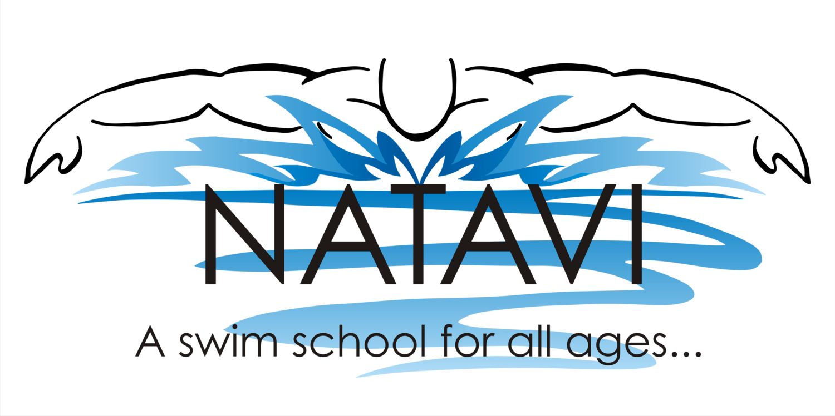
Fall/Winter 2021/2022 - Effective September 7th 2021 – May 30th 2022 – Subject to change
**Dates and format Varies - Check Facebook or call for events and dates**

