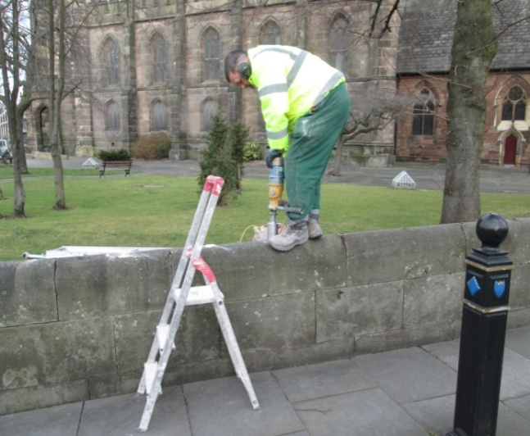
Moving round the church yard it was a nice surprise to find that the funding was in place for work to be done to the boundary wall to the car park.
To prevent future damage the removal of the remains of the metal railings (and the lead used to secure them) has being undertaken and a new core of stone will be fitted shortly. This work being financed as part of the Archway project being undertaken by Stockport Council. Once all the scaffolding is removed from the tower and the contractors cabins removed the planting of the new trees will take place and a general tidy-up of the church grounds.

Coming soon – “café church” incorporating a presentation to existing and prospective volunteers and our plan for the management of the “Nave Café”. Sunday, (7th April 10.30am) and Tuesday, 9th April (12.15pm)

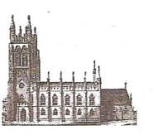
St Mary’s in the Marketplace, Stockport.
Issue No 35 (17th March 2013)

“Securing the future for the next 100 years”
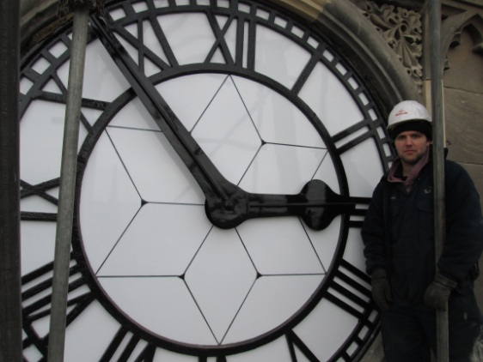
And the time according to St Mary’s is…
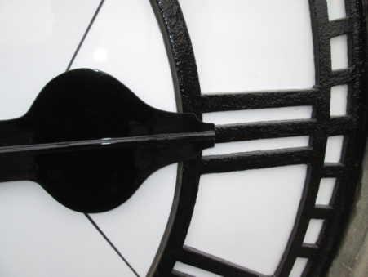

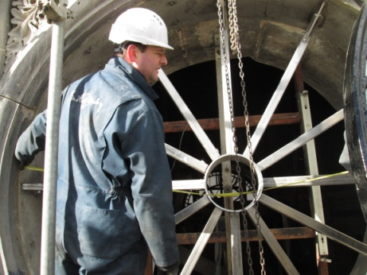
Things are getting better and better and we now have all four clock faces beaming bright over Stockport and telling the correct time. The clock still needs work to be done and we won’t hear all the chimes for some time, but one step at a time towards full restoration. The east clock face has been carefully restored by Smith of Derby and with a lot of technical know-how hoisted into place with our friends from Lambert Walker.
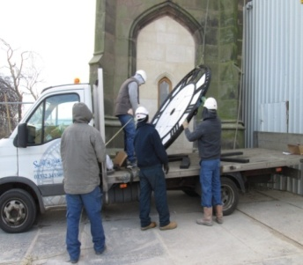

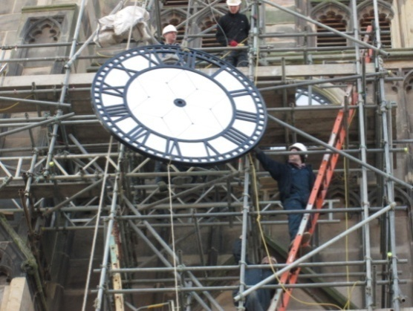
Although closed to the public, it has been a busy week at St Mary’s, the main activity being with the clock of course.
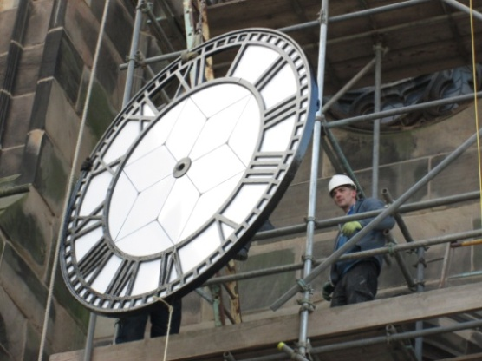
The signing-off of the contract for the Archway, although there is some low level pointing to be done and the required documentation for the faculty to be put in place as soon as we are able. Although the work has been completed there is the need for a retrospective public notice period.
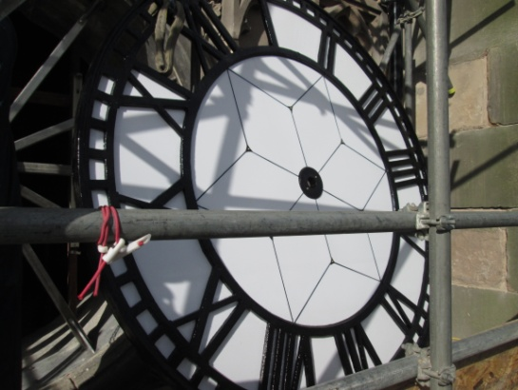
We have had a final meeting with the representative from Alpha Furniture and now happy to complete the contract process for the 200 new chairs (180 ordinary / 20 with arms). As we have decided to await a new plastic guider and fixing bar to be fitted - delivery is now expected to be during May.
Quotations are now also in the pipeline for the pew cushions and café tables. We’re getting there….. those will be ordered any day now!

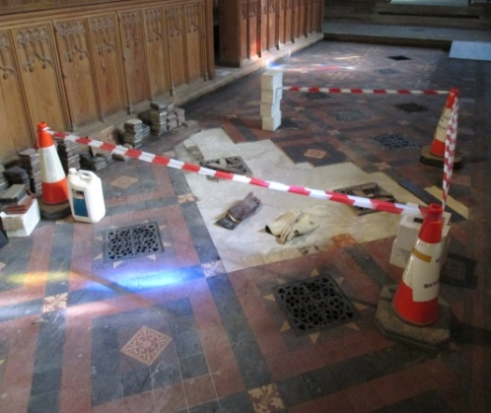
We still have areas of tiling to be completed – the completion of the tiled floor being well behind the original schedule. Roughly 25% of the floor area has so far had to be replaced/re-fixed. Fortunately our contract price is still in check and covering the costs. Care will need to be taken to ensure that, upon completion, we monitor the weight we place upon the tiles to avoid further damage - in particular to the 75% still laid on a fragile foundation. The flooring has been a far greater challenge than we first thought, so agreement has been reached for us to remain closed (except for services) a little longer to allow work to continue. Works are now anticipated to continue into April.

