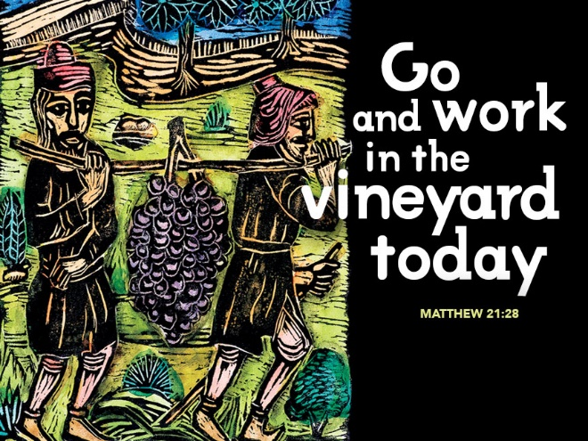

Which Son Are You?
October 1, 2017
Matthew 21:23-32

Grace and peace to you from God Our Father and from the One Good Son, Jesus Christ Our Lord, Amen.
Jesus asked an important question in today’s Gospel. What do you think? He asked that question, but as he told the story it’s pretty obvious which son is the one who did the will of his father. The son who actually went out and worked in the vineyard. Jesus set up this parable so that anyone paying attention would be able to pick the correct answer. Only one son ended up out in the vineyard working. The other son said he would go, but for whatever reason failed his father. He talked the talk, but didn’t walk the walk. Figuring out which son was the “Good Son” isn’t really the point of this parable. It’s pretty easy looking at someone else’s shortcomings and judging them, but Jesus never asks us to assist him in judging others. He asks us to look inside at our own hidden motivations first. So, what do you think? The real question before us today isn’t which of these two sons was the “Good Son”, but rather which son or daughter are you?
Our Gospel story for today takes place during the last week of Jesus’ earthly life. He had just entered Jerusalem on that first Palm Sunday to adoring crowds. They threw palm branches and their cloaks on the ground as Jesus rode in to town on a donkey. Then he proceeded to go into the Temple and overturn the tables of the money changers and drive out the merchants and the animals they were selling for the Temple Sacrifice. He announced, “It is written, ‘My house shall be called a house of prayer’; but you are making it a den of robbers.” While he was there he healed the blind and the lame. The people were amazed and called him a prophet. Then he left the city and spent the night in Bethany. The next day, as he was on his way back to the Temple for more teaching and healing, he was hungry. He and his band of disciples came upon a fig tree. Jesus approached the fig tree he found no fruit on the tree. He cursed the tree saying, “May no fruit ever come from you again.” The tree immediately withered and died. As he did this Jesus was predicting the future of the entire Temple and the sacrifice system for forgiveness of sins.
All this leads up to Jesus returning to Jerusalem on the Tuesday before the first Good Friday. When he returned to the Temple he started to teach, but the Chief Priests and the Elders came to him asking where he got the authority to do all these things. In all fairness, any of us would probably done the exact same thing. They certainly knew he had not received a letter of call from them. Why, his name wasn’t even on their call list from the Synod Bishop’s Office… So, on his third day in town he’s already being called on the carpet for literally upsetting the carts and making way too many changes in the way things are done around here… You see the religious leaders held a pretty tight grip on the rules and regulations and no newcomer upstart was going to come around and tell them they were doing things wrong.
The religious leaders had created many regulations and laws regarding how to get right with the Lord. Most of their laws and regulations benefited themselves. Reminds me of another legislative body that makes burdensome laws for the people, but they themselves don’t have to abide by them, but that’s a topic for another day… the upshot of all this was that the religious leaders actually thought they knew exactly what God required and they were living the letter of the laws of God perfectly. At the same time, they were passing judgment on the “Sinners” of the world. Right there’s the rub for Jesus. These Chief Priests and Elders thought they were doing the will of the Father, they certainly told everyone they were… Jesus came to let them know they were not even close. They should have been out there in the vineyard loving on the sick, the poor, and the “sinners.” Instead they made elaborate rules and regulations that kept themselves separated and isolated from the very people God sent them to love. What do you think? Which son were the religious leaders of Jesus time?
On the other hand, Jesus came directly to the sick, the poor, and the “Sinners”, calling for repentance. The Greek word for repentance is metanoia. It means to literally change direction, to change your mind, and to regret your prior decision and make a change. All these followers of Jesus were doing just that. They recognized they were sinners, they regretted their lifestyles, and were making changes in order to follow their Lord and Savior, Jesus Christ. As they did so, they were immediately entering into the Kingdom of God. Remember the Kingdom of God is anywhere and everywhere that God rules in the hearts and minds of God’s people. Jesus wasn’t telling the religious leaders they would never make it to heaven, but rather, these “Sinners” would make it there first, because they repented and followed.
Now for the uncomfortable part of every sermon. What happens when we turn Jesus’ story from then to now? What do you think? Who are the religious leaders of our day? Living in the “Post Christian” era, where most people out there claim no religion at all, guess what? We’re all the “Chief Priests” and “Elders” today. If so, then what do you think about where we fall in this parable? How quick are we to judge others while thinking we’re all pretty good Christians? How much do you really side with the sick, the poor, and the “Sinners?” I’m not dumb enough to try to answer that for you, but I’ll tell you for myself, I don’t think I stack up all that well. I’m pretty quick to judge the actions of others while ignoring my own shortfalls. As much as I try, I don’t make the time to visit the sick as much as I should. As far as the poor, well, I give to my Church and I do some work with our outside partners, but even with all that, I give out of what’s left. That’s not totally true. For the salary that you all are generous to provide, I ask that more than 10% be deducted before you pay even me. I’m not bragging, but I consider that’s what I owe to this church because I’m a member. You can’t be a member of the Lions Club or even the YMCA without paying the dues and fees. That’s my 10%. Then I try to give more than that out of my delight in the lord and that’s where I think I fall short. I’ve been so blest in my life with a great family, many friends, and a totally awesome Church family. I’ve been fortunate not to have had just one career that made me feel productive, useful, and gave me a purpose for living, but two. Yet I fall short and daily need to confess. Just yesterday, I had to apologize for getting on my holier than thou high horse and going off on a rant. I’m lucky to be married to someone who won’t let me get away with that for too long and I soon regretted my behavior and asked for forgiveness, which was fully given. I guess, in a way, I am a bit like the first son. I did regret my behavior and repent…
I learned a bit about this parable from examining my own behavior. I discovered that neither son in this story is without blame or sin and neither am I. Now here’s the really uncomfortable part, neither are you… That’s right, none of us are the “Good Sons” or Good Daughters” for that matter. We either think we’re pretty good, and by that I mean, we think we’re God’s gift to humanity or we realize we have some basic shortcomings and we keep playing them over and over like a well-loved song. It occurs to me there’s only ever been one Good Son and we religious leaders put Him on a cross… We, and I mean all of us either can’t or won’t walk the walk of true obedience to God. Jesus not only walked the walk, he talked the talk as well. He told the Father I’ll do it and he did. He came down from heaven, lived the perfect life, suffered under Pontius Pilate, was crucified, died and buried. Three days later Jesus was resurrected from the dead. He now reigns at God’s right hand and will come again. By the way, I have to keep reminding myself of this, when He comes back it’ll be to do the judging. We’re supposed to leave that part to Him… God did all of that, not because we were such “Good” sons and daughters, Jesus died for all of us bad sons and bad daughters…
As Saint Paul sang along with early Church, may God grant us the wisdom to be of one mind with Jesus Christ, who emptied himself of all his eternal glory and became a slave and servant of all. May we likewise humble ourselves to be obedient servants. May we be willing workers in God’s vineyards until that day when every knee bends and every tongue confesses Jesus is Lord and Savior, amen.

