**Coin Cleaning**

* To remove Dirt, acids or destructive materials
* Water, olive oil, pure alcohol, toothpick
* Silvo, polish,
* Wax

Coating in Oil

* Coins normally come with a small amount of oils on them, alcohol/soap will remove those oils which protect the coin.
* Options used are wiping coin, cooking coin

If you have a quality coin it is recommended getting PCGS to address issues prior to grading otherwise self cleaning may result in non-grading.

[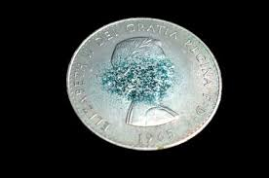](https://www.google.com.au/url?sa=i&rct=j&q=&esrc=s&source=images&cd=&ved=2ahUKEwjj6b_TzeDiAhXFTX0KHVJpBREQjRx6BAgBEAU&url=https%3A%2F%2Fwww.thesprucecrafts.com%2Fpvc-damage-on-coins-768300&psig=AOvVaw37n_PytZqRnenWVvEhMKah&ust=1560314202562442)

PVC Damage

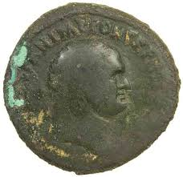

Coin being eaten by acid

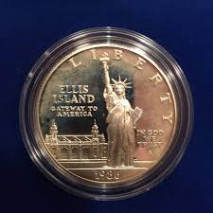

Coin Haze – minting lubricant?

Don’t clean

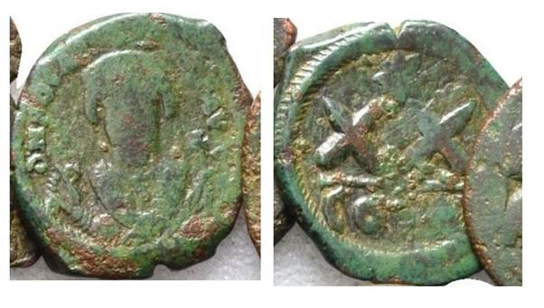

Oiled and unoiled coins

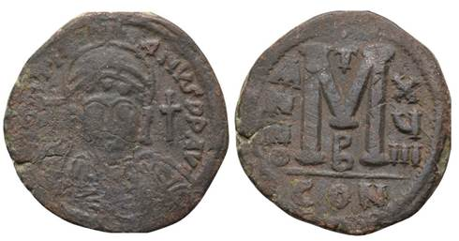

[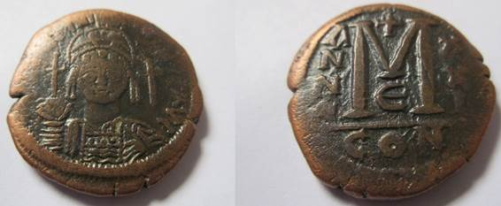](https://www.google.com/url?sa=i&rct=j&q=&esrc=s&source=images&cd=&ved=2ahUKEwju6-WA0ODiAhULYysKHa9oBhEQjRx6BAgBEAU&url=https%3A%2F%2Fwww.cointalk.com%2Fthreads%2Fhave-my-coins-been-oiled.289340%2F&psig=AOvVaw3ZKj5PxDOsZRhatqzXGTeq&ust=1560314872184311)

PCGS Restorations:

**TYPES OF RESTORATION ISSUES**

**TONING:** Removing unattractive toning is the most common use of Restoration. Toned coins may or may not be candidates for Restoration. Coins that suffer from abnormal and unsightly toning caused by the presence of some foreign or caustic substance may be restorable. Coins that have been artificially toned may be restorable, but often the artificial toning covers another problem such as cleaning or altered surfaces. Note that if a coin is attractively toned, we will not restore it just because you want a “white” coin. It’s not appropriate for us to make all coins white and destroy natural, attractive toning.

**SPOTTING:** The other most common type of successful Restoration is removing spots. Spots can usually be removed from silver, nickel, and clad coins. The one exception is modern .999 silver coins from the various world mints. The U.S. Mint has even publicly acknowledged this problem and attributed it to the manufacturing process of the silver planchets. Spots on gold coins are difficult to remove and spots on copper coins can almost never be removed without damaging the coin.

**HAZE:** Restoration to remove haze from the surface of a coin is often quite successful. The only caveat is that sometimes the haze is covering scratches, marks or other problems, and removing the haze may have a negative impact on the appearance of a coin.

**WEAR:** There is no Restoration process which can reverse wear. If a coin’s surfaces show wear due to normal circulation, or for any other reason, the wear cannot be reversed. Wear permanently alters the condition of your coin. Do not submit your coin for Restoration with the hope that wear can be reversed or improved in any way. Your coin will be returned as is and you will be charged an examination fee. We cannot make a “Good” coin

“Very Good.” We cannot make an “About Uncirculated” coin “Mint State.”

**CLEANING:** There is no Restoration process for a coin that has been cleaned. When a coin is cleaned the surface luster and original patina are removed. Often the surfaces exhibit hairlines as a result of contact with a cloth, a brush, or another item used to clean the surfaces.

Hairlines cannot be removed. Surface luster and original patina cannot be restored. Do not submit a cleaned coin for Restoration. The coin will be reviewed and returned to you unchanged. You will be charged an examination fee.

**DAMAGE:** Coins that have been damaged will not be repaired by PCGS. This includes coins that have been scratched, scrapped, whizzed, tooled, holed, plugged, exhibit rim damage, or have been altered in any way. PCGS does not add or remove metal or in any way move metal during the Restoration

Process. Damaged coins cannot be restored using the non-invasive processes that are used during the PCGS Restoration process. Damaged coins that are submitted for Restoration will be returned as is and you will be charged an examination fee.

**CONCEALED PROBLEMS:** Many coins actually suffer from multiple problems. For example, there may be unsightly spotting or toning, but underneath the toning there is substantial surface damage. Restoration may be able to remove the toning but cannot address the surface damage. If such a coin is submitted for Restoration, at best, it will be returned in a “Genuine” holder.

**METALS**

Restoration processes and success depend a great deal on the metal content of the coin.

Here are some guidelines based on the metal content of your coins:

**SILVER:** Restoration of silver coins can often be quite successful.

**GOLD:** Gold coins can usually be restored if the problem is haze or discoloration. Spots on gold coins usually cannot be removed.

**NICKEL:** Nickel coins can often be restored if the problem is unattractive toning, haze, or spotting; however, success rates for Restoration of nickel coins is less than that of silver coins.

**COPPER:** This is one area where Restoration seldom works. PCGS will never use any harsh techniques which effectively strip the surface of the coin, nor will we use any techniques which could change the colour and surfaces of the coin. Because of this we will not attempt to restore many darkened or toned copper coins.

**CLAD:** The post-1964 clad coins can often be successfully restored depending on the problem. Success rates are similar to those of nickel coins.

**Restoration Candidates**

The coins that have the best results from the PCGS Restoration service are:

Silver coins with unattractive toning. It is usually fairly easy (at least for professional experts) to remove unattractive toning from silver coins, and it has been a market accepted practice for decades. Removing toning usually does not affect a coin’s surface and

is many times undetectable to even expert eyes.

Gold, silver, nickel, and clad coins with haze. Many coins develop a hazy look over time, and occasionally coin doctors will artificially haze a coin to deceptively enhance its appearance. It is usually very easy to remove haze from coins. Brilliant proof gold coins. The appearance of brilliant proof gold coins that have haze or discoloration can often be improved with Restoration techniques. Spotted nickel, silver, and clad coins. Spots can usually be removed from nickel, silver, and clad coins, provided the spots have not eaten into the surfaces of the coin. Spots usually cannot be removed from gold and copper coins.

**Restoration Tips**

Restoration works in many cases and can produce wonderful results on many coins. Often the result is simply a much more attractive coin.

# Detecting Doctored Coins, Part 1

PCGS - April 4, 2000

This originally toned Barber half dollar has even and *deep* coloring.

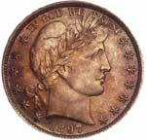

Reprinted with permission from Professional Coin Grading Service (PCGS). Excerpt taken from *The Official Guide to Coin Grading and Counterfeit Detection*

**Chapter 11 - DOCTORED COINS**

"Coin doctors" have become increasingly active in recent years in the rare-coin marketplace. Unfortunately, their role has not been to cure the market's ailments, but rather to spread an epidemic: the alarming proliferation of coins that have been chemically treated, or otherwise tampered with, to make them appear better-and more valuable-than they really are.

The "doctoring" of coins is a special concern as well as a constant challenge for PCGS. Over the years, practitioners of this black art have become ever more sophisticated in their methods, making it harder and harder to distinguish their wares from original, untreated coins. The PCGS grading staff identifies and intercepts the great majority of these coins when they are submitted for certification, returning them to their consignors as ungradable. Even with all of their expertise and vigilance, however, graders are occasionally fooled and certify one of these coins. When that happens, the company's guarantee covers any loss incurred by the ultimate purchaser. However, the fact that it happens at all is testament to the seriousness of the problem. It also serves to underscore the value of certification in a marketplace where such dangers are all too common.

Lumped with doctoring is the cleaning of coins that really do need it. This is an area of much confusion, as evidenced by letters written to coin publications about coins that have been graded and placed in holders after being "cleaned" by dipping them in a commercial solvent or dip. Not all coins that have been altered by chemicals are considered doctored. No matter how the results are achieved, many coins have been improved by judicious cleaning with commercial dips, solvents, or plain soap and water. PCGS grades many coins that have had their surfaces altered by the removal of "problems," perceived or otherwise. The coins it does not grade are the ones altered by adding substances to the surface or altering the surfaces by physical methods.

**Fooling with Mother Nature**

"All coins are doctored," an astute numismatist once observed. "It's just a matter of degree and by whom Mother Nature or Joe Dipper." His point, one worth pondering, is that coins by their very nature are subject to chemical change because they are made from metals which, to a greater or lesser degree, are reactive. The surfaces of a coin begin to react with the environment from the very moment the coin is struck. Depending on how and where it is stored, the coin may change very little over time or, conversely, undergo a radical transformation. Sometimes the change is positive-spectacular color from a reactive holder. Other times it is very negative-PVC damage, salt-water damage, or other intrusive damage.

There is, however, a fundamental difference between the natural changes that occur in a coin's appearance because of environmental factors, on the one hand, and the artificial changes wrought by the intervention of larcenous profiteers who are, quite literally, fooling with Mother Nature to perpetrate a fraud. Natural toning, for instance, can greatly enhance the appearance of a coin in the eyes of many observers by embellishing its original color with dazzling rainbow hues. Artificial toning, by contrast, tends to be less attractive and is used all too often to conceal important flaws that could lower a coin's value if these flaws were visible. This, in fact, is one of the major ways in which coins are doctored: chemicals are used not to remove something from these coins, but to hide or obscure a problem.

Nearly every chemical known to man has been applied to the surfaces of coins to "improve" their look, and they have been subjected to bizarre and often ingenious forms of treatment, such as being washed in sulfur shampoo, blasted with cigarette smoke, even baked inside Idaho potatoes covered with corn oil! Some of the techniques are primitive, to be sure, but they can be effective in deceiving the unwary. And some of them are subtle and hard to detect.

**Preservation or Exploitation?**

Is doctoring inherently wrong and reprehensible? After all, no one cries "Foul!" when a painting is restored, and that involves the use of artificial means to enhance a collectible. Nor is there an outcry when museums "expertly clean" their ancient coins. At one time, in fact, it was common practice even among professionals to clean U.S. coins. It has been reported that coins in the National Numismatic Collection at the Smithsonian Institution were "polished to a high gloss" three times by the start of the twentieth century. In the early days of U.S. coin collecting, and even into the early 1900s, many hobbyists cleaned their coins with little regard for the consequences. The coins in some early U.S. collections were stored in wooden coin cabinets and regularly wiped to "improve" their look, giving rise to the term "cabinet friction." Today, these practices would be abhorrent to many-but at the time, they were accepted and looked upon as forms of enhancement as well as preservation.

The key difference between all of these practices and most of today's coin doctoring is that many of those engaged in such activities today are doing so for fraudulent gain. They are seeking to mislead others-the grading services and prospective purchasers, in particular-into accepting their coins at excessively high grade and price levels by disguising the deficiencies of those coins.

Beyond the issue of intent, the practice of doctoring can often be harmful to the health of the coins. Some of the processes and chemicals applied to coins actually do help preserve them in certain cases. The problem is, many of them do not. When an organic solvent such as alcohol or acetone is used to remove damage from the surfaces of coins that were stored in PVC flips, those coins are not only improved, but probably saved from ruin. On the other hand, the use of abrasive or corrosive chemicals can directly cause irreparable damage, rather than save the coin. This damage may not be apparent at first, but over time the coin may change as the chemicals further react with the coin's metals. The instability of many altered coins is noted only with the passage of time, sometimes too late to "save" the patient.

Doctoring is practiced in several ways. Three of the major methods are artificial toning, surface alteration, and etching. No analysis of the subject could be totally comprehensive, since new techniques probably are being tried every day. However, this chapter will examine in detail the basic techniques coin doctors practice. It also will tell you how to recognize these practitioners and how to develop skills to avoid their deceit. When a coin's surfaces are doubtful and it is being offered at a bargain price, a red flag is raised. When something seems too good to be true, it probably is.

**QUESTIONABLE TONING**

All U.S. coins tone to some degree. How and to what degree are determined by various factors. Their metal content, where and how they are stored, and atmospheric conditions play the biggest roles in determining the depth and color of the toning. When acquired naturally over time, toning is often viewed as a positive attribute of grading, unless it becomes too dark, thick, mottled, or splotchy. When the toning results from the application of chemicals to the surface of a coin over a short period of time, perhaps with the use of heat to speed the process, the coin is said to have artificial or questionable toning.

The most obvious difference between natural and questionable toning is the way in which the toning "lies" upon the surface of a coin. When an original coin tones over time, the toning appears to be attached to the surface from the "bottom up." There is an appearance of depth to the toning and the colors are rich and natural looking. When a coin is toned quickly by the introduction of chemicals and/or heat to the coin's surfaces, the toning floats on the surface and the color lacks depth. The toning appears shallow and not "attached" to the surface, as with original color. The colors associated with this type of toning tend to be unnatural-looking, often called "crayon" colors because they look as though they were "colored" on the coin's surface-weak pastel colors "painted" by a first-grader.

**Naturally Retoned Coins**

Many coins that were cleaned in the past have since retoned naturally. In error, these are sometimes said to be questionably toned. This is a difficult area, since there is a very subtle difference between cleaned coins that have toned naturally and coins that have had the toning process enhanced by chemicals and/or heat. This is further discussed in chapter 5, Elements of a Coin's Grade, under the section about second toning. Because there are so many factors involved in original and artificial toning, discussion of every color and type of toning is impossible. However, understanding the processes of original and artificial toning is essential in recognizing the differences.

Once the original surface is removed from a coin by some type of commercial dip or cleaning, toning will no longer "adhere" in the same way it does with original coins. There are several chemical and physical reasons for this. One of the main reasons is that in coinage alloys, the subordinate metal tends to "leach" out or migrate to the surface. When the coin is cleaned, the first several layers of molecules are removed-and if leeching has been occurring for a substantial period of time, more of the minority metal is removed by any cleaning. Because the mix of the metals is now different, any new toning, whether natural or artificial, will be different and will adhere differently from the original toning.

A cleaned coin also will have "slicker" surfaces at times, probably due to residue from the cleaning compound and/or the "flattening" of the flow lines. These flow lines-or stress lines, as they sometimes are called occur when the metal flows into the recesses of the dies upon striking. This provides a rougher and minutely larger surface for the toning to adhere to-and when cleaning removes or "flattens" these flow lines, the toning will not adhere as easily and evenly as before. This contributes to the "floating" colors noted on second and artificial toning.

**Showing True Colors**

The chemicals in many of the old coin holders (the Wayte Raymond and Meghrig holders, for example) are responsible for the bright, usually peripheral, rainbow colors seen on many coins from old-time collections. These are among the colors that coin "chemists" try to duplicate with their concoctions. Another source of sometimes beautiful colors is the tissue in which the Mint wrapped Proof coins, and occasionally Mint State examples, from the 1850s onward. These colors, too, are widely imitated. However, these imitation colors are never quite right and do not "lie" correctly.

Toned original coins usually can be identified as such without much difficulty. However, there is little obvious difference between lightly cleaned coins that have retoned naturally over many years and coins that have been enhanced with chemicals and/or heat. By examining coins that you know have toned or retoned naturally over many years and comparing these with chemically enhanced coins, you will gain familiarity with the often subtle differences between these types of toning. You might also consider conducting your own experiments with inexpensive coins, applying nontoxic chemicals to their surfaces, then studying the reactions that occur. The results of such experiments will provide greater insight into the characteristics of artificial toning. How the colors and toning "lie" on the surfaces is one of the easiest-learned tools of the trade.

Chemicals, such as sulfur compounds, often result in "crayon" colors as opposed to more natural-looking greens, blues, reds, and yellows. Also, these "artificial" colors often do not blend as evenly as do original colors. When the colors are splotchy or uneven, there is a good chance Mother Nature did not cause them. Regardless of the process used, when the colors "float," have unusual lines, and are uneven, the coin is probably artificially enhanced. Sometimes these colors are applied just to the periphery, while other coins have the entire surface treated. Tab toning has also been simulated by chemically treating an original holder and applying heat to speed up the toning process. These are sometimes very deceptive, as the "tab" in the center of a coin is often taken as "proof' that a particular coin is original. Again, this applied toning will "float" and usually will have colors not seen on originally toned specimens. Other coins are noted with mottled toning, which often is applied over light original toning to make the colors appear "deeper" than they actually are. These mottled-toned coins usually have colors that are just a little off" crayon" colors or unusual blues or greens. Another form of added toning is often seen on Proof coins that have had the toning "rubbed" off of the high points. Toning is added to the "rubbed" areas, often blending quite well with the original toning. This is occasionally seen on Mint State coins as well.

Another type of artificial toning used to hide defects is the kind produced by "smoking" or "hazing" a coin by bombarding it with cigarette or cigar smoke. This method leaves a filmy, usually slightly opaque haze on the surface of a coin-a look that is sometimes described as "smoky." Hazy toning also can be acquired naturally through storage in flips or envelopes. If the area affected by the haze is localized over marks or hairlines, it probably was applied artificially. This type of alteration could just as easily be listed in the next section on surface alteration techniques, since toning usually is associated with more vivid colors, and this technique results in a milky white to a slightly creamy-white appearance.

*For a look at detecting sophisticated surface alteration techniques, click on* [*Detecting Doctored Coins, Part Two*](https://www.pcgs.com/news/Detecting-Doctored-Coins-Part-2)

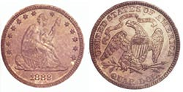

Artificially toned 1882 Liberty Seated quarter. Obverse: Light color was probably added by sulfur or related chemicals. Reverse: Nothing *heavy* in this toning, just light pastel.

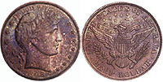

Artificially toned 1882 Liberty Seated quarter. Obverse: Light color was probably added by sulfur or related chemicals. Reverse: Nothing *heavy* in this toning, just light pastel.

# Detecting Doctored Coins, Part 2

PCGS - April 11, 2000

Chrome-like alteration. Surfaces were   
unnaturally treated to hide hairlines and imperfections.

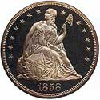

Reprinted with permission from Professional Coin Grading Service (PCGS). Excerpt taken from *The Official Guide to Coin Grading and Counterfeit Detection*

*For a look at chemically altered and toned coins, click on* [*Detecting Doctored Coins, Part One.*](https://www.pcgs.com/news/Detecting-Doctored-Coins-Part-1)

**DETECTING SOPHISTICATED SURFACE ALTERATION TECHNIQUES**

There are other ways to hide or obscure surface problems besides adding color or toning. The most common of these surface techniques is the application of "nose" grease. This combination of skin oils and other skin chemicals often is used to dull shiny spots on the high points of coins that may represent slight wear or incomplete striking. Sometimes this method also is used on tiny marks or light hairlines in the fields, thought it is usually easier to detect in the open fields than on high points.

When the amount of nose grease used is minimal, this type of alteration may be difficult to detect, since the area doctored may be essentially clear and quite small. When larger amounts are used, the surfaces sometimes have a golden or light yellow-brown color and may be slightly opaque. Over time, most of the coins "done" by this method will start to discolor, the treated area becoming brown and splotchy. This technique is used on gold, silver, nickel, and copper coins, but it usually is more obvious on silver coins. "Thumbing" and Other Techniques

One common variation of nose grease is a process called thumbing, which is used mainly on silver dollars. In this process, the skin oils are rubbed across the desired area, with the thumb acting like a brush, rubbing the oils into the "skin" of the coin. This method is often used to obscure shiny lines or marks on the face of Miss Liberty on Morgan and Peace dollars, and is sometimes so minor that it is nearly undetectable. The breast feathers on Morgan dollars are sometimes "dulled" by this method also, especially when there is a shiny area resulting from contact. When the oils are applied vigorously, the affected areas appear duller, with the luster inhibited. When the coin is tilted under a good light source, the marks or hairlines that have been obscured by the thumbing are visible-though some "thumb" experts are so skillful at this technique that their handiwork is difficult to detect. Once you become familiar with this method, you will usually have no trouble recognizing the telltale signs-principally the dullness associated with the thumbed area.

Dental wax and auto-body putty also are used for surface alteration. Dental wax is particularly subtle because it leaves a thin, clear layer on the area where it is applied. This substance is used much like nose grease. Nothing is contained in the wax to discolor a coin's surfaces, but sometimes, after the water and alcohol have evaporated, a white powdery residue can be seen.

Auto-body putty and other car products were first used on Morgan dollars to duplicate frosty devices or cover blemishes on Miss Liberty's face or the eagle's breast feathers. PCGS has seen this method used on three-cent nickels, where the head of Miss Liberty was "frosted" with these compounds. This is not considered a very deceptive method because it is easy to spot after having examined a few of the coins on which it was previously used. This is also considered a form of artificial frosting, therefore could have been listed in the next section on chemical etching and artificial frosting. It is listed here, however, because it is more a method of surface alteration than a chemical process.

**Whizzing**

Although it is used only occasionally, whizzing should be mentioned here, since light whizzing plus added toning can be deceptive. Whizzing is a technique in which surface metal is moved mechanically to create the illusion of luster. Heavy whizzing produces unnatural surfaces whose brightness does not resemble original luster. The "cartwheel" effect is replaced by a "sheen" that causes light to bounce off the surface differently, often with a diffused effect. When whizzing is light and is covered by natural or artificial toning, it is much more difficult to detect. If a coin lacks sharp detail but the luster appears full, light whizzing may be the culprit.

Magnification is the best way to differentiate weakly struck coins from worn-die and lightly whizzed coins. On weakly struck coins, flow lines will still be present and luster will still "cartwheel." Worn-die coins may not have much "cartwheel" but still may have radial flow lines often the result of die erosion. Whizzed coins will appear smooth, and because the flow lines have been disturbed, they will not have normal "cartwheel" luster, but rather a diffused look.

A sophisticated whizzing process is sometimes used on Proof coins, though PCGS has seen it on a few proof-like business strikes as well. This is a refinement of the process used to create the so-called "California Proof" Morgan and Peace dollars. The most common method involves the use of a high-speed drill, such as a dentist's drill, with some type of fine burr or attachment to "enhance" the surface and smooth away scratches, marks, and hairlines. Recently, PCGS has seen some very deceptive coins, mostly Proofs, with plated-looking surfaces, possibly produced by this method in combination with chemicals and/or heat. The plated appearance hides hairlines, planchet flaws, marks, and other defects. These surfaces have a "chromed" look that, once noticed, will appear very unnatural.

In yet another form of surface alteration, the surfaces of Proof coins are heated to actually melt the hairlines or other defects. This method may involve anything from a match held under the surface for a few seconds to a high temperature torch selectively applied to a specific area. Coins altered in this manner sometimes have a wavy look or different "depth" to the mirrored surface. These clues are especially noticeable on Proof gold coins, since the surfaces are so delicate. Also, many Proof gold coins have "orange-peel" surfaces that are flattened by this method. If the mirrored fields vary across the surface of a coin, heat treatment of the fields is often the cause.

**CHEMICAL ETCHING AND ARTIFICIAL FROSTING**

To create the cameo devices seen on many U.S. coins, the Mint sometimes sandblasted the dies or pickled them in acid, then polished the fields, leaving the recesses of the dies with rough surfaces that produced the frosty devices. Before the introduction of completely hubbed dies, the die-making process also contributed to frosted letters and devices, because the ends of the punches were not always smooth. This roughness, and the pressure used to impart the letters and devices to the dies, often left the recessed areas with "frost." This resulted in frosty letters or devices from the letter- and device-punching process. Proof coins almost always were struck from these specially prepared dies, and some business-strike coins also were struck from the Proof dies and other dies treated in a similar way.

To recreate this frost, some coins are chemically treated on the devices, often with mild acids. PCGS also has seen some other coins, usually Proofs, which appear to have had their devices lightly sandblasted or acid-etched to imitate frosting. Other substances also are used to imitate frosting-among them auto-body putty, as mentioned in the previous section-but these will usually "dip off' in commercial dips or certain organic solvents. These treatments are applied most commonly to silver coins, but gold, nickel, and even copper coins also are sometimes seen with imitation frosted devices.

**LEARNING TO DETECT DOCTORED COINS**

Examining coins known to have been doctored in particular ways is the best way to learn how to recognize the various processes used and their results. Seeing such coins is worth even more than the "thousand words" of the old saying. No amount of discussion or analysis can fully instruct one about the subtle differences between original and altered coins. With experience, one will be able to spot certain doctored coins with just a casual glance. Once a particular process has been "seen," coins that result from that process may very well become extremely obvious.

Some of the alteration techniques are difficult to detect, and even experienced numismatists miss them at times. As more and more coins are examined and the "look" of totally original coins becomes increasingly familiar, any deviation from that look will serve as a tip-off to coins that have been altered in some way.

A coin is not necessarily ungradable just because it is not totally original. In some cases, in fact, altering a coin may actually improve its grade. One example of this would be dipping a coin that has splotchy, mottled, or dull toning and thereby revealing a blazing white gem. Another would be removing PVC flip damage with an organic solvent. Also, with gold, silver, and nickel coins, rinsing them in hot water sometimes is necessary to remove light surface contaminants. This should not be employed on copper coins, as the chemicals in the water plus the heat may affect the color and luster. Copper coins are much more difficult to work with, and in most cases should be left alone. If green corrosion appears on the surface of a copper coin, remove it mechanically, if possible, usually with a soft camel-hair brush. Copper aficionados sometimes have brushes they have used for decades, carefully protecting them. These "used" brushes have oils from years of use and their owners swear that these "protect" the surfaces of copper coins brushed by them. There is truth to this, as many coins brushed appear unchanged after many years. These, however, should only be used by knowledgeable copper experts, because even the fine camel hair can damage surfaces. Only when this method has been tried and failed should one attempt to remove something chemically from the surface of a copper coin.

Obviously, one needs to learn what is acceptable alteration in order to know what is not acceptable. Once the original and non-original "looks" of coinage have been mastered, one must learn what is acceptable and not acceptable for coins that are not original. When unsure about a coin, ask the owner. Although the owner wants to sell you the coin, he or she does not want you to call six months later and ask why the coin has changed colors.

There are many subtle areas that only experience can clarify. The cloudiness on shipments of U.S. gold coins imported from Europe is very similar to the hazing or "smoking" seen on some altered coins. Second toning, in many cases, looks similar to artificial toning. The difference is subtle, but there are telltale signs that knowledgeable numismatists recognize. Learning the difference takes time and effort, but an "eye" can be developed for the "look."

*For a look at chemically altered and toned coins, click on* [*Detecting Doctored Coins, Part One.*](https://www.pcgs.com/news/Detecting-Doctored-Coins-Part-1)

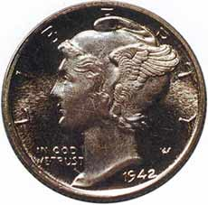

Artificially frosted. This coin was chemically altered to simulate the frosted cameo effect found on the devices and lettering of many Proof issues. Note lines and marks *under* the frost.

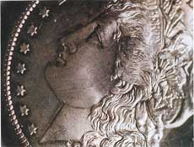

Artificially frosted. This coin was chemically altered to simulate the frosted cameo effect found on the devices and lettering of many Proof issues. Note lines and marks *under* the frost.

### **The Sniffer**

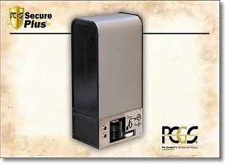The coin ‘Sniffer’ directs beams of light at targeted areas of each coin that is placed in the device. It is not harmful to coins. With human guidance and computer software, the sniffer is able to determine which substances are in particular areas of each coin. If there is auto body putty in the right obverse (front) inner field, such putty can be found and located. Different substances are ‘excited’ by rays of light on different frequencies of the light spectrum.

The PCGS maintains a database of the ‘light signatures’ of substances employed by coin doctors and of many other substances. The mere presence of a wax does not prove that a coin has been doctored. A microscopic quantity of wax can ‘end-up’ accidentally on a coin. A century ago, a collector may have stored coins in wax paper. The amount of an unwanted substance has to be significant, above a rationally determined threshold, for the sniffer and accompanying software to flag a coin for further study.