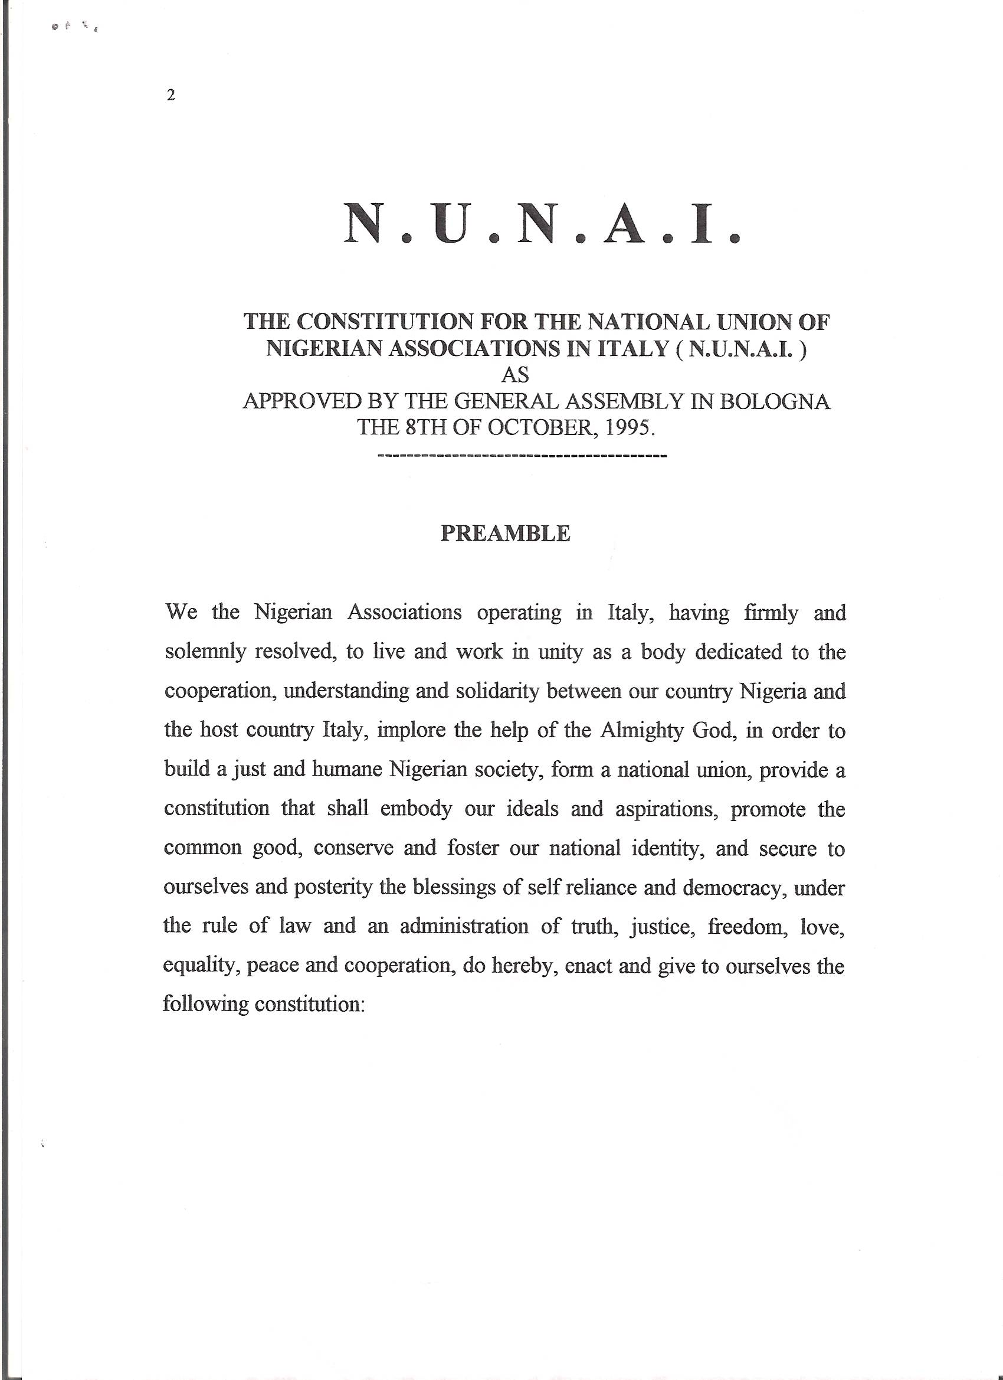
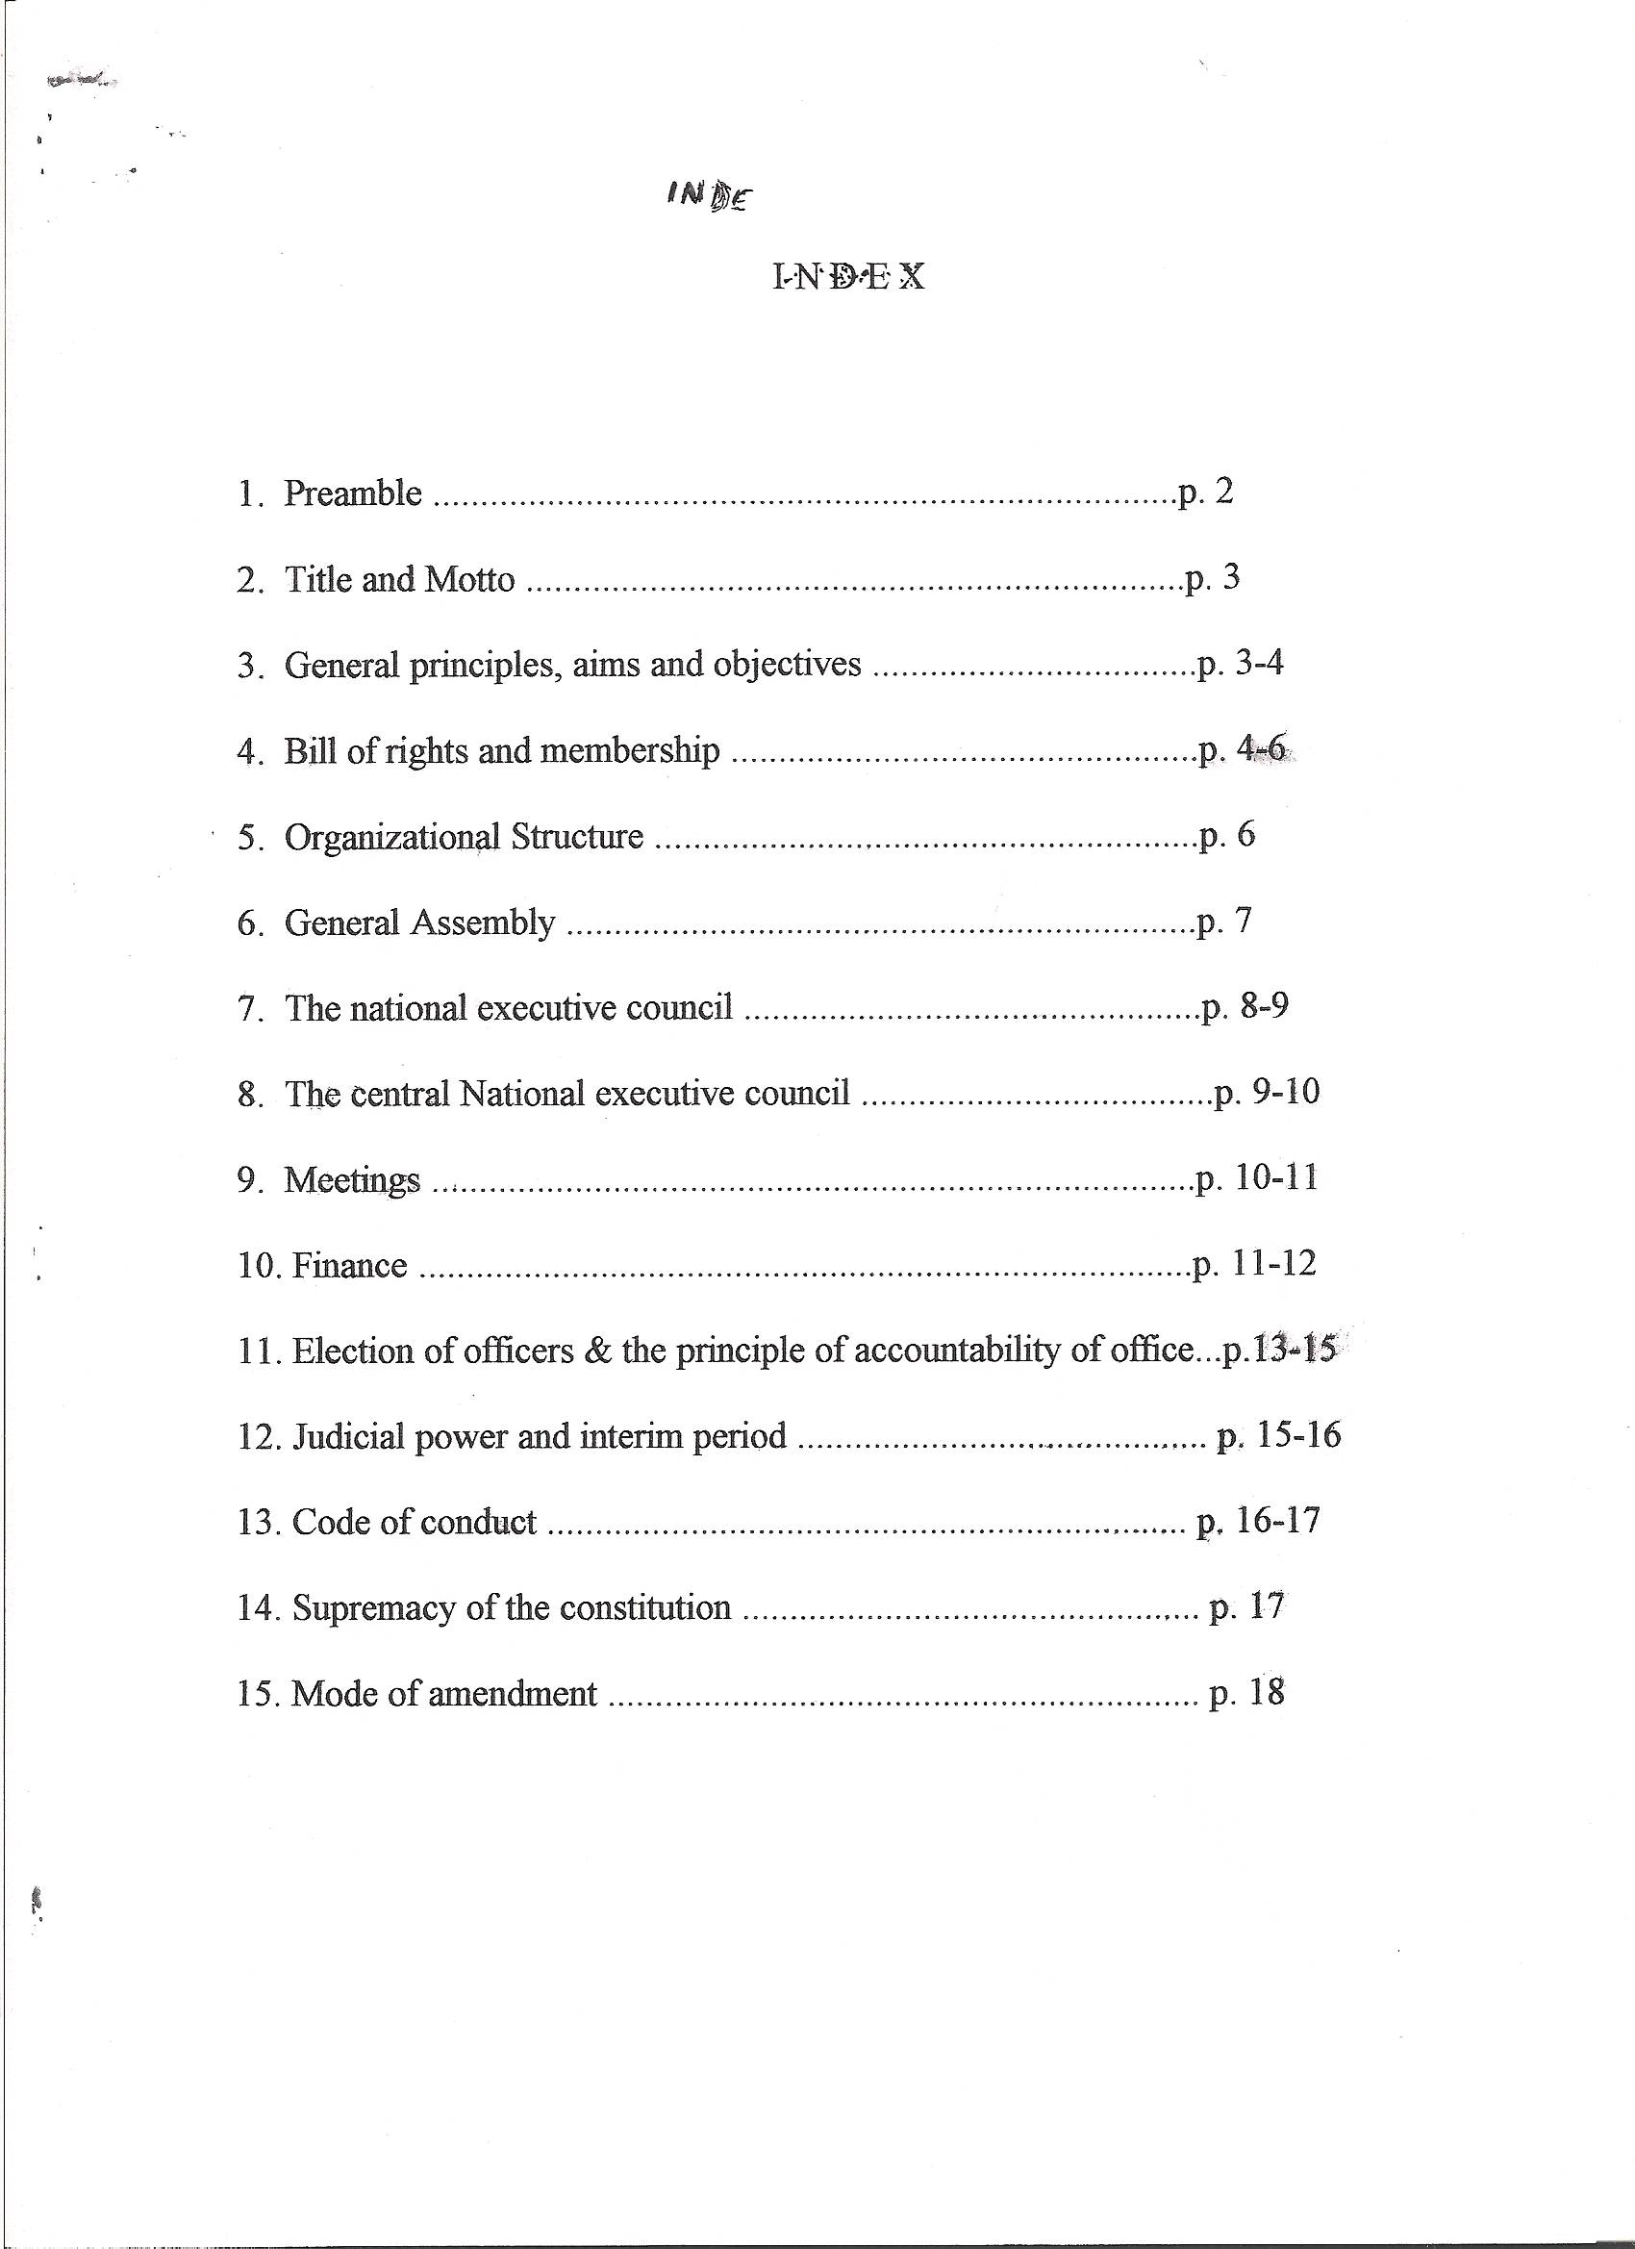
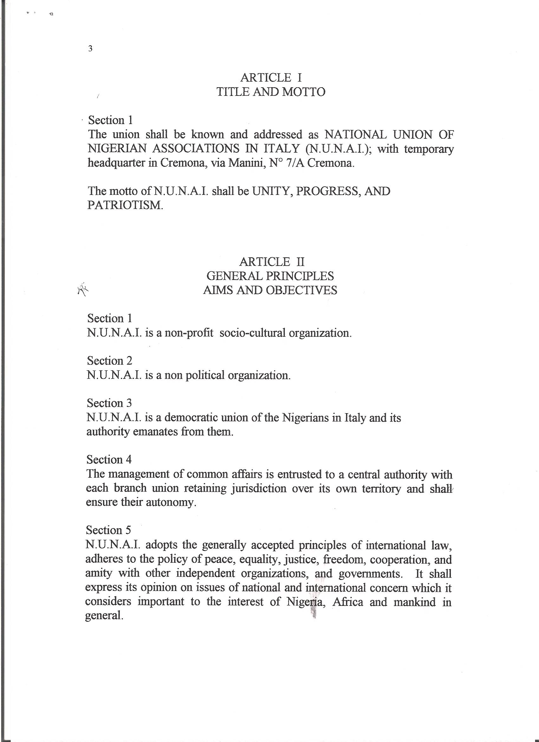
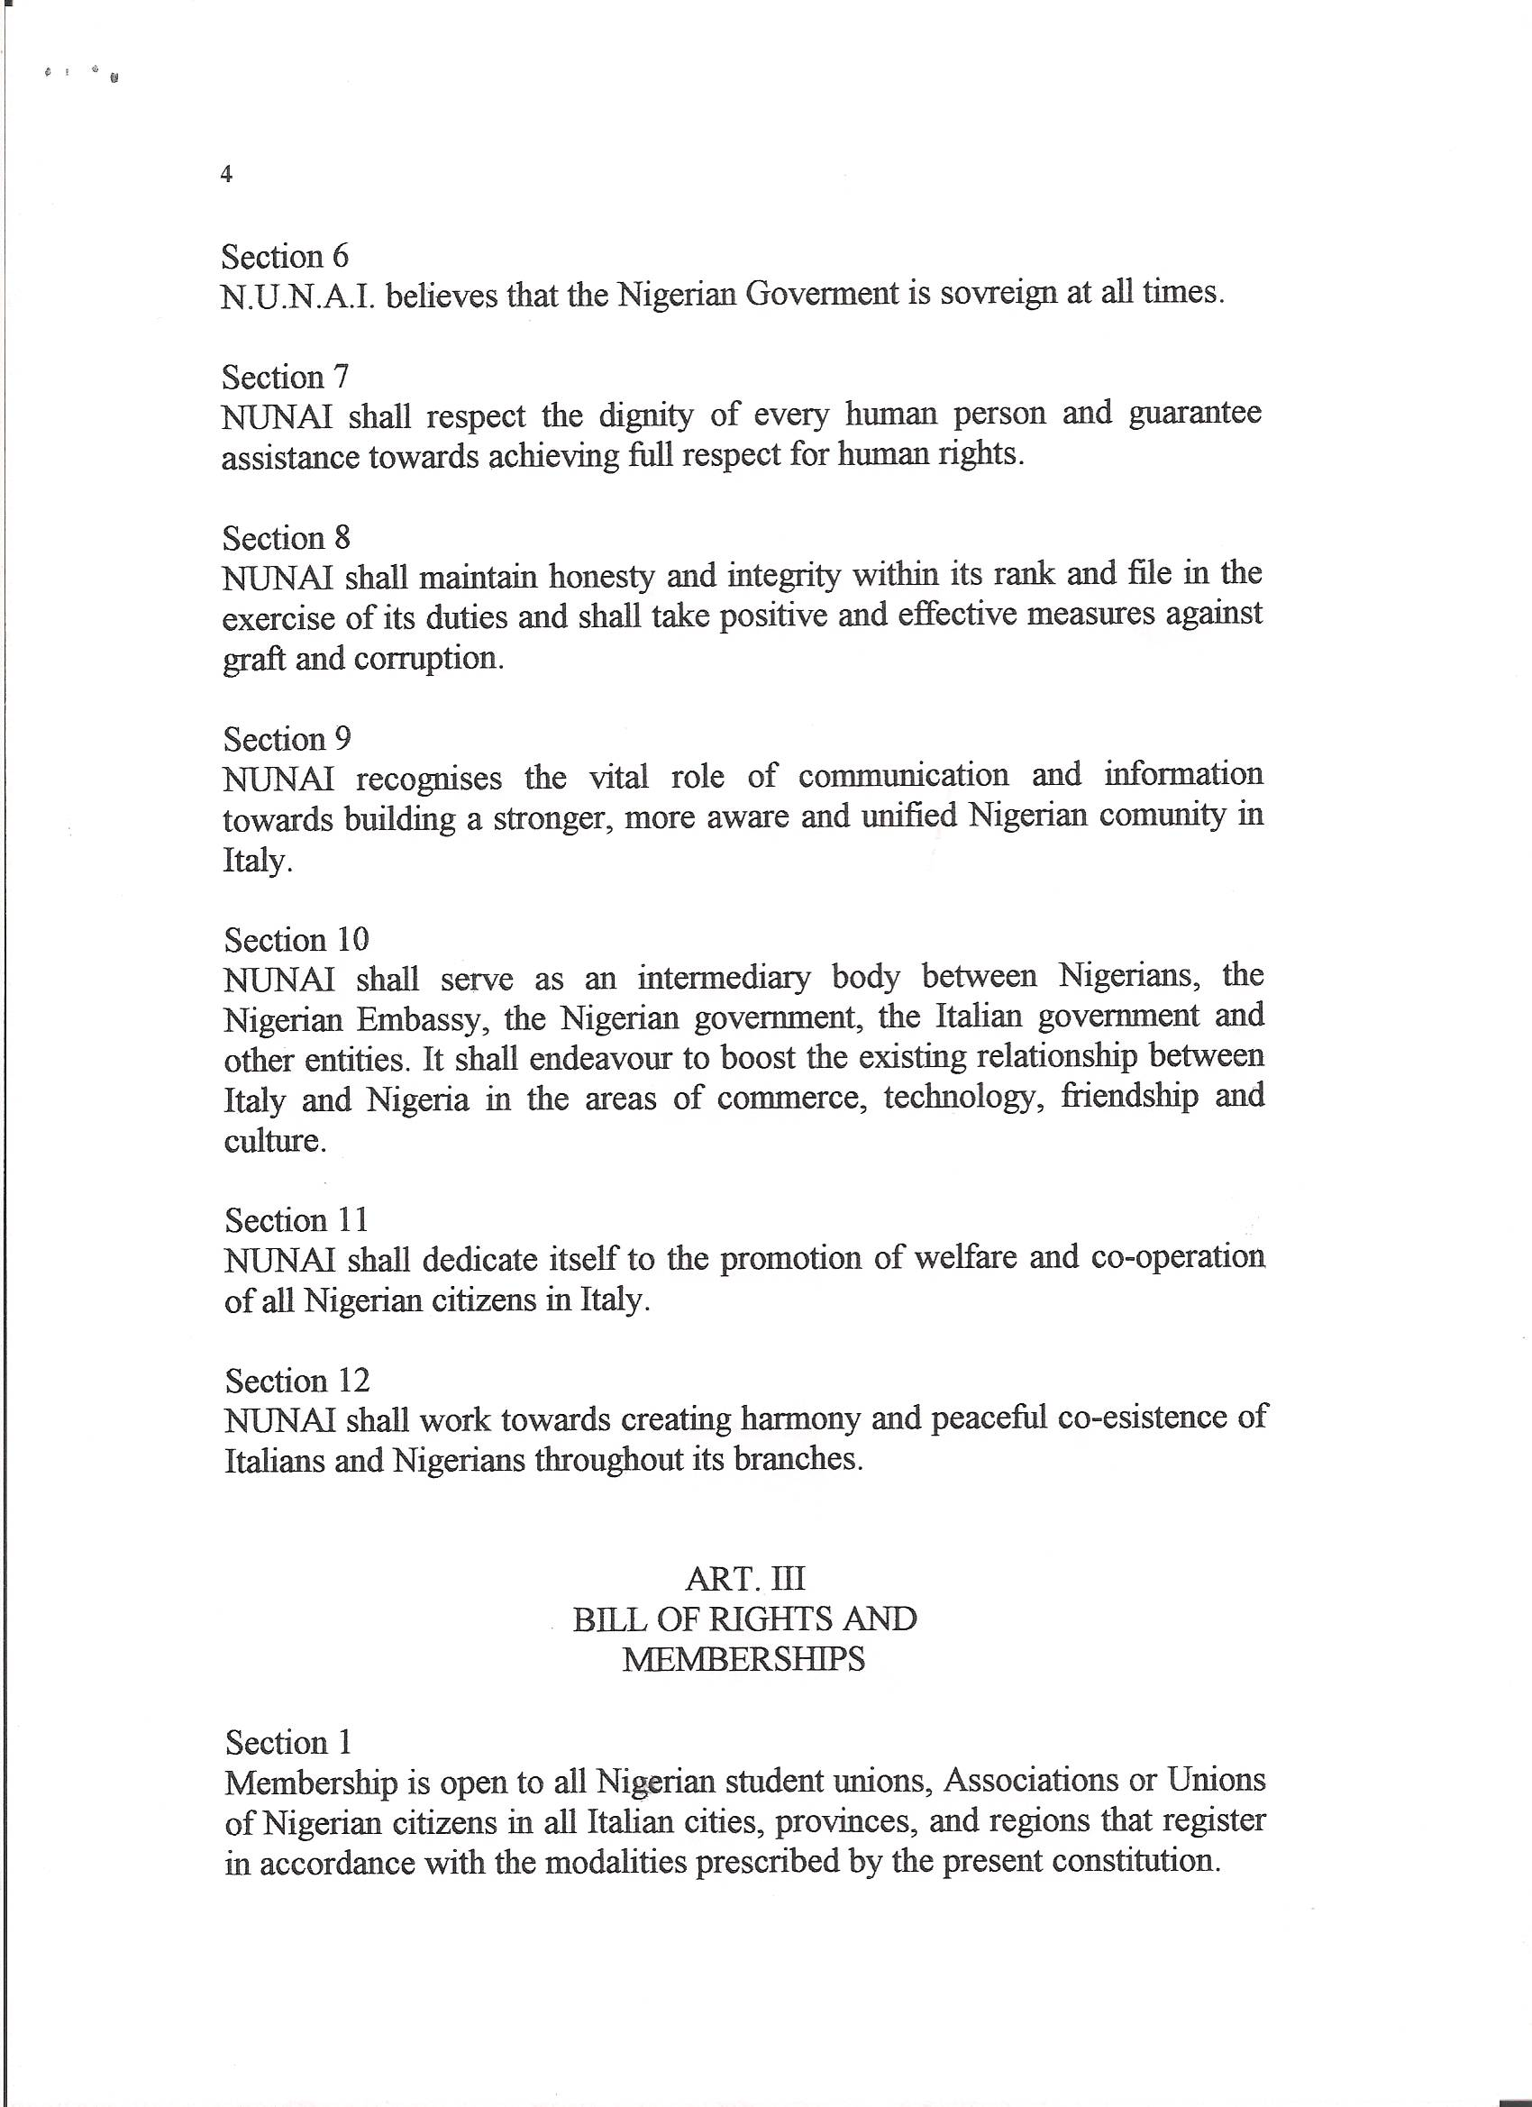
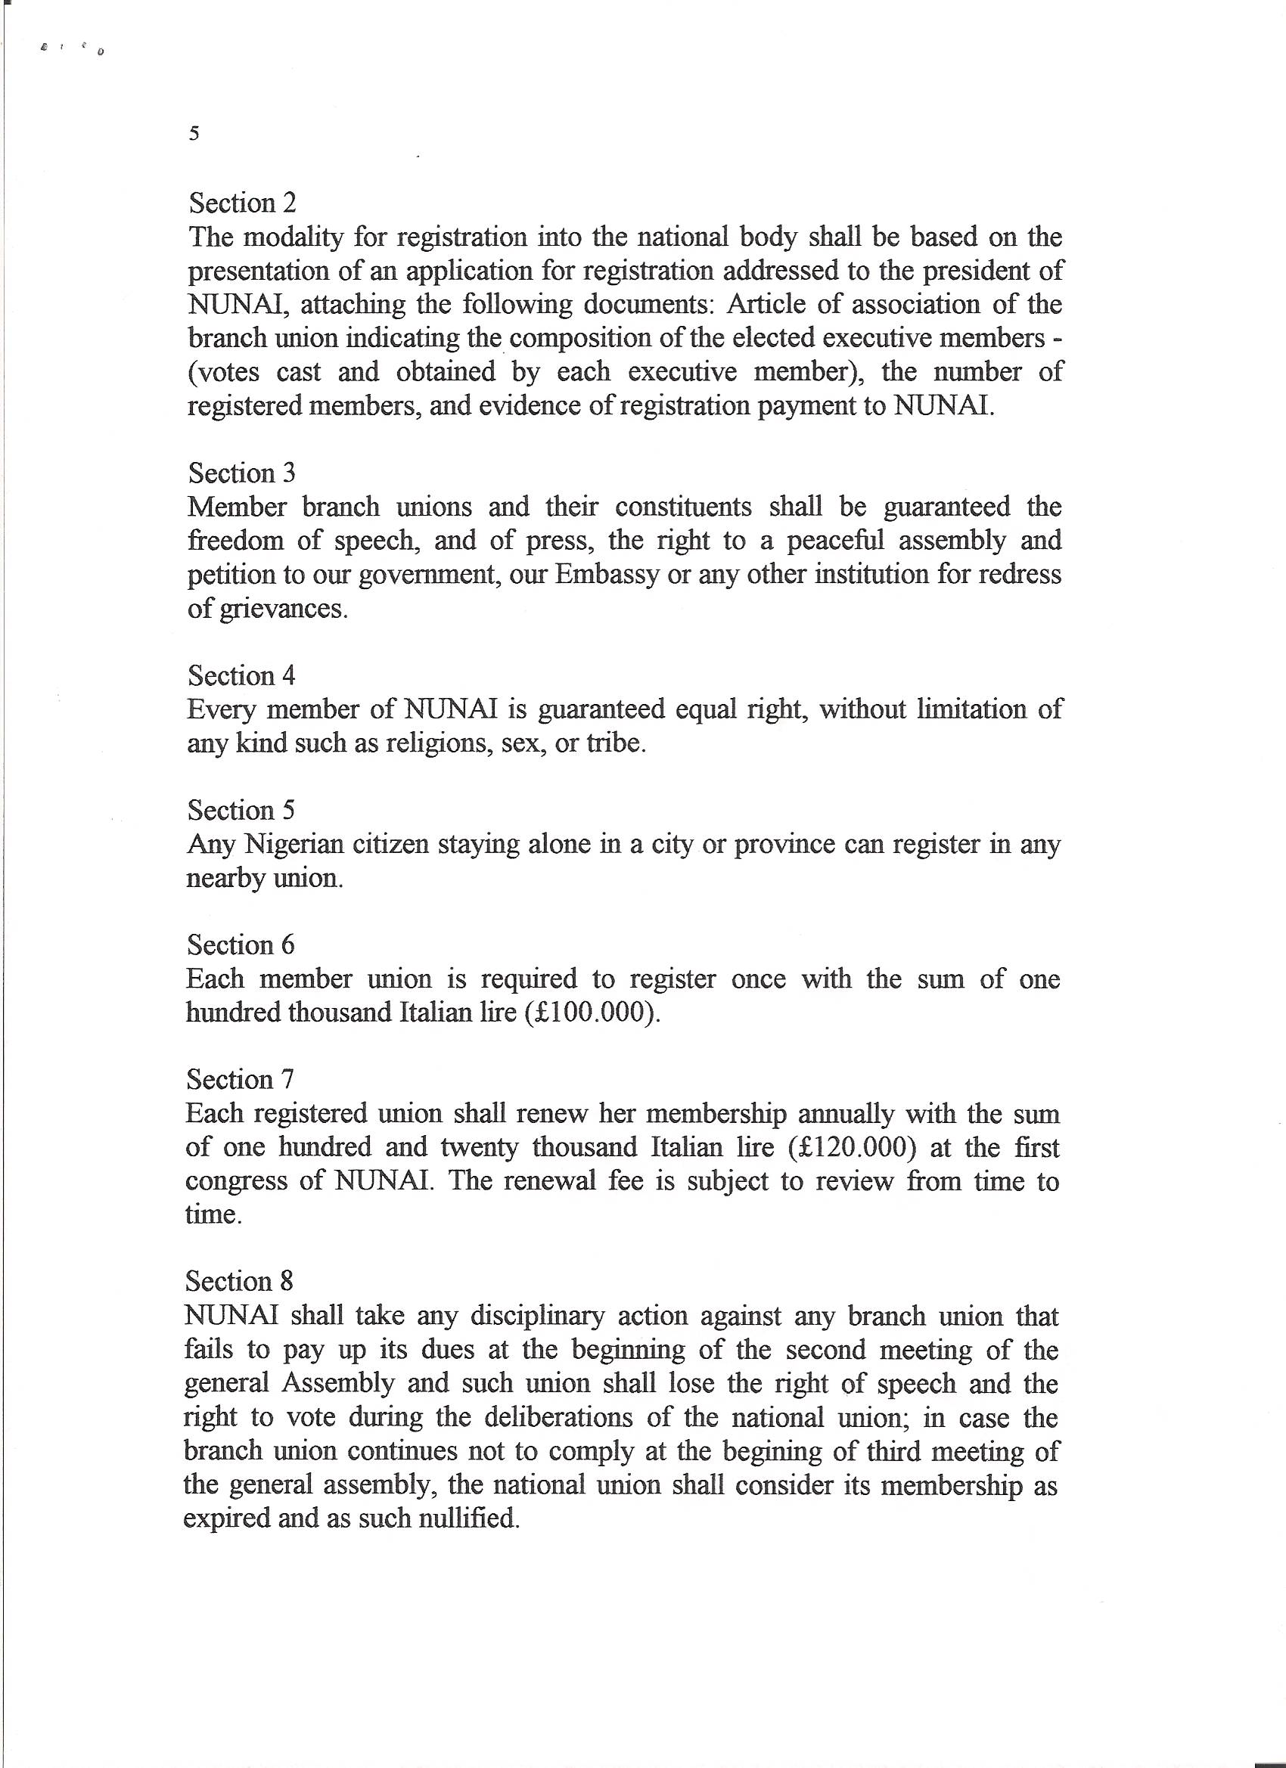
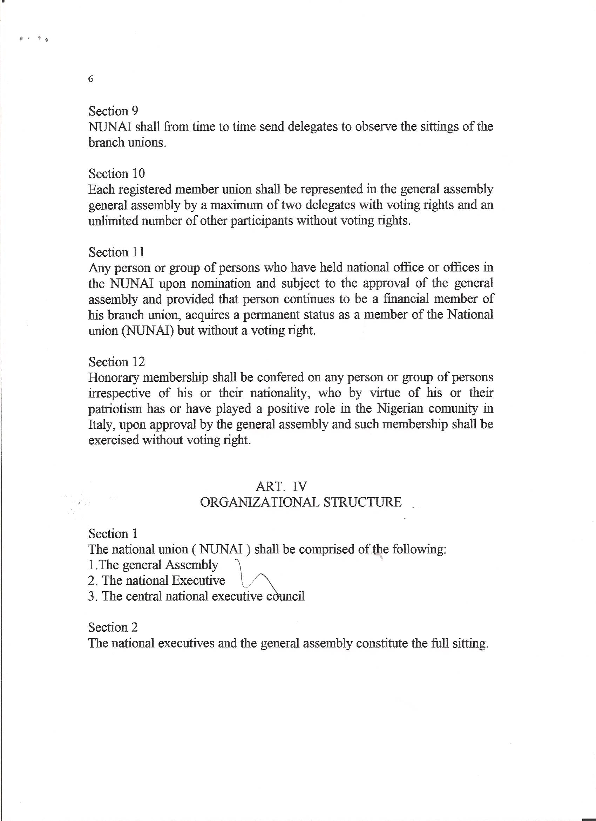
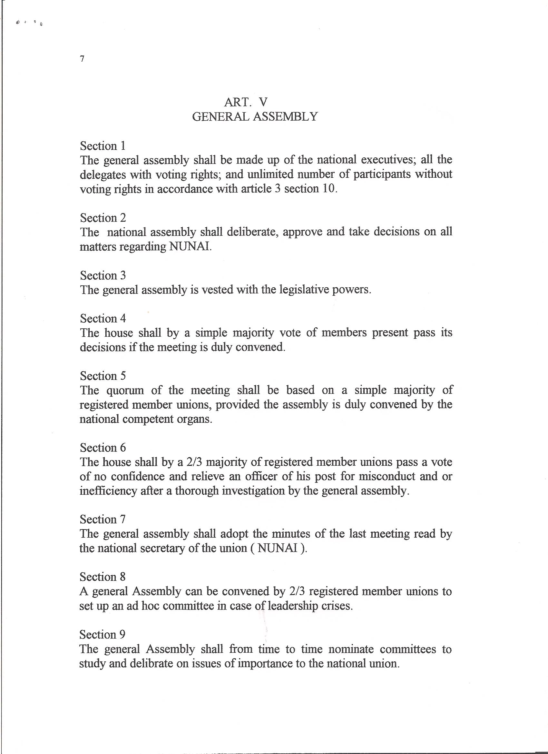
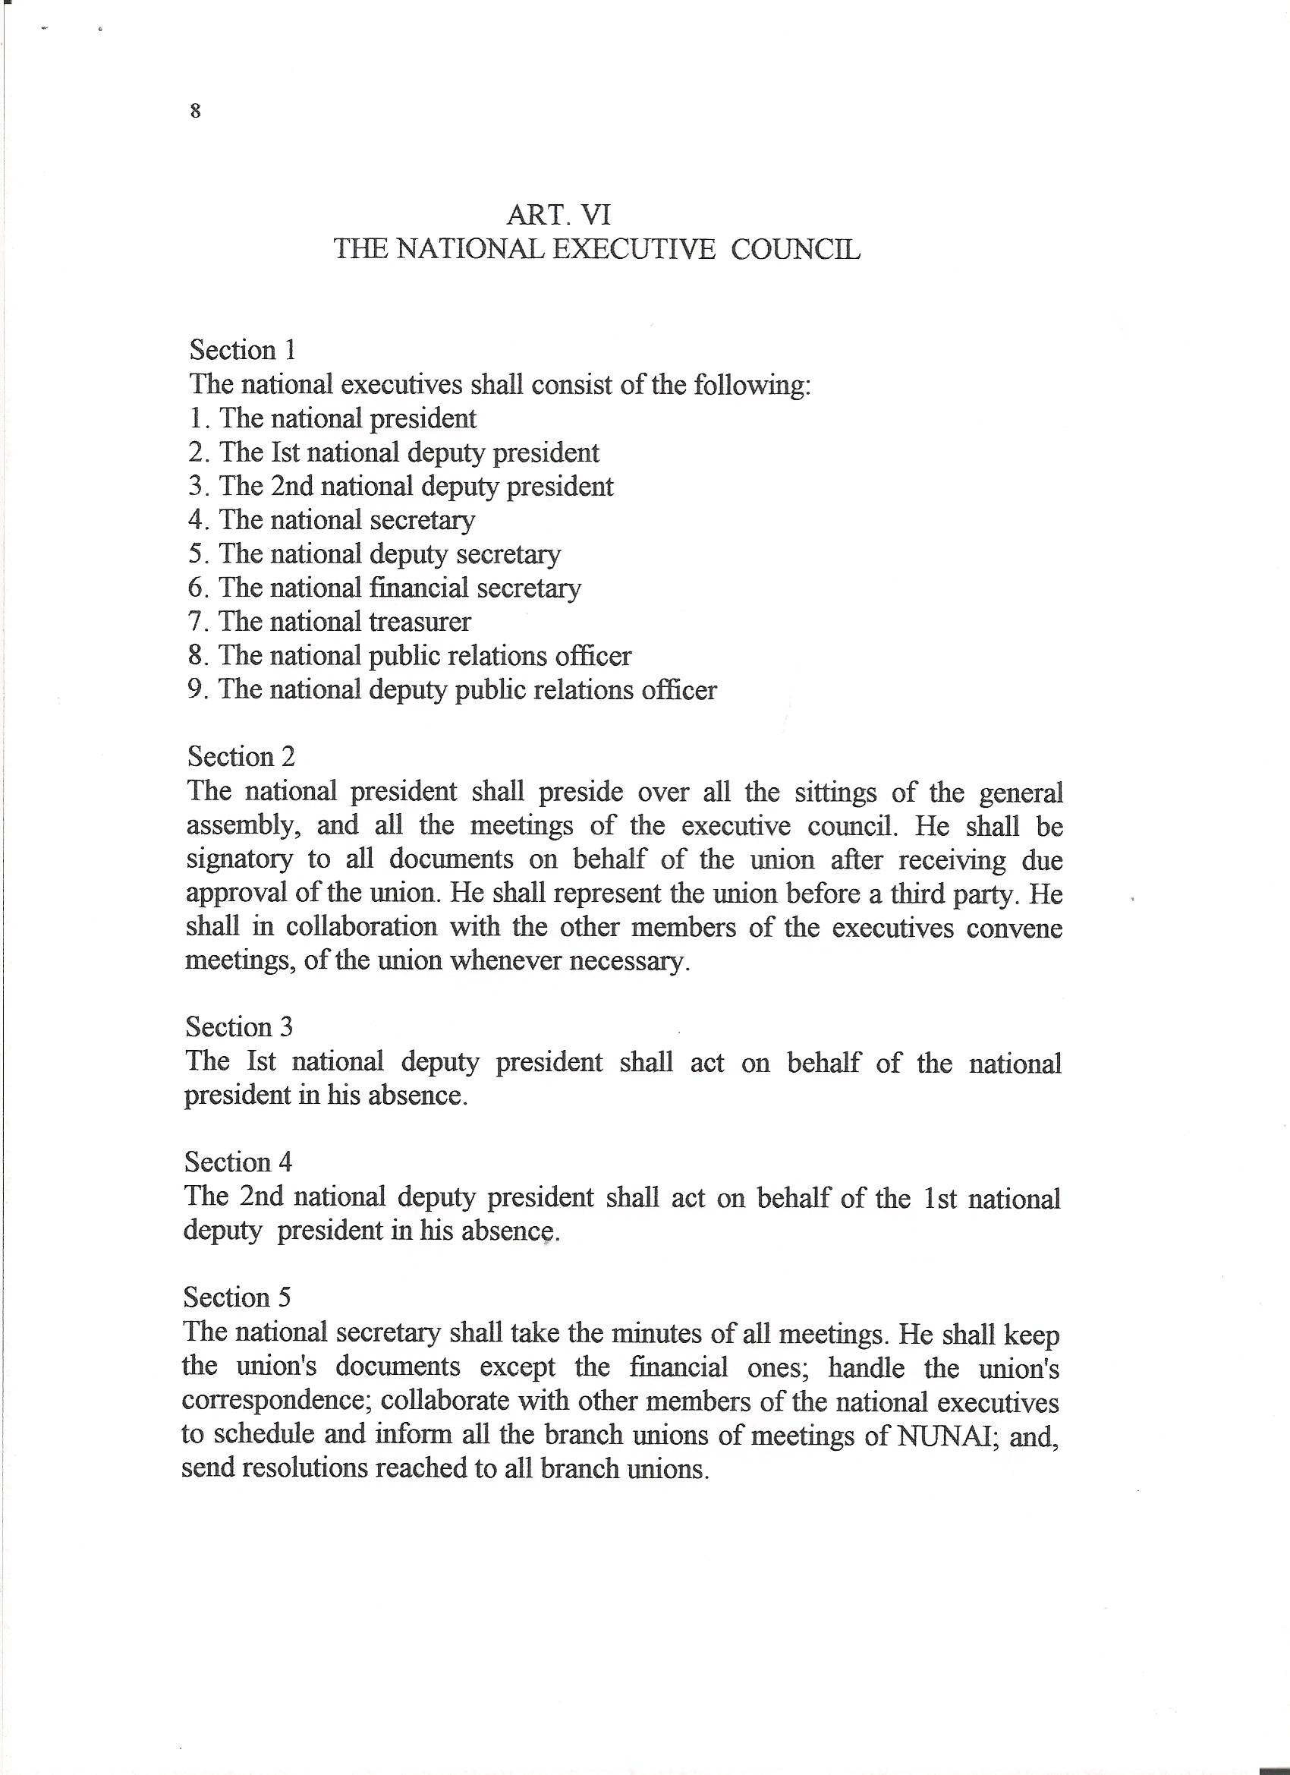
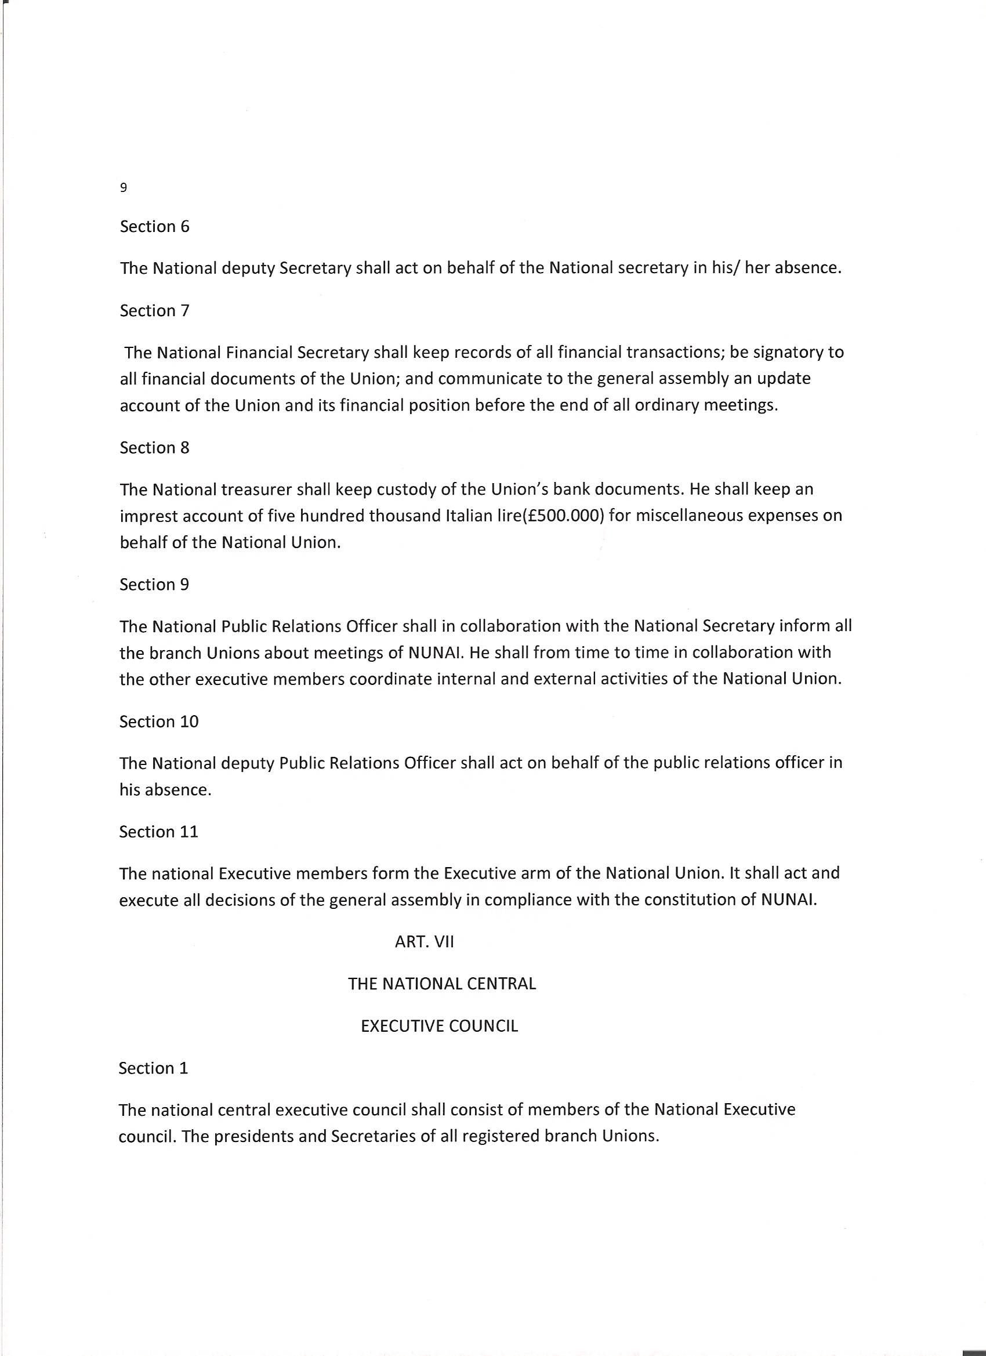
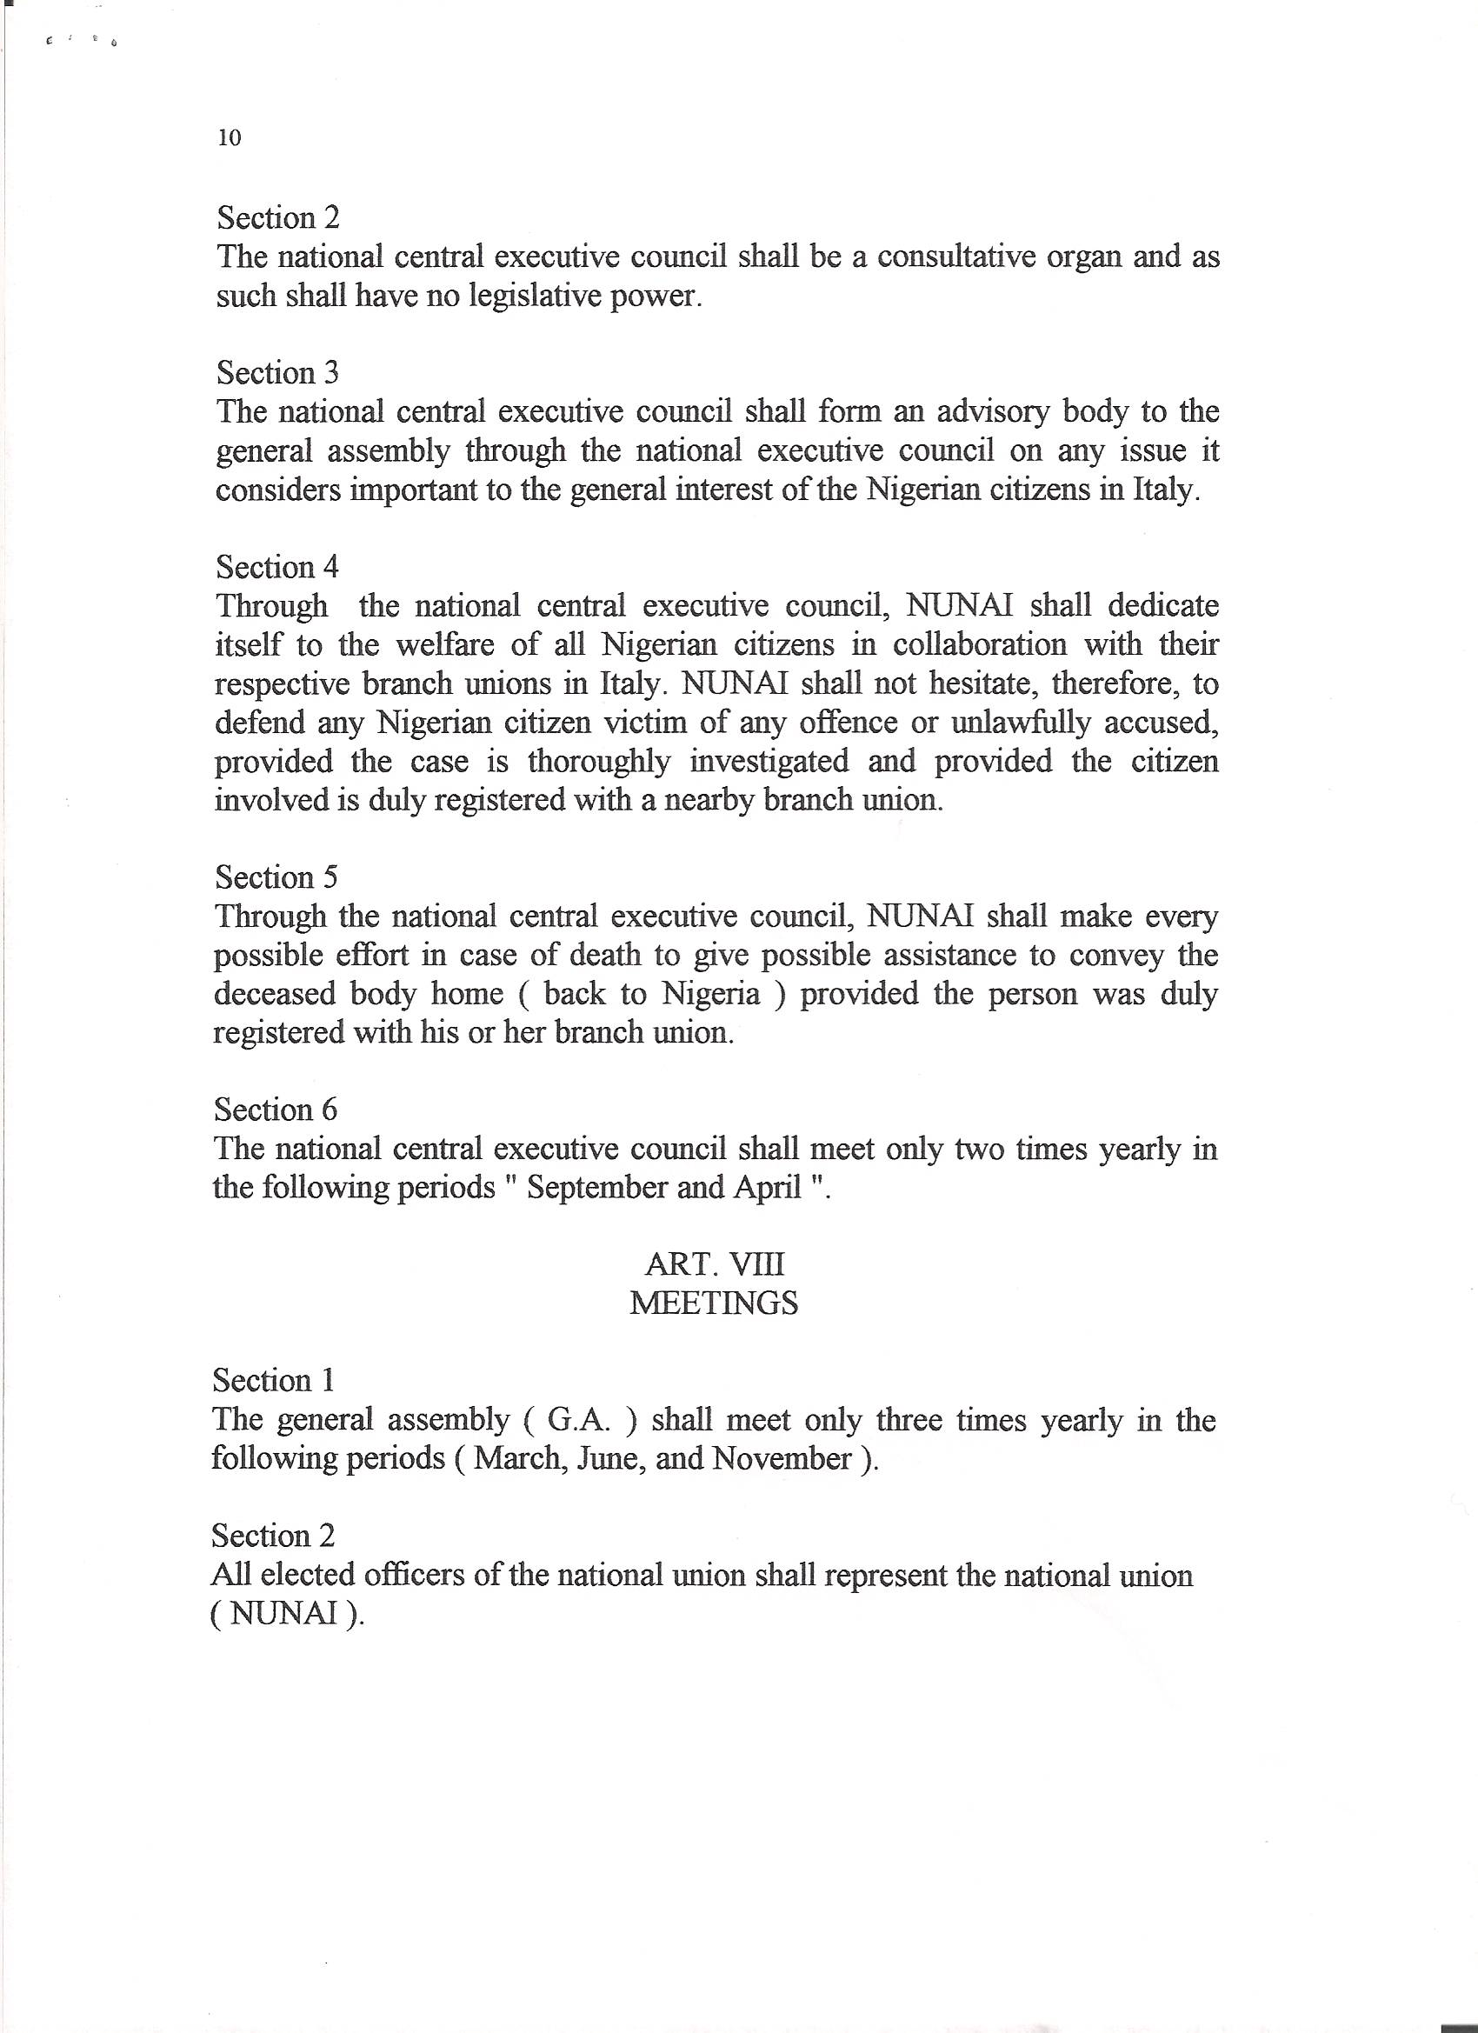
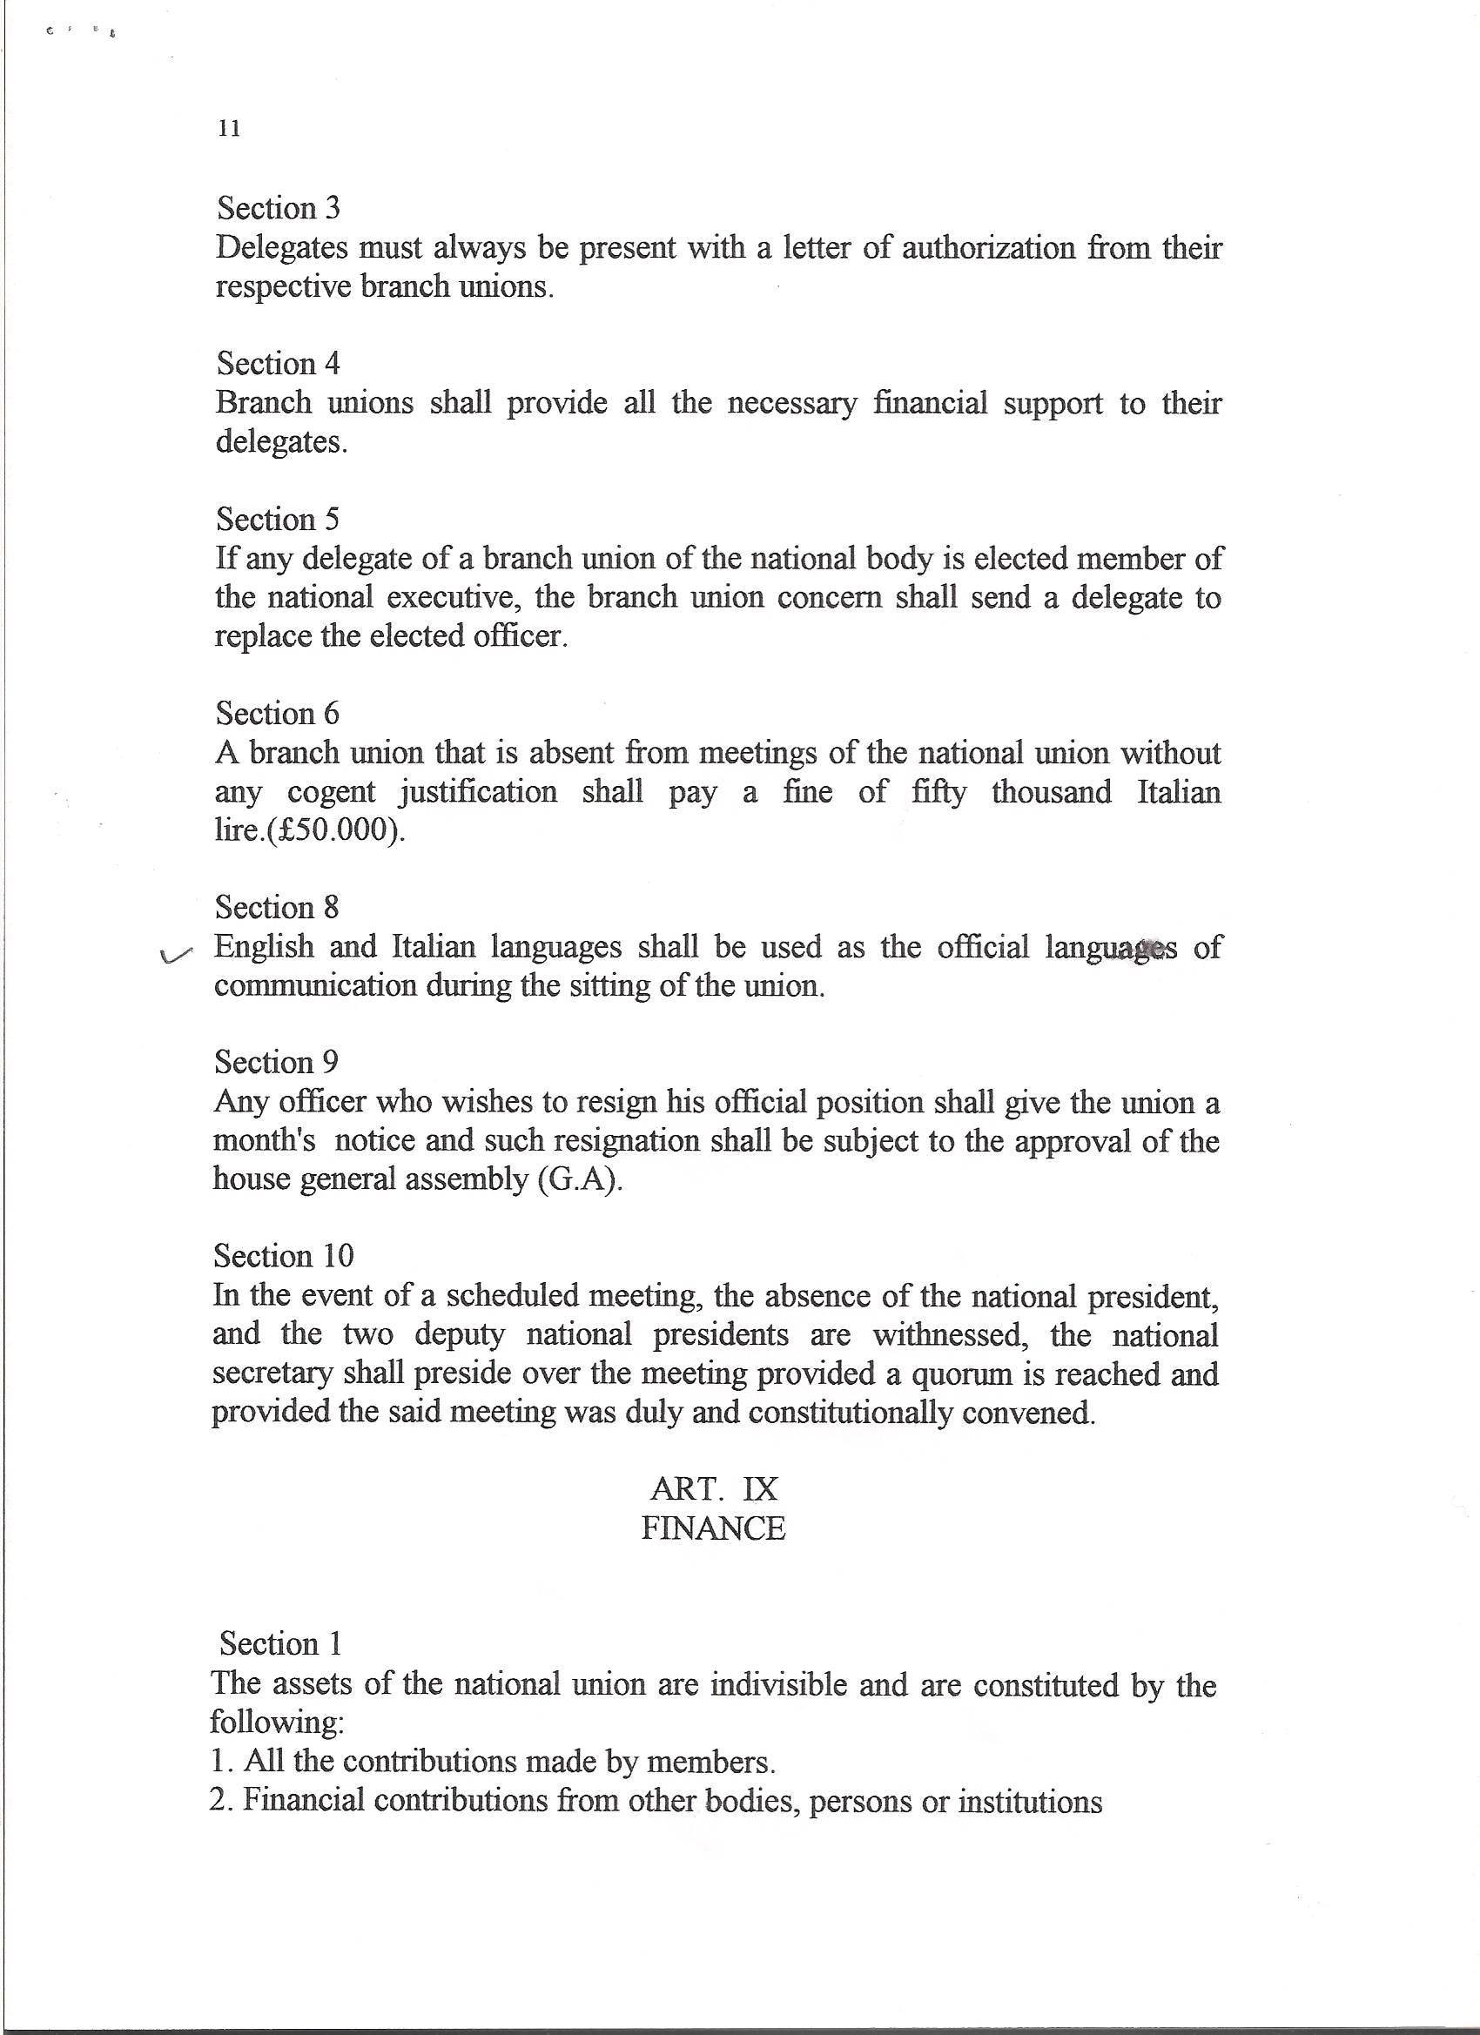
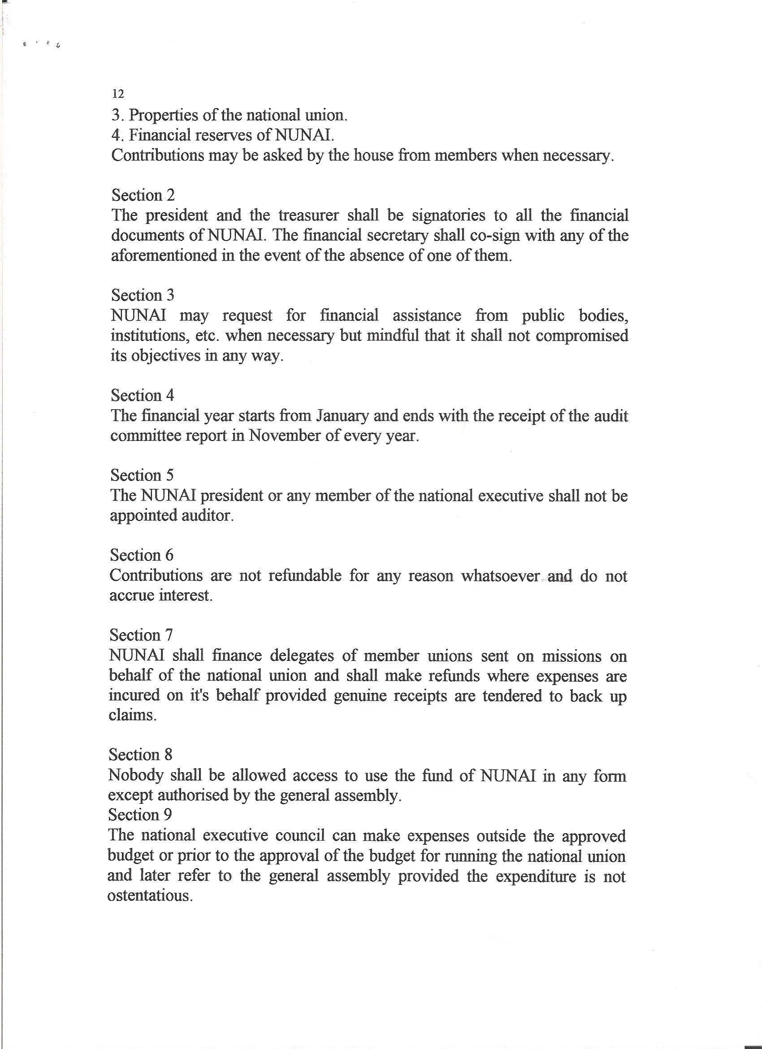
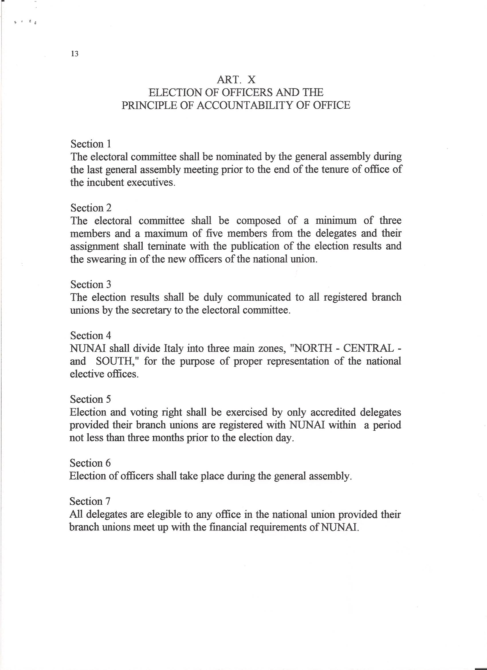
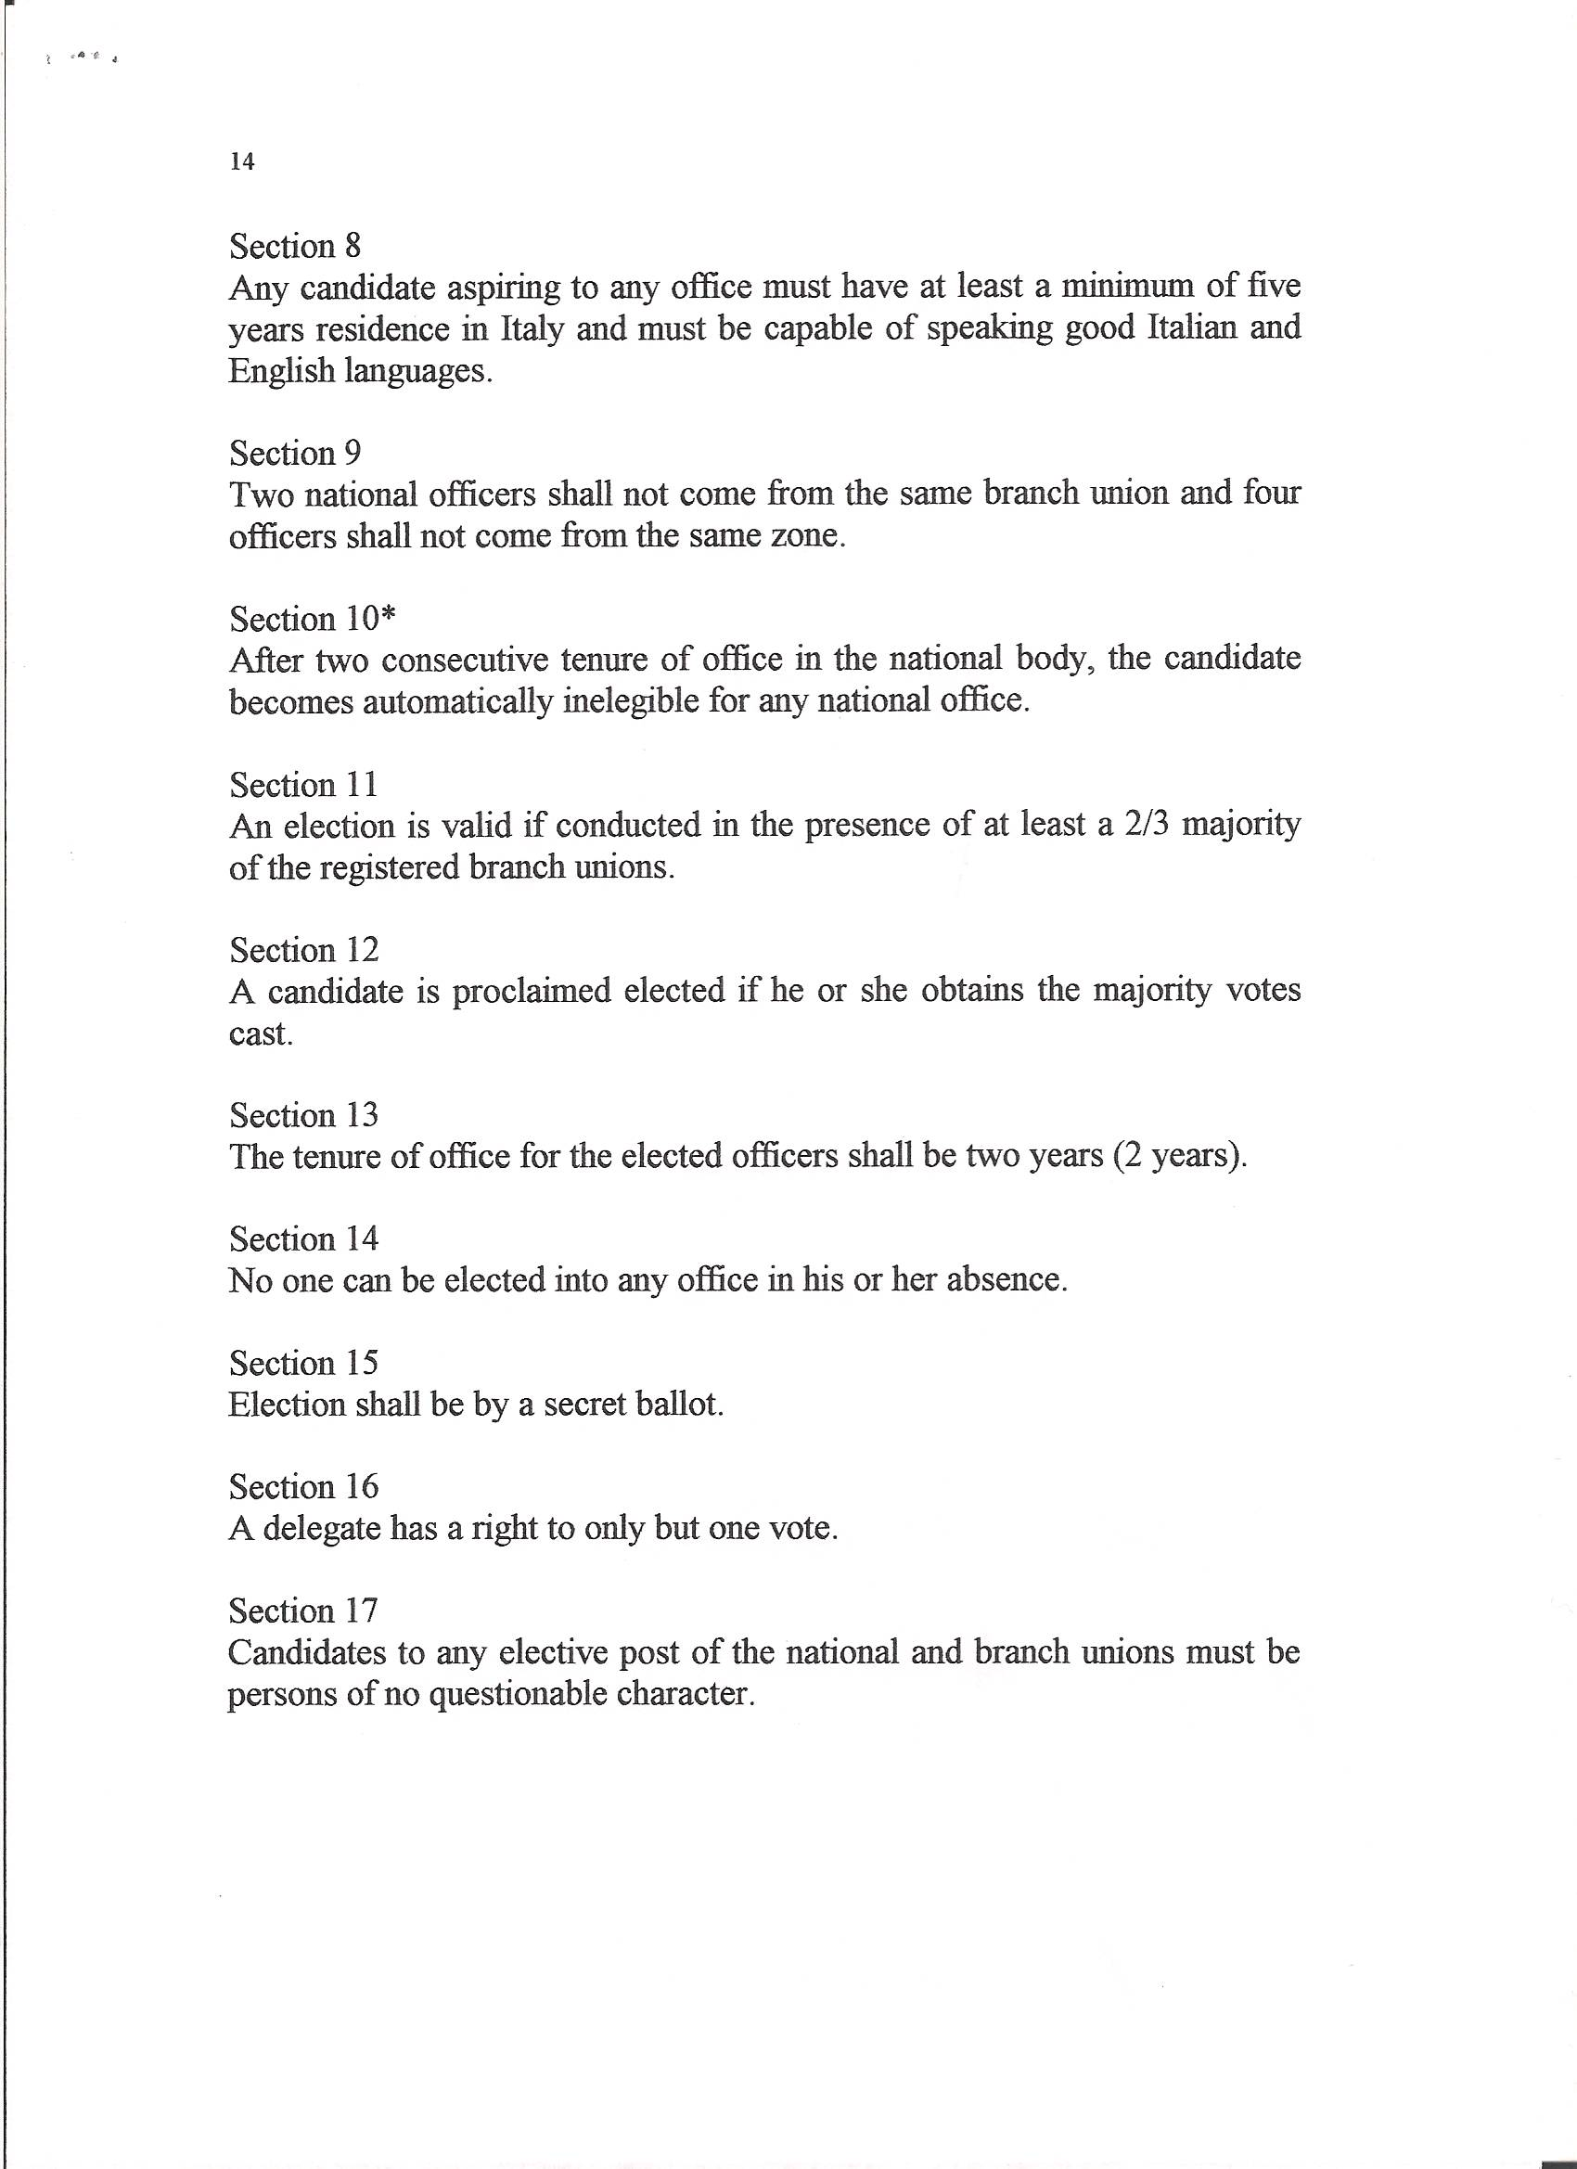
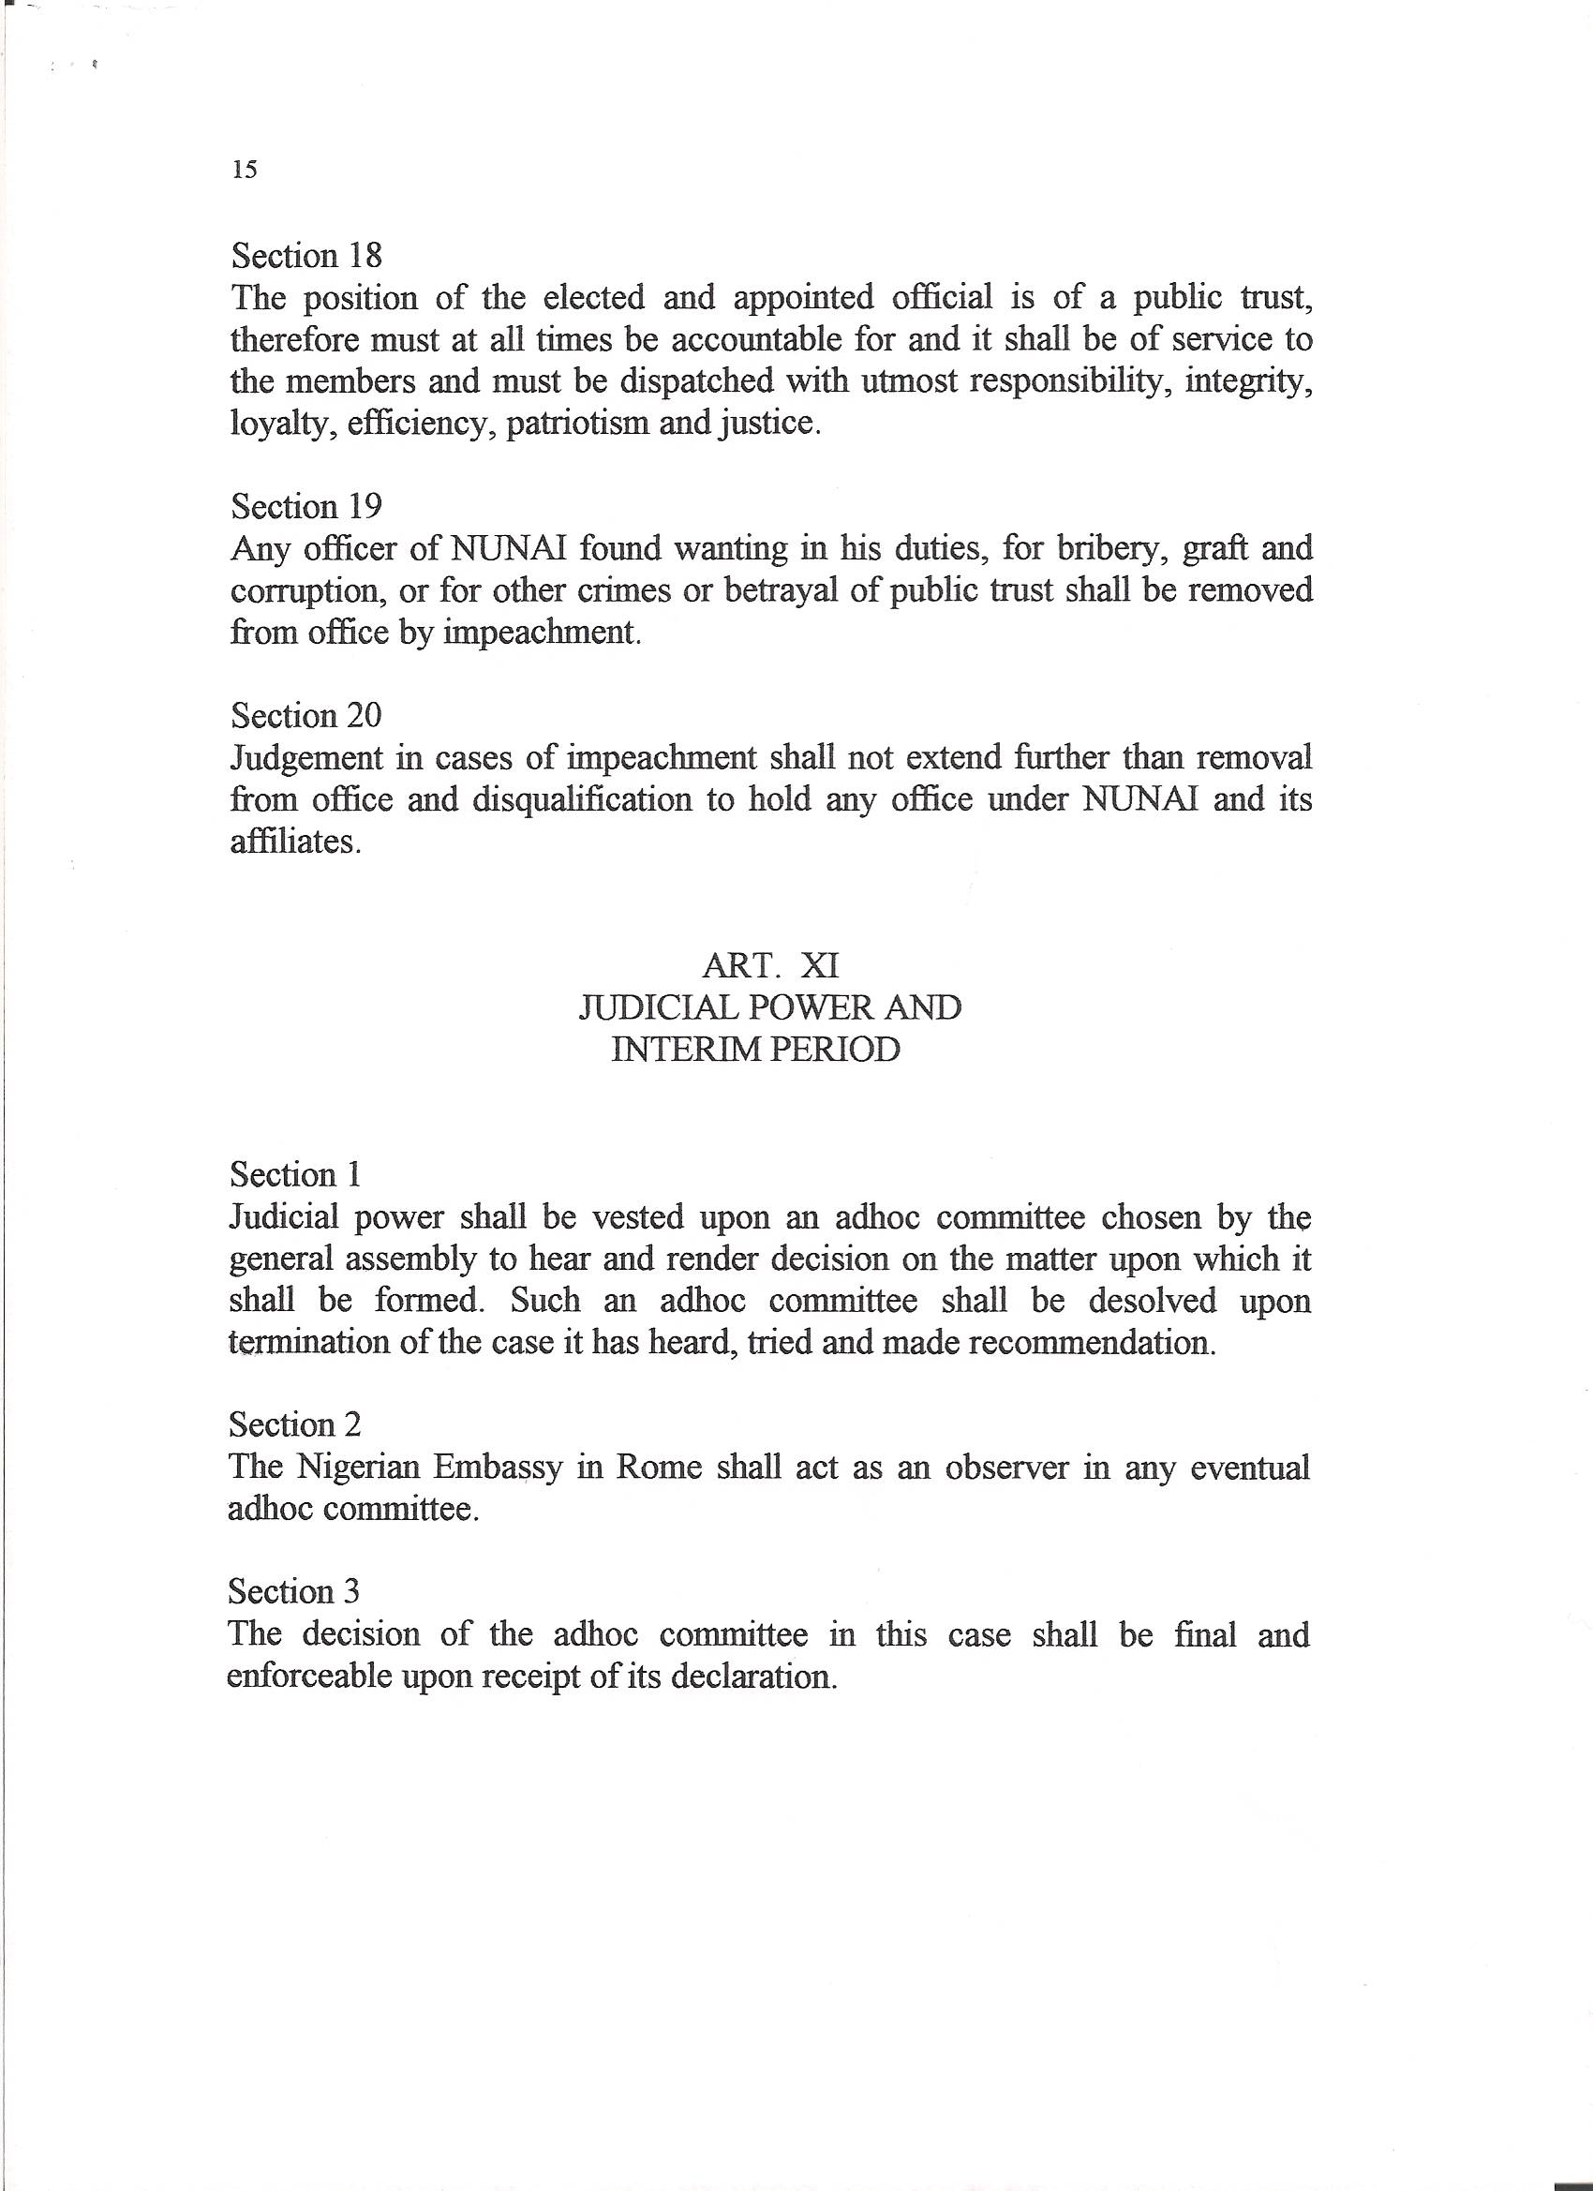
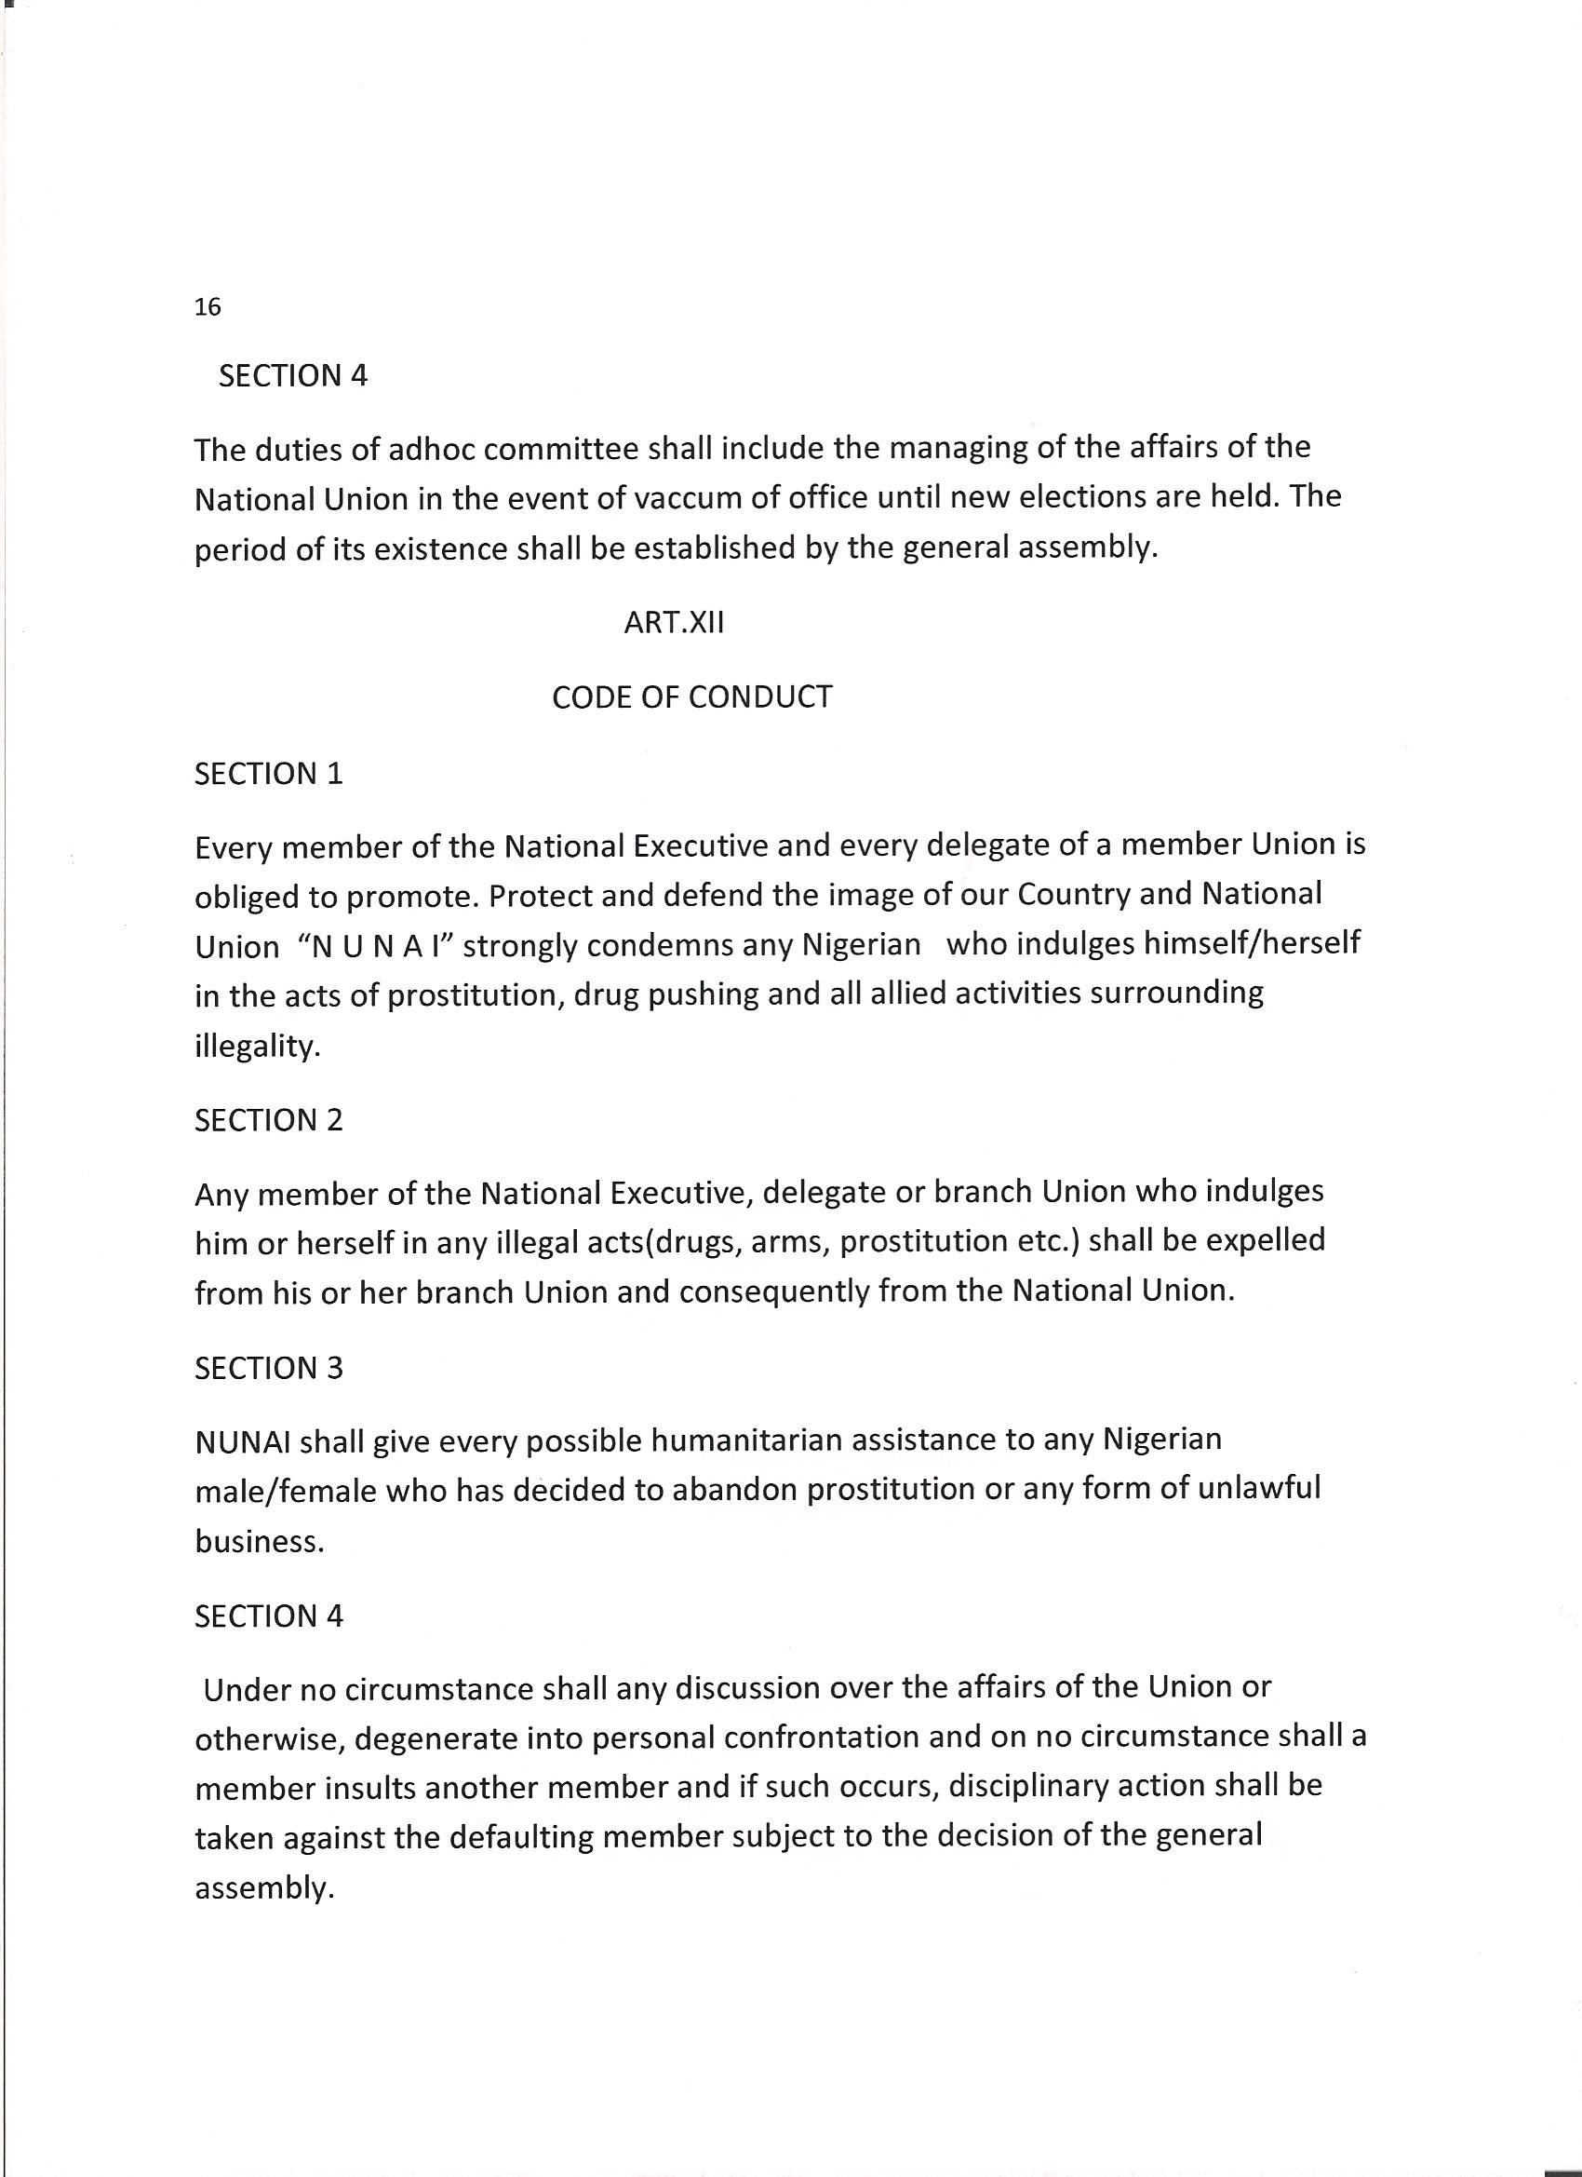
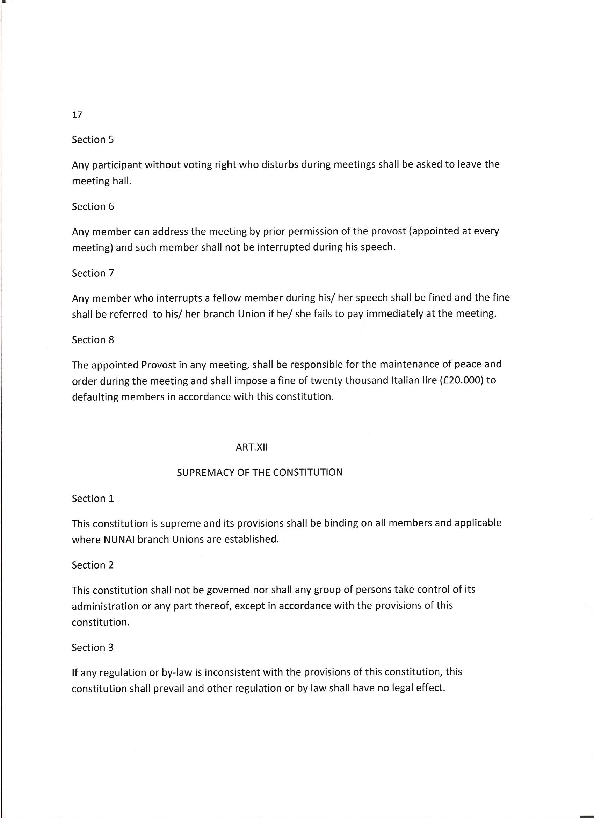
The reviewed constitution
ARTICLE X
-----------------
ELECTION OF OFFICERS AND THE PRINCIPLE OF ACCOUNTABILITY OF OFFICE

1.The Electoral Committee shall be nominated by the general assembly during the last general assembly meeting prior to the end of the tenure of office of incumbent executive members.
2.The Electoral Commission shall be composed of a minimum three members or maximum five members from the delegates and its assignment shall terminate with the publication of the election results and the swearing-in of the new National Executive Members.
3.The Electoral Commission has as a duty to ascertain the validity of documents presented by candidates and their source. It also reserves the right to reject the application of a candidate when the documents are incomplete or there are doubts about their authenticity.
4. The Chairman of the Electoral Commission shall be the Chief Returning Officer and shall swear in the newly elected officers. Results of the Election shall be communicated to all Associations affiliated to the National body by the Secretary to the Electoral Commission.
5. NUNAI recognizes those branch Associations that are registered with it.
6. The right to vote and be voted for belongs to every Nigerian who meets the conditions stipulated for every position in NUNAI.
7.A candidate must prove that he/she belongs to an Association duly registered with NUNAI.
8. Voting is by secret ballot and only one member of the delegates has a voting right.
9*After two consecutive tenure of office in the national body, the candidate becomes automatically ineligible for any national office.

ARTICLE X(a)
COMPOSITION AND POSITIONS IN THE EXECUTIVE COMMITTEE
- PRESIDENT/VICE
- SECRETARY GENERAL/VICE
- PUBBLIC RELATIONS OFFICER(P R O )/VICE
- TREASURER/VICE
- FINANCIAL SECRETARY/VICE
- WELFARE OFFICER/VICE and
- PROVOST
ARTICLE X(b)
REQUIRMENTS/ QUALIFICATIONS

PRESIDENT/VICE
1.Must have a minimum academic qualification of School Certificate or its equivalent.
2. Must have been resident in Italy for at least five years.
3. Must be employed.
4. Must be in possession of Italian Residents’ Permit (Permesso di Soggiorno)
5. Must produce his/her penal Certificate and evidence that he is not under going trial in any court in Italy (Certificato Penale e Carichi Pendenti)
SECRETARY GENERAL/VICE
The requirements as above.
PUBLIC RELATIONS OFFICER/VICE
The requirements as above
TREASURER/VICE
The requirements as above.(In extreme case may be asked to produce a collateral)
FINANCIAL SECRETARY/VICE
1.Must have lived in Italy for at least three years and must meet requirements 3-5 as above.
WELFARE OFFICER/VICE
Must meet the requirements as above.
PROVOST

Must meet the requirements as above.

ADDENDUM
ARTICLE1X
The president , Secretary General and the Treasurer shall be the sole signatories to the Union’s account. The financial Secretary is to read the Union’s financial situation during meetings. He/she could also collect money on behalf of the Union for onward transfer to the Treasurer.

