The Directors Trio

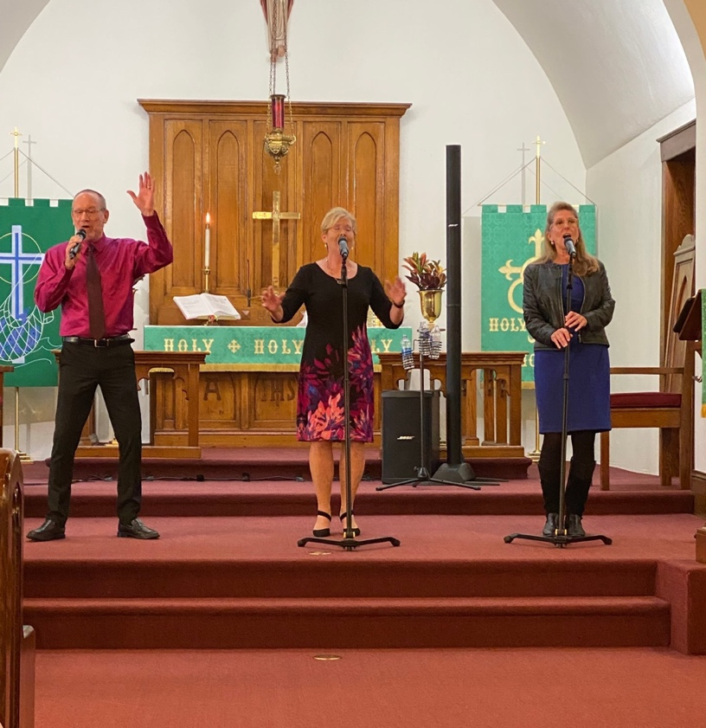

in Concert

Date: ________________________________

Time: ________________________________

Place: ________________________________

www.thedirectorstrio.com

