TRINITY UNITED METHODIST CHURCH
The Rev. Charles Wilbanks ___ Minister
April 25, 2021 Color: White
FOURTH SUNDAY OF EASTER
"We welcome you to our service this morning and pray that your time with us will be a blessing to you"
THE ORDER FOR WORSHIP
Prelude Mr. Eddie Welborn
The Prelude is a time for silent preparation for worship.
Welcome and Announcements Mr. Grady Senn
The Chiming of the Hour Mr. Eddie Welborn
The Lighting of the Candles
The Processional of the Cross
The Call to Worship Rev. Charles Wilbanks
Opening Prayer Rev. Charles Wilbanks
The Children’s Time Rev. Charles Wilbanks
The Hymn of Adoration: “O For a Thousand Tongues to Sing” Page 57
*Responsive Reading: Psalm 23 Page 754
*The Apostles Creed Page 881
*The Gloria Patri: “Glory Be to the Father”
Prayer Concerns and Praises Mr. Grady Senn
The Pastoral Prayer/The Lord’s Prayer Rev. Charles Wilbanks
Tithes and Offering Ushers / Mr. Grady Senn
*The Doxology: “Praise God From Whom All Blessings Flow”
*The Hymn of Preparation: “The Church’s One Foundation” Page 546
First Reading: Acts 4:5-12 Rev. Charles Wilbanks
Second Reading: 1 John 3:16-24 Mr. Grady Senn
*Gospel: John 10:11-18 Rev. Charles Wilbanks
Musical Transition Mr. Eddie Welborn
The Sermon: Are We Sheep? Rev. Charles Wilbanks
*The Hymn of Service: “Christ is Made the Sure Foundation” Page 559
*The Returning of the Light

*The Benediction Rev. Charles Wilbanks

*Three-Fold Amen Mr. Eddie Welborn
*The Postlude Mr. Eddie Welborn
*All who are able stand. The altar is open for prayer during the last hymn.
Technician: Mr. Bryan Waldrop

The Altar Flowers are to the Glory of God.

Next Sunday – May 2

Altar Flowers: Open; Technician: Caroline Senn

Our Faithfulness
Live Streaming, April 11: 104
Live Streaming, April 18: 86
Worship Attendance for April 18, 2021: 19
Total Budget for 2021: $ 149,647.00
Weekly Offering Needed: $ 2,877.83
Offering Received April 11, 2021: $ 1,586.00
Offering Received April 18, 2021: $ 637.00
2021 Average Weekly Offering YTD: $ 2,289.00

The Concerns of Trinity
Our Known Hospitalized:
Recent Hospitalizations and/or Surgeries: Johnny Marlowe
Nursing Home:
Continued Prayers: Jane and Robert Pollard, James and Jeanette Poag, Cheryl Longshore, Shirley Berry, Jim Waldrop, Gloria Brehmer, Rebecca Bundrick,, Shin Wilbanks, Alice and John Longshore, Mary Forrest, Frieda Kesler, Crystal Waldrop

Family and Friends of Trinity: Blake Hendrix, Jennie O’Shields. Phillip Sanders, Eddie Fisk, Richard Douglas, Wilson Bowles, Charlotte Berry, Sal Welborn, Harriett Connelly, Merle Simpleton Reynolds, Megan Wainwright, Joyce Bedenbaugh Murray, Jessica Griffen

JOIN THE CHOIR!
The Bishop has authorized churches to assemble choirs again.
If you would like to add your voice to the Voices of Trinity,
please let Jane Pollard or the Pastor know.
Help us to make a Joyful Noise to the Lord!

UPDATE!
AS of April 11th, Trinity UMC’s weekly bulletin can be accessed
by going to www.trinityumcnewberry.net website.
The monthly NEWSLETTER can also be seen at this location.
Keep checking as this website is constantly being revised to best
serve it viewers and church members.

WELCOME VISITORS

Thank you for coming today! We are delighted you are here! We hope
you will join us again as we continue to discover the difference God’s love makes in our lives. If you have questions or desire to become a member of Trinity UMC, please speak to pastor. We’re blessed because you’re here.

Trinity United Methodist Church Please visit our website:
1160 Trinity Church Road www.trinityumcnewberry.net
Newberry, SC 29108
Rev. Charles Wilbanks, Pastor
803-276-1245 (Church Office)
803-768-7687 (Church’s cellphone)
803-206-4623 (Pastor’s Cell)
clwilbanks@bellsouth.net

Trinity
United
Methodist
Church

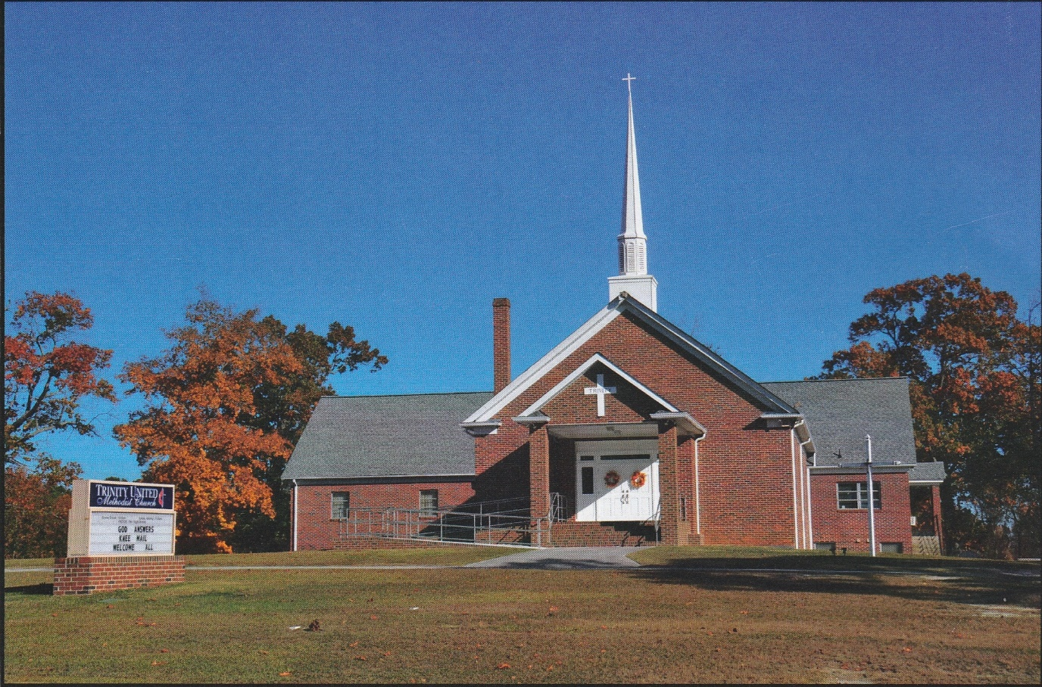

1160 Trinity Church Road
Newberry, SC 29108
Trinityumcnewberry@gmail.com

