Ktique German Shepherd Dogs
Questionnaire
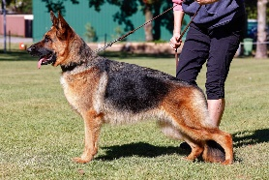
- Your name:

- Your address:

- Your email address:

- Your mobile number:

- Are interested in a pet or a show dog?

- If there are Long Stock Coat would you prefer a Stock Coat (Mum/Dad) or Long Stock Coat?

- Male or female or are you open to either?

- Have you had any experience with German Shepherds?

- How many other pets do you have? Please list type/age/breed.

- Do you have children, if yes, how old are they? We like to match puppies to buyers re energy levels.

- Do the adults work outside the home?

- How many hours a day would the dog be left alone?

- How do you feel about potentially everything being destroyed which is left out in the puppy’s area? i.e. shoes, clothes, toys, rugs, tables.

Our philosophy is to set a puppy up for success so we fully recommend puppy proofing areas if you are concerned about damage because they will chew and quite often dig.

- Which age category are you in? 18 – 29, 30 – 49, 50 – 69 or 70+

Please send us some photos of your home, other pets and family.

Prices:
Pet home puppies are $4,500
Show home puppies are $5,000

All puppies are Micro-Chipped, Vaccinated, Wormed, Vet Checked and have Limited Register papers through Dogs Queensland (unless a Show Puppy). They come with 6 weeks free Pet Insurance and a Gift Bag with lots of goodies.

Terms and Conditions:
Once your application is approved and when the puppies are born, we do require a $1000 holding deposit. Should your circumstances change or change of mind, you will get a full refund less an administration fee of $50. This will be paid to you when the new buyer has paid their deposit.

